

HTML5, CSS, and JavaScript

Semester: 1 |  | Curriculum Code: 7023
Duration: 90 minutes |  | Total Marks: 20



Practical Examination Paper

Question 01: (10 points)
You are given the file question1.html which creates the home page for Jake’s Coffee Shop website. This displays as shown in figure 1.
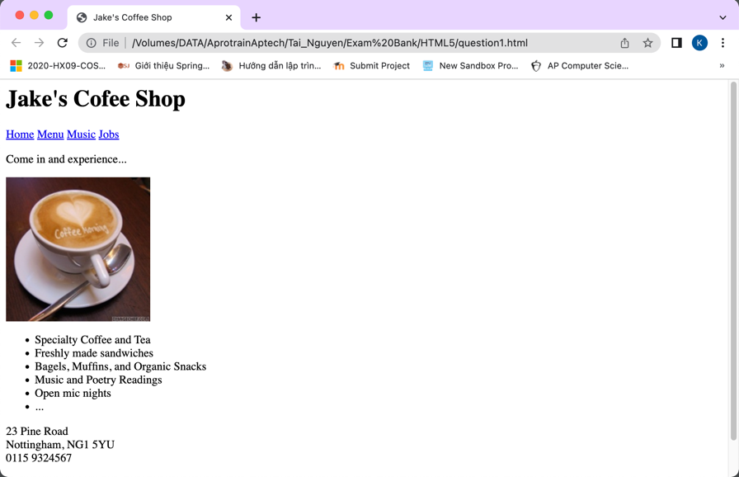
Figure 1. Display of original HTML file
Write the appropriate CSS (style.css) to change the presentation of the webpage to that shown in figure 2. The new page layout includes a header section, two columns (one for navigation menu and one for the main content) and a footer section.
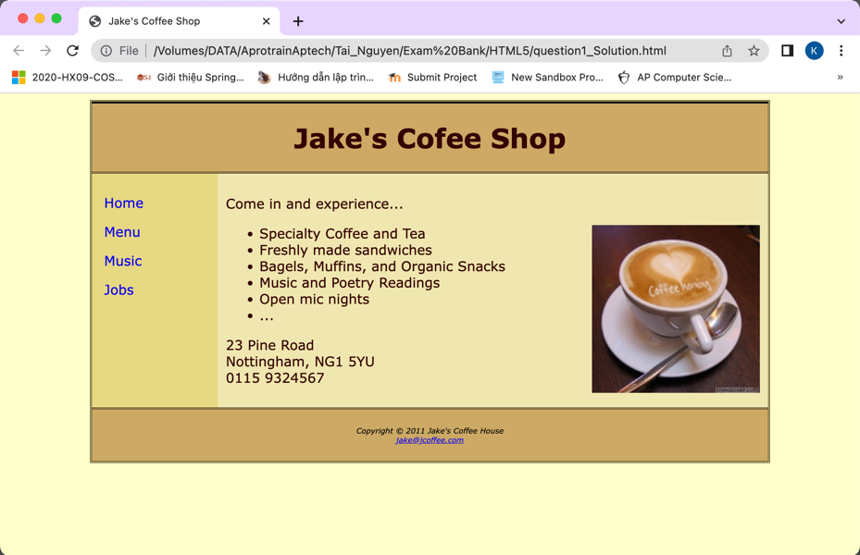
Figure 2. Display of question1.html with CSS
The colors used are as follows:
Text: #330000
Body background: #ffffcc
Header and footer background: #ccaa66
Left (navigation) column background: #E8D882
Right (main content) column background: #f1e8b0
The text is displayed in Verdana font.
You should write an external CSS file. You need to modify the original HTML file only to link to this style sheet, mark up sections (using <div> tags) and set appropriate class and id attributes.
Question 02: (6 points)
Design a web page with HTML5 as below figure:
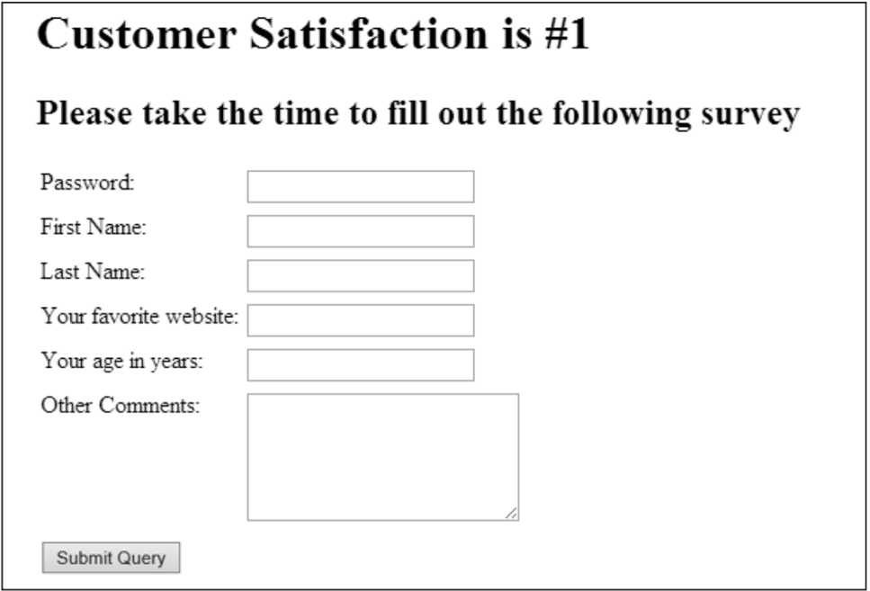
The password input control is the standard method of prompting users for sensitive information. As you type your password, each character is replaced with a glyph so that any onlookers can’t see your password.
Question 03: (4 points)
Write HTML5 code to draw the below image using Canvas.


