On Rails Shooter

Contents

Package description and features 2

Demos: 2

Features: 2

Update History: 2

Credits 3

Overview of the game’s library contents 4

Customization guide 5

Opening the demo 5

The Game Controller 6

The player 6

Weapons 7

Waypoints 8

Enemies 9

Pickups 10

Projectiles 10

# Package description and features

Create your very own On-Rails Shooter game using the ORS template! The game is ready to release straight out of the box, and it can also be easily customized to make it even more engaging to your players. The game supports PC/Mac. It can be played with the mouse, keyboard, and gamepad.

## Demos:

[Standalone demo](https://drive.google.com/file/d/1ZQdd2RnnK7ojlcdv5FQuk5n1Gd9c94C5/view?usp=sharing)

## Features:

- Game ready for release straight out of the box, just build and play!

- Supports multiple resolutions and aspect ratios, automatically.

- Supports Mouse, Keyboard, and Gamepad controls.

- Easily customizable with lots of options to control game difficulty.

- Great learning resource with commented scripts and documentation.

- All assets included: graphics, sounds, and code.

## Update History:

**0.60 (20.12.2017)**

- Examples of destructible environment objects such as barrels and buildings.

* Destroyable objects/enemies and pickup items give bonus score.
* You can set loot drop from destroyable objects, including items list and drop chance.
* End-of-game statistics show bonus score for accuracy, health, and completion, and a rating icon based on the total score.
* You can set one or more actions that happen when the player reaches a waypoint. This can be chosen from any object and public function in the scene.
* You can have a list of attack types that the enemy can use in sequence or randomly. Each attack has its own animation/effect/damage/range.
* You can have a melee enemy attack type which gets closer to the player and then attacks them directly without throwing a projectile.
* Randomized corpse rotation for a nicer variation when enemies die.

**0.40 (19.11.2017)**

* You can set a custom hurt effect for each enemy projectile, which appears on-screen.
* You can add a health bar and name label above each enemy. Health bars are world UI.
* Optimized scenes for mobile play, tested on Samsung Galaxy S6 and LG V400.
* Bug fix: If an enemy who has slowmotion effect dies, the slowmotion is cancelled.
* Bug fix: Recoil position is no longer affected by actual screen size.

**0.31 (30.10.2017)**

* Updated package to Unity 5.5, 5.6, and 2017
* Removed script assets from Unity demo.
* Prepared basis for further feature updates.

**0.3 (02.11.2016)**

* You can set multiple paths from each waypoint, so the player can choose where to go next.
* Weapons now have a Recoil attribute, which makes them kickback when shooting.
* Hittable objects ( things that can be hit, destroyed, and enemies ) can flash when hit.
* You can set the player to keep moving even when enemies appear. This allows you to create "driveby" encounters.
* Player auto aligns to the starting waypoint inside the editor, so you can see where it will start playing.
* You can create a slow motion effect.
* Enemy Animator can be placed anywhere within the enemy prefab.
* Particle effects now play a random seed each time they trigger.
* You can set a de-spawn time for enemies, making them hide again after appearing.
* You can choose to attach hit effects to the parent object that was hit.

## Credits

The sounds are courtesy of [the free sound project](http://www.freesound.org/index.php).

Music is Global Resonance by Knight of Fire (Public Domain)

Credits go to these authors for their great sound samples: **denalwa, department64, lucaslara, klawykogut, tiptoe84, qubodup, tm1000, cylon8472, kingsrow, paul368, gameaudio, zyrytsounds, sophiehall3535, peeper66, reitanna,kubatko, kubatko, jawbutch**

**Please rate my file, I’d appreciate it**

# Overview of the game’s library contents

Let's take a look inside the game files. Open the main ORSAssets folder using Unity3D 5.5.0f3 or newer. Take a look at the project library, usually placed on the right or bottom side of the screen. Here are the various folders inside:

**Animations**: Holds the animation clips made with Unity’s built-in animation system.

**FLA**: Holds the object graphics made with Flash CS3. These are vector graphics than can be easily scaled without loss of quality and then exported as PNG to be used in Unity.

**Fonts**: Holds the font used in the game.

**Prefabs**: Holds all the prefabs used in the game. These are distributed to various folders for easier access, Buttons, Enemies, Objects, etc. It also holds all the canvases in the game which are used to hold buttons and other UI elements.

**Scenes**: The first scene that runs in the game is MainMenu. From this scene you can get to the Game scene.

**Scripts**: Holds all the scripts used in the game. Each prefab contains one or more of these scripts.

**Sounds**: Holds all the sounds used in the game. Hit,Smack, etc

**Textures**: Holds all the textures used in the game which are used as sprites in Unity.

# Customization guide

On-Rails Shooter (ORS) is considered a complete project, and as such is supposed to work as the starting point of your planned game, rather than an addition to an existing project. That said, you may of course pick and choose some of the scripts/models to import into your existing project, but ORS works best as a starter kit which you can customize any part of to your liking.

## Opening the demo

In order to try out the demo in your project, go to **ORSAssets > CS_Assets > CS_Scenes > AlienBlaster**. Before editing a scene it is encouraged to duplicate the default one and work on your own copy. This way when the package gets updated there is no chance of it being overwritten by the update.

# The Game Controller

The Game Controller is the main prefab that controls all the progress of the game from start to finish. It controls the UI of the game, moves the player from waypoint to waypoint, allows the player to aim and shoot, activates enemies and items and checks game over condition.

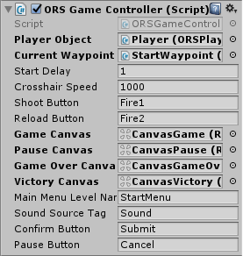

**Player Object** - The player object which moves and shoot. Must be assigned from the scene.

**Current Waypoint** - The first waypoint in the game. Assign this from the scene. This is a useful way to test the game by jumping into a waypoint without having to go through all the ones before it.

**Start Delay** - How long to wait before starting the game.

**Crosshair Speed** - How fast the crosshair moves when controlling it with a gamepad or keyboard

**Shoot/Reload Button** - The shoot/reload button, click it or press it to shoot/reload

**Main Menu Level Name** – The level of the main menu that can be loaded after the game ends.

**Confirm Button** – The keyboard/gamepad button that will restart the game after game over.

**Pause Button** – The keyboard/gamepad button that pauses the game.

**User Interface** – Various canvases for the UI, assign them from the scene.

**Sound Source Tag** – The audio source from which the Game Over sound plays.

# The player

The player is the second most important object in the game after the gamecontroller. Without it you can’t move from waypoint to waypoint, shoot enemies, or pickup items. This object must be assigned in the gamecontroller from the scene.

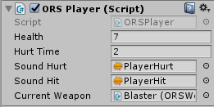

**Health** - The health of the player. If this reaches 0, the player dies.

**Hurt Time** - The hurt time is used to make sure that the player doesn't lose too much health at once

**Sounds** - These sounds play when the player is hurt.

**Current Weapon** - The main weapon used by the player. This is the default weapon that we return to after using all the ammo in a picked-up weapon.

# Weapons

The player can hold and collect different weapons during gameplay. You can customize each weapon’s icon, damage, spread, and fire rate.

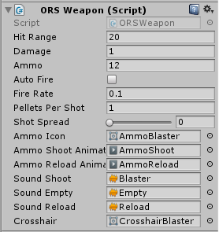

**Hit Range** - How far this weapon can hit. Beyond this distance the weapon can’t hit anything.

**Damage** - How much damage a single pellet in a shot causes. For example if you use a shotgun then each pellet will cause x damage.

**Ammo** - The number of bullets we have in the weapon. When this number is 0 you must reload the weapon. If this is not the default weapon, it will be replaced by the default one.

**Auto Fire** - How quickly this weapon shoots.

**Pellets Per Shot** - How many pellets each shot releases. For example the Blaster and Stinger releases one pellet each shot, while the shotgun releases 8 pellets at once. Each pellet causes damage and goes in a different direction based on shot spread.

**Ammo Icon** - The icon that appears on screen as the ammo of the weapon.

**Ammo Shoot Animation** - The animation that appears when shooting this weapon (ammo flying off).

**Ammo Reload Animation** - The animation that appears when reloading this weapon.

**Sounds** - Various sounds for shooting, reloading, and shooting when no ammo is left.

**Crosshair**- The shape of the crosshair for this weapon.

# Waypoints

A waypoint is an object that can be placed in the map to make the player go to it. Waypoints can be connected to create a path. Each waypoint can have a list of enemies/pickups associated with it. When the player reaches a waypoint, all the relevant enemies/pickups are activated.

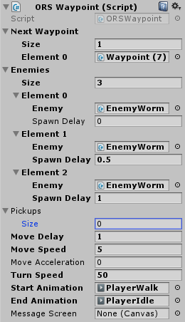

**Next Waypoint** - The next waypoint that the player will move to from this waypoint.

**Enemies** - A list of all the enemies that will spawn when the player reaches this waypoint. The enemies are assigned from the scene and have a red gizmo line connecting them to the waypoint. Each enemy has a spawn delay

**Pickups** - A list of all the pickup items that will spawn when the player reaches this waypoint. The pickups are assigned from the scene and have a blue gizmo line connecting them to the waypoint.

**Move Delay** - How long to wait before moving from this waypoint to the next. If there are enemies you will not move until you kill all of them.

**Move Speed** - How fast the player moves from this waypoint to the next. If there are enemies you will not move until you kill all of them.

**Move Acceleration** - How fast the player move speed increases. This is used for example when doing a jump from waypoint to waypoint when going down the cliff at the start of the game, so we start with a low speed and then increase it with the acceleration to give a feel of jumping down.

**Turn Speed** - How quickly the player rotates towards the angle of the next waypoint. When the player reaches the waypoint the turn speed smooths out and increases drastically in order to finish the transition quickly.

**Start/End Animation** - The animation that plays when the player starts moving from a waypoint to the next, and when the player reaches the target waypoint.

**Message Screen** - The canvas screen that appears when reaching this waypoint. In the demo we used it at the start of the game to show the fade-from-black with a message.

# Enemies

An enemy spawns at certain waypoint, looks at the player and attacks it every few seconds.

**Hit Effect** - The effect that appears when this enemy gets hit by a player shot.

**Health** - The health of the enemy. If this reaches 0, the enemy dies.

**Health Bar** - The health bar object that appears over the enemy and shows current health. This has a fill amount value which displays the percentage of health left for the player.

**Enemy Body** - The enemy body is the part of the enemy that looks at the player along the Y(Up) axis only.

**Enemy Head** - The enemy head is the part of the enemy that looks directly at the player.

**Muzzles** - These are the points from which shots are released in the direction of the muzzle. If you have more than one muzzle, each shot is released from a random point.

**Spawn Effect** - The spawn effect that appears at the position of this object when it's activated.

**Attack Delay Range** - This is the delay before an enemy attack the player, chosen randomly between two values.

**Projectile** - This is the delay before an enemy attack the player, chosen randomly between two values.

Look at this video to see how you can edit the Health Bar object and the Name Tag object:

<https://youtu.be/67T6enzeGGM>

# Pickups

A pick up is an item that can be clicked by the player to get a weapon or health increase.

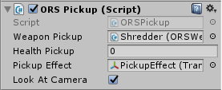

**Weapon Pickup** - The weapon that is given to the player when picking up this item.

**Health Pickup** - The health value that is given to the player when picking up this item.

**Pickup Effect** - The effect that appears when this item is picked up by the player.

**Look At Camera** - Make the item look at the camera at all times. This is used for 2D items.

# Projectiles

A projectile is an object that is released from an enemy's muzzle when shooting at the player.

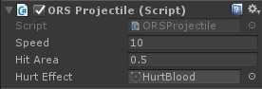

**Speed** - The speed of the projectile.

**Hit Area** - The range at which this projectile can hit the player.

**Hurt Effect** - The hurt effect that appears on the screen when this projectile hits the player.