Manuscript title

Authors

Date or affiliation

# Heading 1

## Heading 2

### Heading 3

#### Heading 4

##### Heading 5

This is some body text with a reference (R Core Team, 2017) and some inline code. Below there is a table with a caption (Table 1) and a figure with a caption (Figure 1).

print("This is a code block")

## [1] "This is a code block"

Table 1 - A table with caption.

|  |  |  |
| --- | --- | --- |
| **Column 1** | **Column 2** | **Column 3** |
| 1 | 2 | 3 |
| 4 | 5 | 6 |

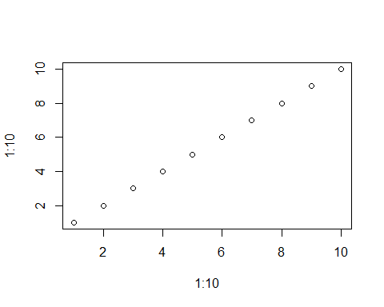

Figure 1 - A plot with caption.

# References

R Core Team. 2017. R: A language and environment for statistical computing. R Foundation for Statistical Computing, Vienna, Austria. <https://www.R-project.org/>.