# CS 255 System Design Document Template

Joshua Lewis

CS-255

10/14/2023

## UML Diagrams

### UML Use Case Diagram

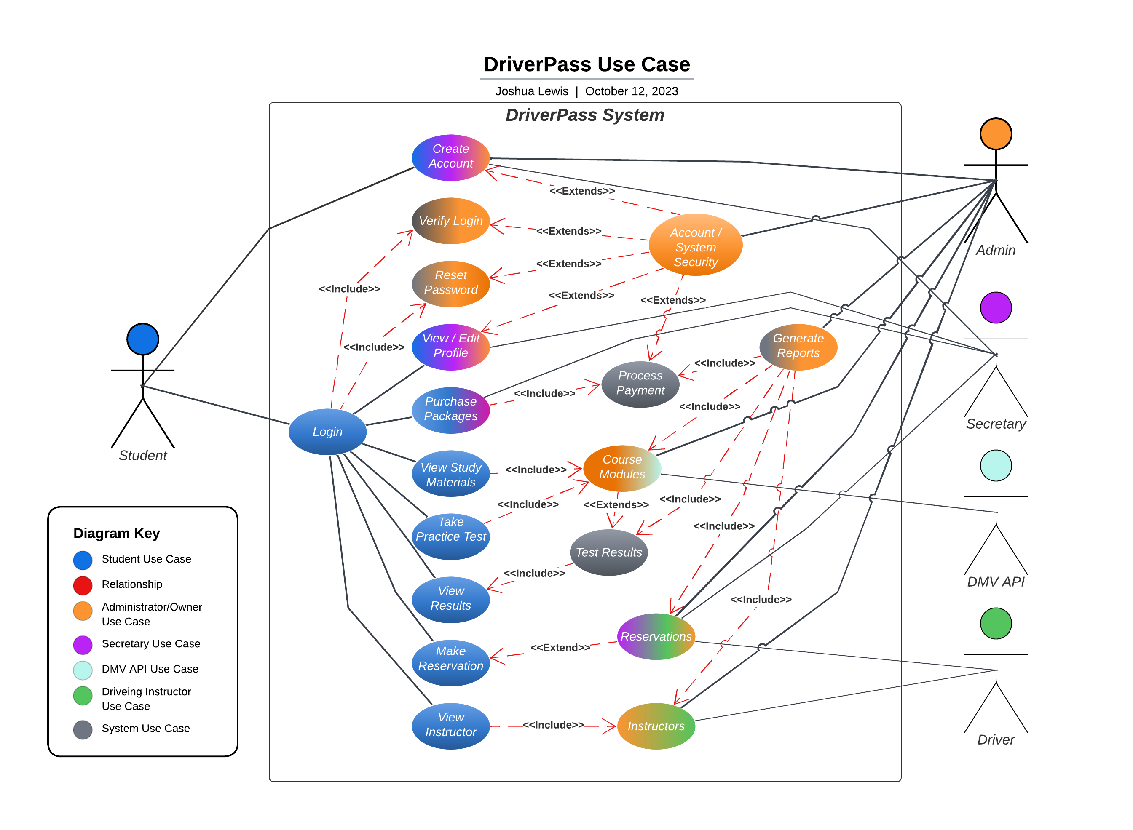

### UML Activity Diagrams

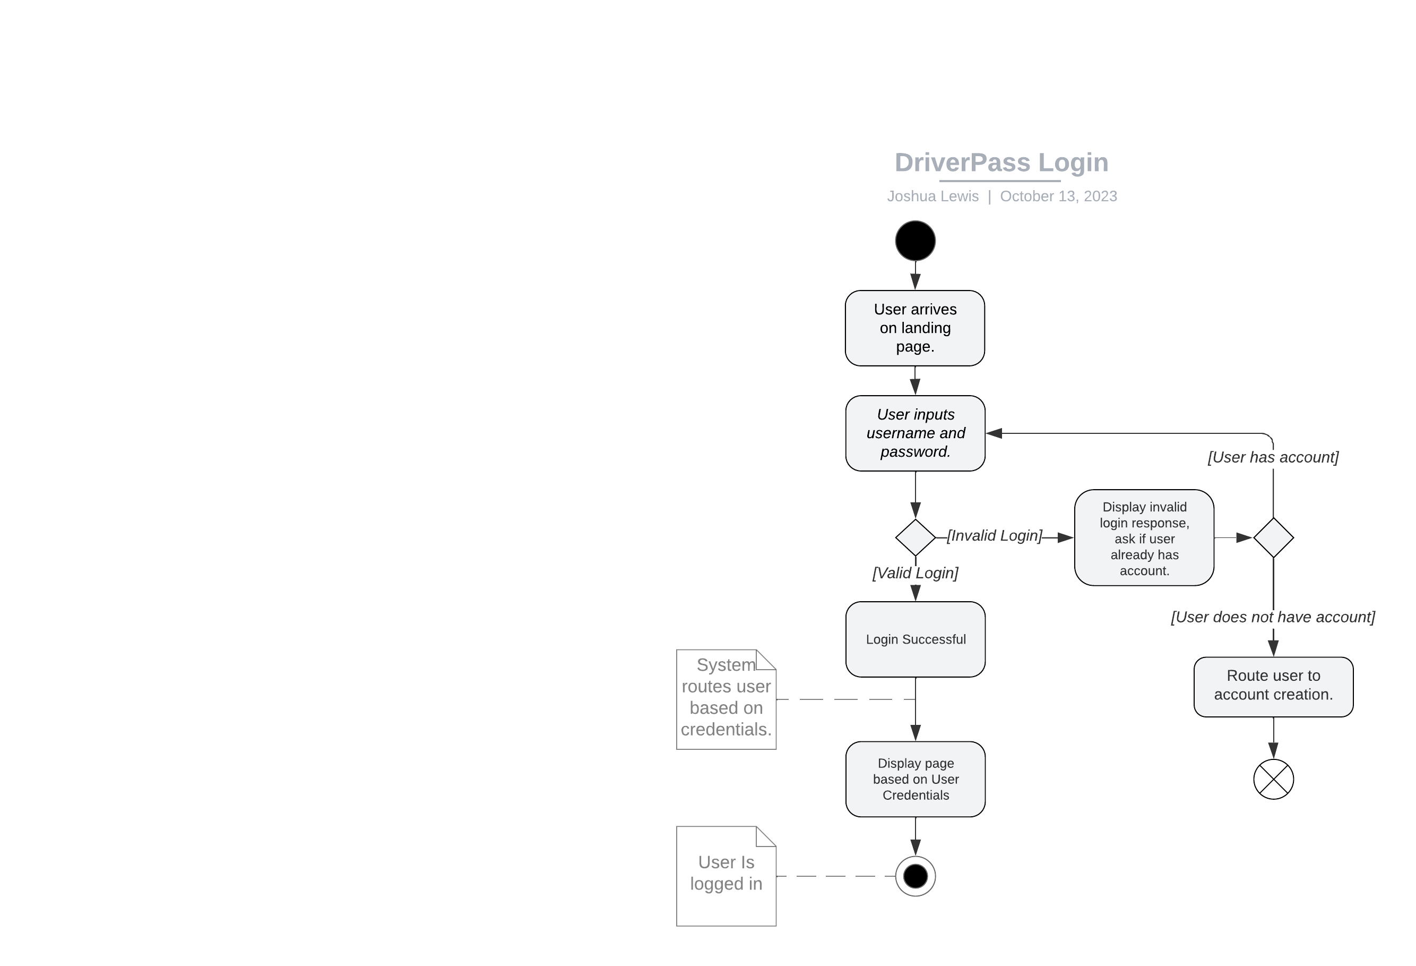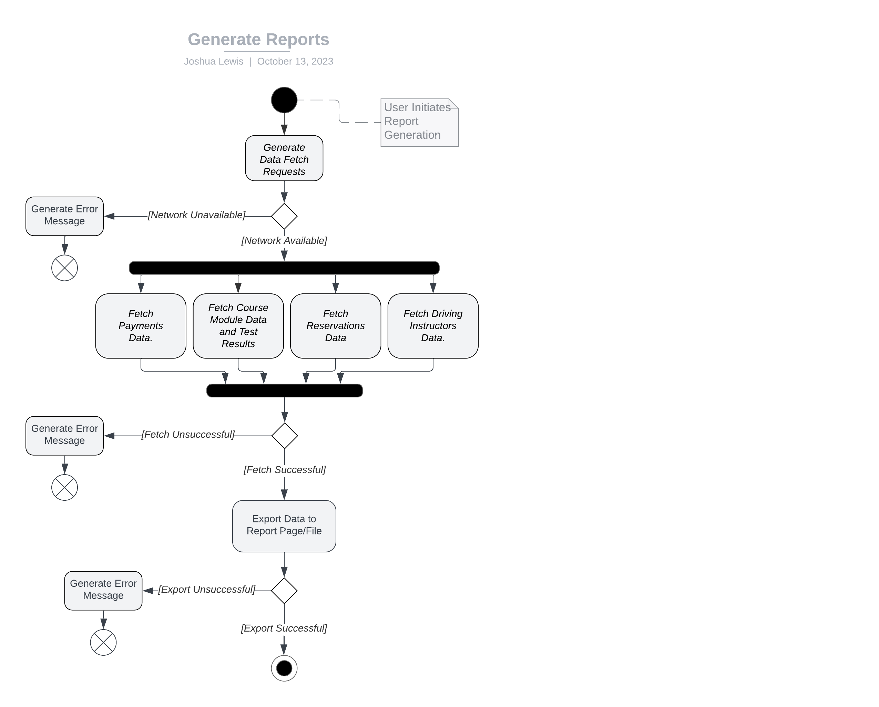

### UML Sequence Diagram

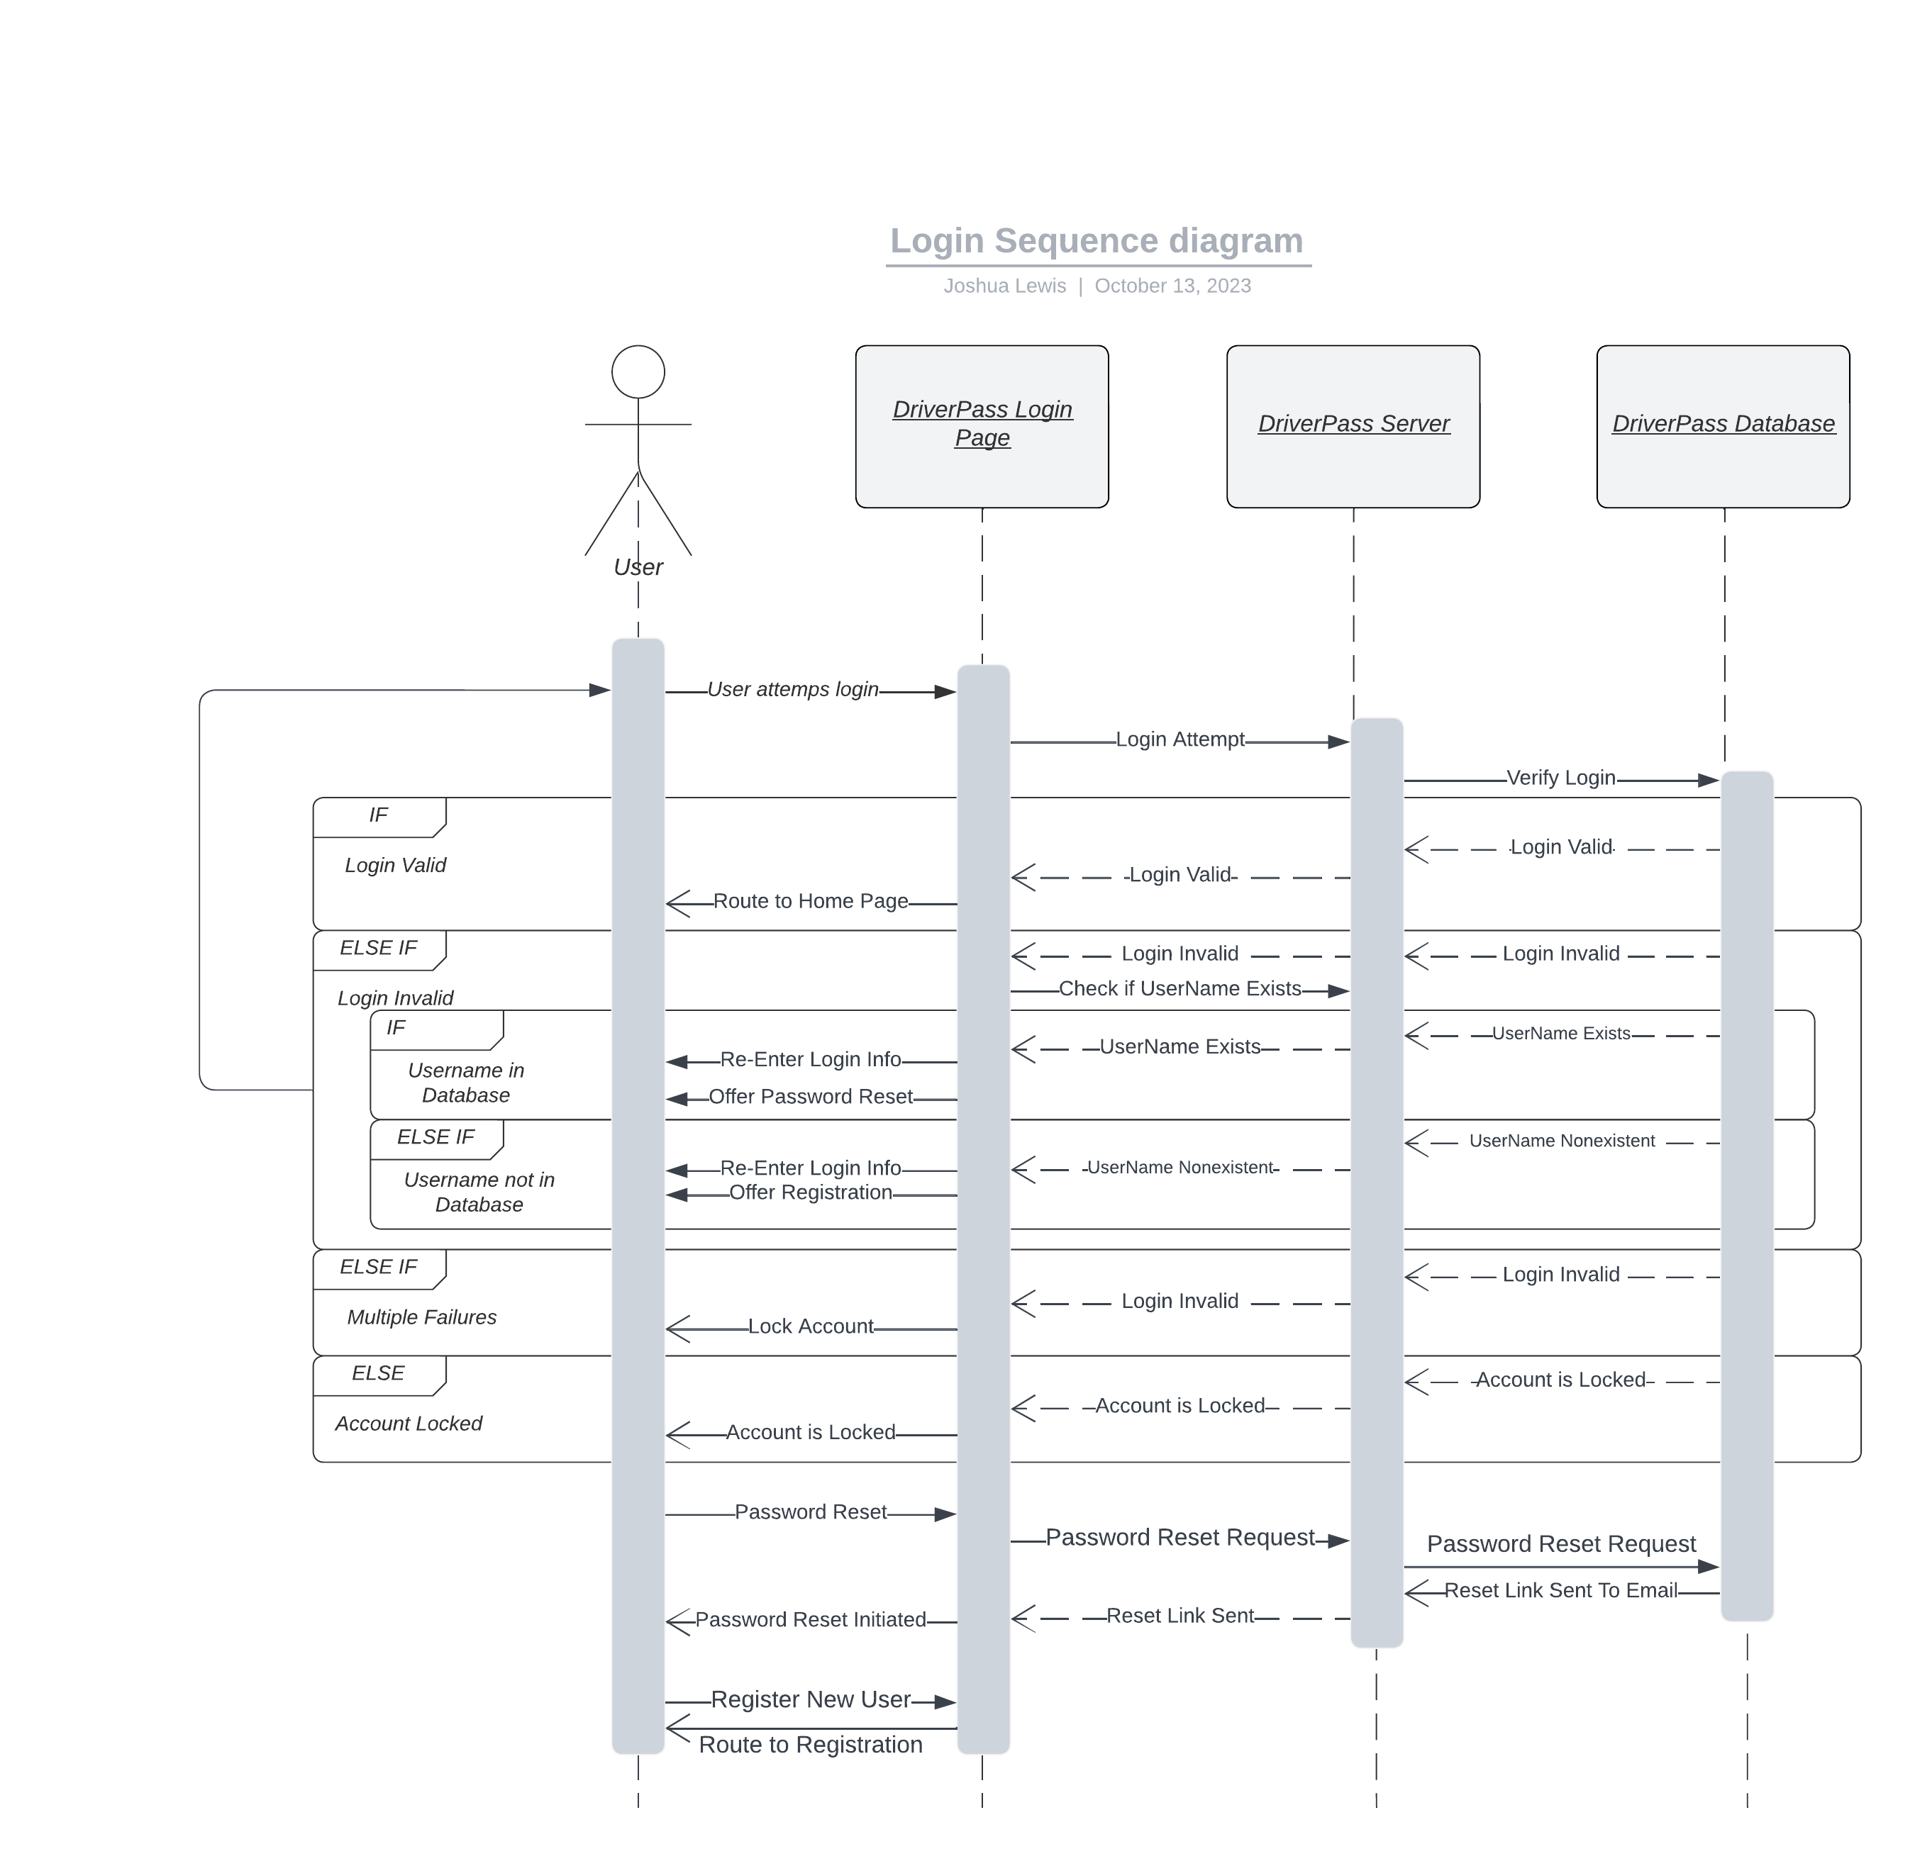

### UML Class Diagram

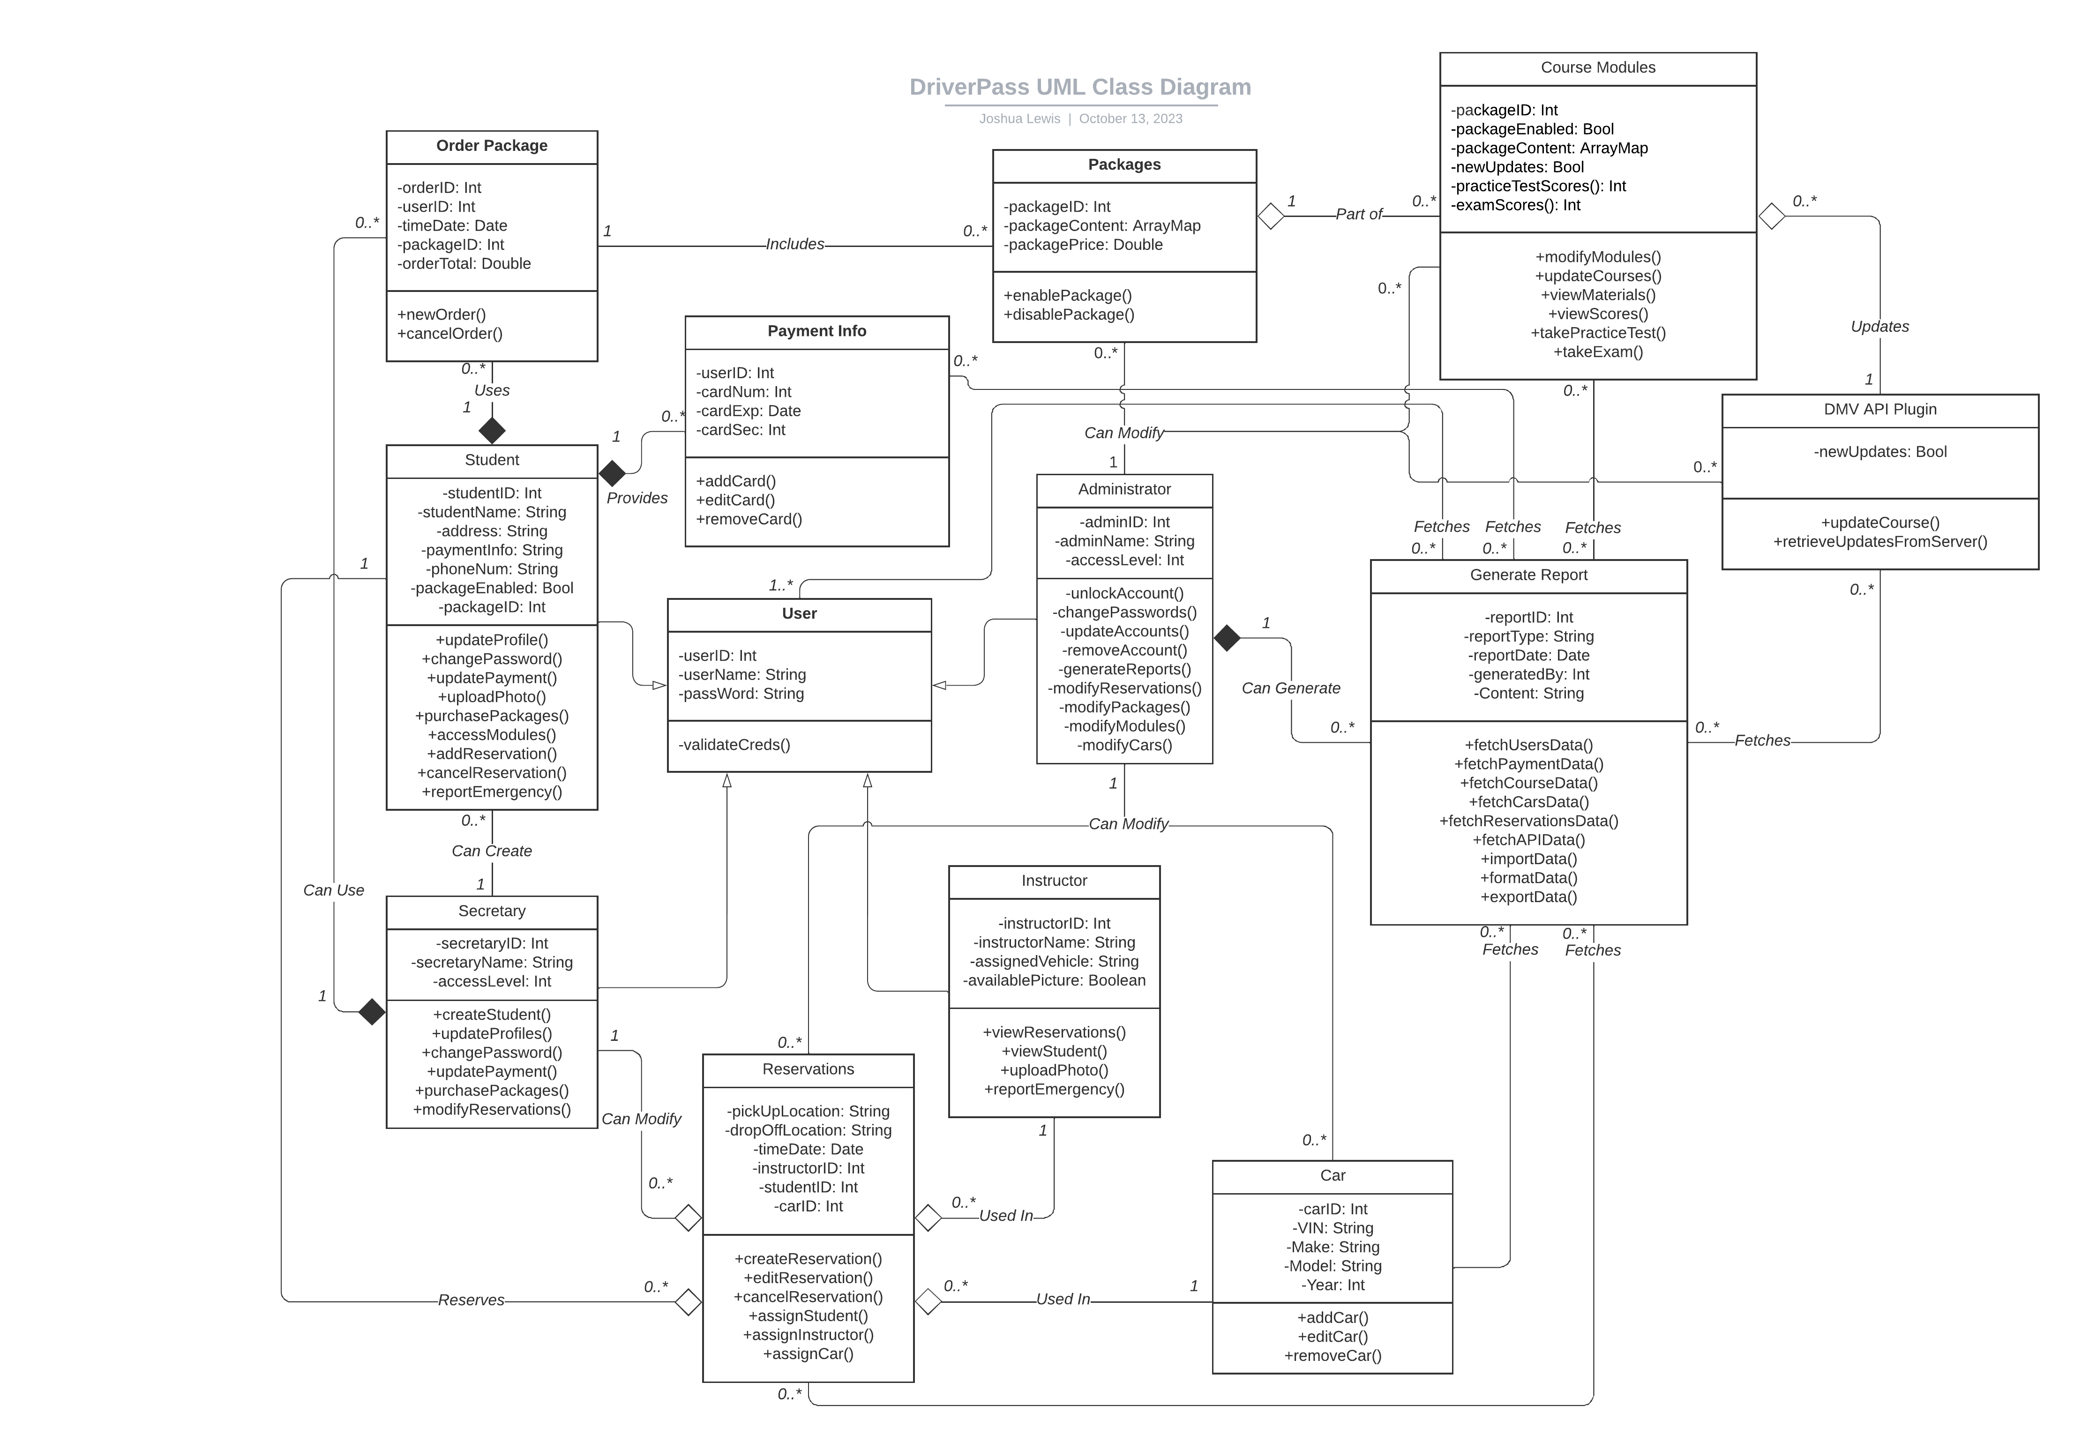

## Technical Requirements

**Host:**

The host will be responsible for the security, maintenance, and ensuring the uptime of the server itself. As such, the host will need an extensive list of software/tools, hardware, and the infrastructure available to maintain, and physically house the server hardware. Listed below:

The Hardware requirements for the host are:

* Server Rack
* Server Grade Internals:
  + GPU (Graphics Processing Unit)
  + CPU (Central Processing Unit)
  + Hard Drives
  + RAM (Random Access Memory)
  + Power Supplies
* Networking Cables
* Cooling Systems
* Peripherals:
  + Monitors
  + Keyboards
  + Mice
* ISP (Internet Service Provider)

The software requirements for the host are:

* Server Configuration Management Tools
* Monitoring Tools
* Server Logging Software
* Backup and Recovery Software
* Security Tools
* Internet Connection
* DriverPass System Software

The infrastructure required of the host:

* The host needs to have a large enough space available to house the hardware required to run the server. This space also needs to be kept clean, cool, and have adequate air flow to keep the hardware from overheating. They need to have access to high-speed, high bandwidth internet to handle the flow of traffic and information.

**Client**

The client is responsible for the system being hosted on the server. They are responsible for their system’s security, maintaining its integrity, and daily operations.

The hardware requirements for the client are:

* Desktop, Laptop Computer, Mobile Phone
* Peripherals:
  + Monitors
  + Keyboards
  + Mice/Trackpad
* ISP
* Network Switch
* Core Router
* Network Cables

The software requirements for the client are:

* Operating System for hardware
* Internet Connection
* Network maintenance, monitoring, and security tools
* System maintenance management software.

The infrastructure requirements for the client:

* The client needs to be able to securely access the server, this is best done through a private network. Devices/Users that connect to secure/core functions of the system should only be allowed to access the system from the secure network. The client will need space to accommodate a network switch and router and connect network cables to secure devices. However, it is also understood that the client needs flexibility, this can be achieved by allowing partial access for users to the server from any network with reduced functionality unless connected to the secure network.

**End Users:**

The end users are the students, and potential customers. They need to be able to access the server from anywhere, at any time. As such, all their requirements should be minimal. They require little hardware, little software, and no infrastructure on their end.

The hardware requirements for the end users to access the system are:

* Any device that can access the internet
* Any device able to input and display information

The Software requirements for the end users to access the system are:

* Any device with an operating system
* Ability to access the internet
* Ability to use supported internet browsers.

The infrastructure for the end users is:

* None, the user can access the system from anywhere and at any time.