选择三个因素作为影响房价的最有影响因素：一氧化碳浓度，每栋住宅的平均房间数，低收入人口比例

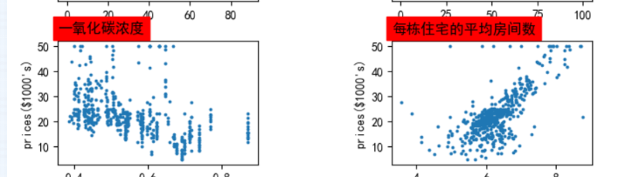

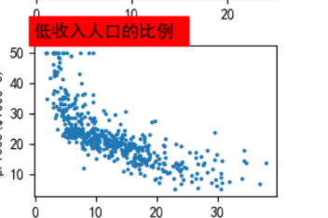

第一次

learn_rate = 0.01

iter = 2600

display_step = 200

i: 0, Tain Loss: 298.276276, Test Loss: 310.951874

i: 200, Tain Loss: 41.590420, Test Loss: 43.248405

i: 400, Tain Loss: 34.968678, Test Loss: 34.737530

i: 600, Tain Loss: 30.508158, Test Loss: 30.354147

i: 800, Tain Loss: 27.202946, Test Loss: 27.305801

i: 1000, Tain Loss: 24.742685, Test Loss: 25.156544

i: 1200, Tain Loss: 22.902010, Test Loss: 23.656580

i: 1400, Tain Loss: 21.516504, Test Loss: 22.627535

i: 1600, Tain Loss: 20.466139, Test Loss: 21.939510

i: 1800, Tain Loss: 19.663227, Test Loss: 21.497858

i: 2000, Tain Loss: 19.043640, Test Loss: 21.233662

i: 2200, Tain Loss: 18.560440, Test Loss: 21.096718

i: 2400, Tain Loss: 18.179214, Test Loss: 21.050518

i: 2600, Tain Loss: 17.874676, Test Loss: 21.068560

第二次：

learn_rate = 0.01

iter = 2500

display_step = 100

i: 0, Tain Loss: 298.276276, Test Loss: 310.951874

i: 100, Tain Loss: 56.871407, Test Loss: 64.292152

i: 200, Tain Loss: 41.590420, Test Loss: 43.248405

i: 300, Tain Loss: 37.784935, Test Loss: 37.881989

i: 400, Tain Loss: 34.968678, Test Loss: 34.737530

i: 500, Tain Loss: 32.570187, Test Loss: 32.331696

i: 600, Tain Loss: 30.508158, Test Loss: 30.354147

i: 700, Tain Loss: 28.732903, Test Loss: 28.697962

i: 800, Tain Loss: 27.202946, Test Loss: 27.305801

i: 900, Tain Loss: 25.882948, Test Loss: 26.136492

i: 1000, Tain Loss: 24.742685, Test Loss: 25.156544

i: 1100, Tain Loss: 23.756382, Test Loss: 24.337875

i: 1200, Tain Loss: 22.902010, Test Loss: 23.656580

i: 1300, Tain Loss: 22.160742, Test Loss: 23.092278

i: 1400, Tain Loss: 21.516504, Test Loss: 22.627535

i: 1500, Tain Loss: 20.955551, Test Loss: 22.247513

i: 1600, Tain Loss: 20.466139, Test Loss: 21.939510

i: 1700, Tain Loss: 20.038229, Test Loss: 21.692705

i: 1800, Tain Loss: 19.663227, Test Loss: 21.497858

i: 1900, Tain Loss: 19.333788, Test Loss: 21.347090

i: 2000, Tain Loss: 19.043640, Test Loss: 21.233662

i: 2100, Tain Loss: 18.787395, Test Loss: 21.151838

i: 2200, Tain Loss: 18.560440, Test Loss: 21.096718

i: 2300, Tain Loss: 18.358845, Test Loss: 21.064127

i: 2400, Tain Loss: 18.179214, Test Loss: 21.050518

i: 2500, Tain Loss: 18.018656, Test Loss: 21.052858

