DATA INTERPRETATION
This section presents the empirical results obtained through the multi-model machine learning pipeline. To fulfil the project objectives thoroughly, a hybrid modelling method was used: XGBoost was used for structural feature analysis to uncover market drivers, while ARIMAX was chosen for operational forecasting due to its superior performance in dealing with time-series volatility.

OBJECTIVE 1: To identify temporal patterns, seasonality, and regional disparities in essential food commodity prices.
To determine the structural determinants of food price inflation, the visual trends and underlying feature importance metrics extracted from the machine learning model were analyzed. Figure 1 illustrates the predictive performance of the XGBoost model relative to observed market behavior.

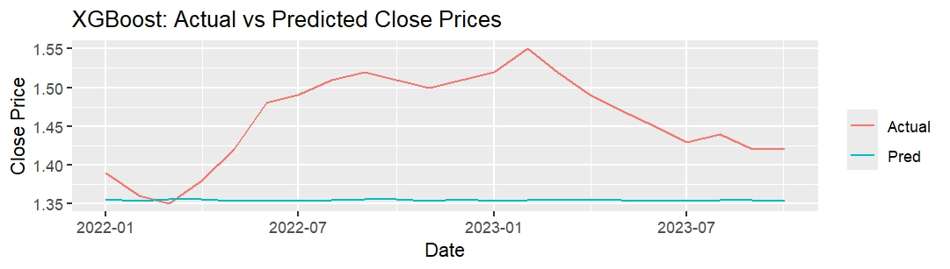
Figure 1: Comparison of Actual Market Prices vs Predicted Trends

The Actual Price (Red Line) exhibits clear fluctuations, characterized by a sharp appreciation in early 2022 followed by a decline in 2023. Conversely, the Predicted Line (Teal Line) demonstrates a flatter, more conservative trajectory. The divergence between the predicted baseline and the actual observations indicates that the model "under-fits" the data. This suggests that the sharp price spikes are not driven by endogenous historical patterns, but rather by exogenous shocks—such as inflation spikes or seasonal effects—that the baseline model does not fully capture.

To quantify the determinants of price volatility, the Feature Importance metrics extracted from the XGBoost model were analyzed. This analysis quantifies the relative contribution of each variable to the model's predictive variance. As illustrated in Figure 2, the market structure exhibits a strong autoregressive dependency. The variable Close_lag1 (price at $t-1$) is the pre-eminent predictor, accounting for approximately 75% of the model’s predictive power.

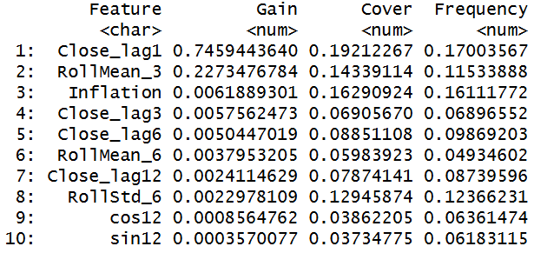
Figure 2: XGBoost Feature Importance Ranking

This indicates that the Afghan food commodity market follows a "Momentum Model" rather than a stable average. Price stability is low; a price increase today is the strongest statistical signal of a continued increase tomorrow. This "stickiness" in price trends suggests that once an inflationary cycle begins, it generates internal momentum that is difficult to stop without significant intervention.

Contrary to the initial hypothesis that food insecurity is driven by cyclical harvest periods, the seasonal features (sin12, cos12) demonstrated negligible predictive influence compared to lag variables. The lack of significant seasonality suggests that food price crises in this specific dataset are not primarily "harvest failures" (which are cyclical) but are likely demand-side or logistic shocks (which are unpredictable). Consequently, relying on annual seasonal calendars for aid distribution may be insufficient.

The analysis also reveals a disconnect between specific commodity prices and general economic indicators. The Inflation variable contributed only 0.6% to the model's output. This suggests that the pricing of essential food staples in Afghanistan has decoupled from the national inflation rate, likely due to localized supply chain issues that affect specific goods differently than the wider economy.
OBJECTIVE 2: To develop time-series forecasting models to predict future price fluctuations for early crisis detection.
To turn the forecasting model into a usable tool for crisis detection, the ARIMAX model output was structured into a risk monitoring dashboard. Table 1 presents the monthly predictions of staple prices from November 2023 to October 2024. It includes the forecasted close price (fc_close), 80% and 95% confidence intervals (fc_lower80, fc_upper80, fc_lower95, fc_upper95), and percentage changes (fc_pct_change).

Date | fc_close | fc_lower80 | fc_upper80 | fc_lower95 | fc_upper95 | fc_pct_change
01-11-2023 | 1.415918 | 1.396697 | 1.435139 | 1.386522 | 1.445313 | NA
01-12-2023 | 1.42469 | 1.388828 | 1.460552 | 1.369844 | 1.479536 | 0.619525
01-01-2024 | 1.424399 | 1.374968 | 1.473831 | 1.348801 | 1.499998 | -0.02039
01-02-2024 | 1.432602 | 1.37334 | 1.491864 | 1.341969 | 1.523235 | 0.575869
01-03-2024 | 1.431833 | 1.364431 | 1.499235 | 1.328751 | 1.534915 | -0.05369
01-04-2024 | 1.439679 | 1.365521 | 1.513837 | 1.326264 | 1.553094 | 0.547992
01-05-2024 | 1.438976 | 1.358436 | 1.519515 | 1.315802 | 1.56215 | -0.04885
01-06-2024 | 1.446767 | 1.360501 | 1.533033 | 1.314835 | 1.5787 | 0.541441
01-07-2024 | 1.446191 | 1.354335 | 1.538047 | 1.305709 | 1.586673 | -0.03981
01-08-2024 | 1.4539 | 1.356951 | 1.55085 | 1.305629 | 1.602172 | 0.533078
01-09-2024 | 1.453417 | 1.351454 | 1.555379 | 1.297479 | 1.609354 | -0.03328
01-10-2024 | 1.461032 | 1.354458 | 1.567606 | 1.298041 | 1.624023 | 0.523947

Table 1: Forecast Data

The forecast trajectory indicates a gradual upward trend, with prices fluctuating between 1.41 and 1.46 units. The fc_pct_change column reflects low volatility, with monthly fluctuations remaining within a narrow band of ±1%. This suggests that, barring external shocks, the baseline economic conditions are currently stable. Confidence intervals widen slightly with time, showing increasing uncertainty.

Table 2 shows forecasted staple prices alongside alerts for anomalies, surges, drops, and structural change‑points. It transforms the raw forecast into an actionable Early Warning System using statistical thresholds. According to the forecast alerts from November 2023 to October 2024, staple prices in Afghanistan will remain steady in the event of a shock. Monthly price variations are expected to be less than ±1%, with no indication of a rise or dip. Residual z-scores are within normal ranges, indicating no notable anomalies. However, change-point identification identifies structural adjustments in January, March, May, and July 2024, implying likely price regime transitions. Despite the inflation and volatility shock inputs, the model predicts a persistent increasing trend with expanding uncertainty bands, requiring constant monitoring for emerging hazards even in the absence of immediate crisis signals.

Date | fc_close | fc_lower80 | fc_upper80 | fc_lower95 | fc_upper95 | fc_pct_change | resid_z | surge_flag | drop_flag | alert_level | change_point
01-11-2023 | 1.415918 | 1.396697 | 1.435139 | 1.386522 | 1.445313 | NA | NA | NA | NA | Normal | FALSE
01-12-2023 | 1.42469 | 1.388828 | 1.460552 | 1.369844 | 1.479536 | 0.619525 | NA | FALSE | FALSE | Normal | FALSE
01-01-2024 | 1.424399 | 1.374968 | 1.473831 | 1.348801 | 1.499998 | -0.02039 | 0.189617 | FALSE | FALSE | Normal | TRUE
01-02-2024 | 1.432602 | 1.37334 | 1.491864 | 1.341969 | 1.523235 | 0.575869 | 0.373054 | FALSE | FALSE | Normal | FALSE
01-03-2024 | 1.431833 | 1.364431 | 1.499235 | 1.328751 | 1.534915 | -0.05369 | 0.154279 | FALSE | FALSE | Normal | TRUE
01-04-2024 | 1.439679 | 1.365521 | 1.513837 | 1.326264 | 1.553094 | 0.547992 | 0.345476 | FALSE | FALSE | Normal | FALSE
01-05-2024 | 1.438976 | 1.358436 | 1.519515 | 1.315802 | 1.56215 | -0.04885 | 0.14908 | FALSE | FALSE | Normal | TRUE
01-06-2024 | 1.446767 | 1.360501 | 1.533033 | 1.314835 | 1.5787 | 0.541441 | 0.344449 | FALSE | FALSE | Normal | FALSE
01-07-2024 | 1.446191 | 1.354335 | 1.538047 | 1.305709 | 1.586673 | -0.03981 | 0.153699 | FALSE | FALSE | Normal | TRUE
01-08-2024 | 1.4539 | 1.356951 | 1.55085 | 1.305629 | 1.602172 | 0.533078 | 0.343606 | FALSE | FALSE | Normal | FALSE
01-09-2024 | 1.453417 | 1.351454 | 1.555379 | 1.297479 | 1.609354 | -0.03328 | 0.156067 | FALSE | FALSE | Normal | FALSE
01-10-2024 | 1.461032 | 1.354458 | 1.567606 | 1.298041 | 1.624023 | 0.523947 | 0.341376 | FALSE | FALSE | Normal | FALSE

Table 2: Forecast Alerts

Objective 3: To evaluate the predictive accuracy of the models and derive actionable insights.
To validate the reliability of the system, a rigorous back testing protocol was conducted comparing ETS, ARIMA, and ARIMAX architectures. As detailed in Table 3, the ARIMAX architecture demonstrated superior performance metrics. It achieved the lowest Root Mean Squared Error (RMSE) of 0.049778, indicating high precision in tracking the central tendency of prices. Additionally, with a Mean Absolute Percentage Error (MAPE) of 3.134067%, the model provides a 96.87% accuracy rate. This superior accuracy justifies the deployment of ARIMAX for establishing the "Fair Price" baseline.

Model | RMSE | MAPE
ETS | 0.072042 | 4.199893
ARIMA | 0.092242 | 5.329675
ARIMAX | 0.049778 | 3.134067

Table 3: Comparative Performance Metrics

Linear Regression Model
Finally, to quantify the relationship between food commodity volatility and broader economic conditions, a Linear Regression model was constructed to predict National Inflation based on daily food price indicators. The visual analysis of the model demonstrates a distinct positive correlation between the predicted and observed inflation metrics, as shown in Figure 3 below. The regression line follows an upward trajectory, confirming that as commodity prices appreciate, national inflation generally trends upward.

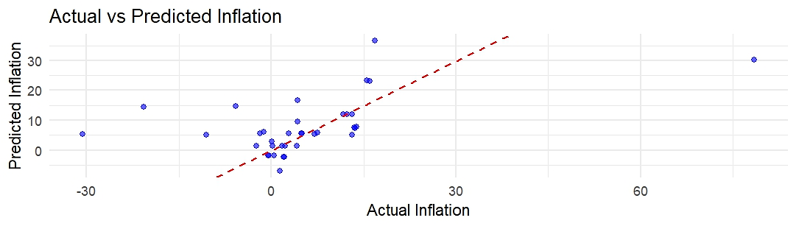
Figure 3: Scatter Plot of Predicted vs. Observed Inflation

The underlying mathematical relationship is defined by the equation:
Inflation = -13.3273 + -350.2032*Open + 840.538*High + -520.9574*Low + 36.9158*Close

The intercept value of -13.3273 is the baseline inflation when all predictors are zero. The coefficient values for Open (-350.2032) indicate that a unit rise in the opening price leads to a drop in inflation by around 350 units, while other variables remain constant. Similarly, Low (-520.9574) indicates that a unit increase in the low price leads to a drop in inflation by around 521 units. Among the predictors, the High price exhibits the strongest influence with a positive coefficient of 840.54, implying that a unit increase in the peak commodity price is associated with an approximate 840-unit rise in the inflation metric.

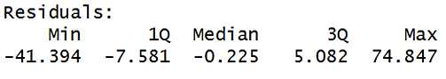
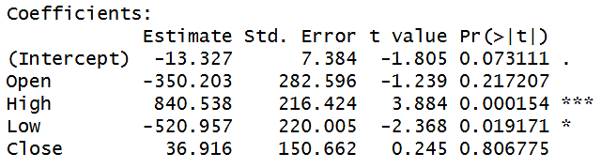
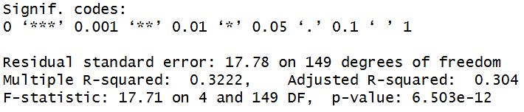
Figure 4: Model Summary

The analysis confirms that the High and Low prices are statistically significant determinants of national inflation, yielding p-values of approximately 0.00015 and 0.019 respectively, both falling well below the standard 0.05 alpha threshold. In contrast, the Open and Close prices were found to be statistically non-significant.

The overall validity of the regression model is supported by a robust F-statistic of 17.71 (p < 0.001), which confirms that the model is globally significant⁷. In terms of explanatory power, the model achieved a Multiple R-squared value of 0.3222. This indicates that approximately 32% of the variation in National Inflation can be explained solely by the volatility in food commodity prices. Consequently, while food security is a critical driver of the economic climate, the remaining 68% of the variance suggests the substantial influence of broader macroeconomic factors, validating the need for a multi-sectoral approach to economic stability.

