Supplementary Material: Global plate model choice impacts reconstructions of the latitudinal biodiversity gradient
—
Lewis A. Jones¹, William Gearty^{2,3}, Lucas Buffan⁴, and Bethany J. Allen^{5,6}
—
¹Department of Earth Sciences, University College London, Gower Street, London, WC1E 6BT, UK
²Division of Paleontology, American Museum of Natural History, New York, NY, 10024, USA
³Open Source Program Office, Syracuse University, Syracuse, NY, 13244, USA
⁴Institut des Sciences de l’Évolution de Montpellier, Université de Montpellier, CNRS, IRD, Place Eugène Bataillon, 34095 Montpellier cedex 05, France
⁵Department of Biosystems Science and Engineering, ETH Zürich, 4056 Basel, Switzerland
⁶Computational Evolution Group, Swiss Institute of Bioinformatics, 1015 Lausanne, Switzerland
—
Corresponding author: Lewis.Jones@ucl.ac.uk

Supplementary tables
Table S 1: Chronostratigraphic stage-level time bins used in this study. Time bins follow the International Geological Timescale Ver. 2023/09 with the exception of the Holocene and Pleistocene stages, which have been collapsed into their equivalent Epoch-level bins.
Bin | Interval | Maximum Age (Ma) | Minimum Age (Ma) | Duration (Myr)
1 | Fortunian | 538.8000 | 529.0000 | 9.8000
2 | Stage 2 | 529.0000 | 521.0000 | 8.0000
3 | Stage 3 | 521.0000 | 514.0000 | 7.0000
4 | Stage 4 | 514.0000 | 509.0000 | 5.0000
5 | Wuliuan | 509.0000 | 504.5000 | 4.5000
6 | Drumian | 504.5000 | 500.5000 | 4.0000
7 | Guzhangian | 500.5000 | 497.0000 | 3.5000
8 | Paibian | 497.0000 | 494.0000 | 3.0000
9 | Jiangshanian | 494.0000 | 489.5000 | 4.5000
10 | Stage 10 | 489.5000 | 485.4000 | 4.1000
11 | Tremadocian | 485.4000 | 477.7000 | 7.7000
12 | Floian | 477.7000 | 470.0000 | 7.7000
13 | Dapingian | 470.0000 | 467.3000 | 2.7000
14 | Darriwilian | 467.3000 | 458.4000 | 8.9000
15 | Sandbian | 458.4000 | 453.0000 | 5.4000
16 | Katian | 453.0000 | 445.2000 | 7.8000
17 | Hirnantian | 445.2000 | 443.8000 | 1.4000
18 | Rhuddanian | 443.8000 | 440.8000 | 3.0000
19 | Aeronian | 440.8000 | 438.5000 | 2.3000
20 | Telychian | 438.5000 | 433.4000 | 5.1000
21 | Sheinwoodian | 433.4000 | 430.5000 | 2.9000
22 | Homerian | 430.5000 | 427.4000 | 3.1000
23 | Gorstian | 427.4000 | 425.6000 | 1.8000
24 | Ludfordian | 425.6000 | 423.0000 | 2.6000
25 | Pridoli | 423.0000 | 419.2000 | 3.8000
26 | Lochkovian | 419.2000 | 410.8000 | 8.4000
27 | Pragian | 410.8000 | 407.6000 | 3.2000
28 | Emsian | 407.6000 | 393.3000 | 14.3000
29 | Eifelian | 393.3000 | 387.7000 | 5.6000
30 | Givetian | 387.7000 | 382.7000 | 5.0000
31 | Frasnian | 382.7000 | 372.2000 | 10.5000
32 | Famennian | 372.2000 | 358.9000 | 13.3000
33 | Tournaisian | 358.9000 | 346.7000 | 12.2000
34 | Visean | 346.7000 | 330.9000 | 15.8000
35 | Serpukhovian | 330.9000 | 323.2000 | 7.7000
36 | Bashkirian | 323.2000 | 315.2000 | 8.0000
37 | Moscovian | 315.2000 | 307.0000 | 8.2000
38 | Kasimovian | 307.0000 | 303.7000 | 3.3000
39 | Gzhelian | 303.7000 | 298.9000 | 4.8000
40 | Asselian | 298.9000 | 293.5200 | 5.3800
41 | Sakmarian | 293.5200 | 290.1000 | 3.4200
42 | Artinskian | 290.1000 | 283.5000 | 6.6000
43 | Kungurian | 283.5000 | 273.0100 | 10.4900
44 | Roadian | 273.0100 | 266.9000 | 6.1100
45 | Wordian | 266.9000 | 264.2800 | 2.6200
46 | Capitanian | 264.2800 | 259.5100 | 4.7700
47 | Wuchiapingian | 259.5100 | 254.1400 | 5.3700
48 | Changhsingian | 254.1400 | 251.9020 | 2.2380
49 | Induan | 251.9020 | 251.2000 | 0.7020
50 | Olenekian | 251.2000 | 247.2000 | 4.0000
51 | Anisian | 247.2000 | 242.0000 | 5.2000
52 | Ladinian | 242.0000 | 237.0000 | 5.0000
53 | Carnian | 237.0000 | 227.0000 | 10.0000
54 | Norian | 227.0000 | 208.5000 | 18.5000
55 | Rhaetian | 208.5000 | 201.4000 | 7.1000
56 | Hettangian | 201.4000 | 199.5000 | 1.9000
57 | Sinemurian | 199.5000 | 192.9000 | 6.6000
58 | Pliensbachian | 192.9000 | 184.2000 | 8.7000
59 | Toarcian | 184.2000 | 174.7000 | 9.5000
60 | Aalenian | 174.7000 | 170.9000 | 3.8000
61 | Bajocian | 170.9000 | 168.2000 | 2.7000
62 | Bathonian | 168.2000 | 165.3000 | 2.9000
63 | Callovian | 165.3000 | 161.5000 | 3.8000
64 | Oxfordian | 161.5000 | 154.8000 | 6.7000
65 | Kimmeridgian | 154.8000 | 149.2000 | 5.6000
66 | Tithonian | 149.2000 | 145.0000 | 4.2000
67 | Berriasian | 145.0000 | 139.8000 | 5.2000
68 | Valanginian | 139.8000 | 132.6000 | 7.2000
69 | Hauterivian | 132.6000 | 125.7700 | 6.8300
70 | Barremian | 125.7700 | 121.4000 | 4.3700
71 | Aptian | 121.4000 | 113.0000 | 8.4000
72 | Albian | 113.0000 | 100.5000 | 12.5000
73 | Cenomanian | 100.5000 | 93.9000 | 6.6000
74 | Turonian | 93.9000 | 89.8000 | 4.1000
75 | Coniacian | 89.8000 | 86.3000 | 3.5000
76 | Santonian | 86.3000 | 83.6000 | 2.7000
77 | Campanian | 83.6000 | 72.1000 | 11.5000
78 | Maastrichtian | 72.1000 | 66.0000 | 6.1000
79 | Danian | 66.0000 | 61.6000 | 4.4000
80 | Selandian | 61.6000 | 59.2000 | 2.4000
81 | Thanetian | 59.2000 | 56.0000 | 3.2000
82 | Ypresian | 56.0000 | 47.8000 | 8.2000
83 | Lutetian | 47.8000 | 41.2000 | 6.6000
84 | Bartonian | 41.2000 | 37.7100 | 3.4900
85 | Priabonian | 37.7100 | 33.9000 | 3.8100
86 | Rupelian | 33.9000 | 27.8200 | 6.0800
87 | Chattian | 27.8200 | 23.0300 | 4.7900
88 | Aquitanian | 23.0300 | 20.4400 | 2.5900
89 | Burdigalian | 20.4400 | 15.9800 | 4.4600
90 | Langhian | 15.9800 | 13.8200 | 2.1600
91 | Serravallian | 13.8200 | 11.6300 | 2.1900
92 | Tortonian | 11.6300 | 7.2460 | 4.3840
93 | Messinian | 7.2460 | 5.3330 | 1.9130
94 | Zanclean | 5.3330 | 3.6000 | 1.7330
95 | Piacenzian | 3.6000 | 2.5800 | 1.0200
96 | Pleistocene | 2.5800 | 0.0117 | 2.5683
97 | Holocene | 0.0117 | 0.0000 | 0.0117

Table S 2: Equal-area latitudinal bins used in this study. Bins are generated assumming a regular spheroid Earth model with a mean radius of ~6,371 km.
Bin | Maximum (º) | Midpoint (º) | Minimum (º) | Area (m²) | Proportion of Area
1 | 41.810 | 65.905 | 90.000 | 8.5e+13 | 0.167
2 | 19.471 | 30.641 | 41.810 | 8.5e+13 | 0.167
3 | 0.000 | 9.736 | 19.471 | 8.5e+13 | 0.167
4 | -19.471 | -9.736 | 0.000 | 8.5e+13 | 0.167
5 | -41.810 | -30.641 | -19.471 | 8.5e+13 | 0.167
6 | -90.000 | -65.905 | -41.810 | 8.5e+13 | 0.167

Table S 3: Counts of the latitudinal bin with peak estimated genus richness (coverage-based rarefaction) for each hemisphere, within each stage, and for each Global Plate Model. Within the table, N denotes Northern Hemisphere latitudinal bins and S denotes Southern Hemisphere latitudinal bins. Note that for some stages, no estimates of genus richness could be generated for entire hemispheres, resulting in no peak estimated richness.
Global Plate Model | High (N) | Middle (N) | Low (N) | Low (S) | Middle (S) | High (S)
GOLONKA | 11 | 46 | 38 | 37 | 38 | 21
MERDITH2021 | 6 | 40 | 50 | 34 | 40 | 21
PALEOMAP | 18 | 36 | 42 | 33 | 35 | 28
TorsvikCocks2017 | 13 | 35 | 46 | 35 | 44 | 16

Supplementary figures
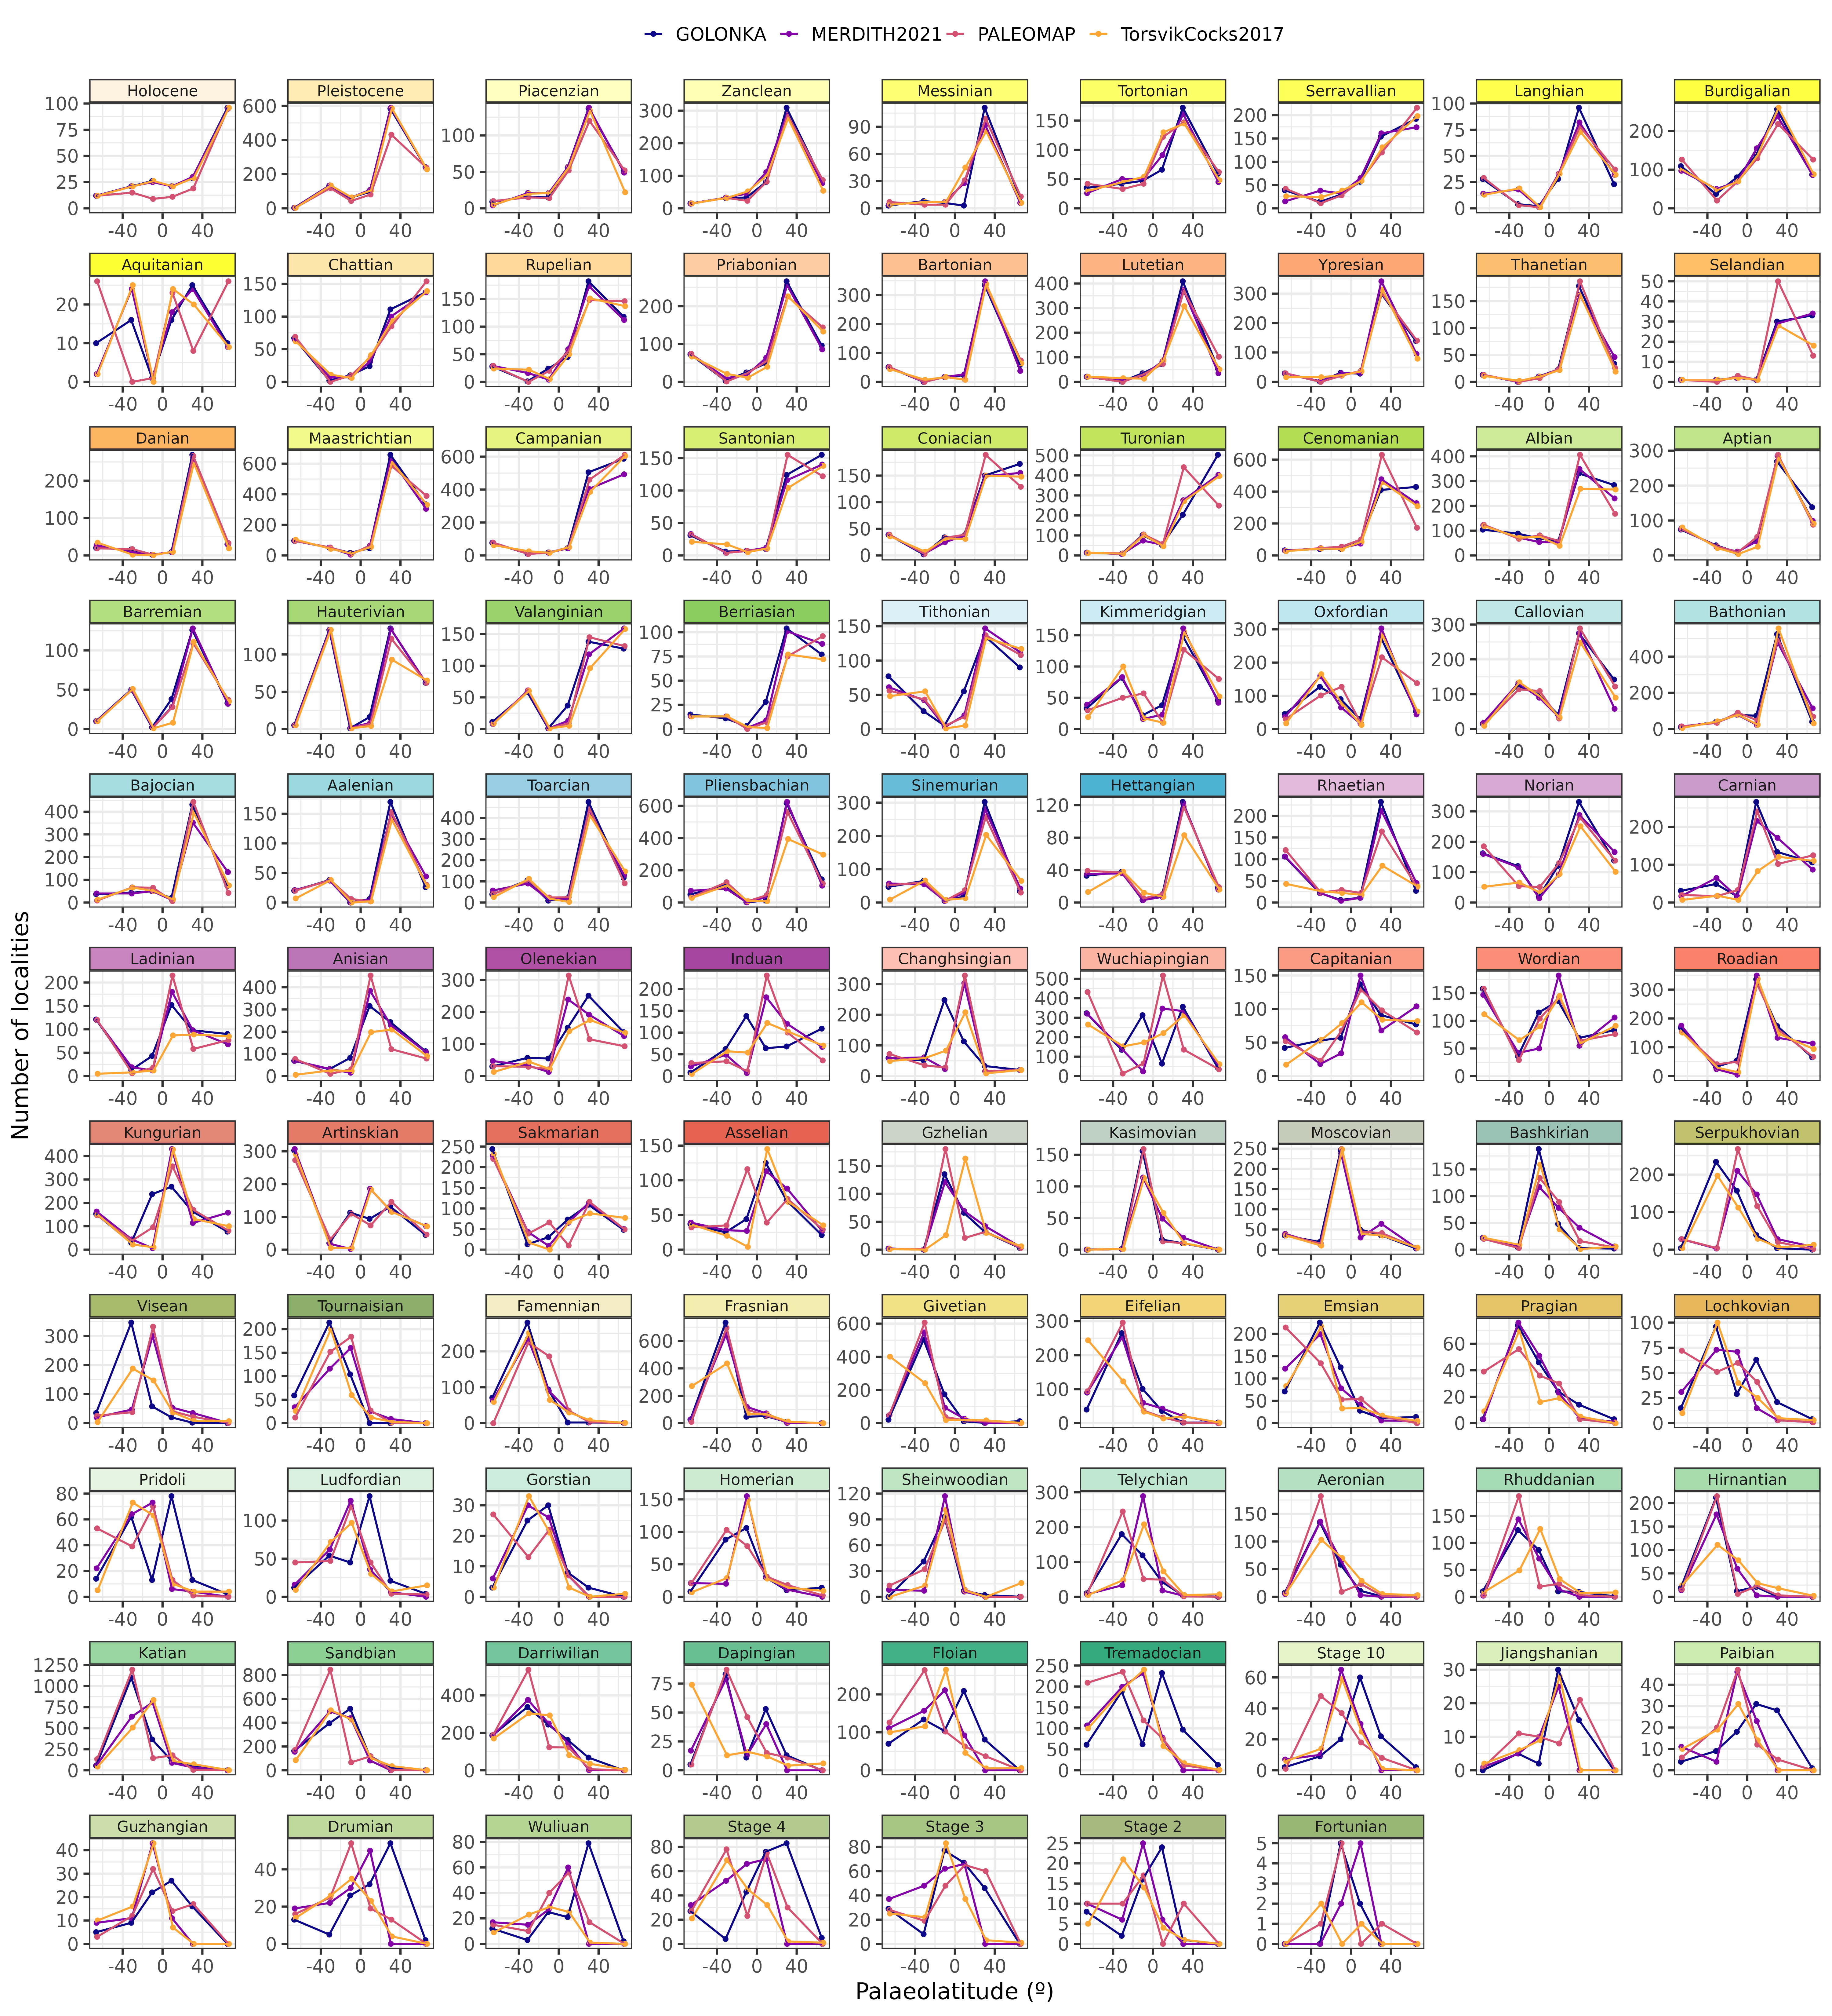
Figure S 1: Number of fossil localities per palaeolatitudinal bin within each Phanerozoic stage that could be palaeogeographically reconstructed using four Global Plate Models: GOLONKA [1], PALEOMAP [2], MERDITH2021 [3], and TorsvikCocks2017 [4]. Differences in the number of localities within each palaeolatitudinal bin reflects differences between Global Plate Models in their palaeogeographic reconstruction.
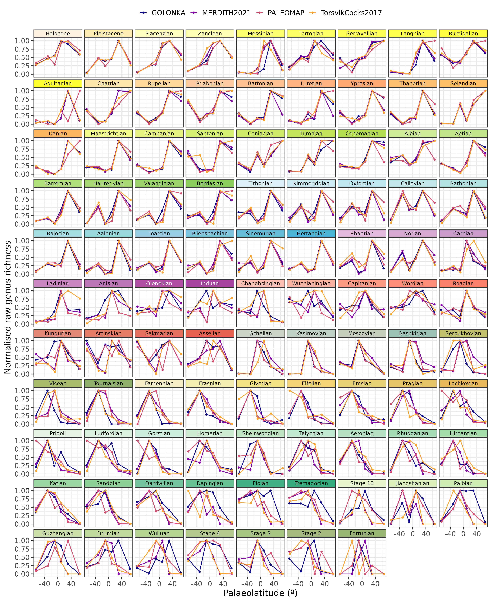
Figure S 2: Phanerozoic stage-level reconstructions of the latitudinal biodiversity gradient for five major marine invertebrate groups (Bivalvia, Brachiopoda, Cephalopoda, Gastropoda, and Trilobita). Each individual plot depicts the raw normalised genus richness within each palaeolatitudinal bin for four Global Plate Models: GOLONKA [1], PALEOMAP [2], MERDITH2021 [3], and TorsvikCocks2017 [4]. Raw genus richness was normalised for each stage and Global Plate Model by dividing the genus counts within each palaeolatitudinal bin by the maximum value across palaeolatitudinal bins.
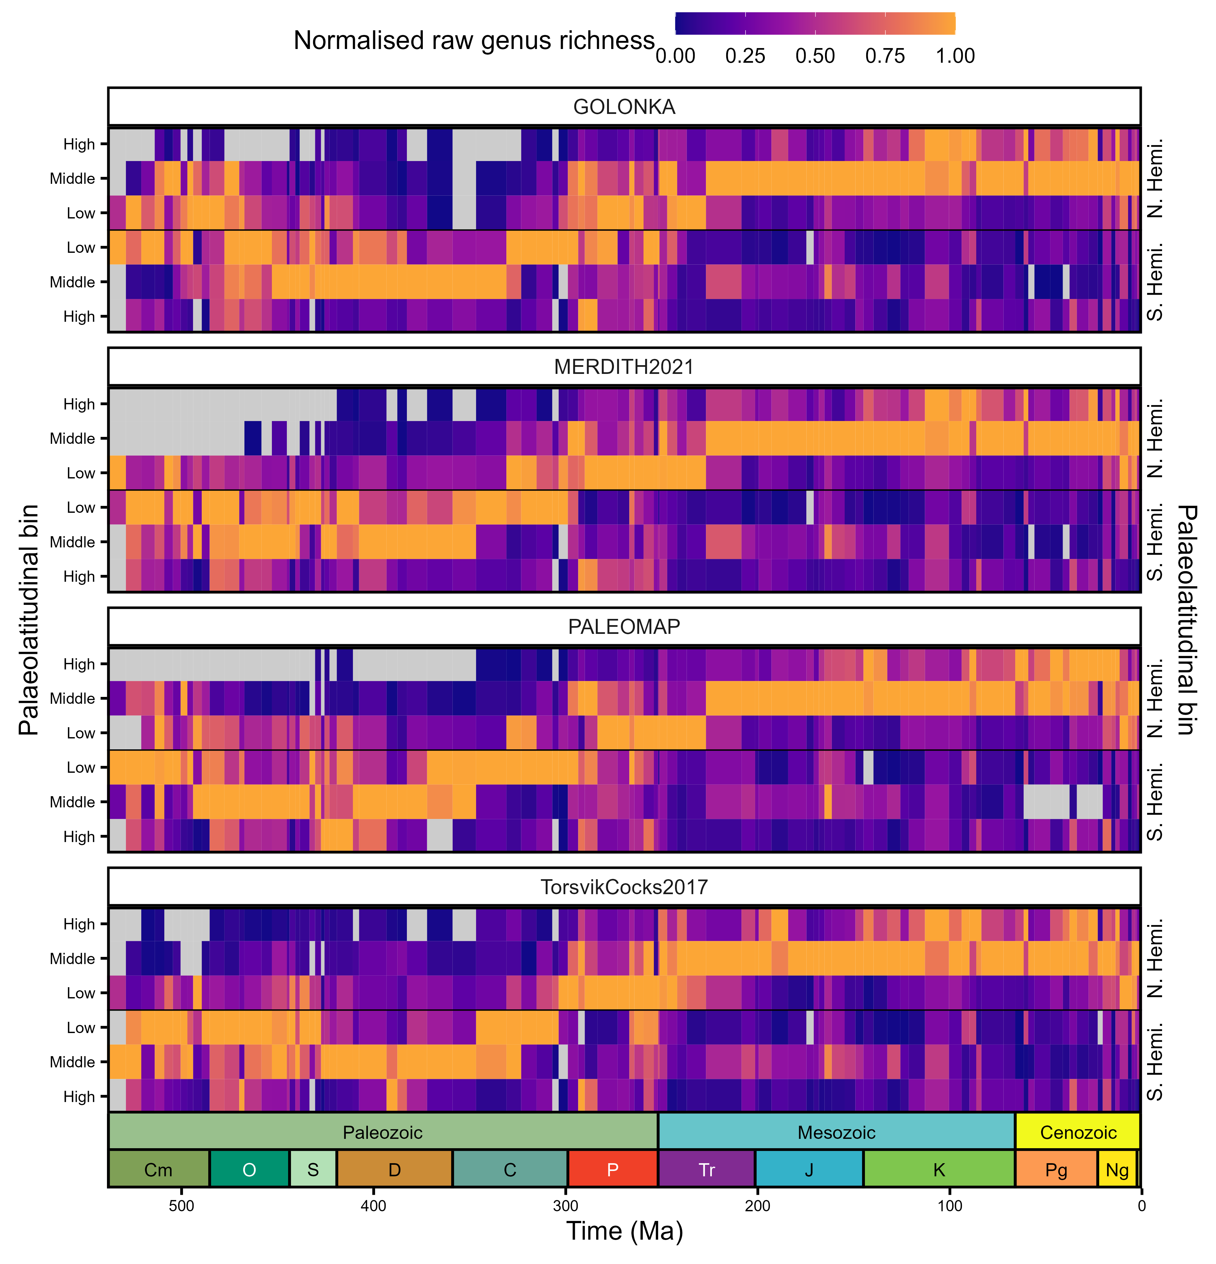
Figure S 3: Phanerozoic heatmaps of raw genus counts for five major marine invertebrate groups (Bivalvia, Brachiopoda, Cephalopoda, Gastropoda, and Trilobita). Each individual panel depicts the normalised genus richness for four Global Plate Models: GOLONKA [1], PALEOMAP [2], MERDITH2021 [3], and TorsvikCocks2017 [4]. Heatmaps depict the normalised raw genus counts within palaeolatitudinal bins (low, middle, and high) within the Northern and Southern Hemisphere. Genus richness was normalised for each stage and Global Plate Model by dividing the genus richness within each palaeolatitudinal bin by the maximum value across palaeolatitudinal bins. Grey tiles indicate palaeolatitudinal bins without sufficient data to generate richness estimates. Period abbreviations are as follows: Cambrian (Cm); Ordovician (O), Silurian (S), Devonian (D), Carboniferous (C), Permian (P), Triassic (Tr), Jurassic (J), Cretaceous (K), Paleogene (Pg) and Neogene (Ng). The Quaternary is not depicted. The geological time scale axis was added to the plot using the R package ‘deeptime’ ver. 2.1.0 [5].
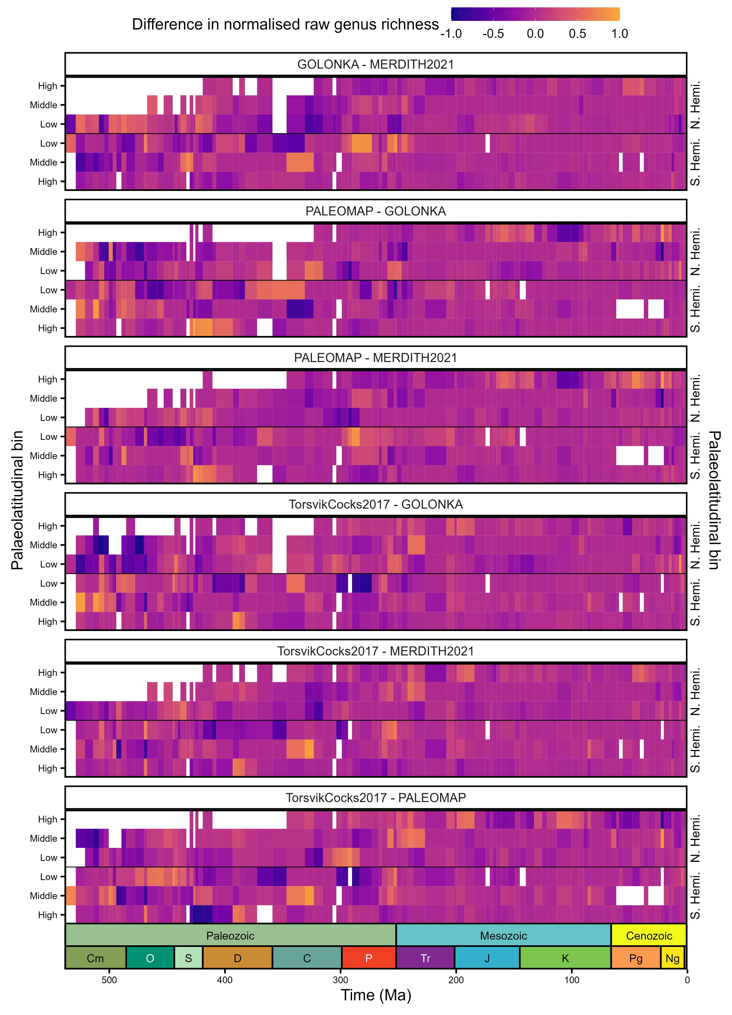
Figure S 4: Phanerozoic heatmaps of the pairwise difference in normalised raw genus richness for four Global Plate Models: GOLONKA [1], PALEOMAP [2], MERDITH2021 [3], and TorsvikCocks2017 [4]. Genus richness was computed for each stage, palaeolatitudinal bin, and model using raw counts. Genus richness was normalised for each stage and Global Plate Model by dividing the genus richness within each palaeolatitudinal bin by the maximum value across palaeolatitudinal bins. White tiles indicate palaeolatitudinal bins without sufficient data to generate richness estimates or where estimates are not available for both GPMs being compared. Period abbreviations are as follows: Cambrian (Cm); Ordovician (O), Silurian (S), Devonian (D), Carboniferous (C), Permian (P), Triassic (Tr), Jurassic (J), Cretaceous (K), Paleogene (Pg) and Neogene (Ng). The Quaternary is not depicted. The geological time scale axis was added to the plot using the R package ‘deeptime’ ver. 2.1.0 [5].
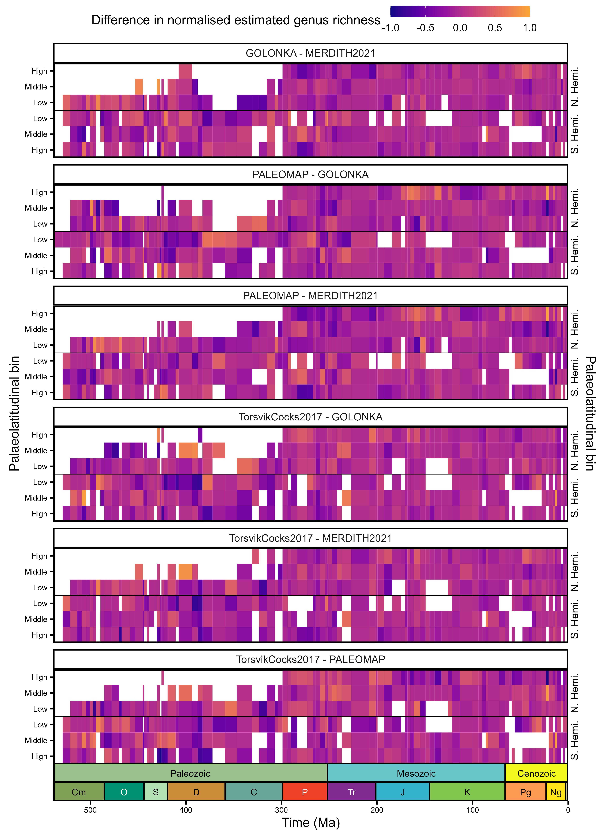
Figure S 5: Phanerozoic heatmaps of the pairwise difference in normalised estimated (coverage-based rarefaction) genus richness for four Global Plate Models (GPMs): GOLONKA [1], PALEOMAP [2], MERDITH2021 [3], and TorsvikCocks2017 [4]. Genus richness was estimated for each stage, palaeolatitudinal bin, and model using coverage-based rarefaction using the iNEXT R package ver. 3.0.1 [6] with a coverage level (otherwise known as a quorum level) of 0.4. Estimated genus richness was normalised for each stage and GPM by dividing the genus richness within each palaeolatitudinal bin by the maximum value across palaeolatitudinal bins. White tiles indicate palaeolatitudinal bins without sufficient data to generate richness estimates or where estimates are not available for both GPMs being compared. Period abbreviations are as follows: Cambrian (Cm); Ordovician (O), Silurian (S), Devonian (D), Carboniferous (C), Permian (P), Triassic (Tr), Jurassic (J), Cretaceous (K), Paleogene (Pg) and Neogene (Ng). The Quaternary is not depicted. The geological time scale axis was added to the plot using the R package ‘deeptime’ ver. 2.1.0 [5].
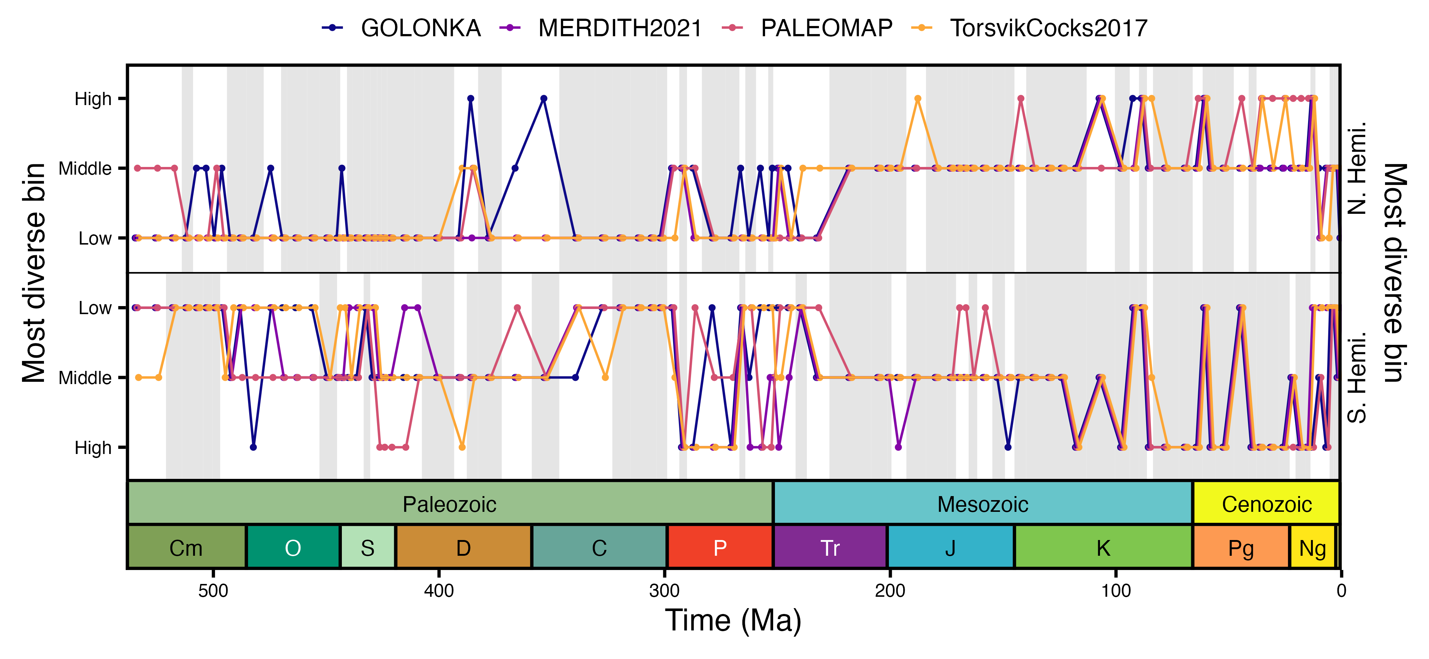
Figure S 6: Phanerozoic plot of the palaeolatitudinal bin (low, middle, high) with the greatest raw genus counts within the Northern Hemisphere and Southern Hemisphere for each Global Plate Model: GOLONKA [1], PALEOMAP [2], MERDITH2021 [3], and TorsvikCocks2017 [4]. Grey shading highlights intervals in which the palaeolatitudinal bin with the greatest genus richness is in agreement across the four GPMs. Period abbreviations are as follows: Cambrian (Cm); Ordovician (O), Silurian (S), Devonian (D), Carboniferous (C), Permian (P), Triassic (Tr), Jurassic (J), Cretaceous (K), Paleogene (Pg) and Neogene (Ng). The Quaternary is not depicted. The geological time scale axis was added to the plot using the R package ‘deeptime’ ver. 2.1.0 [5].
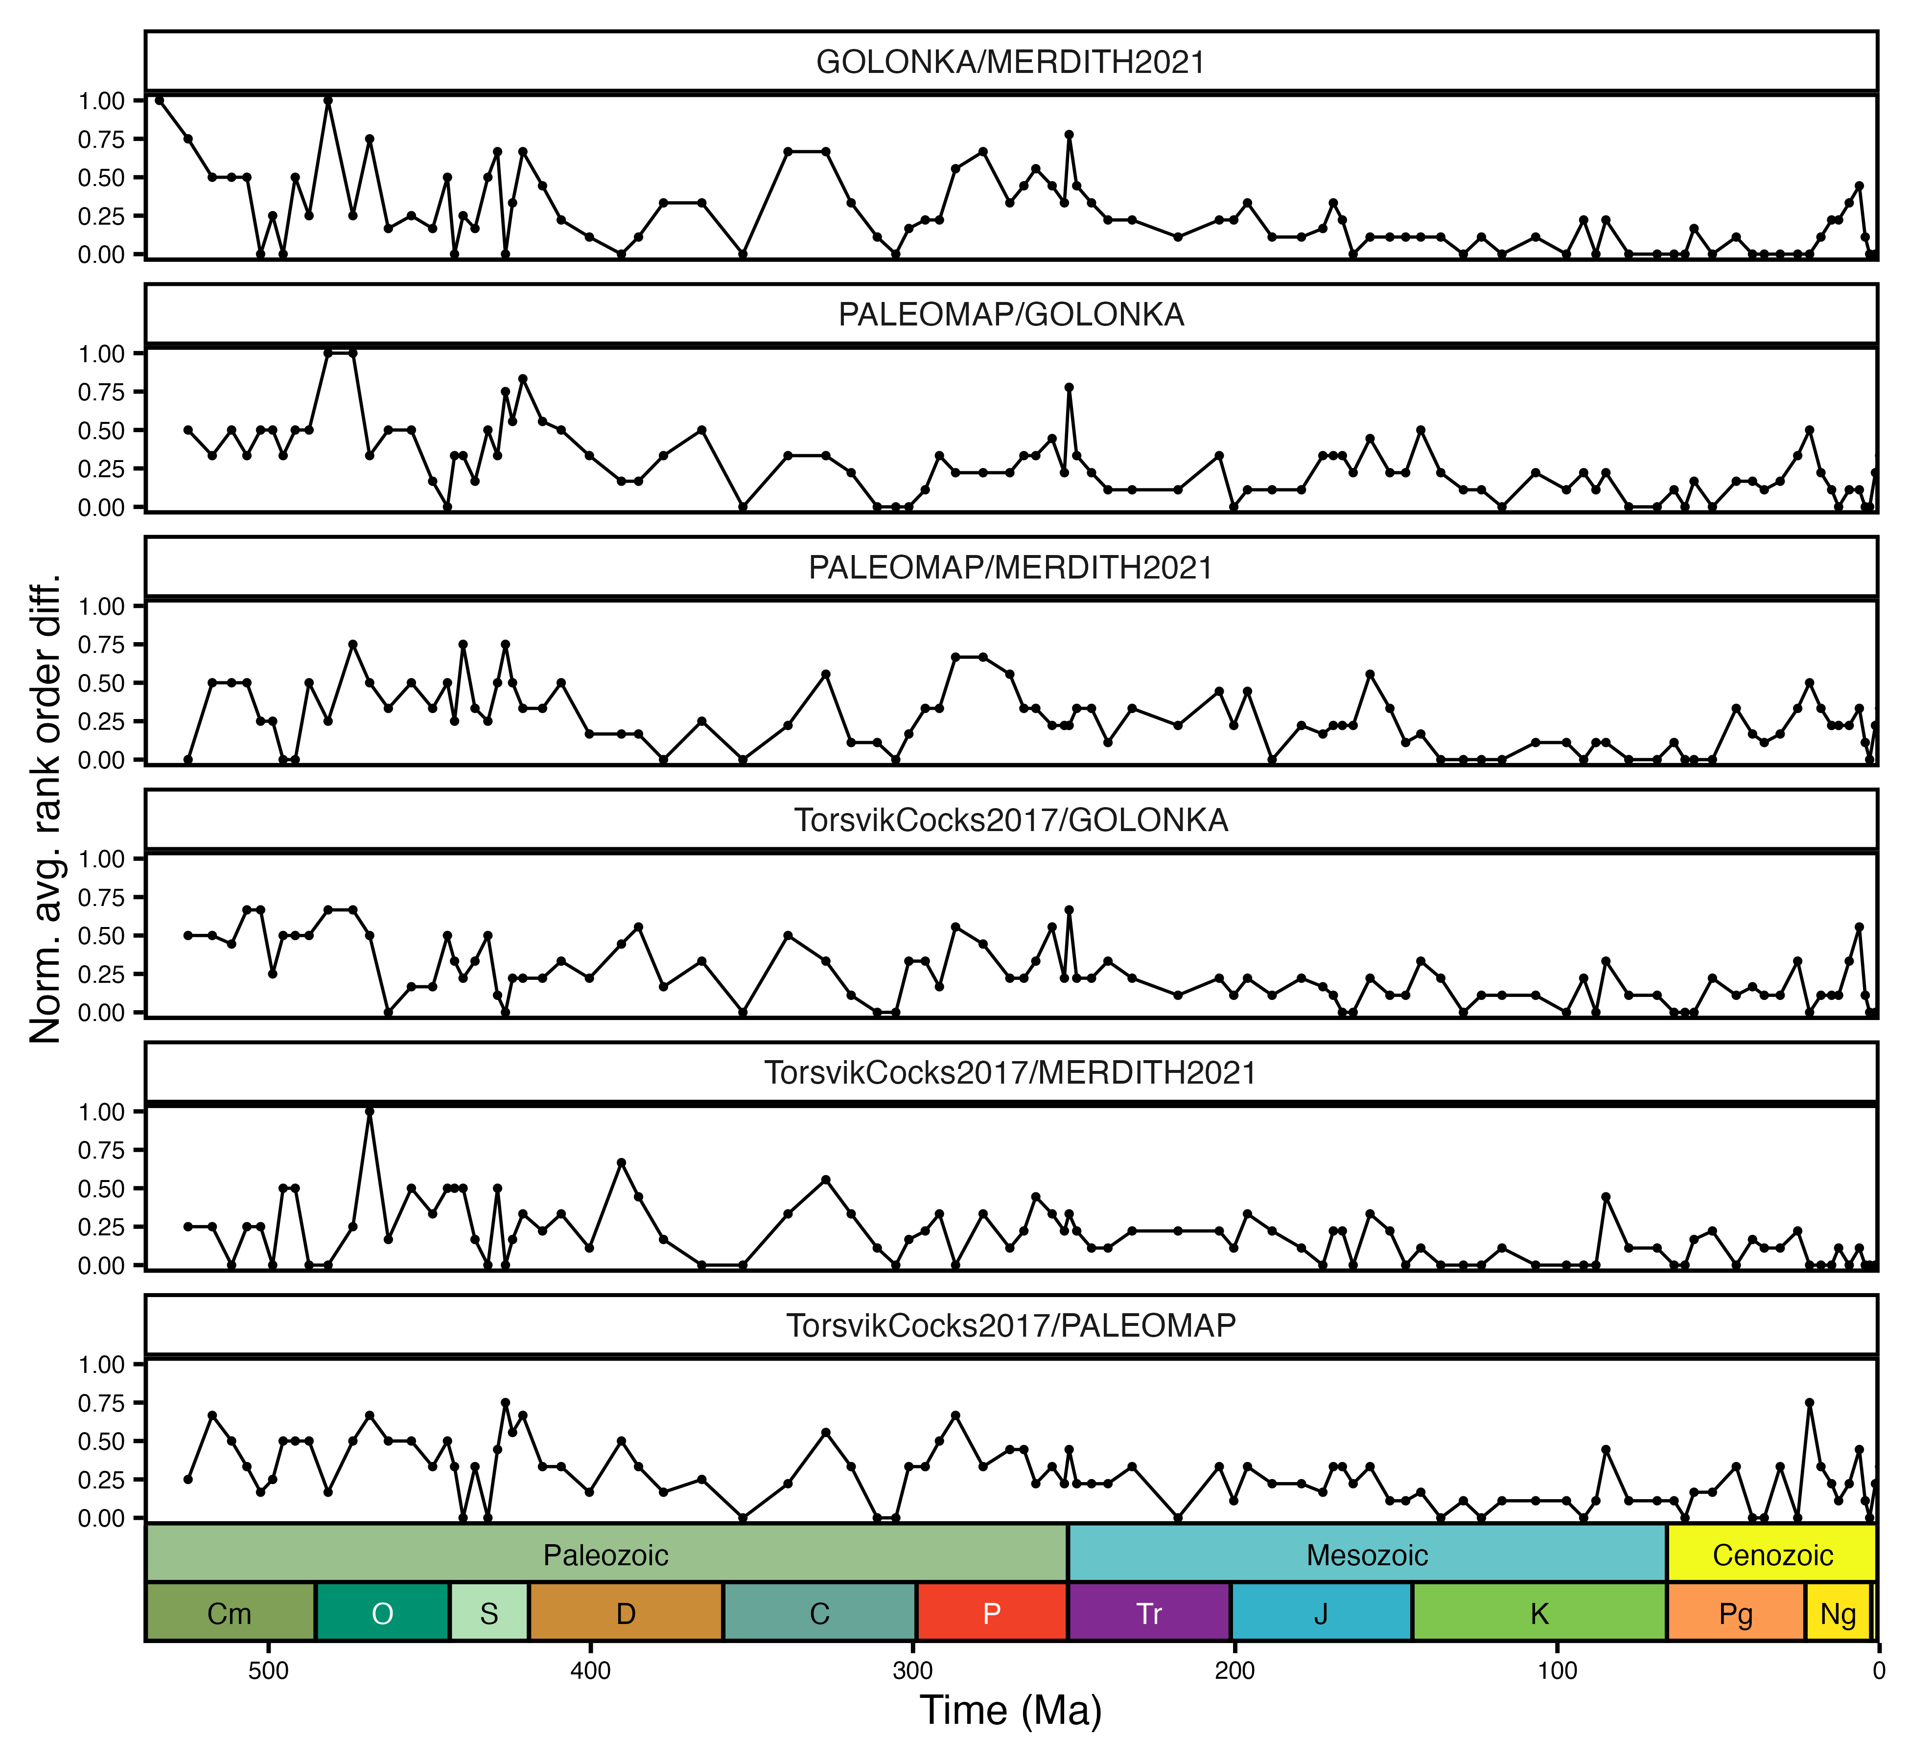
Figure S 7: Phanerozoic plot of the normalised average rank order pairwise difference between latitudinal biodiversity gradients (raw genus richness) for each Global Plate Models: GOLONKA [1], PALEOMAP [2], MERDITH2021 [3], and TorsvikCocks2017 [4]. Average rank order differences are normalised by maximum possible average difference given the number of ranks available. Period abbreviations are as follows: Cambrian (Cm); Ordovician (O), Silurian (S), Devonian (D), Carboniferous (C), Permian (P), Triassic (Tr), Jurassic (J), Cretaceous (K), Paleogene (Pg) and Neogene (Ng). The Quaternary is not depicted. The geological time scale axis was added to the plot using the R package ‘deeptime’ ver. 2.1.0 [5].

References
1. Wright N, Zahirovic S, Müller RD, Seton M. 2013 Towards community-driven paleogeographic reconstructions: integrating open-access paleogeographic and paleobiology data with plate tectonics. Biogeosciences 10, 1529–1541. (doi:10.5194/bg-10-1529-2013)
2. Scotese C, Wright NM. 2018 PALEOMAP paleodigital elevation models (PaleoDEMs) for the phanerozoic PALEOMAP project.
3. Merdith AS et al. 2021 Extending full-plate tectonic models into deep time: Linking the neoproterozoic and the phanerozoic. Earth-Science Reviews 214, 103477.
4. Torsvik TH, Cocks LRM. 2017 Earth history and palaeogeography. Cambridge University Press.
5. Gearty W. 2024 Deeptime: Plotting tools for anyone working in deep time. R package version 2.1.0 (doi:10.32614/CRAN.package.deeptime)
6. Hsieh TC, Ma KH, Chao A. 2016 iNEXT: an R package for rarefaction and extrapolation of species diversity (Hill numbers). Methods in Ecology and Evolution 7, 1451–1456. (doi:10.1111/2041-210X.12613)

