palaeoverse: towards a community-driven R package

Lewis A. Jones[1], Kilian Eichenseer[2], Bethany Allen[3], William Gearty[4], Miranta Kouvari[5], Alessandro Chiarenza[6], Sofía Galván[7], Emma M. Dunne[8]

# R Markdown

This is an R Markdown document. Markdown is a simple formatting syntax for authoring HTML, PDF, and MS Word documents. For more details on using R Markdown see <http://rmarkdown.rstudio.com>.

When you click the **Knit** button a document will be generated that includes both content as well as the output of any embedded R code chunks within the document. You can embed an R code chunk like this:

summary(cars)

## speed dist   
## Min. : 4.0 Min. : 2.00   
## 1st Qu.:12.0 1st Qu.: 26.00   
## Median :15.0 Median : 36.00   
## Mean :15.4 Mean : 42.98   
## 3rd Qu.:19.0 3rd Qu.: 56.00   
## Max. :25.0 Max. :120.00

## Including Plots

You can also embed plots, for example:

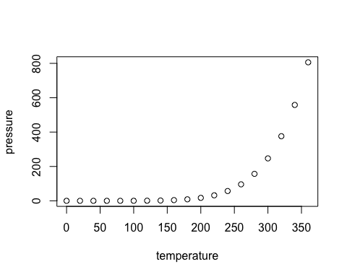

Note that the echo = FALSE parameter was added to the code chunk to prevent printing of the R code that generated the plot.

1. Centro de Investigación Mariña, Grupo de Ecoloxía Animal, Universidade de Vigo, 36310 Vigo, Spain, [LewisA.Jones@outlook.com](mailto:LewisA.Jones@outlook.com)
2. Department of Earth Sciences, Durham University, South Road, DH1 3LE, Durham, United Kingdom
3. Department of Biosystems Science and Engineering, ETH Zürich, Basel, Switzerland; Computational Evolution Group, Swiss Institute of Bioinformatics, Lausanne, Switzerland
4.
5. (1) Department of Earth Sciences, University College London, Gower Street, WC1E 6BT, London, United Kingdom (2) Life Sciences Department, Natural History Museum, Cromwell Road, SW7 5BD, London, United Kingdom
6. Centro de Investigación Mariña, Grupo de Ecoloxía Animal, Universidade de Vigo, 36310 Vigo, Spain, [a.chiarenza15@gmail.com](mailto:a.chiarenza15@gmail.com)
7. Centro de Investigación Mariña, Grupo de Ecoloxía Animal, Universidade de Vigo, 36310 Vigo, Spain, [sofia.galvan@uvigo.es](mailto:sofia.galvan@uvigo.es)
8. School of Geography, Earth & Environmental Sciences, University of Birmingham, Birmingham, B16 8GY, UK