Problems

Use the database shown in Figure P3.1 to answer Problems 1-9.

FIGURE P3.1 The Ch03_StoreCo Database Tables
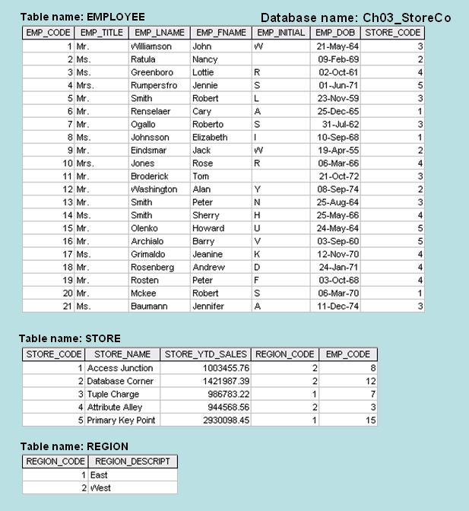

- For each table, identify the primary key and the foreign key(s). If a table does not have a foreign key, write None in the space provided.

  - EMPLOYEE: EMP_CODE (primary), STORE_CODE
  - STORE: STORE_CODE (primary), EMP_CODE, REGION_CODE
  - REGION: REGION_CODE (primary), NONE
- Do the tables exhibit entity integrity? Answer yes or no and then explain your answer.
EMPLOYEE does not exhibit entity integrity, although STORE and REGION do.

- Do the tables exhibit referential integrity? Answer yes or no and then explain your answer. Write NA (Not Applicable) if the table does not have a foreign key.
Yes, as the tables have foreign key values that have a match in the corresponding tables. REGION however is not applicable, as it has no foreign key.

- Describe the type(s) of relationship(s) between STORE and REGION.
One Region can have many Stores.
- Create the ERD to show the relationship between STORE and REGION.
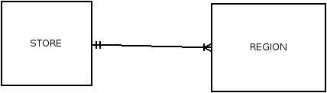
- Create the relational diagram to show the relationship between STORE and REGION.
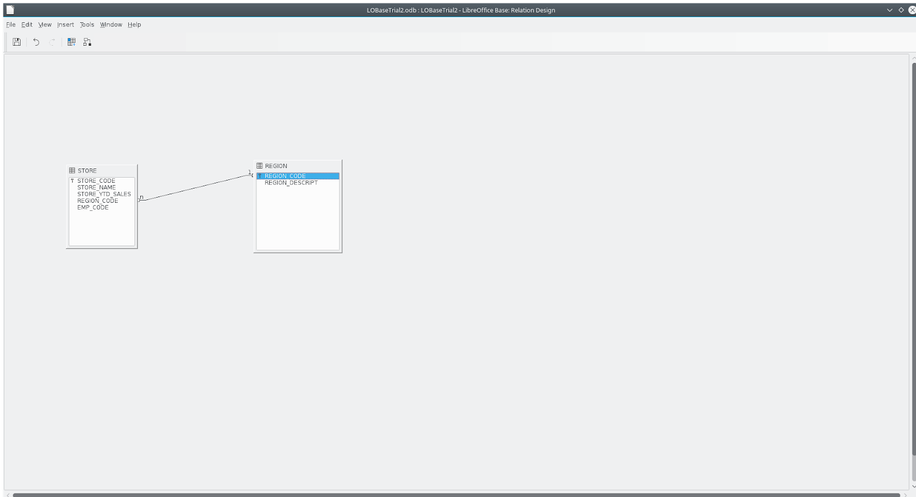
- Describe the type(s) of relationship(s) between EMPLOYEE and STORE. (Hint: Each store employs many employees, one of whom manages the store.)
One store for many employees, one manager for one store and one manager for many employees.

- Draw the ERD to show the relationships among EMPLOYEE, STORE, and REGION.
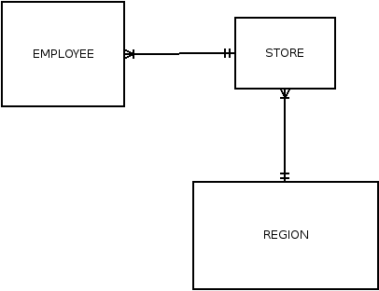

- Create the relational diagram to show the relationships among EMPLOYEE, STORE, and REGION.
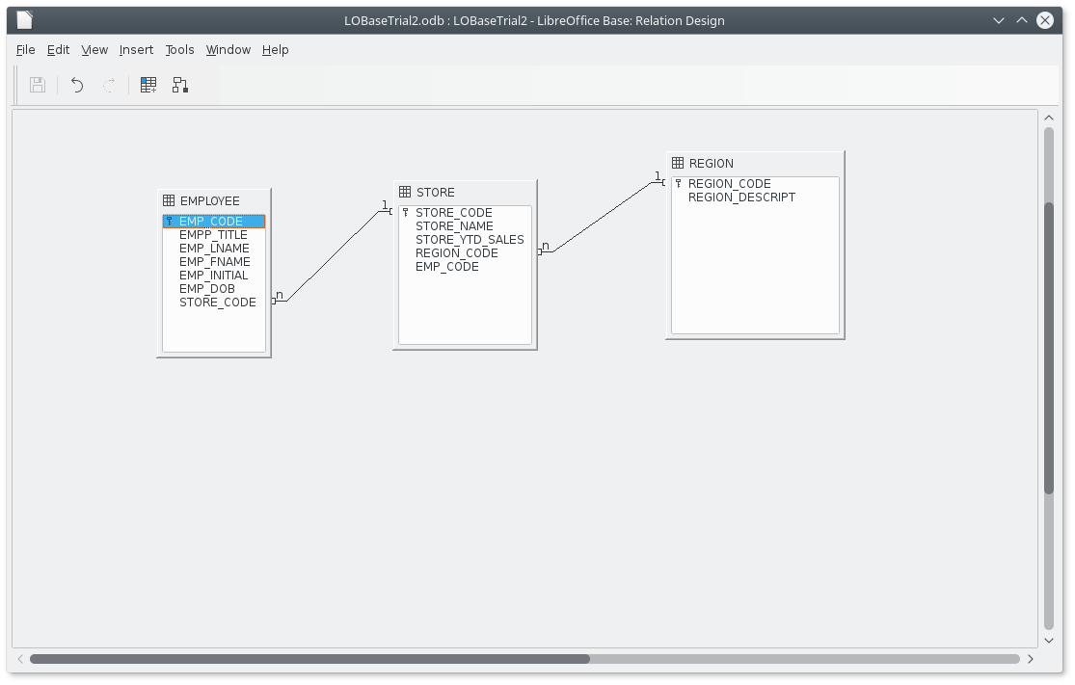

*** SKIP TO PROBLEM 24 ***

Use the database shown in Figure P3.24 to answer Problems 24−31. ROBCOR is an aircraft charter company that supplies on-demand charter flight services using a fleet of four aircraft. Aircrafts are identified by a unique registration number. Therefore, the aircraft registration number is an appropriate primary key for the AIRCRAFT table.

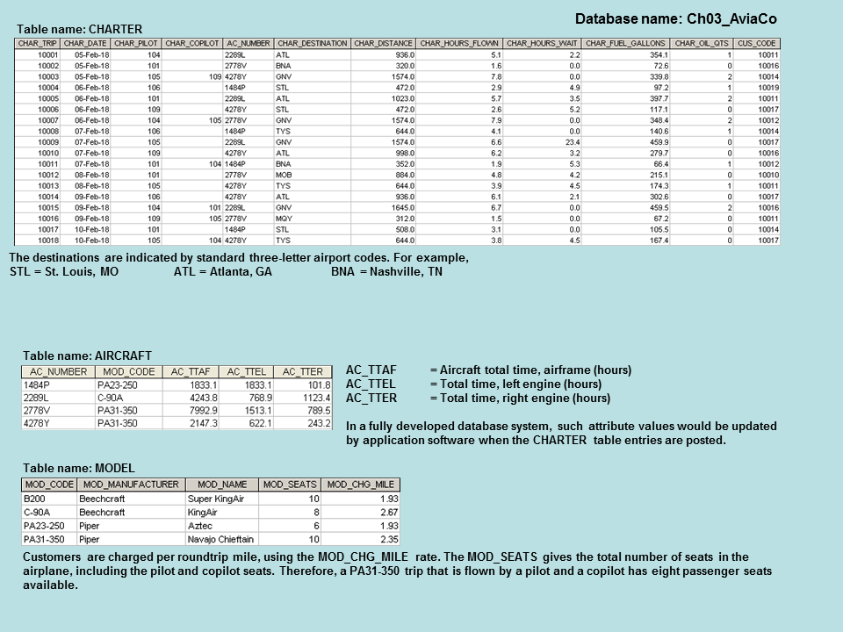
FIGURE P3.24 The Ch03_AviaCo Database Tables (Part 1)

The nulls in the CHARTER table’s CHAR_COPILOT column indicate that a copilot is not required for some charter trips or for some aircraft. Federal Aviation Administration (FAA) rules require a copilot on jet aircraft and on aircraft having a gross take-off weight over 12,500 pounds. None of the aircraft in the AIRCRAFT table are governed by this requirement; however, some customers may require the presence of a copilot for insurance reasons. All charter trips are recorded in the CHARTER table.
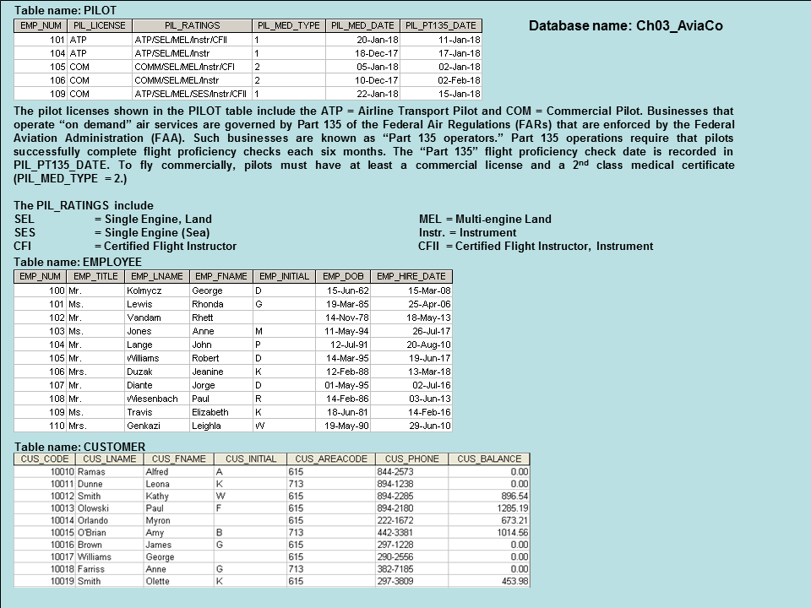
FIGURE P3.24 The Ch03_AviaCo Database Tables (Part 2)

NOTE
Earlier in the chapter, it was stated that it is best to avoid homonyms and synonyms. In this problem, both the pilot and the copilot are pilots in the PILOT table, but EMP_NUM cannot be used for both in the CHARTER table. Therefore, the synonyms CHAR_PILOT and CHAR_COPILOT were used in the CHARTER table.

Although the solution works in this case, it is very restrictive and it generates nulls when a copilot is not required. Worse, such nulls proliferate as crew requirements change. For example, if the AviaCo charter company grows and starts using larger aircraft, crew requirements may increase to include flight engineers and load masters. The CHARTER table would then have to be modified to include the additional crew assignments; such attributes as CHAR_FLT_ENGINEER and CHAR_LOADMASTER would have to be added to the CHARTER table. Given this change, each time a smaller aircraft flew a charter trip without the number of crew members required in larger aircraft, the missing crew members would yield additional nulls in the CHARTER table.

You will have a chance to correct those design shortcomings in Problem 27. The problem illustrates two important points:
- Don’t use synonyms. If your design requires the use of synonyms, revise the design!
- To the greatest possible extent, design the database to accommodate growth without requiring structural changes in the database tables. Plan ahead and try to anticipate the effects of change on the database.

ROBCOR is an aircraft charter company that supplies on-demand charter flight services, using a fleet of four aircraft. Aircraft are identified by a (unique) registration number. Therefore, the aircraft registration number is an appropriate primary key for the AIRCRAFT table.

The nulls in the CHARTER table’s CHAR_COPILOT column indicate that a copilot is not necessarily required for some charter trips or for some aircraft. Federal Aviation Administration (FAA) rules require a copilot on jet aircraft and on aircraft having a gross take-off weight over 12,500 pounds. None of the aircraft in the AIRCRAFT table is governed by this requirement; however, some customers may require the presence of a copilot for insurance reasons. All charter trips are recorded in the CHARTER table.

NOTE
Earlier in the chapter it was stated that it is best to avoid homonyms and synonyms. In this problem, both the pilot and the copilot are pilots in the PILOT table, but EMP_NUM cannot be used for both in the CHARTER table. Therefore, the synonyms CHAR_PILOT and CHAR_COPILOT were used in the CHARTER table.

Although the “solution” works in this case, it is very restrictive and it generates nulls when a copilot is not required. Worse, such nulls proliferate as crew requirements change. For example, if the AviaCo charter company grows and starts using larger aircraft, crew requirements may increase to include flight engineers and load masters. The CHARTER table would then have to be modified to include the additional crew assignments; such attributes as CHAR_FLT_ENGINEER and CHAR_LOADMASTER would have to be added to the CHARTER table. Given this change, each time a smaller aircraft flew a charter trip without the number of crew members required in larger aircraft, the “missing” crew members would yield additional nulls in the CHARTER table.

You will have a chance to correct those design shortcomings in Problem 33. The problem illustrates two important points:
- Don’t use synonyms. If your design requires the use of synonyms, revise the design!
- To the greatest possible extent, design the database to accommodate growth without requiring structural changes in the database tables. Plan ahead—and try to anticipate the effects of change on the database.

- For each table, where possible, identify:
  - The primary key: CHAR_TRIP, AC_NUMBER, MOD_CODE EMP_NUM, EMP_NUM, CUS_CODE,
  - A superkey: CHAR_TRIP, AC_NUMBER, MOD_CODE, EMP_NUM, EMP_NUM, CUS,_CODE
  - A candidate key: CHAR_TRIP, AC_NUMBER, MOD_CODE, EMP_NUM, EMP_NUM, CUS_CODE
  - The foreign key(s): AC_NUMBER, AC_NUMBER, EMP_NUM, CUS_CODE
  - A secondary key: CHAR_PILOT, AC_TTAF, MOD_NAME, PIL_LICENSE, EMP_LNAME, CUS_LNAME
- Create the ERD. (Hint: Look at the table contents. You will discover that an AIRCRAFT can fly many CHARTER trips but that each CHARTER trip is flown by one AIRCRAFT. Similarly, you will discover that a MODEL references many AIRCRAFT but that each AIRCRAFT references a single MODEL, etc.)
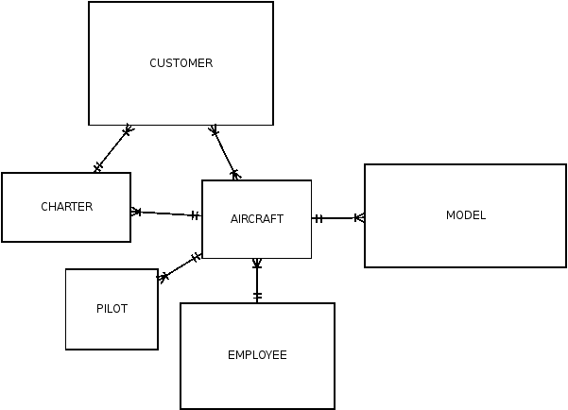

- Create the relational diagram.
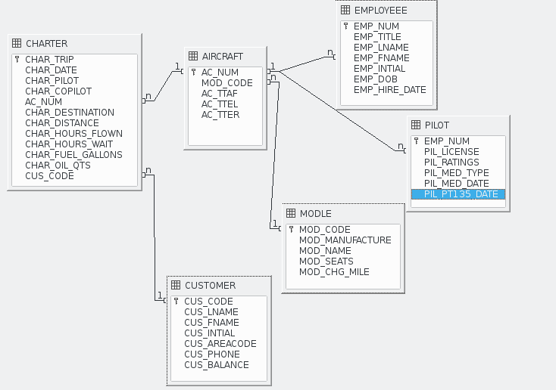
- Modify the ERD you created in Problem 25 to eliminate the problems created by the use of synonyms. (Hint: Modify the CHARTER table structure by eliminating the CHAR_PILOT and CHAR_COPILOT attributes; then create a composite table named CREW to link the CHARTER and EMPLOYEE tables. Some crew members, such as flight attendants, may not be pilots. That’s why the EMPLOYEE table enters into this relationship.)
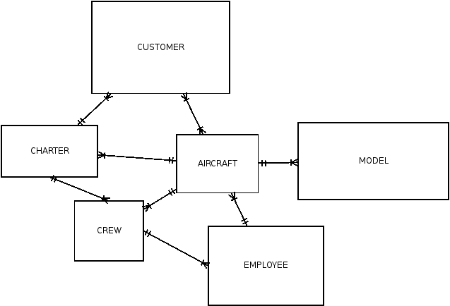

- Draw the relational diagram for the design you revised in problem 27. (After you have had a chance to revise the design, your instructor will show you the results of the design change, using a copy of the revised database named Ch03_AviaCo_2).
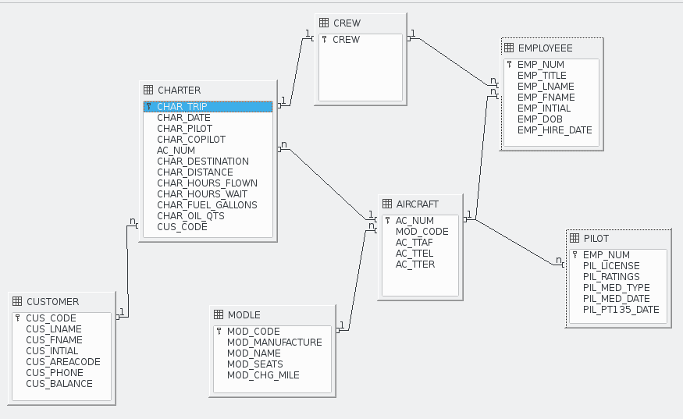
You are interested in seeing data on charters flown by either Mr. Robert Williams (employee number 105) or Ms. Elizabeth Travis (employee number 109) as pilot or copilot, but not charters flown by both of them. Complete problems 29 – 31 to find these data.

- Create the table that would result from applying the SELECT and PROJECT relational operators to the CHARTER table to return only the CHAR_TRIP, CHAR_PILOT, and CHAR_COPILOT attributes for charters flown by either employee 105 or employee 109.
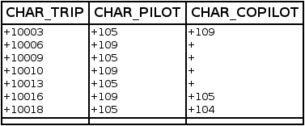

- Create the table that would result from applying the SELECT and PROJECT relational operators to the CHARTER table to return only the CHAR_TRIP, CHAR_PILOT, and CHAR_COPILOT attributes for charters flown by both employee 105 and employee 109.
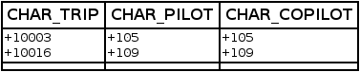

- Create the table that would result from applying a DIFFERENCE relational operator of your result from problem 29 to your result from problem 30.
