Testing

# Testers:

**1) Paddy Robinson**

**2) Ilya Kiselev**

**3) Aneesa Raza**

**Test Format**

Each of the testers started with the app open on the upcoming birthdays page. They were asked to complete a test, and note down their thoughts on the app from their experience of completing a test case.

# Test 1 - Navigate to the friends view and add a new friend

**Comments**

**1) I’m unsure of the significance behind the numbers in the navigation bar. The add button could be placed at the bottom of the page rather than the top in regards to usability. Other than that, the process was straightforward and I had no issues adding a new friend.**

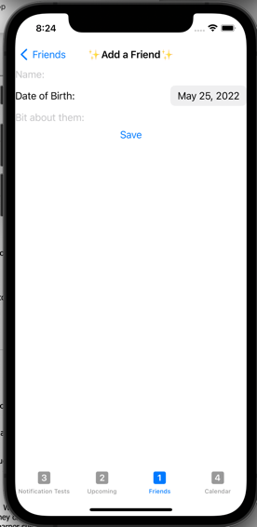**2) The form is very squished together in the top half of the screen. This leave too much whitespace on the bottom half of the form. This paired with inconsistent text colours and sizes makes the form an eyesore.**

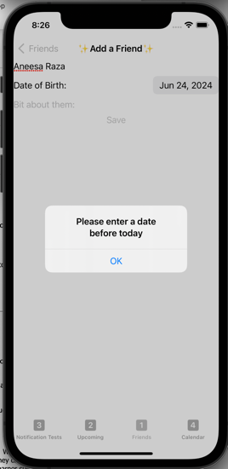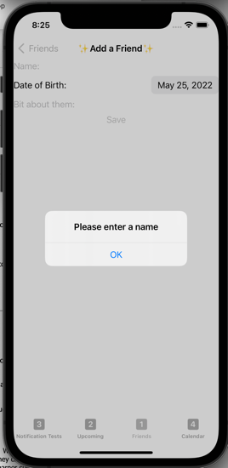**3) The add a friend form is properly validated (I can’t enter a birthday in the future or leave the name blank). It could be elongated down the page a bit more as well as I think more space is needed for the “bit about them section”. The text fields do not stand out.**

# Test 2 - Edit the created friend by giving them a new name and birthday

**Comments**

1. **The edit button is extremely misleading for new users of the app as it only allows the user to change the order of the list and delete them. After that hurdle I realized you could tap the friend to bring up a similar page that let me change the name of the friend I created.**

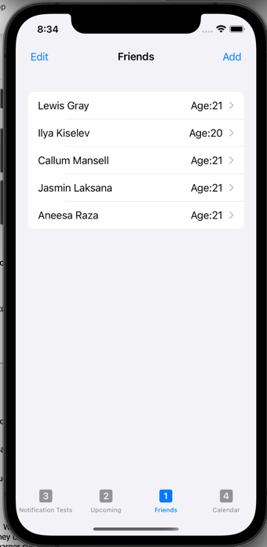

**2) After tapping on the edit button and realizing it didn’t let me edit the user, I ended up tapping on the friend itself and I was brought to a screen that looks similar to the add a friend screen. My comments in test 1 can be carried over to here as the forms follow a similar format.**

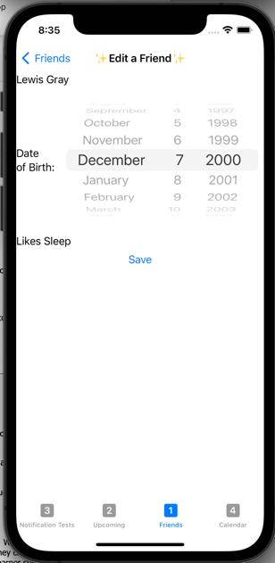

**3) I don’t like the scrolling wheel calendar selection. I think that the other calendar was easier to use and it should be consistent throughout the app.**

# 

# Test 3 - Delete the friend

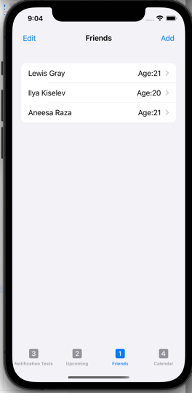**Comments**

1. **This test was easy to complete as I’d stumbled across the delete functionality in the previous test. Had that not happened, there isn’t really any indication on how to delete a friend.**

**2) An undo button would be a good additional feature as the swipe to delete looks very unforgiving if you accidentally delete someone.**

**3) By swiping to delete an item in the list I ended up navigating to the calendar view by accident. I wasn’t previously aware of this navigation method but it really gets in the way of deleting a user.**

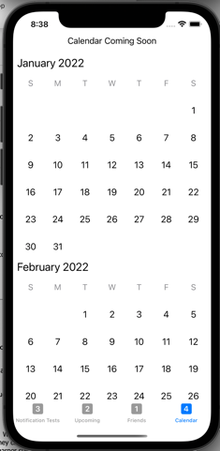

# Test 4 – Navigate to the upcoming view and append a birthday plan

**Comments**

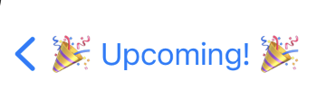

1. **This test was easy to complete as the process is very similar to test 2. I noticed that the back button doesn’t save changes, you should implement a warning if you leave the page with unsaved changes**

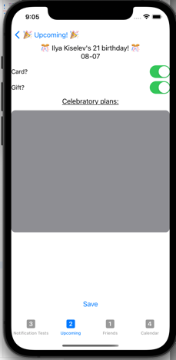

1. **The grey text area doesn’t fit the form and the text associated with the toggle switches would look better next to them**

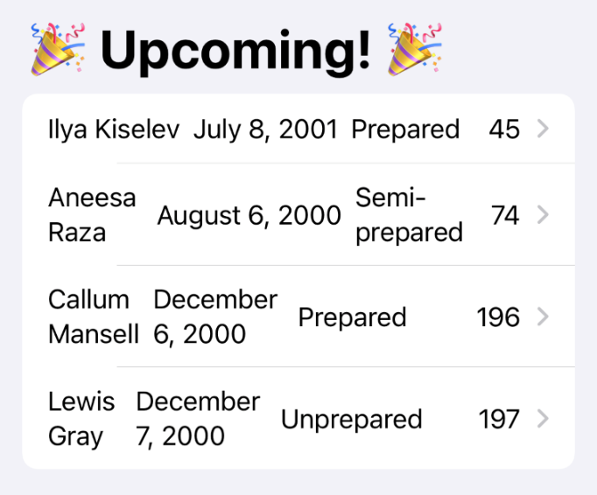**3) Swipe navigation is nice now that I know it exists. The upcoming list is extremely cluttered and at it took me a while to realize what the final number in the row was (days until the birthday). Also, the status’s aren’t very distinguishable and make the list items larger than they need to be.**

# Test 7 - Trigger notifications to view

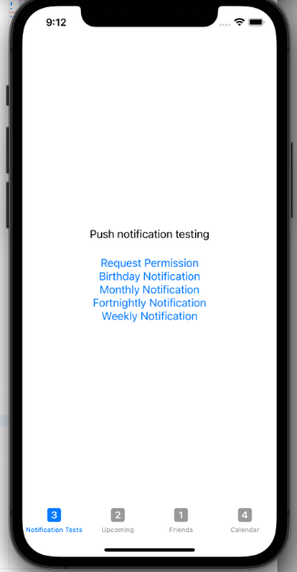**Comments**

**1) I noticed that when a notification was pressed, I was taken to the notification test screen. In deployment this could take me to the person’s birthday screen.**

**2) Less text in the notification header would make the notification look better as currently the text over-runs. The app icon should have a clear background.**

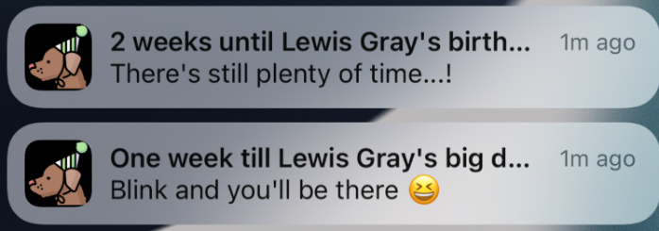

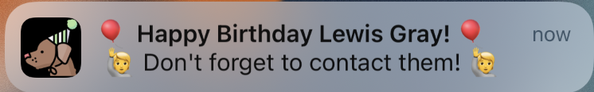**3) I like the creative use of emojis. If they send when they’re supposed to these serve as a notification that will stand out.**

# Test 9 – Open the app

**Comments**

**1) I’m not a huge fan of the teal colour in the startup screen. I’d recommend a pastel colour to fit with the app icon**

**2) The dark icon background doesn’t fit with the light theme of the app.**

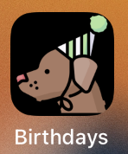

1. 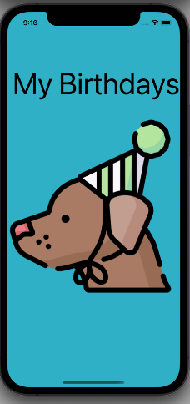**The theme inside the app should be the same as this one! Background colour could carry on through this startup screen. White font would look better for the text**

# Extra comments

**1) Turning the phone landscape makes the birthday plan screen look awful and becomes unusable. Consider locking the screen to portrait only**

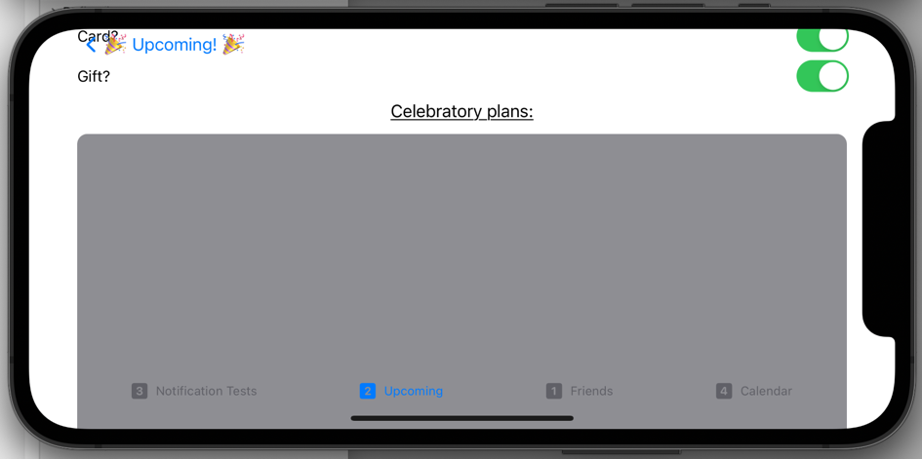

**2) None**

**3)No**

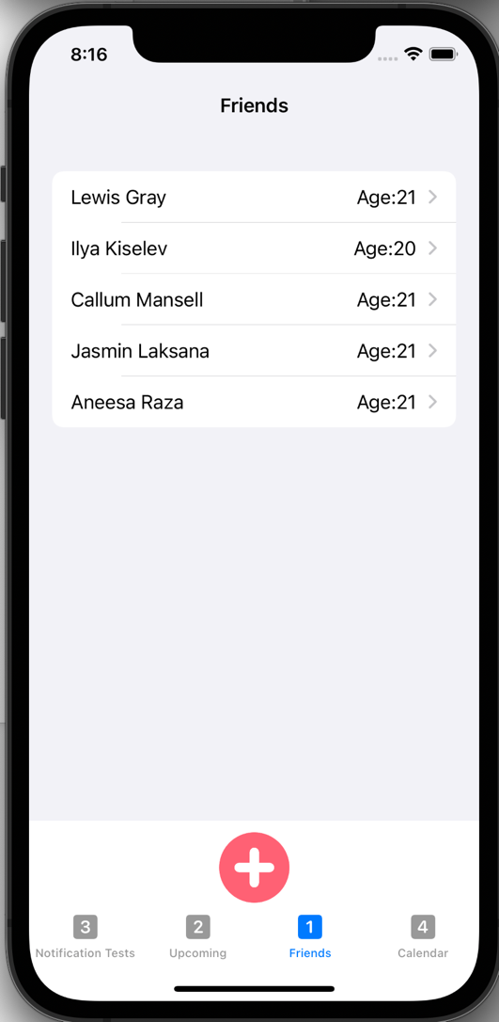**Postmortem**