**Exploration of the use and application of a learning Artificial Intelligence agent in video games.**

Is it possible to use genetic algorithms within a learning AI system to create a dynamically increasing gameplay challenge within a video game?



Lewis Graydon  
S6021534

Contents

Overview 3

Project rationale 3

Technical Overview 4

Areas of investigation 4

Genetic algorithms 4

Machine learning 4

Data format for AI 4

Background research 5

Genetic algorithms 5

Machine Learning 5

Literature review of sources 6

Methodology 6

Development methodology 6

Collecting Results 7

Source Control 7

Research ethics 7

Project plan 8

Deliverables 9

References 10

# Overview

The idea behind my Final Year Project is to explore the potential uses and applications for an Artificial Intelligence (AI) system, which utilises learning through a genetic algorithm, in gaming that progressively learns and adapts to overcome certain situations that the AI agent encounters. I would go about implementing this by initially creating a system such as Snake where the first generation of snake would not know how to effectively search out food and how to avoid the fail states of the game but as the snake went through multiple generations it would adapt and improve its method of playing the game. I intend to save the state of the snake AI at a fixed number of generations and then compare that against the average of human playtesters, to see how the performance of the snake is and at what point the snake AI becomes better than a human if it does at all.

The success of my project will be determined by whether I can create an AI system that initially has little to no information on how to play the game I have created and progressively learns more information which will allow it to determine the best method to play the game. Ideally, the AI that I create will eventually perform better than all the testers however the success of the system is not dependent on this.

# Project rationale

I have chosen to undergo this project as I have not done any work in AI previously, but it is an area in the gaming industry that has always interested me. Working on a learning AI system that utilises a genetic algorithm to improve would provide me with a good technical challenge that will test my skills and allow me in the process to learn something new. Additionally, AI in some form is in most games today so it would be very beneficial to know for future employment.

# Technical Overview

## Areas of investigation

The project will require me to know in-depth about genetic algorithms and how to program them within C++. I will also be required to know of machine learning and the different types of learning. Additionally, I will need to know how to save the AI data at fixed generations.

### Genetic algorithms

Due to the project being centred around an AI learning to play the game Snake, I want the AI to go into the game not knowing anything at the start and then as the AI progresses through generations it will have more information on the most effective way to play the game. The snake will also learn how to survive, as to not hit the confines of the play space or the body of the snake itself as well as the optimal way to search out the food which will increase the size of the snake as well as the score.

### Machine learning

The core of this project is centred on machine learning, as this is what enables AI systems to improve and learn based on experience without being programmed clearly to do so. I will need to investigate into the fundamentals of machine learning as well as the different methods of learning that I can expose the AI to.

### Data format for AI

Since I am wanting to compare the performance of the snake at set generations against the results of human players, I want to be able to save the AI data of the snake to a file. This will allow me to boot up the game and have the snake play using a preset collection of data from the generations to visualise its performance.

## Background research

The background research that I’ve carried out so far is focused on genetic algorithms, the different types of machine learning and more importantly what machine learning is.

### Genetic algorithms

A genetic algorithm is a heuristic search method and is used to find an optimised solution to search problems based on the theory of natural selection and evolutionary biology. Genetic algorithms use the current population to create the children that make up the next generation. The algorithm will select parents in the current population who contribute their data to the children. There are multiple stopping conditions that you can use for the algorithm, such as when the algorithm reaches a set number of generations, when a time limit has passed or when the performance reaches a certain threshold.

### Machine Learning

Machine learning is an application of AI which enables systems to learn and advance based upon prior experience without being clearly programmed. It focuses on the development of programs that can access data and then use that data for their own learning.

The different machine learning types are:

* Supervised learning
  + Supervised machine learning takes what it has previously learnt and applies that to new data using labelled examples to predict future patterns and events. The AI will find patterns where we have a dataset of correct answers to learn from.
* Unsupervised learning
  + Unsupervised learning finds patterns where we don’t which may be due to the correct answer being unobservable, infeasible to obtain, or maybe there isn’t even a correct answer for a given problem.
* Semi-supervised learning (SSL)
  + Semi-supervised learning is a mix between supervised and unsupervised learning. It is used because many problems that some AI is used to solve require a balance of both approaches.
* Reinforced learning
  + Reinforcement learning is a type of dynamic programming that trains algorithms using a system of reward and punishment.

Deep learning

Deep learning, also known as Deep Neural Learning or Deep Neural Network, is a specialised form of machine learning that imitates the workings of the human brain in processing data and creating patterns for use in decision making. This type of machine learning has been used to create AI that are able to beat the top percentage of players in some video games, such examples include the AlphaStar AI (Deepmind, 2019) which can play StarCraft II (Blizzard Entertainment, 2010) at a grandmaster level and the Super Smash Bros. Melee (HAL Laboratory, 2001) SmashBot AI (Massachusetts Institute of Technology, 2017).

## Literature review of sources

The literature I have chosen is directly linked to the areas I have chosen to investigate. It is crucial to locate and identify sources that will help me understand the theory of how to implement genetic algorithms and machine learning as well as inform me on which type of machine learning is best for my project.

A useful book I have found is “An Introduction to Genetic Algorithms” (Mitchell, 1998) and despite its age, it is still a useful source to me as I know very little of genetic algorithms and the book will help me get an understanding on the topic which will help me understand more in depth sources.

The website (Certes, 2018) provides a guide on the different types of AI and it is useful to me because it will inform me about the four different types of machine learning. The source explains each type clearly as well as explaining about deep learning, which is a specialised form of machine learning, and provides me with enough information about each type to come to a conclusion on what type of machine learning I would like to incorporate into my AI system.

## Methodology

### Development methodology

When it came to choosing a development methodology, I was initially wanting to use agile as I had the most experience with it from projects I have done in the past however for this project a waterfall approach would be more suitable due to the requirements of this project being well defined in what needs to be delivered. I have chosen to adopt an Agile-Waterfall hybrid for my development methodology as it will allow me to retain the clarity and tracking that the waterfall method offers whilst also allowing for flexibility of agile.

### Collecting Results

I intend to have participants test the Snake game and collect data from their performance. Firstly, I would need to find participants for the tests and I would also need to create a form for ethical reasons to obtain the participants consent and inform them on what I will record. The information that I will record will be their name, their experience playing the game Snake as well as their score. Additionally, I will be collecting data from the AI to then compare quantitatively against the participants data to come to a conclusion on the performance of the AI agent.

### Source Control

Whilst working on this project, I shall be using GitHub as my source control system in order to keep backups of my work as well as a comprehensive log of all the features added a any changes made. I am very familiar with GitHub and whilst there is GitHub Desktop available, I am more familiar with using Git through the terminal and so I will be using that to put things on source control. Source control is crucial for projects like these as every change that is pushed to the remote server is accessible at any time, and if you have a broken project due to local changes or due to changes you have pushed to GitHub, you are able to revert the project to a workable state.

## Research ethics

At some point during of the course of my project, I will require people to come and play the game so that I can record data on their performance. However, due to the nature of including others in this research, I will be required to obtain consent from the participants that they are happy to take part in this research and that they are aware that their data will be stored to ensure the results are genuine. If I am going to use any premade libraries or graphics programs to visualise the game, I will need to ensure that I adhere to copyright or any licensing that there may be.

In compliance with the British Computer Society (BCS), the AI that I will create is not going to be used for harm and to ensure this, I plan to limit the amount of information that the AI has access to and prevent the AI accessing any information from outside the game. The purpose of my AI is to determine whether a challenging AI that can learn similar to a human can make a game more enjoyable for a user.

# Project plan

|  |  |
| --- | --- |
| Day | Module that I will be focusing on |
| Monday | AI for Games Engines |
| Tuesday | AI for Games Engines |
| Wednesday | Games Programming Project |
| Thursday | Games Programming Project |
| Friday | Games Programming Project |
| Saturday | Spare time / Module overflow |
| Sunday | Spare time |

I intend to work an average working day (9am – 5pm) which should give me plenty of time to split between both of my modules. Monday and Tuesday will be dedicated to working on my other module, AI for Games Engines, where Wednesday to Friday will be spent working on this project. The weekends will be my free time, though I am going to be working on a Saturday if there is any overflow on either module to ensure I don’t fall behind.

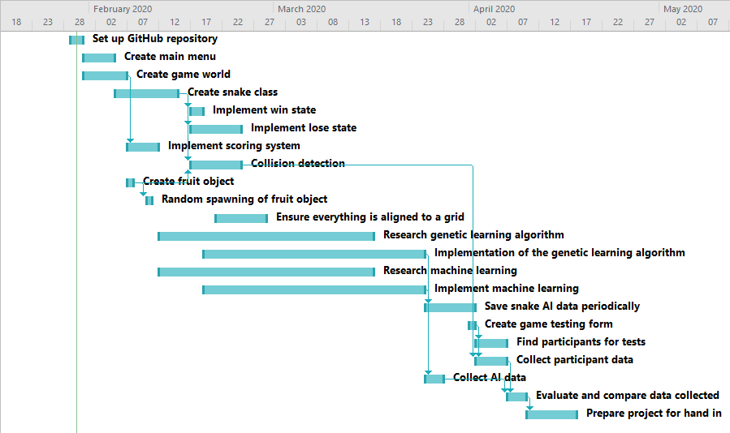

Pictured above is the Gantt chart for my project. It shows the tasks I have to complete, the order in which they require completing and it shows any tasks that need to be done in parallel. An example of the parallel tasks is the research and implementation of the genetic learning algorithm and machine learning. If I am able to stick to this, then the project will be finished come the deadline.

# Deliverables

The product that I’m going to deliver at the end of the development cycle will be a fully functional Snake game which provides the capability to be played by either a user or by the AI agent. I will also be producing a script that will continuously create generations until the score hits a certain threshold, which will be the highest score possible in the game. At a predetermined number of generations, the script will write out the data information of the AI to a file which I will then be used on the main menu of the snake game to choose which dataset for the AI we want to have it use. When the AI uses this dataset, no additional generations will be created.

On the main menu of the Snake game, if the user chooses to play the game themselves, then the game will function as a classic Snake game however should the user select the option on the main menu for the AI agent to play the game instead of the user, the user will then be prompted to select a particular generation, from a collection of generation data, for the snake AI to use to play the game. This will allow us to visualise the snake’s performance at those generations.

Alongside the snake game, I will also deliver an evaluation of the performance of the AI in comparison to the results I obtain from participants testing the game and determine whether the AI which I have created exceeds the capability of those participants, is on par with the participants or whether the AI performs worse than the participants.

# References

1. Hou, N.C., Hong, N.S., On, C.K. and Teo, J. (2011). *Infinite Mario Bross AI using Genetic Algorithm*. 2011 IEEE Conference on Sustainable Utilization and Development in Engineering and Technology. Available at: <https://ieeexplore.ieee.org/abstract/document/6089330> (Accessed 29 Jan. 2020).
2. ‌Verma, M.A. and McOwan, P.W. (2020). *An adaptive methodology for synthesising Mobile Phone Games using Genetic Algorithms*. 2005 IEEE Congress on Evolutionary Computation. Available at: <https://ieeexplore.ieee.org/abstract/document/1554774> (Accessed 29 Jan. 2020).
3. ‌Sorenson, N. and Pasquier, P. (2010). *Towards a Generic Framework for Automated Video Game Level Creation*. Applications of Evolutionary Computation, pp.131–140. Available at: <https://link.springer.com/chapter/10.1007/978-3-642-12239-2_14> (Accessed 29 Jan. 2020).
4. Mitchell, M. (1998). *An introduction to genetic algorithms*. Cambridge, Mass. London: Mit. <https://books.google.co.uk/books?hl=en&lr=&id=0eznlz0TF-IC&oi=fnd&pg=PP9&dq=+An+Introduction+to+Genetic+Algorithms&ots=shpJ92ZaRd&sig=oVDGt5-JYpFHOLbxXY29nzjsaik&redir_esc=y#v=onepage&q=An%20Introduction%20to%20Genetic%20Algorithms&f=false>
5. González-Pardo, A., Palero, F. and Camacho, D. (2015). *An empirical study on collective intelligence algorithms for video games problem-solving*. Available at: <https://repositorio.uam.es/handle/10486/674486> (Accessed 29 Jan. 2020).
6. Mourato, F., dos Santos, M.P. and Birra, F. (2011). *Automatic level generation for platform videogames using genetic algorithms*. Proceedings of the 8th International Conference on Advances in Computer Entertainment Technology - ACE ’11. Available at: <https://dl.acm.org/doi/abs/10.1145/2071423.2071433> (Accessed 29 Jan. 2020).
7. Deepmind. (2019). *AlphaStar: Mastering the Real-Time Strategy Game StarCraft II*. Available at: <https://deepmind.com/blog/article/alphastar-mastering-real-time-strategy-game-starcraft-ii> (Accessed 29 Jan. 2020).
8. Revell, T. (2019). *AI beats professional players at Super Smash Bros. video game*. New Scientist. Available at: <https://www.newscientist.com/article/2122452-ai-beats-professional-players-at-super-smash-bros-video-game/> (Accessed 29 Jan. 2020).
9. Certes. (2018). *Types of Artificial Intelligence: A Detailed Guide - Certes*. Available at: <https://certes.co.uk/types-of-artificial-intelligence-a-detailed-guide/>. (Accessed 29 Jan. 2020).
10. Blizzard Entertainment (2010). *StarCraft II.* [CD, online] PC. Worldwide: Blizzard Entertainment.
11. HAL Laboratory (2001). *Super Smash Bros. Melee.* [CD] GameCube. Nintendo.
12. Clker-Free-Vector-Images / 29583 images. *Cartoon Green Snake*. Available at: <https://pixabay.com/vectors/snake-green-cartoon-spotted-tail-306109/>(Accessed 30 Jan. 2020).