Quaternions

Quaternions are not commutative (qb *qa might != qa *qb)

Quaternions have 4 dimensions, 1 is real, 3 are imaginary. Each imaginary number has the value of sqrroot(-1) or (i), except they are all perpendicular to eachother.

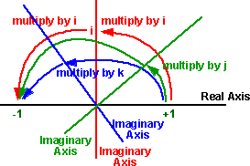

Because of this, we can represent each quaternion as:

a + I **b** + j **c** + k **d**