

**ASSIGNMENT BRIEF – BTEC**

|  |  |  |  |  |  |  |
| --- | --- | --- | --- | --- | --- | --- |
| **Course/Qualification** | | | BTEC Level 3 Extended Diploma in Creative Media Production (Games Development) | | | |
| **Unit Number(s) and Title covered** | | | Unit 5: Working to a Brief in the Creative Media Industries | | | |
| **Assignment Title and Number** | | | Assignment One: Understanding and Interpreting a Brief | | | |
| **Student Name** | | | Lewis Hawkins | | | |
| **Assessor** | | David Matravers | | **Internal Verifier** | James Shaun | |
| **Date issued** | | 11.10.2018 | | **Submission deadline** | 08.11.2018 | |
| **Assessment Criteria** | **To achieve the criteria, the evidence must show that the student is able to:** | | | | | **Assessor confirm met** |
| **P1** | Describe the requirements of working to a brief | | | | | Y |
| **M1** | Explain the requirements of working to a brief with reference to detailed illustrative examples | | | | | Y |
| **D1** | Comprehensively explain the requirements of working to a brief with elucidated examples | | | | | N |

|  |  |  |  |  |  |  |  |
| --- | --- | --- | --- | --- | --- | --- | --- |
| **Assessor feedback - 1st submission** | | | | | | | |
| Lewis,  This is a very good example; you have explained each type of contract well although the advantages and disadvantages could be elaborated on more and there could also be some examples in here to relate it back to the games industry. You Are reading, Negotiating and Opportunities sections have all been written well and explained why each of these areas are important and there are some references to an example although these are quite sporadic. You need to ensure you explain your example specifically and in more detail to achieve the higher grade; how you have had to tackle these areas.  You have proof read your work as there are little to no errors in here; please continue to proof read all assignments.  I am recommending you for the re-work window.  Overall a good submission, well done. | | | | | | | |
| **Did the learner meet the original deadline or agreed extension?** | | Yes  No | | | | | |
| **Assessor signature** | \\bwstahs1201\stausers\MATRAVERSD\Digital Sig.png | | | | **Date** | | 19.11.2018 |
| **Resubmission authorised?** | | Yes  No | | | | | |
| **New agreed deadline date for submission** *\* must be within 10 days of receiving original assignment back* | | 13.12.2018 | | | | | |
| **Lead Internal Verifier signature** |  | | | **Date** | | 19.11.2018 | |
| **Assessor feedback - Resubmission** | | | | | | | |
|  | | | | | | | |
| **Assessor signature** (resubmission only) |  | | **Date** | | | |  |

|  |  |  |  |
| --- | --- | --- | --- |
| **Vocational Scenario/Industrial Context** | | | |
| You have been approached by an up and coming recruitment firm “*Rampant Recruitment”* who specialise in advertising job roles from specific companies however as they are a new company they need to know if a brief can be trusted.  You must comprehensively explain to this company the different types of briefs they could see, how they can read, negotiate and find opportunities within it. | | | |
| **Tasks and criteria covered** | | | |
| Task 1 – **P1, M1, D1**  As stated in the above scenario you will need to comprehensively explain the following topic areas:  **Structure of briefs**: contractual; negotiated; formal; informal; commission; tender; cooperative brief; competition  **Reading a brief**: recognise nature of and demand implicit in brief  **Negotiating the brief**: consultation with client; degree of discretion in interpreting brief; constraints (legal, ethical, regulatory); amendments to proposed final product; amendments to budget; amendments to conditions; fees  **Opportunities**: identify opportunities for self-development; new skills; multi-skilling; contributions to project brief  When writing about these topic areas you should be referencing your own experiences, as well as using elucidated examples to support and improve your points. You should also include how you have had to use these sets of skills to interpret a brief and why each of them are important. | | | |
| **Evidence you must produce for this task** | | | |
| A formal written report with evidence of all bold headings from task. | | | |
| **Sources of information** | | | |
| Textbooks Baylis P, Freedman A, Procter N et al – BTEC Level 3 National Creative Media Production, Student Book (Pearson, 2010) ISBN 978-1846906725  Baylis P, Freedman A, Procter N et al – BTEC Level 3 National Creative Media Production, Teaching Resource Pack (Pearson, 2010) ISBN 978-1846907371 | | | |
| **Student checklist** | | | **Complete?** |
| Proofread | | |  |
| Reference List (if applicable) | | |  |
| All pages attached and numbered – including introduction/conclusion/front sheet | | |  |
| **Authenticity of Evidence Student declaration** | | | |
| I certify that the evidence submitted for this assignment is my own.  I have clearly referenced any sources used in the work.  I understand that false declaration of authenticity (i.e. plagiarised work) is a form of academic misconduct and the relevant College procedures will be instigated if I am found to be in contravention of these. | | | |
| **Student signature** |  | **Date of submission** | 08/11/18 |
| **Re-authentication of Evidence Student declaration *(for resubmission only)*** | | | |
| **Student signature** |  | **Date of resubmission** |  |

**Task One**

**Structure of Briefs:**

A **Contractual** brief is a legal document which lays out clearly what the employee must do in the job. Contractual briefs are the standard when getting a job as an employee at a business, however it’s not the only option. These types of briefs are most common when working at a store as a manager, assistant manager, sales assistant, etc. They’re usually used in the games industry in part or full-time jobs as there’re many conditions the employee must meet to get and keep the job.

A full time 3D modeller applying to work for Activision would most likely get this kind of brief since they would have a lot of things to consider when working (Deadlines, work hours, pay, work quality requirements).

Advantages: The company employed will know exactly what they need to do as its very detailed.

Disadvantages: The company might think there’re issues with the brief. They also create it to their own standards.

**Negotiated** is when a brief is negotiated to get a better deal. The negotiation can include time, work required, or reward. It’s key to getting the best deal possible and to remove areas you feel you cannot complete. In the games industry this kind of brief would usually be used for freelance work since it might only be for a few models or animations, which leaves room for a lot of negotiation.

In a freelance modelling job, you could negotiate the number of models you need to make, the software you need to use, and the maximum polygon count. In a freelance animation job, you could negotiate the FPS of the animation, the software you can use, and the amount of animations/length of animations.

Advantages: The project is more open to multiple perspectives and suggestions, which could make the project more successful.

Disadvantages: Negotiating a brief can waste time unnecessarily.

**Informal** is a verbal brief where the client and company talk face to face or over the phone about the terms of the brief. This can be problematic because either of the parties can refuse to admit any involvement in the project. In the games industry this would usually only be seen being used between close friends working together.

Advantages: There’s more verbal communication.

Disadvantages: There’s no documentation to prove the agreement existed.

**Formal** Is a written and outlines the requirements for the job. It’s very open and both the client and the company will formally agree, but it’s not always a legal binding. This would be used in nearly every situation since it’s the best and most fool proof option. One of the only examples of when it might not be used is between two friends.

Advantages: The client is open to any ideas or issues if there are any.

Disadvantages: The company could feel the client isn’t offering enough information for them to complete the task. They might not be legally binding, and this could cause complications.

**Commission:** This is where a company employs an individual or team to create an asset for them. The individual or team employed gets a cut of the total profits once the game has been released. This brief is typically used for freelance work because it’s better for both the games company and the freelancer.

Advantages: Company doesn’t have to overwhelm themselves with work on a larger game.

Disadvantages: Since there’re two entities working on the project, there’re could be conflict.

**Tender:** This is where the client will advertise their brief and create a proposal which they will pitch to a client. There could be multiple pitches to a client which they’d get to choose from.

Advantages: There are many ideas being pitched meaning one will stand above the rest. This ensures the best product idea will come out of this.

Disadvantages: The companies pitch could be turned down which could set them back.

**Co-operative:** Two or more companies are hired by the client to work together on a project.

Advantages: There’re multiple perspectives on a project and the brief could be more relaxed because of two entities working together.

Disadvantages: It’s more prone to disagreements and conflict between the two entities.

**Commission** is when a large company pays an individual or group to work for them on a project. The company pays the entity to complete a task (Create a game, CGI trailer).

The advantages are that the larger company don’t have to spend time on that area of the project.

A disadvantage would be there is two companies working on the game and quality cannot be ensured.

**Reading Briefs:**

For this section I will be using the Geek Lab UK brief as an example.

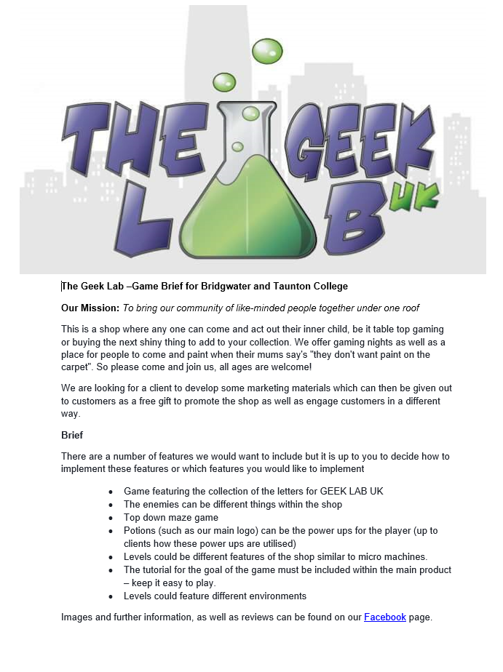

**Nature:** The nature of a brief is what its asking you to do. For example, the brief could be asking you to create a cinematic CGI trailer for an upcoming game. To complete this you would have to create the 3D models, animate them implement the FX and touch it up with post-possessing.

You would also have to organise how you’re going to produce it, by creating timelines and deadlines for yourself.

In the Geek Lab UK brief I am asked to create a game that represents the shop through symbolic references, as shown in the list of potential features (Enemies are different things within the shop, Potions like the one in the logo).

The brief is sepcificaly asking for me to make a game about letters for GEEK LAB UK, where ememies are things within the shop. They also ask for Potions (like the one in the logo) to be used as power-ups. The game should be a top-down maze game with multiple levels in different environments, and a tutorial. The game should also be easy to play.

In my experience I have carefully read what needs to be done and then bullet pointed each heading for reference.

**Demands:** The demands are parts you’re unable to change as they’re key to the project. They could be things like deadlines, amount people allowed to work on it, themes, target audiences.

In the Geek Lab UK brief the demands are the theme (Must be about the shop), the deadline, and must be easy to play.

In my experience I have completed the demands of a brief without question.

**Negotiating the Brief** is key to getting the best deal possible. From amount of work required, to whether you can have help, negotiation is very important. Both budgets and legal issues are important to discuss if not described enough, as you don’t want to have any complications.

There may assets protected by copyright you might want to use and would have to persuade the client that it’s beneficial.

In the Geek Lab UK brief I could negotiate a single level, but endless mode for the game instead. I could also negotiate the idea of top down and having multiple environments. Having potions as power-ups might not fit the game, so this could be changed to collectables.

**Opportunities:** When working for a client there’re many opportunities to take advantage from. Working for a client forces deadline on you creating an environment where you must adjust to, which gets you used to organising time usage.

It’s also an opportunity to enhance skills on an area such as 3D modelling or programming, while creating assets for the game. There’re always new things to learn even if you’ve had years of experience.

I have learnt many things which I would have not learned through taking the work and pushing myself to the limit just to see how far I can go and what I can achieve.

In The GEEK LAB UK brief I face many oppertunitys to improve my productivity in game development as a hole. I could stretch my confort zone in programming, improve on my character modelling, my character animation, and my UV unwraping skills.