**ASSIGNMENT BRIEF – BTEC**

|  |  |  |  |  |  |  |
| --- | --- | --- | --- | --- | --- | --- |
| **Course/Qualification** | | | BTEC Level 3 Extended Diploma in Creative Media Production (Games Development) | | | |
| **Unit Number(s) and Title covered** | | | Unit 5: Working to a Brief in the Creative Media Industries | | | |
| **Assignment Title and Number** | | | Assignment Two Responding to a Brief | | | |
| **Student Name** | | | Lewis Hawkins | | | |
| **Assessor** | | David Matravers | | **Internal Verifier** | James Shaun | |
| **Date issued** | | 22.11.2018 | | **Submission deadline** | 28.03.2019 | |
| **Assessment Criteria** | **To achieve the criteria, the evidence must show that the student is able to:** | | | | | **Assessor confirm met** |
| **P2** | Plan a response to a brief working within appropriate conventions and with some assistance | | | | |  |
| **M2** | Plan a response to a brief competently showing some imagination and with only occasional assistance | | | | |  |
| **D2** | Plan a response to a brief to near-professional standards showing creativity and flair and working independently to professional expectations | | | | |  |
| **P3** | Apply a response to a brief working within appropriate conventions and with some assistance | | | | |  |
| **M3** | Apply a response to a brief competently showing some imagination and with only occasional assistance | | | | |  |
| **D3** | Apply a response to a brief to near-professional standards showing creativity and flair and working independently to professional expectations | | | | |  |

|  |  |  |  |  |  |  |  |
| --- | --- | --- | --- | --- | --- | --- | --- |
| **Assessor feedback – 1st submission** | | | | | | | |
|  | | | | | | | |
| **Did the learner meet the original deadline or agreed extension?** | | Yes  No | | | | | |
| **Assessor signature** |  | | | | **Date** | |  |
| **Resubmission authorised?** | | Yes  No | | | | | |
| **New agreed deadline date for submission** *\* must be within 15 days of receiving original assignment back* | |  | | | | | |
| **Lead Internal Verifier signature** |  | | | **Date** | |  | |
| **Assessor feedback – Resubmission** | | | | | | | |
|  | | | | | | | |
| **Assessor signature** (resubmission only) |  | | **Date** | | | |  |

|  |  |  |  |  |
| --- | --- | --- | --- | --- |
| **Vocational Scenario/Industrial Context** | | | | |
| You have been approached by an up and coming 3D Animation company called “*Animation Revelation”* they would like you to produce a short animation of your choice to fully demonstrate your abilities within this subject area. This animation will reflect what you will produce for Unit 67: Assignment Three.  Before you can start to create the animation you must be able to plan how you are going to go about completing the project along with actually applying your response. | | | | |
| **Tasks and criteria covered** | | | | |
| **Task 1** – *P2, M2, D2*  For this task you are required to plan your response to the brief; the planning elements must incorporate the actual response to the brief itself, but should also include how you are going to manage your time and prepare. Your planning documents should show creativity and flair; and you must demonstrate working to a professional standard independently.  Your planning document must include the following **bold** headings; in *italics* there are areas you may wish to write about:  **Plan**: *prepare plan to meet requirements; health and safety issues; relevant legislation to be followed; team members involved; role of team members; organisational structure; working practices*  **Timescales**: *deadlines; availability; resources; feedback*  **Develop**: *brainstorm; mind-map; identify possible solutions; treatments; scripts; programme/design formats; to meet requirements of brief; research potential of solutions; evaluate against requirements and constraints; select best option; discuss with client; agree final response*  **Task 2** – *P3, M3, D3*  For this task you are required to apply your response to the brief; this means actually creating what the brief has asked you to do (Assignment Three Unit 67); you should take care to monitor your progress throughout with a production log or something similar. You will also need to have close contact with your client to ensure that you are on the right tracks for completion. You must ensure that you work to near professional standards and your work demonstrates creativity and flair working independently to professional expectations.  Your production document must include the following **bold** headings; in *italics* there are areas you may wish to write about:  **Apply**: *pre-production phase; production phase; post-production phase; monitor progress; review; revise*  **Relationship with client**: *liaison with client; dealing with difficulties or complaints; revisions to brief; revisions to plan* | | | | |
| **Evidence you must produce for this task** | | | | |
| Task 1: Planning document including evidence of all **bold** headings  Task 2: Production document including evidence of all **bold** headings | | | | |
| **Sources of information** | | | | |
| Textbooks Baylis P, Freedman A, Procter N et al – BTEC Level 3 National Creative Media Production, Student Book (Pearson, 2010) ISBN 978-1846906725  Baylis P, Freedman A, Procter N et al – BTEC Level 3 National Creative Media Production, Teaching Resource Pack (Pearson, 2010) ISBN 978-1846907371 | | | | |
| **Student checklist** | | | | **Complete?** |
| Proofread | | | |  |
| Reference List (if applicable) | | | |  |
| All pages attached and numbered – including introduction/conclusion/front sheet | | | |  |
| **Authenticity of Evidence Student declaration** | | | | |
| I certify that the evidence submitted for this assignment is my own.  I have clearly referenced any sources used in the work.  I understand that false declaration of authenticity (i.e. plagiarised work) is a form of academic misconduct and the relevant College procedures will be instigated if I am found to be in contravention of these. | | | | |
| **Student signature** |  | **Date of submission** | 23/05/19 | |
| **Re-authentication of Evidence Student declaration *(for resubmission only)*** | | | | |
| **Student signature** |  | **Date of resubmission** |  | |

**Task One:**

**Plan:**

**Health and Safety Issues:**

When working on a screen I need to make sure to take regular breaks (15 minutes every hour) to avoid eye-strain. I will also need to keep wires out of the way to prevent a tripping hazard.

**Role of Team Members:**

Since I’m working on my own I must develop all areas by myself. To achieve this, I will plan and develop areas at different points, only starting a new one once the old is finished. This will be done to prevent the build-up of work.

**Timescales:**

**Deadlines:**

I will need to make sure to have the product handed in on time for the client.

**Resources:**

For this product I will need 3D modelling and animation software (Blender 3D), a powerful PC to render the animation, image manipulation software to texture the 3D models (Gimp), and Microsoft Office to document my work.

**Develop:**

**Mind-Map:**

Below is the mind-map I made:

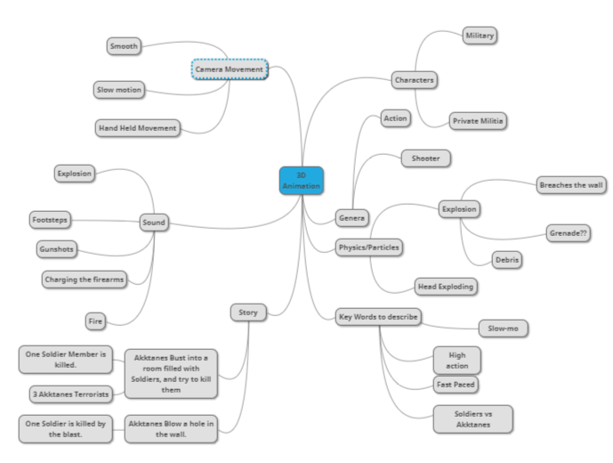 **Storyboard:**

Below is the storyboard I made:

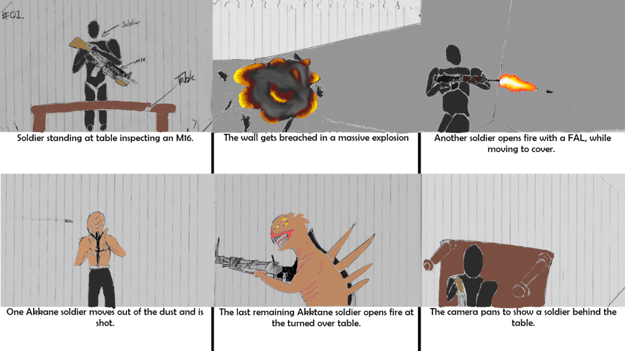

**Task Two:**

**Apply:**

**Preproduction Phase:**

In this phase I created all the concepts and artwork. Several of my drawings are shown below:

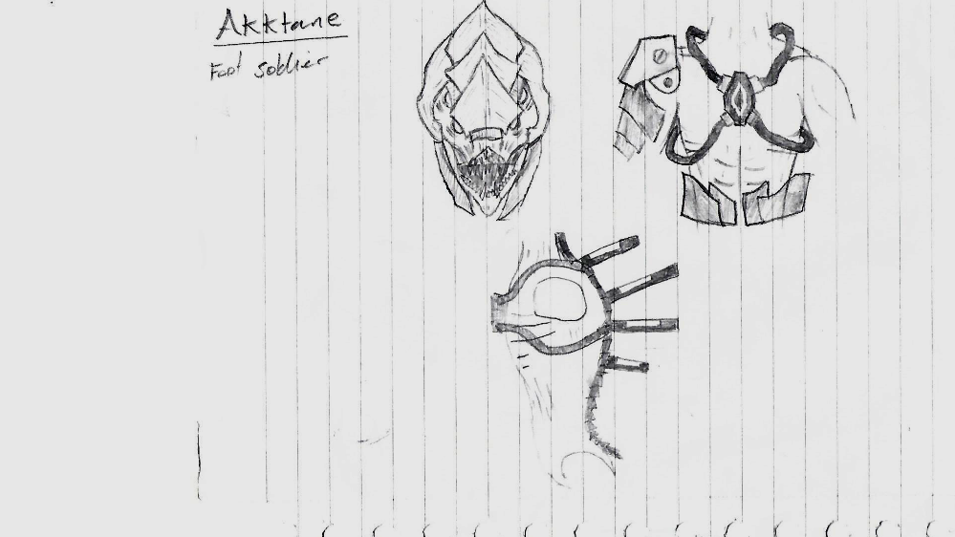

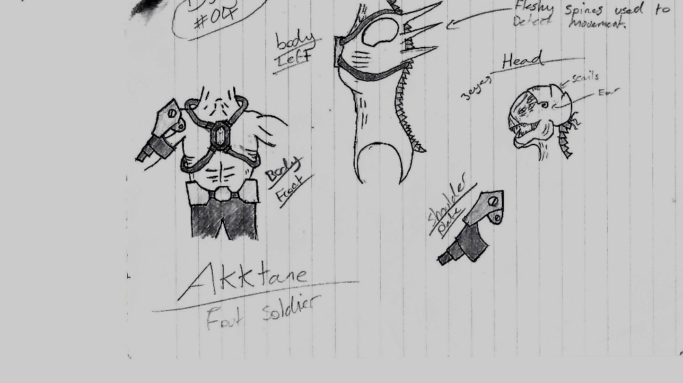

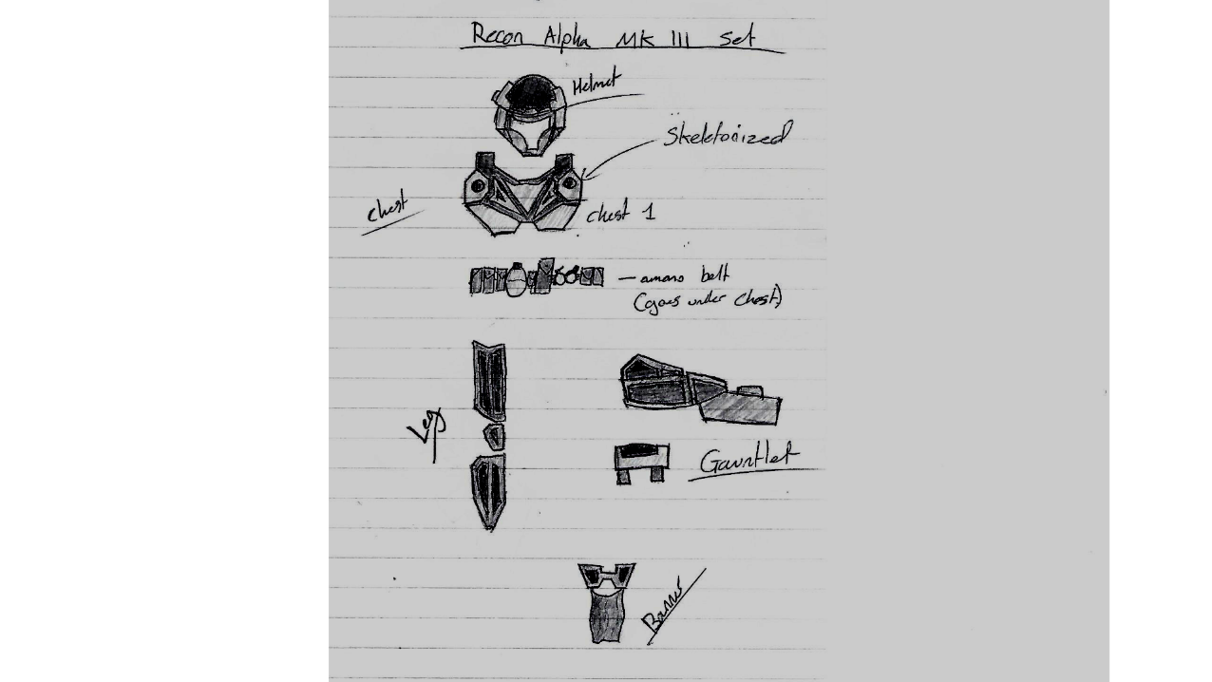

**Production Phase:**

In this phase I created the animation. A few screenshots of the render are shown below:

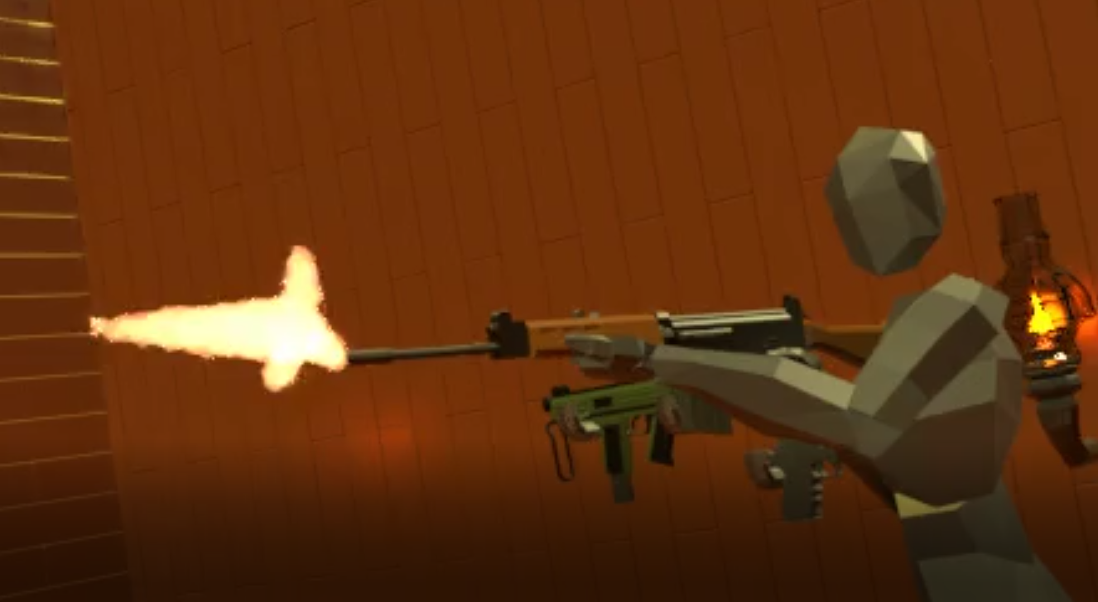

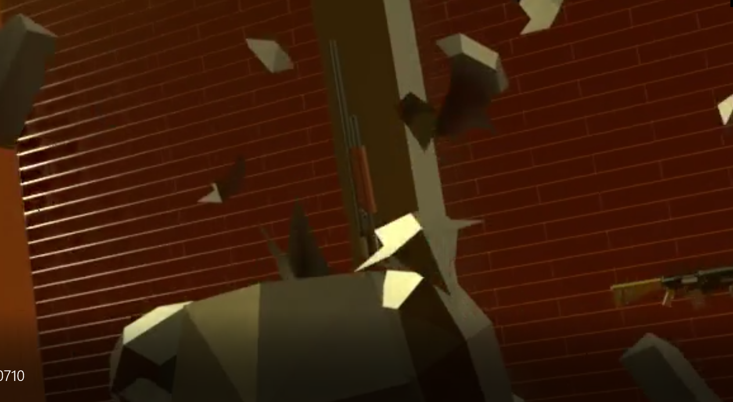

**Review:**

**Reflect on Final Product:**

I believe the final product was of very good quality, fitting into all the required categories. The animation itself resembles the planed idea and concept, but to keep to time constraints I had to cut out the explosion at the beginning. This was because the added polygons for the shrapnel and the volumetric smoke simulation caused too many issues with render times.

**Production Skills:**

I felt I was able to concept the idea in a very reasonable time, allowing for me to start on the concept art sooner. I was also able to animate the product in just a few days allowing for more time to be spent on effects and to flush out the final product.

**Relationship with Client:**

**Dealing with Difficulties:**

During the production I frequently asked the client if the animation was up to standard, to avoid any compilations later on.