



**Assignment Brief – BTEC**

|  |  |  |  |  |  |
| --- | --- | --- | --- | --- | --- |
| **Programme** | | Level 3 Extended Diploma in Creative Media Production (Games Development) | | | |
| **Unit number(s) and title covered** | | Unit 6: Critical Approaches | | | |
| **Assignment number & title** | | Assignment Two: Understanding Responses to Media Products | | | |
| **Student name** | | *Lewis Hawkins* | | | |
| **Assessor** | | David Matravers | **Internal Verifier** | *James Shaun* | |
| **Date issued** | | *19.11.2018* | **Submission deadline** | *07.12.2018 at* ***4.30pm*** | |
| **Assessment Criteria** | **To achieve the criteria, the evidence must show that the student is able to:** | | | | **Assessor confirm met** |
| P3 | Describe how media audiences respond to media products with some appropriate use of subject terminology | | | | Yes |
| M3 | Explain how media audiences respond to media products with reference to detailed illustrative examples and with generally correct use of subject terminology. | | | | No |
| D3 | Comprehensively explain how media audiences respond to media products with elucidated examples and consistently using subject terminology correctly. | | | | No |

|  |  |  |  |  |  |  |  |  |  |
| --- | --- | --- | --- | --- | --- | --- | --- | --- | --- |
| **Assessor feedback - 1st submission** | | | | | | | | | |
| *Task No* | *Targeted Criteria* | *Met* | *Comment* | | | | | | |
| 1 | P3 | Y | A good submission Lewis, you have outlined the key features of the different audience models, and have commented on how different factors such as culture let us respond and understand products. You have also generalised research done on advertising. This is far from your bets work here, and you miss many opportunities to fullu explain or exemplify these points. | | | | | | |
| 1 | M3 | N |
| 1 | D3 | N |
| **Did the learner meet the original deadline or agreed extension?** | | | | Yes ☐ | | | | | |
| **Assessor signature** | | | H:\My Pictures\Jim Signature - Copy (2).jpg | | | | **Date** | | 19/01/2019 |
| **Resubmission authorised?** | | | | Yes ☐ No ☐ | | | | | |
| **New agreed deadline date for submission** *\* must be within 10 days of receiving original assignment back* | | | |  | | | | | |
| **Lead Internal Verifier signature** | | |  | | | **Date** | |  | |
| **Assessor feedback - Resubmission** | | | | | | | | | |
|  | | | | | | | | | |
| **Assessor signature** (resubmission only) | | |  | | **Date** | | | |  |

|  |  |  |  |
| --- | --- | --- | --- |
| **Scenario** | | | |
| You have gained an internship at FNGRGUNS (Finger Guns), an entertainment journalism site set in the South West. You have been requested to write a series of pieces on their “Publishers Insider” column to give consumers a clear picture or the critical approaches used by media producers to target their audiences and make effective products.  Your previous article with FNGRGUNS was a roaring success, and as such you have been tasked with delving deeper into the methods and understanding of consumers for media products. This is a big area of contention and there are many different views and theories relating to audience reception and understanding.  You must develop a balanced and unbiased article that examines the different areas of audience consumption. | | | |
| **Tasks and criteria covered** | | | |
| Task 1  For this task you must examine a range of audience theories in relation to media consumption, and comprehensively explain the different theories and approaches to how audiences respond to media messages. This explanation should weigh up the different merits and weaknesses of the different audience theories, and apply these to different examples to demonstrate their application.  Your discussion should include the following:  Audience Theory:   * Hypodermic Needle Model * Uses and Gratifications Theory * Passive and Active Consumption   Audience Responses:   * Participatory * Cultural Competence * Fan Culture * Oppositional, Preferred, Negotiated   For the final aspect of this assessment, you must develop a discussion on **one** of the following points and incorporate recent scientific research in the area you select. You should comment on the findings of the research, and provide your own defence or support for the research papers you use. You should provide a reference to the selected materials and ensure your comments are a weighing up of the findings from the research.  Effects Debates:   * Violence and Sexual Content in Games * Censorship * Effects of Advertising   [Task Covers P3, M3, D3] | | | |
| **Evidence you must produce for this task** | | | |
| Detailed report with supporting references | | | |
| **Sources of information** | | | |
| **Textbooks**  Baylis P, Freedman A, Procter N et al – BTEC Level 3 National Creative Media Production, Student Book  (Pearson, 2010) ISBN 978-1846906725  Baylis P, Freedman A, Procter N et al – BTEC Level 3 National Creative Media Production, Teaching Resource  Pack (Pearson, 2010) ISBN 978-1846907371  Baylis P, Holmes P, Starkey G – BTEC National in Media Production (Heinemann Educational, 2007)  ISBN 978-0435499198  Abercrombie N, Longhurst B – The Penguin Dictionary of Media Studies (Penguin, 2007)  ISBN 978-0141014272  Branston G, Stafford R – The Media Students Book (Routledge, 2006), ISBN 978-0415371438  Briggs A, Cobley P – The Media: An Introduction (Longman, 2002) ISBN 978-0582423466  Clark V, Jones P, Malyszko B, Wharton D – Complete A-Z Media and Film Studies Handbook (Hodder Arnold,  2007) ISBN 978-0340872659  Gillespie M, Toynbee J– Analysing Media Texts Issues in Cultural/Media Studies (Open University Press, 2006)  ISBN 978-0335218868  McDonald K – Film and Television Textual Analysis (Auteur, 2005) ISBN 978-1903663547  O’Sullivan T Dutton B, Rayner P – Studying the Media: An Introduction (Hodder Arnold, 2003)  ISBN 978-0340807651  Taylor L, Andrew W – Media Studies: Texts, Institutions and Audiences (Wiley Blackwell, 1999)  ISBN 978-0631200277  **Websites**  www.asa.org.uk – the Advertising Standards Authority  www.barb.co.uk – Broadcasters Audience Research Board  www.bbfc.co.uk – the British Board of Film Classification  www.englishandmedia.co.uk/mediamag.html – the English and Media Centre  www.imdb.com – a movie database  www.mediaknowall.com – a web guide for media students  www.mediawatchuk.org – campaign for accountability and decency in the media  www.ofcom.org.uk – the regulator of the UK’s broadcasting, telecommunications and wireless  communications industries  www.rajar.co.uk – official body in charge of measuring radio audiences in the UK  www.vlv.org.uk – the Voice of the Listener and Viewer | | | |
| **Student checklist** | | | **Complete?** |
| Proofread work | | |  |
| Reference / Bibliography (if applicable) | | |  |
| All pages attached and numbered – including introduction/conclusion/front sheet | | |  |
| **Authenticity of Evidence Student declaration** | | | |
| I certify that the evidence submitted for this assignment is my own.  I have clearly referenced any sources used in the work.  I understand that false declaration of authenticity (i.e. plagiarised work) is a form of academic misconduct and the relevant College procedures will be instigated if I am found to be in contravention of these. | | | |
| **Student signature** |  | **Date of submission** | 07/12/18 |
| **Re-authentication of Evidence Student declaration (for resubmission only)** | | | |
| **Student signature** |  | **Date of resubmission** |  |

NB. Students – the assignment starts on the first page **after** these front sheets, i.e. Page 1.

* For your convenience, page numbers have been inserted into the footer. **Please keep them**.
* You may choose to add a contents table (ToC) in this section.
* Please **do** **not use text boxes** for the main body of your written answers.
* Please make sure that images/screenshots are correctly formatted, laid out and labelled. A table of Figures (ToF) may also be added if you wish.
* Make sure you use Page (or Section) Breaks whenever a new page is required. (Rather than adding large numbers of Return/Paragraph characters.) Ensure that new Section breaks continue with correct orientation and correct page numbers.
* Ensure that you have referenced your work throughout, using references in text and that you also have a reference list and full bibliography at the end of the work according to the current **Harvard Referencing** conventions. **Failure to do so will make your work more difficult to authenticate.**

**Task One:**

**Audience Theory:**

**Hypodermic Needle Model:** Hypodermic Needle suggests that media or influencers can “inject” information which is designed to influence large groups of people. It’s aimed at passive audiences because they “don’t think for themselves” and take information without question.

Dictatorships have been known to use this method to inject propaganda into the minds of the public, to falsely create trust.

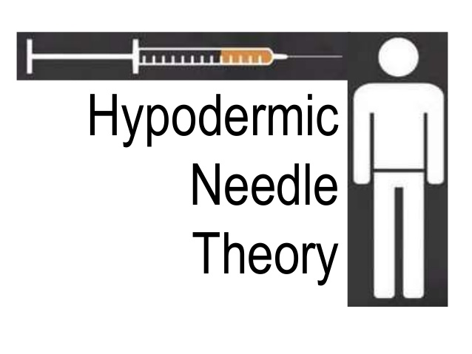

**Uses and Gratifications Theory** is an approach to understanding why and how people actively seek out specific media to satisfy specific needs. It’s an audience-based approach to understand mass communication, diverging from other media effect theories that question “what does media do to people”, and “what do people do with media”.

Media is used as a source of information which is often taken without question by the view/listener. These people are referred to as “passive”. A “passive audience” are known for not thinking for themselves and taking all information as fact, without question. The opposite of a “passive audience” is an “active audience”, which are known sceptical, since they only accept information as fact when they’ve verified it.

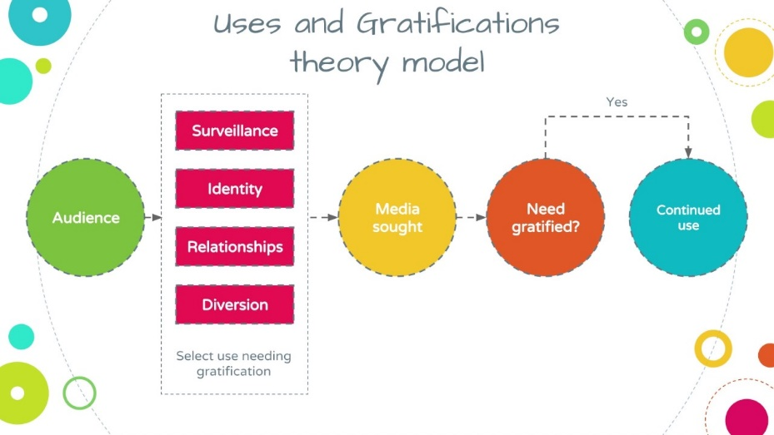

**Passive and Active Consumption:**

**Passive:** A passive audience is best defined as individuals or groups that are easily influenced by media, taking information as fact without question.

An example of an active audience member is someone who hears a statement and takes it as fact without question.

**Active:** Active audience theory suggests that audiences don’t just take information but are instead involved, sometimes unconsciously. An active audience member can take information and decide whether it’s true or not, and through that come up with conclusions. They’re sceptical and will only except information once they’ve verified it.

An example of an active audience member is someone who hears a statement, thinks about it, looks it up, and then either verifies it or debunks it.

|  |  |
| --- | --- |
| Active | Passive |
| Forming Opinions | Accepting Opinions |
| Paying Full Attention | Paying Little Attention |
| Actively Interacting with a video/stream/article/etc of a game. | Watching Game |
| Reviewing a game based on experience and opinion. | Using the medias opinions. |

**Audience Responses:**

**Participatory,** is when an audience member participates in an activity, whether it’s in a game, or on a video/live stream. When in a game participation includes playing with friends, competing on a leader board, leaving comments on videos or livestreams on a game, watching gameplay of a game and criticising/commending a game on a video, live stream, no.

The developers can take data from the audience members participating to help improve their games, Which is used to to help improve the game. Data such as time played, whether someone plays solo or not can be used to provide content updates which appeal to the most people possible. For example, if 90% of players play solo most of the time then it might not be worth making content that needs multiple people.

**Cultural Competence:** This is when cultures are integrated into a game for example to help include / represent the cultural environment in society. It’s used to interact on a personal level with as many people as possible. A good example of this is the BBC as they use as many cultures as possible to reach out to a larger audience.

**Fan Culture:** Fan culture is culture surrounding a games or films universe, created by fans. It can be found online and physically but is often both since many fan cultures are massive with millions of members. Each member of the fan culture has shared beliefs, behaviours, and/or attitudes, while often creating new ones after the story of the central ideology is extended.

Fan cultures can change an individual in significant ways whether it’s their vocabulary/accent, actions, or clothing. It also affects how they spend their money as buying outfits or cosmetic accessories is in most cases key to their fan culture.

Fan cultures offer a sense of belonging to individuals and can fill a gap of uncertainty or unfulfillment. Individuals immersed in fan culture often take the opportunity to become someone else.

**Oppositional, Preferred, Negotiated:**

**Example:** John Lewis advert: Man On the Moon.

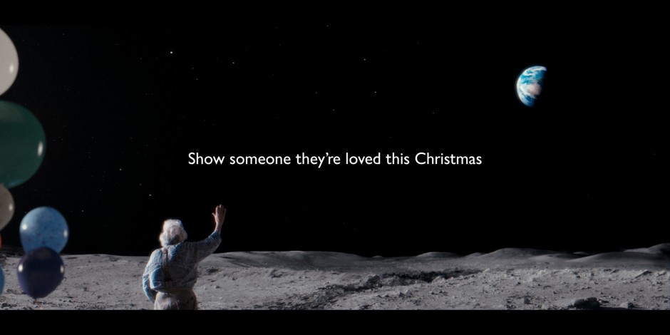

**Oppositional:** The audience might disagree entirely with the message of “Show someone their loved” and the importance of solving isolation. This is the response that the producers want to avoid the most.

The response might be along the lines of “I don’t get it”, or “I don’t like it”, and cause backlash.

**Preferred:** This is when the message is fully decoded, and the audience member completely agrees with the message. In the chosen advert the message is to help older, isolated people, and “Show someone their loved at Christmas”. This adverts goal is ultimately to make you want to buy something from John Lewis.

**Negotiated:** This is a mixture of both Preferred and Oppositional. This is when the audience member gets the message but doesn’t agree with it or want to shop at John Lewis. It could be “I get the message, but I won’t shop at John Lewis”.

**The Effects Debate:**

**Example Used:** <https://www.sciencedirect.com/science/article/pii/S221256711630065X>

**Effects of Advertising:** The study investigates the motivational and emotional factors impact of advertising on online shopping tendencies for airline tickets. It concludes that better comunicaing the advert to the audience by using the newest technologies and expertise.

**Below is the Abstract:**

“The present study was aimed at investigating the impact of advertising on online shopping tendency for airline tickets by considering motivational factors and emotional factors. Current studies show that the impact of advertising on consumers has caused them to gradually change their buying behaviours and re-think of the products they buy. Good advertising can cause consumer tendency for online purchases in the marketing process by making use of proper expertise and technologies. The population of the present study consists of all the members of the society. The research method is applied, basic and developmental in terms of objective and descriptive-survey in terms of method. The results of the analysis showed that emotional and motivational factors are effective in online purchases. Also, appropriate advertising adjusts the impact of motivational and emotional factors when shopping online. Also, the presented model has good fit and finally, several suggestions are presented based on the obtained results.”

**What I Think:** I agree with the study because it happened many times when I have / or seen someone be influenced to buy something based on an advertisement. The emotional connection the advert I usually done by imitating real world concerns within it.