**Unit 4 Assignment 1**

**Company Name:** Molten Planet Productions

**Group Size:** One (Me)

**Product Type and Info:** Video Game

|  |  |  |  |  |
| --- | --- | --- | --- | --- |
| Genre | Art Style | Characters | Gameplay/Mechanics | Setting/Theme |
| RPG | Low-poly / Cartoon Hybrid. | Aliens / Robots / Bosses. | Exo-suit movement:  Double jump, slide, dash. | The solar system has been taken over by hostile aliens. |
| FPS | Bright and Vibrant | Akktanes, Vakites, Chosen,  Zicca, Creators. | Exo attacks:  Ground-pound, left-shoulder mounted grenade launcher, powerful punch. | 5 species of enemies. |
| Sci-fi | Alien Worlds | Animals in the environment | Looting:  Weapons / Armour drop from enemies and completed objectives.  Materials can be collected from resource nodes. | Humanity is on the brink of destruction |
| Adventure | Fantasy | Hostile Plants |  | The player needs to fight back against the invaders, but also wants to find out why they’re here. |

**Below is a copy of the story summary (from story document):**

**Summary:**

Five races have arrived at earth for an unknown reason and are warring with each other and humanity. The player as a British special forces soldier is introduced to a new military programme, which is prototyping new exo-suits, which provide damage resistance, increased strength, and powerful parkour abilities. The player and the rest of the special forces are tasked with taking back Earth, then the rest of the solar system, and find out why they’re here.

As the player progresses through the campaign, new planets and moons are unlocked hiding new enemies and secrets. Finally, the player is brought to a temple hidden deep in the crust of Pluto, which holds information of The Creators. The temple is later found out to be an ancient ship, with one last Creator frozen in cryo-sleep. The player is forced to kill the last remaining Creator after it attacks the player once awakened during the final mission. The campaign ends and it’s up to the player to find out more.

**Note:** All other information such as the story, lore, context, side missions, planning and pre-production / production documentation are included within the folder, each in their own document.

**Survey Results:**

In an RPG / FPS hybrid, which genre would you like to see prioritised?

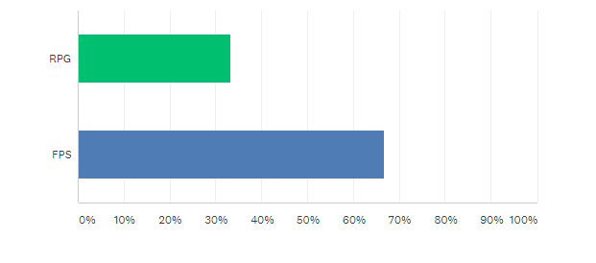

Would you prefer a longer campaign, or more side activities?

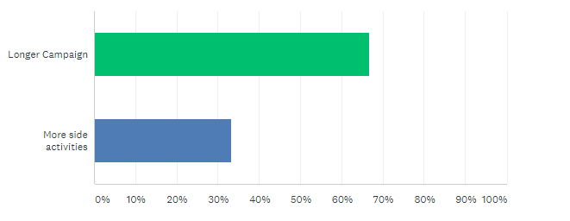

Would you prefer bosses to be more common or rarer and have unique abilities?

