**Assignment Brief – BTEC**

|  |  |  |  |  |  |
| --- | --- | --- | --- | --- | --- |
| **Programme** | | Level 3 Extended Diploma in Creative Media Production (Games Development) | | | |
| **Unit number(s) and title covered** | | Unit 73: Sound for Computer Games | | | |
| **Assignment number & title** | | Assignment One: Noise Art: The Use of Sound and Music in Games | | | |
| **Student name** | | *Lewis Hawkins* | | | |
| **Assessor** | | David Matravers | **Internal Verifier** | *James Shaun* | |
| **Date issued** | | *24.10.2018* | **Submission deadline** | *21.11.2018 at* ***4.30pm*** | |
| **Assessment Criteria** | **To achieve the criteria, the evidence must show that the student is able to:** | | | | **Assessor confirm met** |
| P1 | Describe uses of Sound and Music in Games using some subject terminology appropriately | | | | Y |
| M1 | Explain use of Sound and Music in Games with reference to detailed illustrative examples and with generally correct use of subject terminology | | | | N |
| D1 | Comprehensively Explain use of Sound and Music in Games with elucidated examples and consistently using subject terminology correctly | | | | N |

|  |  |  |  |  |  |  |  |
| --- | --- | --- | --- | --- | --- | --- | --- |
| **Assessor feedback - 1st submission** | | | | | | | |
| Lewis,  This is a good assignment and you have provided enough detail here to achieve the pass grade however there generally needs to be more detail throughout. You must explain how each topic area is used in games along with a specific game example to reiterate your point and explain how it affects the user experience. In places this assignment seems rushed or a little lazy from you; you’re better than this.  There are a couple of minor spelling/grammar errors in this document; please ensure you proof read your work before submitting.  I am recommending you for the re-work window  Overall a good submission, well done. | | | | | | | |
| **Did the learner meet the original deadline or agreed extension?** | | Yes X No ☐ | | | | | |
| **Assessor signature** | \\bwstahs1201\stausers\MATRAVERSD\Digital Sig.png | | | | **Date** | | 04.01.2019 |
| **Resubmission authorised?** | | Yes ☐ No ☐ | | | | | |
| **New agreed deadline date for submission** *\* must be within 10 days of receiving original assignment back* | |  | | | | | |
| **Lead Internal Verifier signature** |  | | | **Date** | |  | |
| **Assessor feedback - Resubmission** | | | | | | | |
|  | | | | | | | |
| **Assessor signature** (resubmission only) |  | | **Date** | | | |  |

|  |  |  |  |
| --- | --- | --- | --- |
| **Scenario** | | | |
| You have been approached by an up and coming independent Sound company “Drowned Sound” who are looking to get into making music and sound for games but they no little to nothing about this.  You have been assigned the task to produce a document comprehensively explaining what the different uses of sound and music are in the games industry with elucidated examples | | | |
| **Tasks and criteria covered** | | | |
| **Task 1 – P1, M1, D1**  Within this task you have to comprehensively explain the following topic headings with elucidated examples. Your explanations should be detailed and cover the full range of the below points, your use of examples should be used to support the points you make in order to demonstrate your understanding of Sound and Music in Games   * **Theory of Sound**: Waveform (wavelength, amplitude, frequency); pitch; Hertz (Hz); Decibel Level (dB); Sound Generator (loudspeaker) * **Psychology of Sound:** Emotion; mood; perception; loudness; timbre; film and game parallels (early cinema, contemporary cinema); sound as information, e.g. speech, iconic, symbolic, metaphoric * **Audio Environment:** Creating ambience; atmosphere; communicating what producer wants the listener to know or experience; 3D audio; surround sound; interactive adaptive audio * **Sources:** Foley artistry; sound libraries; original development; stock music assets * **Game Music:** Purpose, e.g. mood, action, suspense; intro sequence; closing sequence; credit sequence; plot advancement; interactive adaptive music * **Legal Issues:** Copyright; licences; ancillary rights; royalties; property rights; talent release contract   You should take the time to ensure you cover all the bold headings within this task to demonstrate an appropriate range of understanding. Included alongside the bold headings are examples of some of features you may want to include in your document, but you do not have to cover all included examples after the bold headings. | | | |
| **Evidence you must produce for this task** | | | |
| Fully completed portfolio with all bold headings written about. | | | |
| **Sources of information** | | | |
| **Textbooks**  Baylis P, Freedman A, Procter N et al – BTEC Level 3 National Creative Media Production, Student Book  (Pearson, 2010) ISBN 978-1846906725  Baylis P, Freedman A, Procter N et al – BTEC Level 3 National Creative Media Production, Teaching Resource  Pack (Pearson, 2010) ISBN 978-1846907371  Brandon A – Audio for Games: Planning, Process, and Production (New Riders, 2004) ISBN 978-0735714137  Case A – Sound FX: Unlocking the Creative Potential of Recording Studio Effects (Focal Press, 2007)  ISBN 978-0240520322  Marks A – The Complete Guide to Game Audio: For Composers, Musicians, Sound Designers and Game  Developers, 2nd Edition (Focal Press, 2008) ISBN 978-0240810744  McCuskey M – Game Audio Programming (Course Technology, 2003)  Millward S – Fast Guide to Cubase SX (PC Publishing, 2005) ISBN 978-1870775984  Riley R – Audio Editing with Adobe Audition (PC Publishing, 2008) ISBN 978-1906005030  Sanger G et al – The Fat Man on Game Audio: Tasty Morsels of Sonic Goodness (New Riders, 2003)  ISBN 978-1592730094  **Websites**  www.audiosparx.com – online resource for digital audio  www.filmsound.org/game-audio – game audio articles  www.gamasutra.com – respected website for all things game development  www.gamecareerguide.com/features/696/adaptive_audio_a_beginners_guide_.php?page=1 – game audio  article making sounds for video games  www.gamedev.net – a forum, with good articles on all things game development and excellent game  developer resources  www.igda.org – non-profit-making industry body, useful for research and learning support | | | |
| **Student checklist** | | | **Complete?** |
| Proofread work | | |  |
| Reference / Bibliography (if applicable) | | |  |
| All pages attached and numbered – including introduction/conclusion/front sheet | | |  |
| **Authenticity of Evidence Student declaration** | | | |
| I certify that the evidence submitted for this assignment is my own.  I have clearly referenced any sources used in the work.  I understand that false declaration of authenticity (i.e. plagiarised work) is a form of academic misconduct and the relevant College procedures will be instigated if I am found to be in contravention of these. | | | |
| **Student signature** |  | **Date of submission** | *21/11/18* |
| **Re-authentication of Evidence Student declaration (for resubmission only)** | | | |
| **Student signature** |  | **Date of resubmission** |  |

NB. Students – the assignment starts on the first page **after** these front sheets, i.e. Page 1.

* For your convenience, page numbers have been inserted into the footer. **Please keep them**.
* You may choose to add a contents table (ToC) in this section.
* Please **do** **not use text boxes** for the main body of your written answers.
* Please make sure that images/screenshots are correctly formatted, laid out and labelled. A table of Figures (ToF) may also be added if you wish.
* Make sure you use Page (or Section) Breaks whenever a new page is required. (Rather than adding large numbers of Return/Paragraph characters.) Ensure that new Section breaks continue with correct orientation and correct page numbers.
* Ensure that you have referenced your work throughout, using references in text and that you also have a reference list and full bibliography at the end of the work according to the current **Harvard Referencing** conventions. **Failure to do so will make your work more difficult to authenticate.**

**Task One:**

**Theory of Sound:**

**Wavelength:** The distance between each identical wave, from start until it repeats. The wave consists of peaks and troughs. Wavelength and frequency are both linked in such a way that means the higher the frequency the lower the wavelength. Below is an image that displays what the wavelength is.

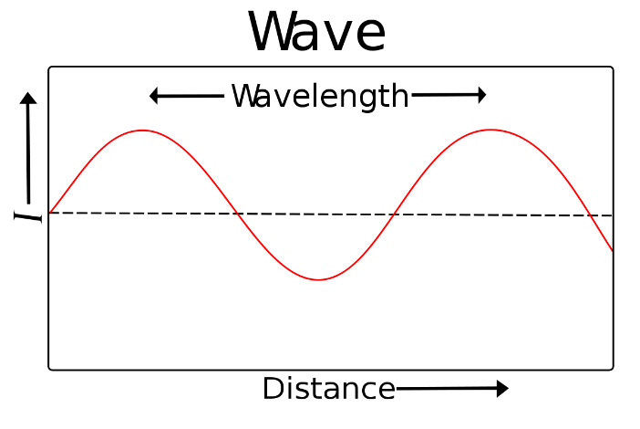

**Frequency:** The rate per second in which a wave occurs. Below is an image that displays what the frequency is. The order in lowest (top) to highest (bottom).

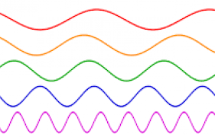

**Pitch:** Pitch is determined by the density of the waves, which is the equivalent to more or less data. This means the higher pitch the more data being sent by the wave, leading to a clearer sound. However, this should not be abused since file size can increase drastically and there will be no noticeable difference beyond a certain point. Below is an image that displays what the pitch is.

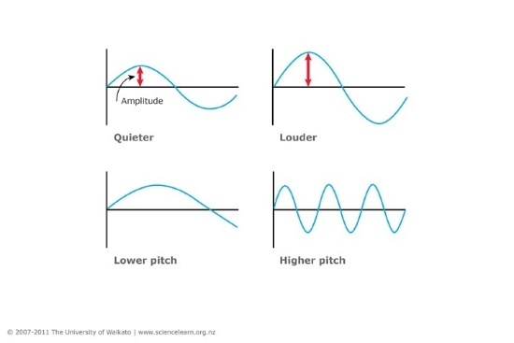

**Amplitude:** Amplitude is the volume of the wave visualised by higher wave peaks. This is caused by the extent of vibration of a particle in the air. Below is an image that displays what the amplitude is.

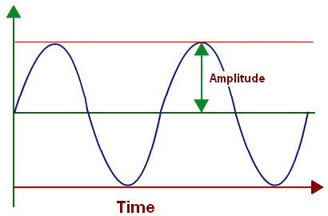

**Hertz/Decibel:** Hertz and decibel are units used to measure the intensity of the audio track (Frequency). They’re widely used in electronics, signals, communication, and of course sound.

**Psychologies:**

Psychology in sound is used in games to set the tone of the scene. In a graveyard the music would be slow, creepy and quiet, but in a city, it would be fast, loud, and exiting. But, all this depends on the context. The roles can switch depending on what the developer wants to achieve in the activity.

In Destiny 2 the music changes to a fast-paced action track when in combat against a boss. This hypes up the player for the battle and gives the illusion of speed when the players mind is focusing on the music. A lot of RPGs do this, but destiny is known for its cinematic and almost perfect sound track which makes even the dullest encounters feel epic.

The background music is only played in the background and doesn’t interfere with other audio sources like dialogue, and gun fire. It’s quiet and aims only to ramp-up action or to make a quiet action free area more immersive. This is because without any background sounds the game feels empty and slow, making minutes seem like hours. This is a large problem in free roam games since most of the time the players just walking from point A to point B, such as Red Dead Redemption 2 which often you find yourself just exploring and looking into the distance. This games sound track can make walking for 5 minutes somewhat enjoyable, and interesting.

Dialogue is used to give context and information to the player, therefore must be prioritised over other audio sources. It can also be used to point the player in the right direction through hints. This allows the developer to help the players out, while also making the player feel as if they figured it out.

In Destiny 2 the player can interact with objects around themselves which add extra context to the game world. This is used to hint to the next objective (like referencing a boss), or to add more lore to what happened.

**Audio Environment:**

**3D Audio:** Usually used in headphones or earphones, this method manipulates the sound to make it seem like it’s coming from a different angle.

**Surround Audio:** This gives a similar effect to 3D Audio but is achieved in a different way. In Surround Audio multiple speakers are placed around the player and are used to simulate real world results.

**Ambient Audio:** In the background and not something you notice unless it sounds off. It’s used to immerse the player into the game using natural audio such as birds, trees creaking, and cars. A game that uses this technique is Grand Theft Auto 5. Grand Theft Auto 5 uses ambient vehicle sounds to make the game feel alive and more realistic.

**Sources:**

**Foley Artistry:** Foley Artistry is the making of sound effects using real world objects (Hitting desk could be knocking on door). This is a useful method of making sound effects as it’s easy and cheap, however it sometimes requires areas to create the sound (as it can get messy), and multiple objects to smash just to get it right.

In games a lot of sounds are either not legal to replicate in real life (Killing someone) or would require a lot of time and money to get / record. This is where Foley comes in. Using a coconut as horse hooves, or a melon as a skull, any sound can be created easily and cheaply with everyday objects. Without this, games like Grand Theft Auto, Destiny, and Monster Hunter would not be possible.

**Sound libraries:** A sound library is a collection of digital sound recordings. The can be used to download sound effects of a website to use within a project, however some (Free Sounds) are exclusively uploaded by users. This creates a copyright risk that can be hard to avoid without completely ignoring the site.

**Original Development** is where you make the sound effects yourself. This is the best method as all effects belong to you and there’s no worry of copyright.

**Game Music:**

**Purpose**: The purpose of music in games is to both set the scene and to raise and lower tensions during missions and cutscenes. It can also be used to create cinematic moments, and keep the player immersed in quiet, action free parts of the game.

In Red Dead Redemption 2 the music changes dynamically during missions to fit the desired emotion. When participating in a robbery the music changes to a fast-paced track to symbolise time. When a character dies sad, slow music plays to invoke emotion.

**Intro Scene**: The intro scene is the first thing the player sees when opening the game. This makes this one of the most important parts of the game because it sets the expectations for the game. This means the music must be picked carefully so it fits atmosphere of the game and is memorable.

**Closing Scene:** This is the final thing the player will remember of the game, so making this good is more about keeping consistent with the game’s quality.

**Legal:**

**Property Rights:** The right for the creator of property to have legal ownership of the product.

**Licences:** This allows the owner of the product to let other people to use it without fear of copyright claims. The licence sets terms of and conditions, and doubles as proof of the agreement.

**Copyright:** The legal right of ownership of a product. This is used to protect the work of an individual or company form others wanting to steal it.

**Ancillary Rights:** A contractual agreement in which a percentage of the profits are received and derived from the sale of action figures, posters, CDs, books, T-shirts, etc. (If a song is 10% of the game its worth 10% of the profits)

**Royalties:** To use a product you must pay a percentage of the products profits. This is typically used in music.

**Talent Release Form:** A talent release form is a document that gives you permission to distribute and sell your video, game or film with the permission of your talent. The form protects you from your talent getting exploited after the product has been finished.