

**ASSIGNMENT BRIEF – BTEC**

|  |  |  |  |  |  |  |
| --- | --- | --- | --- | --- | --- | --- |
| **Course/Qualification** | | | BTEC Level 3 Extended Diploma in Creative Media Production (Games Development) | | | |
| **Unit Number(s) and Title covered** | | | Unit 75: Human-computer Interfaces for Computer Games | | | |
| **Assignment Title and Number** | | | Assignment 1: Human-computer Interfaces, Feedback and Control in Games | | | |
| **Student Name** | | |  | | | |
| **Assessor** | | Bradley Chinn | | **Internal Verifier** | David Matravers | |
| **Date issued** | | 07.11.2018 | | **Submission deadline** | 18.01.2018 at 16:30 | |
| **Assessment Criteria** | **To achieve the criteria, the evidence must show that the student is able to:** | | | | | **Assessor confirm met** |
| **P1** | Describe human-computer interfaces for games with some appropriate use of subject terminology | | | | |  |
| **M1** | Explain human-computer interfaces for games with reference to detailed illustrative examples and with generally correct use of subject terminology | | | | |  |
| **D1** | Critically evaluate human computer interfaces for games with supporting arguments and elucidated examples, and consistently using subject terminology correctly | | | | |  |
| **P2** | Summarise accurately methods of control and forms of feedback in games with some appropriate use of subject terminology | | | | |  |
| **M2** | Explain methods of control and forms of feedback in games with reference to detailed illustrative examples and with generally correct use of subject terminology | | | | |  |
| **D2** | Critically evaluate methods of control and forms of feedback in games with supporting arguments and elucidated examples, and consistently using subject terminology correctly | | | | |  |

|  |  |  |  |  |  |  |  |
| --- | --- | --- | --- | --- | --- | --- | --- |
| **Assessor feedback - 1st submission** | | | | | | | |
|  | | | | | | | |
| **Did the learner meet the original deadline or agreed extension?** | | Yes  No | | | | | |
| **Assessor signature** |  | | | | **Date** | |  |
| **Resubmission authorised?** | | Yes  No | | | | | |
| **New agreed deadline date for submission** *\* must be within 15 days of receiving original assignment back* | |  | | | | | |
| **Lead Internal Verifier signature** |  | | | **Date** | |  | |
| **Assessor feedback - Resubmission** | | | | | | | |
|  | | | | | | | |
| **Assessor signature** (resubmission only) |  | | **Date** | | | |  |

|  |
| --- |
| **Vocational Scenario/Industrial Context** |
| The local games company, “SomerGames” are currently looking to employ a junior designer which specialises in HCI.The company require you to submit a detailed article demonstrating the fundamentals of HCI. |
| **Tasks and criteria covered** |
| **Task 1** *–* ***P1,M1,D1***  Before you begin work for the company, you must demonstrate your knowledge by creating an article on HCI factors, feedback and control in games.  Your article will be based on HCI factors and you will need to critically evaluate each in detail.  Also, the article will need to cover all the **bold** headings below, in *italics* are topic areas you need to write about:  **Technology**: *screens; keyboards; joysticks; pads; touch screens; steering wheels; pointing devices; motion detectors; headsets*  **Interfaces**: *command line input; speech recognition; menu selection and the methods of selection; sense oriented (graphical, speech, touch); capabilities for intensive data manipulation; intelligent systems; avatars*  **Human factors**: *user experience, eg expert, regular, occasional, novice; user requirements, eg vision impaired, physically impaired, learning difficulties; demographics, eg age, gender*  **User interface design principles**: *structured (co-location of related elements); simple (user’s language, meaningful shortcuts); visible (avoidance of distraction); feedback (clarity, relevance); tolerance (undo, redo, inconsistent input); reusable (uniformity, reduction of user memory process)*  **Task 2** *–* ***P2,M2,D2***  Extend your article, by critically evaluating the following content on feedback and control methods used in games:  **Feedback**: *visual, eg iconic, colour psychology, inference, player viewpoint, camera techniques (foreshadowing, reveal), lighting effects; physical, eg vibration; audio, eg ambient, dialogue, Foley effects, music, mood, emotion*  **Information communication**: *information-rich game world; user needs, eg rapid data analysis for decision making (strategy, tactics); rapid input*  **User psychology**: *memory (long term, short term); reasoning; perception; cognition; metaphors*  **Control method design**: *mapping system functionality; control methods and user feedback to an interface; prototyping; measuring functionality against user satisfaction; heuristics analysis; context sensitivity; humancomputer interface (HCI) diagramming methods* |
| **Evidence you must produce for this task** |
| A detailed article evidencing task 1 and task 2. |
| **Sources of information** |

|  |  |  |  |  |
| --- | --- | --- | --- | --- |
| Textbooks  Baylis P, Freedman A, Procter N et al – BTEC Level 3 National Creative Media Production, Student Book (Pearson, 2010) ISBN 978-1846906725  Baylis P, Freedman A, Procter N et al – BTEC Level 3 National Creative Media Production, Teaching Resource Pack (Pearson, 2010) ISBN 978-1846907371  Adams E – Fundamentals of Game Design (Prentice Hall, 2006) ISBN 978-0131687479  Carroll J – Foundations of Design in HCI: A Special Issue of ‘Human-computer Interaction’ (Lawrence Erlbaum Associates Inc, 2006) ISBN 978-0805893823  Carroll J – HCI Model Theories and Frameworks (Morgan Kaufmann, 2003) ISBN 978-1558608085 Choquet D – 1000 Game Heroes (Taschen, 2002) ISBN 978-3822816332  Crawford C – Chris Crawford on Game Design (F T Prentice Hall, 2003) ISBN 978-0131460997  Dix A – Human-Computer Interaction (Prentice Hall, 2003) ISBN 978-0130461094  Koster R – Theory of Fun for Game Design (Paraglyph Press, 2004) ISBN 978-1932111972  Preece J, Rodgers Y and Sharp H – Interaction Design: Beyond Human-Computer Interaction (John Wiley & Sons Ltd, 2007) ISBN 978-0470018668  Premier Press Development – Game Interface Design (Premier Press, 2004) ISBN 978-1592005932 Rouse R – Game Design, Theory and Practice (Wordware Game Developer’s Library, Wordware Publishing Inc, 2006) ISBN 978-1556229121  **Websites**  hci-journal.com – Human-Computer Interaction, a journal of theoretical, empirical, and methodological issues related to user science and system design  www.bcs-hci.org.uk – the website of the British Human-Computer Interaction Group  www.gamasutra.com – website for all things game development, sister publication to the print magazine Game Developer, with excellent game developer resources  www.gamedev.net – a forum, with good articles on all things game development and excellent game developer resources  www.igda.org – non-profit-making industry body, useful for research and learning support | | | | |
| **Student checklist** | | | | **Complete?** |
| Proofread | | | |  |
| Reference List (if applicable) | | | |  |
| All pages attached and numbered – including introduction/conclusion/front sheet | | | |  |
| **Authenticity of Evidence Student declaration** | | | | |
| I certify that the evidence submitted for this assignment is my own.  I have clearly referenced any sources used in the work.  I understand that false declaration of authenticity (i.e. plagiarised work) is a form of academic misconduct and the relevant College procedures will be instigated if I am found to be in contravention of these. | | | | |
| **Student signature** |  | **Date of submission** |  | |
| **Re-authentication of Evidence Student declaration *(for resubmission only)*** | | | | |
| **Student signature** |  | **Date of resubmission** |  | |

**Feedback**: *visual, eg iconic, colour psychology, inference, player viewpoint, camera techniques (foreshadowing, reveal), lighting effects; physical, eg vibration; audio, eg ambient, dialogue, Foley effects, music, mood, emotion*

**Information communication**: *information-rich game world; user needs, eg rapid data analysis for decision making (strategy, tactics); rapid input*

**User psychology**: *memory (long term, short term); reasoning; perception; cognition; metaphors*

**Control method design**: *mapping system functionality; control methods and user feedback to an interface; prototyping; measuring functionality against user satisfaction; heuristics analysis; context sensitivity; humancomputer interface (HCI) diagramming methods*

**Technology**: *screens; keyboards; joysticks; pads; touch screens; steering wheels; pointing devices; motion detectors; headsets*

**Interfaces**: *command line input; speech recognition; menu selection and the methods of selection; sense oriented (graphical, speech, touch); capabilities for intensive data manipulation; intelligent systems; avatars*

**Human factors**: *user experience, eg expert, regular, occasional, novice; user requirements, eg vision impaired, physically impaired, learning difficulties; demographics, eg age, gender*

**User interface design principles**: *structured (co-location of related elements); simple (user’s language, meaningful shortcuts); visible (avoidance of distraction); feedback (clarity, relevance); tolerance (undo, redo, inconsistent input); reusable (uniformity, reduction of user memory process)*

**Task 1**

**Technology:**

**Screens:** A type of screen is a monitor, which is used to display an image that a computer has created. They’re an essential part of both building games and playing them, since without a screen it’s just noises and a few other outputs (minus visual).

Below is an image of a monitor.

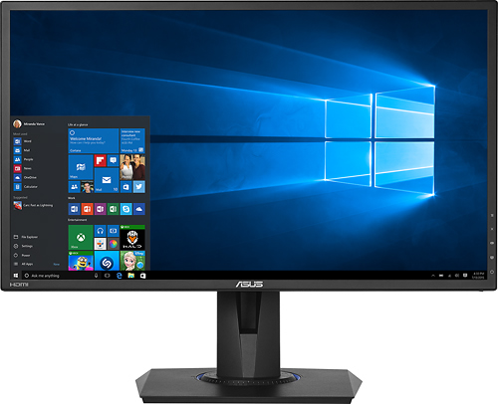

**Keyboards:** A Keyboard is used for typing and is built-in on phones and laptops, but on desktops they’re usually external and are sold separately. A keyboard is used all the time on laptops and desktops, but often doesn’t see as much use in mobile devices. This is usually down to mobile platforms using touch screen, rendering a keyboard and mouse useless, however when using a search engine like Google, or playing a text adventure game, a keyboard is required.

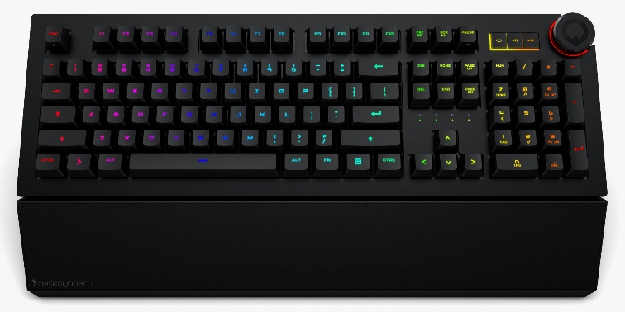

**Joysticks:** A joystick or analog is used for getting data on all axes and is usually used for moving a player or camera in a video game. Most people prefer mouse and keyboard; however, the limitations of this combo are resolved by Joysticks. For example, when using WASD you are limited to moving in 45° intervals (0°, 45°, 90°, 135°, 180°, -135°, -90°, -45°), however when using a joystick, it’s a full 360° including decimal places.

A type of game where joysticks are the better option would be racing. Typically, games that use precision like FPSs are the favourite of mouse and keyboard.

**Pads:**

**Interfaces:**

**Human Factors:**

**User Interface Design Principles:**

**Task 2**

**Feedback:**

**Visual:** Visual feedback is the most common and broad method of feeding back to the player. The most common use of visual feedback is completion of a mission (Mission complete text, cutscene, etc). another one that is often used is killing an enemy, where the screen might flash (Red Dead Redemption 2).

Often, lights are used to draw the players attention towards the mission objective. This is done to decrease player frustration, without making them feel as is the game is doing it for them.

Below is Borderlands. Borderlands is a good example because visual feedback is presented to the player in many ways. One is the damage numbers, which don’t only let the player know when an enemy is hit, but for how much damage. Another is “[R] RELOAD”, which lets the player know when their guns are low on ammo.

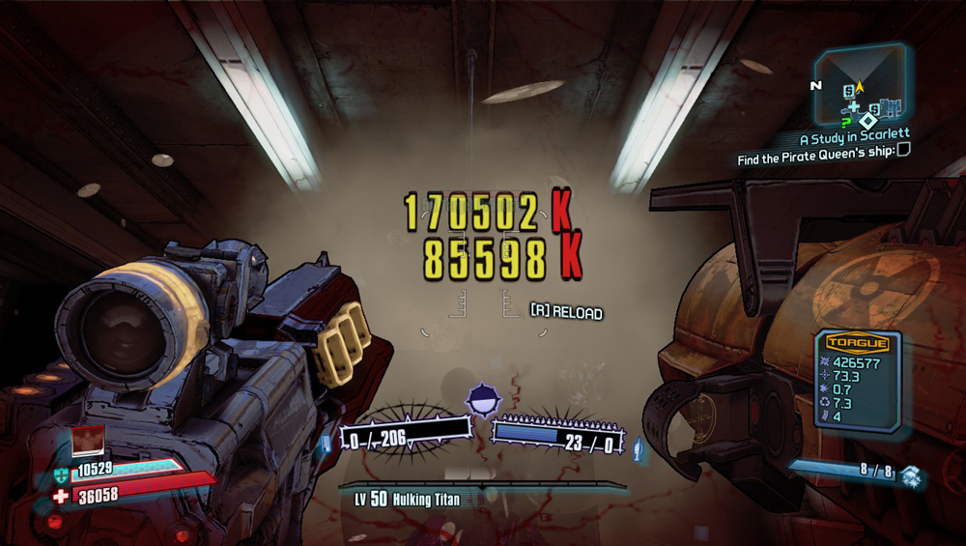

**Physical:** Physical feedback is seen most commonly in gamepads (controllers). Gamepads are often fitted with motors for vibrations, which trigger during explosions, gunshots, and sometimes heartbeats in horror games. These features are not very common in PC gaming but in Console and Arcade it’s an essential part which is almost always used in some way.

Physical feedback is often used alongside visual and audio to further enhance the

**Audio:**