

**ASSIGNMENT BRIEF – BTEC**

|  |  |  |  |  |  |  |
| --- | --- | --- | --- | --- | --- | --- |
| **Course/Qualification** | | | BTEC Level 3 Extended Diploma in Creative Media Production (Games Development) | | | |
| **Unit Number(s) and Title covered** | | | Unit 75: Human-computer Interfaces for Computer Games | | | |
| **Assignment Title and Number** | | | Assignment 1: Human-computer Interfaces, Feedback and Control in Games | | | |
| **Student Name** | | |  | | | |
| **Assessor** | | Bradley Chinn | | **Internal Verifier** | David Matravers | |
| **Date issued** | | 07.11.2018 | | **Submission deadline** | 18.01.2018 at 16:30 | |
| **Assessment Criteria** | **To achieve the criteria, the evidence must show that the student is able to:** | | | | | **Assessor confirm met** |
| **P1** | Describe human-computer interfaces for games with some appropriate use of subject terminology | | | | | Y |
| **M1** | Explain human-computer interfaces for games with reference to detailed illustrative examples and with generally correct use of subject terminology | | | | | Y |
| **D1** | Critically evaluate human computer interfaces for games with supporting arguments and elucidated examples, and consistently using subject terminology correctly | | | | | N |
| **P2** | Summarise accurately methods of control and forms of feedback in games with some appropriate use of subject terminology | | | | | Y |
| **M2** | Explain methods of control and forms of feedback in games with reference to detailed illustrative examples and with generally correct use of subject terminology | | | | | Y |
| **D2** | Critically evaluate methods of control and forms of feedback in games with supporting arguments and elucidated examples, and consistently using subject terminology correctly | | | | | N |

|  |  |  |  |  |  |  |  |
| --- | --- | --- | --- | --- | --- | --- | --- |
| **Assessor feedback - 1st submission** | | | | | | | |
| Well done Lewis, you have managed to achieve the merit criteria for this assignment by ensuring that you have explained the interfaces, control and forms of feedback for a HCI solution.  You will need to just check throughout both tasks for elucidated examples and supporting arguments which can be completed in the rework.  Overall, Lewis you have achieved the merit criteria for this assignment and require the rework for the higher grades (Subject to the Lead IV’s Decision). | | | | | | | |
| **Did the learner meet the original deadline or agreed extension?** | | Yes | | | | | |
| **Assessor signature** |  | | | | **Date** | | 05/03/2019 |
| **Resubmission authorised?** | | Yes | | | | | |
| **New agreed deadline date for submission** *\* must be within 15 days of receiving original assignment back* | | **05/04/2019** | | | | | |
| **Lead Internal Verifier signature** |  | | | **Date** | | **07/03/2019** | |
| **Assessor feedback - Resubmission** | | | | | | | |
|  | | | | | | | |
| **Assessor signature** (resubmission only) |  | | **Date** | | | |  |

|  |
| --- |
| **Vocational Scenario/Industrial Context** |
| The local games company, “SomerGames” are currently looking to employ a junior designer which specialises in HCI.The company require you to submit a detailed article demonstrating the fundamentals of HCI. |
| **Tasks and criteria covered** |
| **Task 1** *–* ***P1,M1,D1***  Before you begin work for the company, you must demonstrate your knowledge by creating an article on HCI factors, feedback and control in games.  Your article will be based on HCI factors and you will need to critically evaluate each in detail.  Also, the article will need to cover all the **bold** headings below, in *italics* are topic areas you need to write about:  **Technology**: *screens; keyboards; joysticks; pads; touch screens; steering wheels; pointing devices; motion detectors; headsets*  **Interfaces**: *command line input; speech recognition; menu selection and the methods of selection; sense oriented (graphical, speech, touch); capabilities for intensive data manipulation; intelligent systems; avatars*  **Human factors**: *user experience, eg expert, regular, occasional, novice; user requirements, eg vision impaired, physically impaired, learning difficulties; demographics, eg age, gender*  **User interface design principles**: *structured (co-location of related elements); simple (user’s language, meaningful shortcuts); visible (avoidance of distraction); feedback (clarity, relevance); tolerance (undo, redo, inconsistent input); reusable (uniformity, reduction of user memory process)*  **Task 2** *–* ***P2,M2,D2***  Extend your article, by critically evaluating the following content on feedback and control methods used in games:  **Feedback**: *visual, eg iconic, colour psychology, inference, player viewpoint, camera techniques (foreshadowing, reveal), lighting effects; physical, eg vibration; audio, eg ambient, dialogue, Foley effects, music, mood, emotion*  **Information communication**: *information-rich game world; user needs, eg rapid data analysis for decision making (strategy, tactics); rapid input*  **User psychology**: *memory (long term, short term); reasoning; perception; cognition; metaphors*  **Control method design**: *mapping system functionality; control methods and user feedback to an interface; prototyping; measuring functionality against user satisfaction; heuristics analysis; context sensitivity; humancomputer interface (HCI) diagramming methods* |
| **Evidence you must produce for this task** |
| A detailed article evidencing task 1 and task 2. |
| **Sources of information** |

|  |  |  |  |  |
| --- | --- | --- | --- | --- |
| Textbooks  Baylis P, Freedman A, Procter N et al – BTEC Level 3 National Creative Media Production, Student Book (Pearson, 2010) ISBN 978-1846906725  Baylis P, Freedman A, Procter N et al – BTEC Level 3 National Creative Media Production, Teaching Resource Pack (Pearson, 2010) ISBN 978-1846907371  Adams E – Fundamentals of Game Design (Prentice Hall, 2006) ISBN 978-0131687479  Carroll J – Foundations of Design in HCI: A Special Issue of ‘Human-computer Interaction’ (Lawrence Erlbaum Associates Inc, 2006) ISBN 978-0805893823  Carroll J – HCI Model Theories and Frameworks (Morgan Kaufmann, 2003) ISBN 978-1558608085 Choquet D – 1000 Game Heroes (Taschen, 2002) ISBN 978-3822816332  Crawford C – Chris Crawford on Game Design (F T Prentice Hall, 2003) ISBN 978-0131460997  Dix A – Human-Computer Interaction (Prentice Hall, 2003) ISBN 978-0130461094  Koster R – Theory of Fun for Game Design (Paraglyph Press, 2004) ISBN 978-1932111972  Preece J, Rodgers Y and Sharp H – Interaction Design: Beyond Human-Computer Interaction (John Wiley & Sons Ltd, 2007) ISBN 978-0470018668  Premier Press Development – Game Interface Design (Premier Press, 2004) ISBN 978-1592005932 Rouse R – Game Design, Theory and Practice (Wordware Game Developer’s Library, Wordware Publishing Inc, 2006) ISBN 978-1556229121  **Websites**  hci-journal.com – Human-Computer Interaction, a journal of theoretical, empirical, and methodological issues related to user science and system design  www.bcs-hci.org.uk – the website of the British Human-Computer Interaction Group  www.gamasutra.com – website for all things game development, sister publication to the print magazine Game Developer, with excellent game developer resources  www.gamedev.net – a forum, with good articles on all things game development and excellent game developer resources  www.igda.org – non-profit-making industry body, useful for research and learning support | | | | |
| **Student checklist** | | | | **Complete?** |
| Proofread | | | |  |
| Reference List (if applicable) | | | |  |
| All pages attached and numbered – including introduction/conclusion/front sheet | | | |  |
| **Authenticity of Evidence Student declaration** | | | | |
| I certify that the evidence submitted for this assignment is my own.  I have clearly referenced any sources used in the work.  I understand that false declaration of authenticity (i.e. plagiarised work) is a form of academic misconduct and the relevant College procedures will be instigated if I am found to be in contravention of these. | | | | |
| **Student signature** |  | **Date of submission** |  | |
| **Re-authentication of Evidence Student declaration *(for resubmission only)*** | | | | |
| **Student signature** |  | **Date of resubmission** |  | |

**Task 1**

**Technology:**

**Screens:** A type of screen is a monitor, which is used to display an image that a computer has created. They’re an essential part of both building games and playing them, since without a screen it’s just noises and a few other outputs (minus visual).

Below is an image of a monitor.

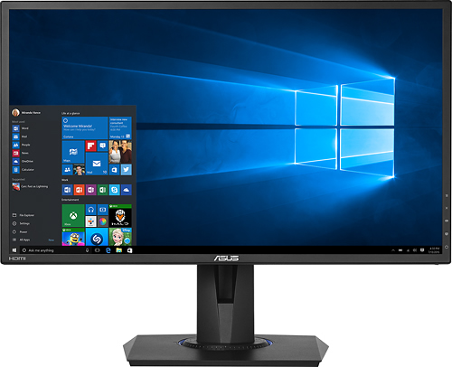

**Keyboards:** A Keyboard is used for typing and is built-in on phones and laptops, but on desktops they’re usually external and are sold separately. A keyboard is used all the time on laptops and desktops, but often doesn’t see as much use in mobile devices. This is usually down to mobile platforms using touch screen, rendering a keyboard and mouse useless, however when using a search engine like Google, or playing a text adventure game, a keyboard is required.

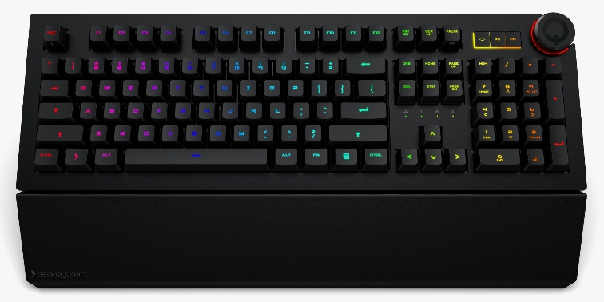

**Joysticks:** A joystick or analog is used for getting data on all axes and is usually used for moving a player or camera in a video game. Most people prefer mouse and keyboard; however, the limitations of this combo are resolved by Joysticks. For example, when using WASD you are limited to moving in 45° intervals (0°, 45°, 90°, 135°, 180°, -135°, -90°, -45°), however when using a joystick, it’s a full 360° including decimal places.

A type of game where joysticks are the better option would be racing. Typically, games that use precision like FPSs favour mouse and keyboard, due to their ease of use and easier speed manipulation. Joysticks are used on most controllers including the PS4 and Xbox One, but they can be used on PC if the game supports that or external software is used.

**Touch Screens:** A touchscreen is used mostly by mobile devices since they lack typical input devices (Keyboard, Mouse). The touch screen is used for games and built in keyboards, making mobile platforms usable without needing external input devices.

Typically, games use touchscreen buttons, which help with the lack of actual buttons on the device. This also allows for other types of inputs to be registered like pressure, which can be used for drawing in image manipulation programs.

**Interfaces:**

**Speech Recognition:** Speech recognition is used in few games but is very often used in the platforms they run on. Both PlayStation 4 and Xbox One utilize this feature, which is integrated into the core foundations of the system. This means it can be used to access most features such as opening applications, taking screenshots / video clips, and turning of the system.

**Avatars:** An avatar is a personalized character that represents the user. They’re often used to give a human touch to the system, which in turn makes the user generate a stronger attachment to the system. Xbox One uses a 3D avatar system, featuring character creator with clothes, facial features and accessories. In the gaming industry avatars are usually used to identify accounts, some even allowing for the upload of personalised images.

**Sense Orientated:**

Graphical: The graphical side of user interfaces boils down to menu screens and HUDs, otherwise known as the GUI. There’re other types, but these are the best examples as they’re used nearly all the time and when they’re it’s part of the core of the game.

Menu screens are used to navigate around the settings, options, inventory, and objective, tabs if they exist. They’re the foundation for navigating, whether it be starting the game, or changing the graphical settings.

HUD or Heads up Display is used to relay information to the player, regarding game play. One good example of a HUD component is the “ammo counter”. This is the text in TPSs and FPSs, that tells the player how much ammo their equipped gun has. In games like Call of Duty Black ops 4 and Grand Theft Auto 5, the ammo counter is a core component of the game. However, in tactical games like Escape from Tarkov the ammo counter is removed, because realistic features like having to remove the magazine to check ammo fit the game better.

Touch: The most common form of Touch in user interfaces is touch screen. This is primarily used on mobile devices, since carrying around a keyboard and mouse isn’t ideal for a phone. Apples iPhone 7 uses touch screen for everything except for returning to the home screen, volume and power, however there’re optional touch screen buttons for those.

Touchscreen can make up for the lack of buttons on a device, by only having the buttons needed open. This is something that you can’t do with physical keyboards.

Speech: Speech recognition is the most common form of speech user interfaces. It’s used my nearly every large tech company nowadays, with Cortana, Alexa and Siri. They’re used to make a person’s life easier, by introducing simplistic commands the owner can use. Alexa for example, can buy stuff of Amazon in a few words.

**Human Factors:**

**User Experience:** The user experience is defined by how the user feels about the game and its value. If the user is stuck with unorganised and messy GUI then no matter how good the game is they’ll struggle to play and not enjoy their time. The goal of game developers is to create a good user experience, which can be challenging since everyone is different. This is where the target market comes into the equation.

One huge factor is difficulty, which is solved by the developer through making an average, and then creating an easier / harder option. This is the difficulty level, which Call of Duty campaigns have.

**User Requirements:** If a user is unable to see then typical games like Call of Duty, would be nearly impossible to play. However, there’re games that have been made to be played by people with disabilities. One type of game that could be played by a blind person is a text-based adventure with a voice reading the text, then using speech, text would be inputted into the computer.

**Demographics:** This is what the games developer uses to decide their target market. Facts such as “more men play open world games, than women” and “a 3-year-old is more likely to play a 2D game like Angry Birds than Call of Duty”, allow the developer to create a game more interesting to the target market they choose. New controllers have been created for people with no hands, which are already being used.

**User Interface Design Principles:**

**Structured:** This is how the GUI is laid out on the screen. If a button is hard to find then it can put the player off the game, though stress. The user interface is designed to be easy to navigate, failure to complete this could result in the game becoming frustrating to play.

A game with a good user interface is World War 3. This game has minimal buttons and features, allowing for the user to understand only what they need to.

**Simple:** The user interface needs to be simple, because the player needs to be able to navigate it quickly and easily first-time round. If the player struggles to navigate the game can become frustrating.

**Reusable:** Using more advanced code to make all UI out of one system, can make the development easier, while also allowing the user to apply old information to a new system.

**Task 2**

**Feedback:**

**Visual:** Visual feedback is the most common and broad method of feeding back to the player. The most common use of visual feedback is completion of a mission (Mission complete text, cutscene, etc). another one that is often used is killing an enemy, where the screen might flash (Red Dead Redemption 2).

Often, lights are used to draw the players attention towards the mission objective. This is done to decrease player frustration, without making them feel as is the game is doing it for them.

Below is Borderlands. Borderlands is a good example because visual feedback is presented to the player in many ways. One is the damage numbers, which don’t only let the player know when an enemy is hit, but for how much damage. Another is “[R] RELOAD”, which lets the player know when their guns are low on ammo.

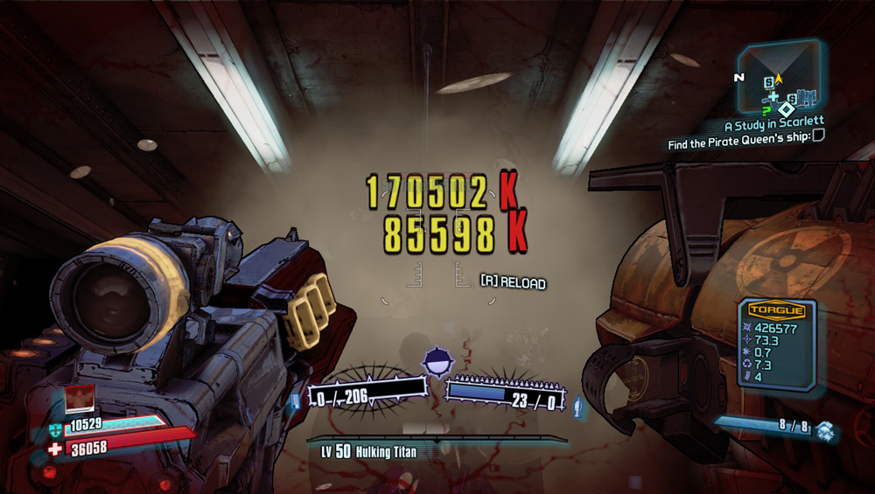

**Physical:** Physical feedback is seen most commonly in gamepads (controllers). Gamepads are often fitted with motors for vibrations, which trigger during explosions, gunshots, and sometimes heartbeats in horror games. These features are not very common in PC gaming but in Console and Arcade it’s an essential part which is almost always used in some way.

Grand Theft Auto V uses physical feedback in the form of vibrations to let the player know when an explosion has gone off.

Physical feedback is often used alongside visual and audio to further enhance the likelihood that the user notices a completed objective for example.

**Audio:** One a mission is completed an in-game character is likely to tell you “objective completed”, or “next objective”, depending on the circumstances. In Call of Duty: Modern Warfare 4, the player is given orders, which are usually objectives.

Music is often used to let the player know when they’re in a combat situation. In Ark: Survival Evolved, music plays when an enemy is trying to, or currently attacking you.

**Information Communication:**

**Information-rich Game World:** An information-rich game world is defined by the extent of information around the player and how its displayed. Within missions the game world is often used to hint at where to go, like in destiny which uses lights when in dark caves.

The game world can also be used to relay information to the player, about lore and current events. Destiny is also a good example for this, because in its 3rd expansion The Taken King; the player can interact with objects around the world, which revealed information about what was happening.

**User Needs:** User needs is the requirements that adds value to the product. In a games console, the user expects to be able to buy games, play them, update them and play with friends. In a game, the user expects that what they see in trailers is the game they got, but they also expect the basics to be there as well. For example, in an RPG, the player expects to have looting, and progression.

Anthem is an example of what happens when the users’ needs are not met. The game launched with almost none of the content promised or basic requirements, which led to the game losing almost all players in a matter of weeks.

**User Psychology:**

**Memory:** In games, a user’s memory can be used to add further depth to a story. In Borderlands 2, the main antagonist; Handsome Jack is constantly reminding you he’s there throughout the campaign. This allows the player to be introduced and intimidated by the antagonist.

**Reasoning:** This is when the player makes educated decisions as to what to do. The game gives small amounts of information, in a way that lets the player guess at what to do, but it’s not enough to make the player feel as if they’re being given the info. The player decides based on what they think and the information they have been given.

In Destiny 2 the raids are a good example of this. The raid itself doesn’t contain any information on how to beat it, but previous, easier encounters often use similar tactics, which serve as an introduction.

**Perception:** This is how the player perceives the game. The developers can manipulate the players decisions, through making the player think about different things. This is used in Red Dead Redemtion 2 where Dutch is seen as an almost father figure to Arthur, but signs of his sanity falling apart begin to remove the previous expectations of him. At the end of the campaign, after betraying his most loyal followers, he saves your life by killing his last remaining gang member. This again reverts the expectations.

**Control Method Design:**

**Prototyping:** Prototyping is the best way to see if something works. A prototype is a basic design, with all the fundamentals integrated. It’s used to test how well an idea works without having to guess.

**Measuring functionality****Over User Satisfaction:** This is the decision that designers must make when deciding as to whether a feature is worth adding. A good example of this is Destiny 2, because Bunge must determine if a weapon is too powerful or not, before adding it.

**Heuristics Analysis:** This is when a feature is evaluated to discover usability problems. Game developers will constantly be creating prototypes, and testing new features, which will be evaluated and removed if need be.