



**Assignment Brief – BTEC**

|  |  |  |  |  |  |
| --- | --- | --- | --- | --- | --- |
| **Programme** | | Level 3 Extended Diploma in Creative Media Production (Games Development) | | | |
| **Unit number(s) and title covered** | | Unit 6: Critical Approaches | | | |
| **Assignment number & title** | | Assignment One: Understanding Audiences and Products | | | |
| **Student name** | |  | | | |
| **Assessor** | | David Matravers | **Internal Verifier** | *James Shaun* | |
| **Date issued** | | *01.10.2018* | **Submission deadline** | *19.10.2018 at* ***4.30pm*** | |
| **Assessment Criteria** | **To achieve the criteria, the evidence must show that the student is able to:** | | | | **Assessor confirm met** |
| P1 | Describe how media producers define audiences with some appropriate use of subject terminology | | | |  |
| P2 | Describe how media producers create products for the specific audiences with some appropriate use of subject terminology | | | |  |
| M1 | Explain how media producers define audiences with reference to detailed illustrative examples and with generally correct use of subject terminology | | | |  |
| M2 | Explain how media producers create products for the specific audiences with reference to detailed illustrative examples and with generally correct subject terminology | | | |  |
| D1 | Comprehensively explain how media producers define audiences with elucidated examples and consistently using subject terminology correctly | | | |  |
| D2 | Comprehensively explain how media producers create products for audiences with elucidated examples and consistently using subject terminology correctly | | | |  |

|  |  |  |  |  |  |  |  |  |  |
| --- | --- | --- | --- | --- | --- | --- | --- | --- | --- |
| **Assessor feedback - 1st submission** | | | | | | | | | |
| *Task No* | *Targeted Criteria* | *Met* | *Comment* | | | | | | |
|  |  |  |  | | | | | | |
|  |  |  |  | | | | | | |
|  |  |  |  | | | | | | |
| **Did the learner meet the original deadline or agreed extension?** | | | | Yes ☐ No ☐ | | | | | |
| **Assessor signature** | | |  | | | | **Date** | |  |
| **Resubmission authorised?** | | | | Yes ☐ No ☐ | | | | | |
| **New agreed deadline date for submission** *\* must be within 10 days of receiving original assignment back* | | | |  | | | | | |
| **Lead Internal Verifier signature** | | |  | | | **Date** | |  | |
| **Assessor feedback - Resubmission** | | | | | | | | | |
|  | | | | | | | | | |
| **Assessor signature** (resubmission only) | | |  | | **Date** | | | |  |

|  |  |  |  |
| --- | --- | --- | --- |
| **Scenario** | | | |
| Despite the move to digital platforms and a significant drop in physical sales, games journalism is still a significant sector in media and a source for many in the decision-making process for selecting new purchases.  There are a number of current issues in games journalism, from gender roles, discussions on rating systems and whether publishers should be allowed to block negative reviews, but fundamentally games journalism provides a service to the average consumer which remains a powerful platform.  You have gained an internship at FNGRGUNS (Finger Guns), an entertainment journalism site set in the South West. You have been requested to write a series of pieces on their “Publishers Insider” column to give consumers a clear picture or the critical approaches used by media producers to target their audiences and make effective products. | | | |
| **Tasks and criteria covered** | | | |
| **Task 1**  For this task you must comprehensively explain how media producers define audiences, including the processes and methods used to identify and categorise these audience. Your explanations should include the techniques of audience research used and what specifically the categories of audience demographics are.  You should formulate your explanation in a detailed report which covers:   * Quantitative methods used by media producers such as questionnaires, Views/Platform hits and collected by agencies such as BARB and RAJAR. * Qualitative methods used by media producers such as Interviews, focus groups, surveys   In terms of the definitions of audiences and their products, the following bulleted list should be covered, and your explanations should be sufficiently detailed to include an explanation of the purpose of each audience demographic. There should be some consideration on what the systems are used for and to what purpose, i.e. Psychographics/ABC to inform on newspaper selections and how audience profiles are constructed.   * Audience profiles for specific products *i.e. define the product and explain the audience //* * Socioeconomic Status // * Age // * Psychographics * Gender * ABC // * Geodemographic * Mainstream/Alternative   // = Must do.  [Task Covers P1, M1, D1]  **Task 2:**  In this task you must examine the following products, **Shadow of The Tomb Raider** and **Animal Crossing: Pocket Camp**.  These products have been specifically designed for specific audiences, and their producers have used a range of codes and techniques to effectively target these audiences.  You must explain how these two products are constructed to be appealing to the specific target audiences. You should ensure your explanations are detailed and links to specific content of the selected products. You are recommended to use images and examples from the products to support the points that you make, and ensure you fully explain how the audience is targeted.  You explanations of both products should include:   * Full Descriptions of the audience for each product including audience demographics * Language * Colour * Technical and Symbolic Codes * How the product appeals to specific psychographics and ABC demographics * Fonts * Content   [Task Covers P2, M2, D2] | | | |
| **Evidence you must produce for this task** | | | |
| Fully completed portfolio with all bold headings written about. | | | |
| **Sources of information** | | | |
| **Textbooks**  Baylis P, Freedman A, Procter N et al – BTEC Level 3 National Creative Media Production, Student Book  (Pearson, 2010) ISBN 978-1846906725  Baylis P, Freedman A, Procter N et al – BTEC Level 3 National Creative Media Production, Teaching Resource  Pack (Pearson, 2010) ISBN 978-1846907371  Baylis P, Holmes P, Starkey G – BTEC National in Media Production (Heinemann Educational, 2007)  ISBN 978-0435499198  Abercrombie N, Longhurst B – The Penguin Dictionary of Media Studies (Penguin, 2007)  ISBN 978-0141014272  Branston G, Stafford R – The Media Students Book (Routledge, 2006), ISBN 978-0415371438  Briggs A, Cobley P – The Media: An Introduction (Longman, 2002) ISBN 978-0582423466  Clark V, Jones P, Malyszko B, Wharton D – Complete A-Z Media and Film Studies Handbook (Hodder Arnold,  2007) ISBN 978-0340872659  Gillespie M, Toynbee J– Analysing Media Texts Issues in Cultural/Media Studies (Open University Press, 2006)  ISBN 978-0335218868  McDonald K – Film and Television Textual Analysis (Auteur, 2005) ISBN 978-1903663547  O’Sullivan T Dutton B, Rayner P – Studying the Media: An Introduction (Hodder Arnold, 2003)  ISBN 978-0340807651  Taylor L, Andrew W – Media Studies: Texts, Institutions and Audiences (Wiley Blackwell, 1999)  ISBN 978-0631200277  **Websites**  www.asa.org.uk – the Advertising Standards Authority  www.barb.co.uk – Broadcasters Audience Research Board  www.bbfc.co.uk – the British Board of Film Classification  www.englishandmedia.co.uk/mediamag.html – the English and Media Centre  www.imdb.com – a movie database  www.mediaknowall.com – a web guide for media students  www.mediawatchuk.org – campaign for accountability and decency in the media  www.ofcom.org.uk – the regulator of the UK’s broadcasting, telecommunications and wireless  communications industries  www.rajar.co.uk – official body in charge of measuring radio audiences in the UK  www.vlv.org.uk – the Voice of the Listener and Viewer | | | |
| **Student checklist** | | | **Complete?** |
| Proofread work | | |  |
| Reference / Bibliography (if applicable) | | |  |
| All pages attached and numbered – including introduction/conclusion/front sheet | | |  |
| **Authenticity of Evidence Student declaration** | | | |
| I certify that the evidence submitted for this assignment is my own.  I have clearly referenced any sources used in the work.  I understand that false declaration of authenticity (i.e. plagiarised work) is a form of academic misconduct and the relevant College procedures will be instigated if I am found to be in contravention of these. | | | |
| **Student signature** |  | **Date of submission** | 01/10/18 |
| **Re-authentication of Evidence Student declaration (for resubmission only)** | | | |
| **Student signature** |  | **Date of resubmission** |  |

NB. Students – the assignment starts on the first page **after** these front sheets, i.e. Page 1.

* For your convenience, page numbers have been inserted into the footer. **Please keep them**.
* You may choose to add a contents table (ToC) in this section.
* Please **do** **not use text boxes** for the main body of your written answers.
* Please make sure that images/screenshots are correctly formatted, laid out and labelled. A table of Figures (ToF) may also be added if you wish.
* Make sure you use Page (or Section) Breaks whenever a new page is required. (Rather than adding large numbers of Return/Paragraph characters.) Ensure that new Section breaks continue with correct orientation and correct page numbers.
* Ensure that you have referenced your work throughout, using references in text and that you also have a reference list and full bibliography at the end of the work according to the current **Harvard Referencing** conventions. **Failure to do so will make your work more difficult to authenticate.**
* Quantitative methods used by media producers such as questionnaires, Views/Platform hits and collected by agencies such as BARB and RAJAR.
* Qualitative methods used by media producers such as Interviews, focus groups, surveys

**Task One:**

Qualitive and Quantitative in general.

BARB (Broadcasters Audience Research Board) is the organisation that compiles audience measurement and television ratings in the UK. It was founded in 1981 to replace two previous systems.

They’re Responsible for collecting data such as who is watching, what are they watching, when are the watching, the screen they’re watching on, and how did it get on the screen.

They gather device-based data information, by working with the broadcasters to embed software code into their services. This allows the system to generate data detailing (who is watching, what are they watching, when are the watching, the screen they’re watching on, and how did it get on the screen).

With the data they collect they create charts detailing the percentages. 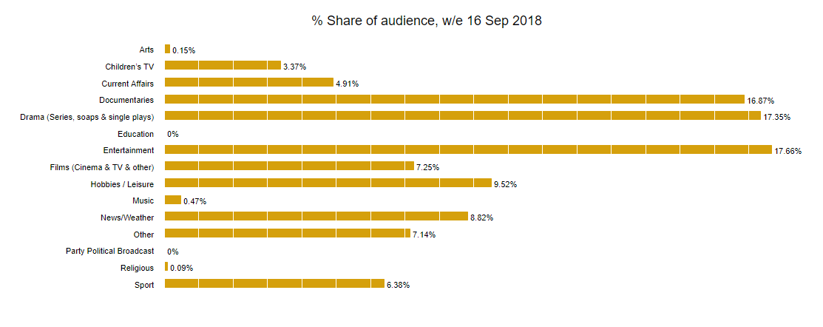

**RAJAR (Radio Joint Audience Research)** is the official body in charge of measuring radio audiences in the UK. It is jointly owned by the BBC and the Radiocentre on behalf of the commercial sector.

They collect information such as how many are listening, how long are they listening, what are they listening on, and where they’re listening. Below is one of RAJARs graphs, which displays how many people are listening to the radio.

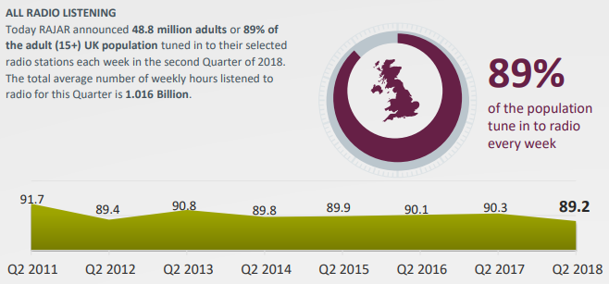

My target game for the audience profile is Destiny 2. Below is the audience profile I created.

|  |  |  |  |
| --- | --- | --- | --- |
|  | **What?** | **Why?** | **How?** |
| **Gender** | Male | The direction the game is being taken in is more appealing to males. | It uses things that are biologically masculine (Exploration, Leadership). |
| **Age** | 16 | The game needed to require extended play-time, during multiple days a week, while also having large amounts of violence. | The game features large amounts of violence but puts the player in a position where they’re only fighting aliens. The absence of blood and gore are also key features. |
| **Occupation** | Un-employed or part-time | The game needs a lot of time to be invested into repeating missions, to progress forward. | The power of the player is determined through the level of the weapons and armour, which are acquired through completing missions. |
| **Geodemographics** | UK, North America, Australia (English speaking countries). | The English language is standard for games made by Bungie/Activision. | The characters are all English speaking, although subtitles can be enabled for most languages. |

**Socioeconomic status** is a combination of both a persons economics and sociological status. It can be work experience, occupation, financial position, and education.

**Age** is the statistic