**Assignment Brief – BTEC**

|  |  |  |  |  |  |
| --- | --- | --- | --- | --- | --- |
| **Programme** | | Level 3 Extended Diploma in Creative Media Production (Games Development) | | | |
| **Unit number(s) and title covered** | | Unit 71: Object-Oriented Design for Computer Games | | | |
| **Assignment number & title** | | Assignment One: The Purpose of OO Design | | | |
| **Student name** | |  | | | |
| **Assessor** | | James Shaun | **Internal Verifier** | *David Matravers* | |
| **Date issued** | | *11.10.2018* | **Submission deadline** | *08.11.2018 at* ***4.30pm*** | |
| **Assessment Criteria** | **To achieve the criteria, the evidence must show that the student is able to:** | | | | **Assessor confirm met** |
| P1 | Describe the purpose of object-oriented design for games with some appropriate use of subject terminology | | | |  |
| M1 | Explain the purpose of object-oriented design for games with reference to detailed illustrative examples and with generally correct use of subject terminology | | | |  |
| D1 | Comprehensively explain the purpose of object- oriented design for games with elucidated examples and consistently using subject terminology correctly | | | |  |

|  |  |  |  |  |  |  |  |  |  |
| --- | --- | --- | --- | --- | --- | --- | --- | --- | --- |
| **Assessor feedback - 1st submission** | | | | | | | | | |
| *Task No* | *Targeted Criteria* | *Met* | *Comment* | | | | | | |
|  |  |  |  | | | | | | |
|  |  |  |  | | | | | | |
|  |  |  |  | | | | | | |
| **Did the learner meet the original deadline or agreed extension?** | | | | Yes ☐ No ☐ | | | | | |
| **Assessor signature** | | |  | | | | **Date** | |  |
| **Resubmission authorised?** | | | | Yes ☐ No ☐ | | | | | |
| **New agreed deadline date for submission** *\* must be within 10 days of receiving original assignment back* | | | |  | | | | | |
| **Lead Internal Verifier signature** | | |  | | | **Date** | |  | |
| **Assessor feedback - Resubmission** | | | | | | | | | |
|  | | | | | | | | | |
| **Assessor signature** (resubmission only) | | |  | | **Date** | | | |  |

|  |  |  |  |  |
| --- | --- | --- | --- | --- |
| **Scenario** | | | | |
| You work as a freelance games journalist that has been approached by Player magazine in Glasgow, who have shown an interest in you to become a monthly columnist in their esteemed publication.  They have asked for you to demonstrate your work by writing an article on aspects and fundamentals of object orientated design in games, using examples so that readers of all ages will find it accessible, though there will be areas where simplification is difficult. | | | | |
| **Tasks and criteria covered** | | | | |
| **Task 1**  You must write an article which comprehensively explains the purpose of object-orientated design for games. This will cover a definition what an object is, alongside how the object orientated design process is used to improve the design process for games development.  You make comprehensive arguments to explain why using an object orientated approach is the best method for games development and should include how features of OOD can improve communication between teams for the designing process. You should also comment on how the selection and use of objects as well as how recycling game objects and classes can be effective in time saving for developers or prototyping.  Your article should include an explanation of the following and how these are well suited to the games design and development process of a 2D or 3D games. You should take care to use detailed examples that support your points.   * Game objects *(swords, characters, walls, scenery, pickups)* * Properties (*colour, size, speed, sounds, health, damage etc)* * Actions and events (*Input, clicks, button press, collision, destroy)* * Inheritance *(parent/child)* * Reusability *(prefabs, DLC, sequels)* * Maintenance *(Improve, fix, optimise)* * Communication *(between teams)* * Real world modelling   [Task Covers P1, M1, D1] | | | | |
| **Evidence you must produce for this task** | | | | |
| Report  Supporting Images | | | | |
| **Sources of information** | | | | |
| **Sources of information**  **Textbooks**  Baylis P, Freedman A, Procter N et al – BTEC Level 3 National Creative Media Production, Student Book  (Pearson, 2010) ISBN 978-1846906725  Baylis P, Freedman A, Procter N et al – BTEC Level 3 National Creative Media Production, Teaching Resource  Pack (Pearson, 2010) ISBN 978-1846907371  Gold J— Object-Oriented Game Development (Addison-Wesley, 2004) ISBN 978-0321176608  Makar J – Macromedia Flash MX Game Design Demystified (Macromedia, 2002) ISBN 978-0735713987  Miles R and Hamilton K – Learning UML 2.0 (O’Reilly Media Inc, 2006) ISBN 978-0596009823  Overmars M – ‘Learning Object-Oriented Design by Creating Games’ in Potentials  (the journal of the Institute of Electrical and Electronic Engineers), December 2004-January 2005, Volume 23,  Issue 5, pages 11-13 (available from www.cs.uu.nl/research/techreps/repo/CS-2004/2004-057.pdf)  Rollings A and Morris D – Game Architecture and Design: NRG Programming (New Riders, 2003)  ISBN 978- 0735713634  Swamy N and Swamy N – Basic Game Design and Creation for Fun and Learning (Charles River Media, 2006)  ISBN 978-1584504467  **Websites**  www.cs.uu.nl/research/techreps/repo/CS-2004/2004-057.pdf – article on learning object-oriented design by  creating games, by M Overmars, author of Game Maker software (available from www.yoyogames.com/  make)  www.developer.com/design/ – software development resources and articles  www.devmaster.net/articles/oo-game-design/ – game development encyclopaedia  www.gamasutra.com – respected website for all things game development, sister publication to the respected  print magazine Game Developer; excellent game developer resources  www.macromedia.com/devnet/mx/director/articles/oop_dir_flash.html – article on designing and  implementing objects  www.tdan.com/special003.htm – special feature on event progress diagrams | | | | |
| **Student checklist** | | | | **Complete?** |
| Proofread work | | | |  |
| Reference / Bibliography (if applicable) | | | |  |
| All pages attached and numbered – including introduction/conclusion/front sheet | | | |  |
| **Authenticity of Evidence Student declaration** | | | | |
| I certify that the evidence submitted for this assignment is my own.  I have clearly referenced any sources used in the work.  I understand that false declaration of authenticity (i.e. plagiarised work) is a form of academic misconduct and the relevant College procedures will be instigated if I am found to be in contravention of these. | | | | |
| **Student signature** |  | **Date of submission** | 08/11/18 | |
| **Re-authentication of Evidence Student declaration (for resubmission only)** | | | | |
| **Student signature** |  | **Date of resubmission** |  | |

NB. Students – the assignment starts on the first page **after** these front sheets, i.e. Page 1.

* For your convenience, page numbers have been inserted into the footer. **Please keep them**.
* You may choose to add a contents table (ToC) in this section.
* Please **do** **not use text boxes** for the main body of your written answers.
* Please make sure that images/screenshots are correctly formatted, laid out and labelled. A table of Figures (ToF) may also be added if you wish.
* Make sure you use Page (or Section) Breaks whenever a new page is required. (Rather than adding large numbers of Return/Paragraph characters.) Ensure that new Section breaks continue with correct orientation and correct page numbers.
* Ensure that you have referenced your work throughout, using references in text and that you also have a reference list and full bibliography at the end of the work according to the current **Harvard Referencing** conventions. **Failure to do so will make your work more difficult to authenticate.**

**Task One**

**Game Objects:** Game Objects are entities within the game which are split into two categories; physical and non-physical.

Physical are either visible to the player (Building), or interactable (Trigger collider).

Non-Physical are game objects that don’t interact and are often invisible. They’re used to hold scripts and other components but can also be UI elements like the HUD.

**Properties:** A property is a variable that’s used to control an action, such as speed, spawn position, items to drop, and boolens that control different behaviours.

**Actions/Events:** An action is the response an event (Move forward, shoot, die, increase score.), Events are the inputs and collisions which lead to an action.

**Inheritance:** Inheritance enables objects to take on properties of another object. The property is created in one class, and is can be taken using subclasses. Below is an example of a class (Left) and a subclass (Right) which I created.

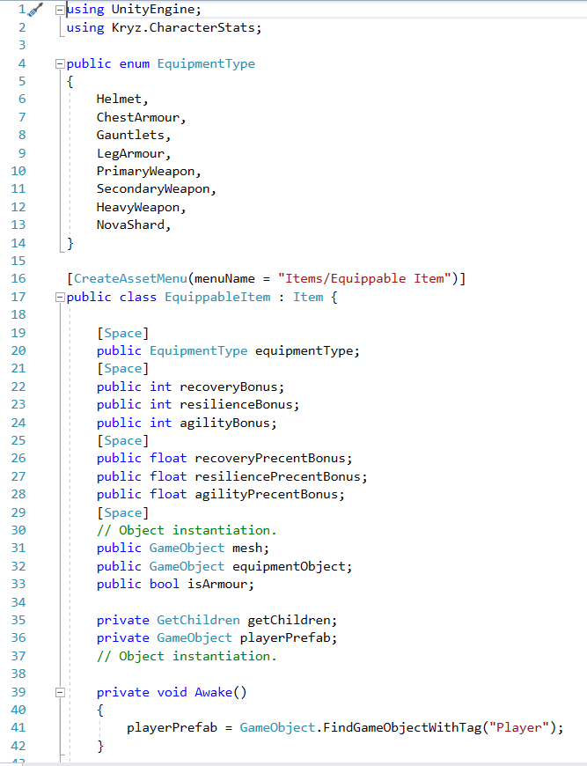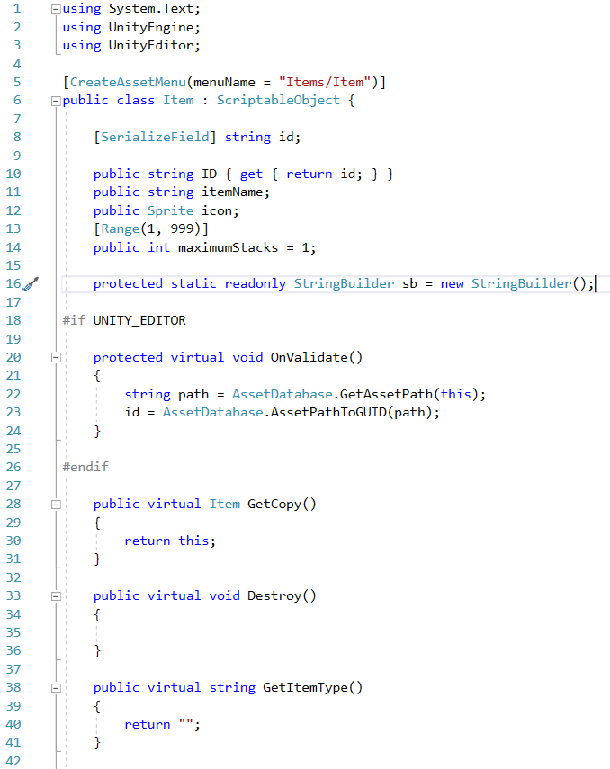

Inheritance is a useful tool as it allows the programmer to separate classes making them easier to reuse and read. It also creates less stress on the machine as its only possessing code it needs and isn’t going through unneeded functions. Also, it allows the developer to use the script execution order (Unity engine), instead of having to write more code just to make sure it’s read in the right order.

**Reusability:** Making code reusable is arguably the most important priority besides functionality and optimisation. Making code reusable allows for less time to be spent on programming and more on other development aspects. This means one class can be used for all agents instead of having a different one just for a slight change such as flying or animation.

My code above is a good example of making code reusable, as it takes advantage of Scriptable Objects. A Scriptable Object is like a regular MonoBehaviour except it doesn’t have to be attached to an object. Instead it acts as a data file which can be taken and used by a game object and used to store other objects to be used later.

A good example of how these can be used is an inventory like what i’m using it for. They make it easy to create a new item in seconds (All I need to do is create one in the project window and assign the properties.).

**Maintenance:** Maintaining code is key to making it readable and

**Real World Modelling:**