Overview
This API will serve project ideas, projects, and project materials for a user. They will be able to add new project ideas and create projects where they can then add materials (ie. Articles, references, etc) and the actual project files.

Entity Relationship Diagram
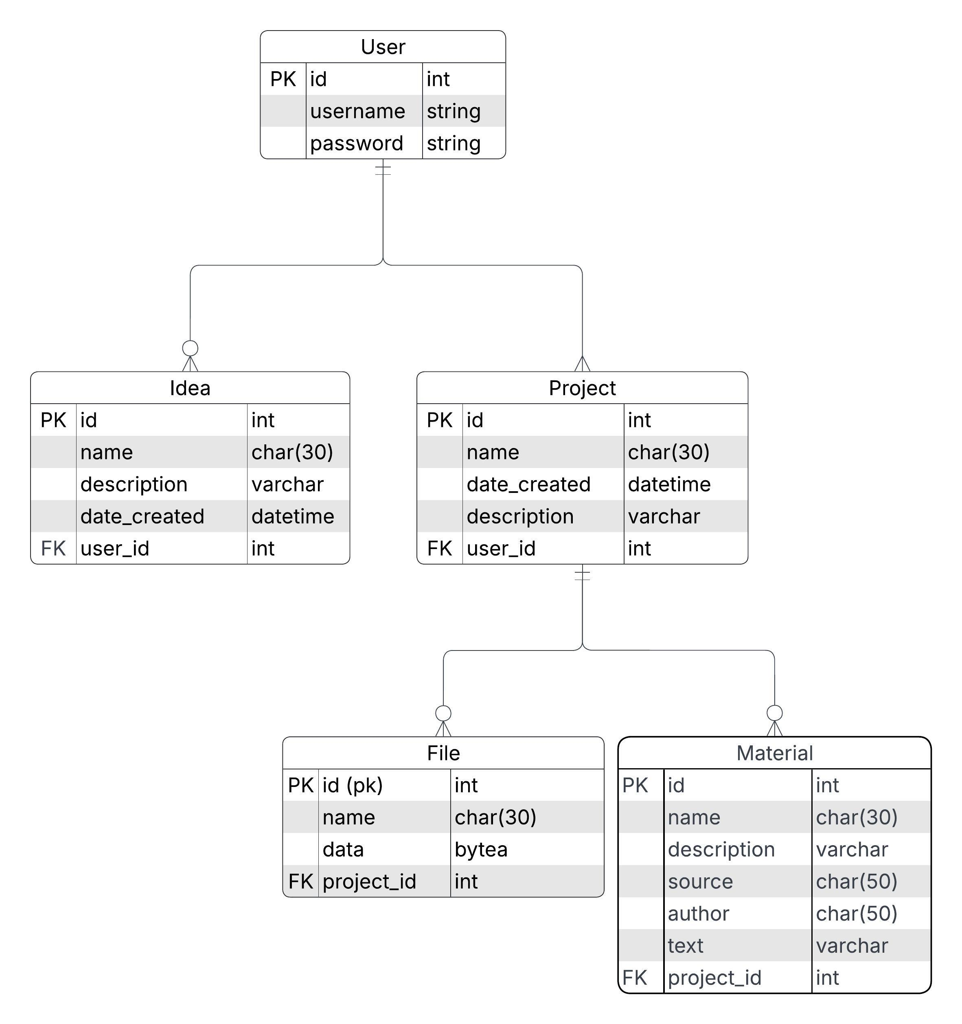

Endpoints

Authentication
Create new user: POST /api/auth/signup
Description: Create a new user account
Login: POST /api/auth/login
Description: Log in and receive a JWT

Ideas

Get all ideas: GET /api/ideas
Description: Get all ideas for the signed in user.
Access: Owner
Success Response:
200 OK
{
{
“id”: 1,
“name”: “Idea 1”,
“description”: “Idea 1 description.”
},
{
“id”: 2,
“name”: “Idea 2”,
“description”: “Idea 2 description.”
}
}
Error Cases:
- 401 Unauthorized: User hasn’t logged in.
- 404 Not Found: User has no ideas in the database.

Create: POST /api/ideas
Description: Add a new idea to the database
Access: User
Success Response:
201 CREATED
{
“id”: 3,
“name”: “Idea 3”,
“description”: “Idea 3 description.”
}
Error Cases:
- 400 Bad Request: Invalid JSON format.
- 401 Unauthorized: User hasn’t logged in.
- 409 Bad Request: Idea with that name already exists.

Change: PUT /api/ideas/:id
Description: Change an idea
Access: Owner
JSON Request:
{
“name”: “Updated idea 1”,
“description”: “Updated idea 1 description.”
}
Success Response:
201 Updated
{
“id”: 1,
“name”: “Updated idea 1”,
“description”: “Updated idea 1 description.”
}
Error Cases:
- 400 Bad Request: Id is not formatted properly.
- 401 Unauthorized: User hasn’t logged in.
- 403 Forbidden: User does not have access to this idea.
- 404 Not Found: No idea exists with that id
- 409 Conflict: Idea with that name already exists

Delete: DELETE /api/ideas/:id
Description: Delete an idea
Access: Owner
Success Response:
- OK
Error Cases:
- 400 Bad Request: Id is not formatted properly.
- 401 Unauthorized: User hasn’t logged in.
- 403 Forbidden: User does not have access to this idea.
- 404 Not Found: No idea exists with that id

Projects
Get all: GET /api/projects/
Description: Get all projects for a user
Access: Owner
Success Response:
200 OK
{
{
“id”: 1,
“name”: “Project 1”,
“description”: “Project 1 description.”,
“files”: [ file1, file2, file3, file4 ]
},
{
“id”: 2,
“name”: “Project 2”,
“description”: “Project 2 description.”,
“files”: [ file1, file2, file3, file4 ]
}
}
Error Cases:
- 401 Unauthorized: User hasn’t logged in.
- 404 Not Found: User has no projects in the database.
Get by id: GET /api/projects/:id
Description: Get a project by Id
Access: Owner
Success Response:
200 OK
{
“id”: 1,
“name”: “Project 1”,
“description”: “Project 1 description.”,
“files”: [ file1, file2, file3, file4 ]
}
Error Cases:
- 400 Bad Request: Id not formatted properly (<0, String, etc).
- 401 Unauthorized: User hasn’t logged in.
- 403 Forbidden: User does not have access
Create new: POST /api/projects/
Description: Add a new project to the database
Access: User
JSON Request:
{
“name”: “Project 3”,
“description”: “Project 3 description.”
}
Success Response:
201 Created
{
“id”: 3,
“name”: “Project 3”,
“description”: “Project 3 description.”,
}
Error Cases:
- 400 Bad Request: Invalid information.
- 401 Unauthorized: User hasn’t logged in.
- 409 Bad Request: Project with that name already exists under this user.

Update: PUT /api/projects/add/:id
Description: Change an idea
Access: Owner
JSON Request:
{
“name”: “Updated Project 3”,
“description”: “Updated Project 3 description.”
}
Binary Request:
C:/some/url/to/a/binary/file1.docx
Success Response:
- Updated
{
“id”: 1,
“name”: “Updated Project 3”,
“description”: “Updated Project 3 description.”
“files”: [ file1.docx ]
}
Error Cases:
- 400 Bad Request: Id is not formatted properly.
- 401 Unauthorized: User hasn’t logged in.
- 403 Forbidden: User does not have access to this project.
- 404 Not Found: No project exists with that id
- 409 Conflict: Project with that name already exists

Delete: DELETE /api/projects/:id
Description: Delete a project by id
Access: User
Success Response:
200 OK
Error Cases:
- 400 Bad Request: Id is not formatted properly.
- 401 Unauthorized: User hasn’t logged in.
- 403 Forbidden: User does not have access to this project.
- 404 Not Found: No project exists with that id.

Materials
Get all: GET /api/materials
Description: Get all materials for the signed in user.
Access: Owner
Success Response:
200 OK
{
{
“id”: 1,
“projectId”: 1,
“name”: “Resource 1”,
“description”: “Resource 1 description.”,
“source”: “Source 1”,
“author”: “Author 1”,
“text”: “Resource 1 text.”
},
{
“id”: 2,
“projectId”: 1,
“name”: “Resource 2”,
“description”: “Resource 2 description”,
“source”: “Source 1”,
“author”: “Author 1”,
“text”: “Resource 1 text.”
}
}
Error Cases:
- 401 Unauthorized: User hasn’t logged in.
- 404 Not Found: User has no materials in the database.

Get all related to a project: GET /api/materials/:projectId
Description: Get all materials related to a project.
Access: Owner
Success Response:
200 OK
{
{
“id”: 1,
“projectId”: 1,
“name”: “Resource 1”,
“description”: “Resource 1 description.”,
“source”: “Source 1”,
“author”: “Author 1”,
“text”: “Resource 1 text.”
},
{
“id”: 2,
“projectId”: 1,
“name”: “Resource 2”,
“description”: “Resource 2 description”,
“source”: “Source 1”,
“author”: “Author 1”,
“text”: “Resource 1 text.”
}
}
Error Cases:
- 401 Unauthorized: User hasn’t logged in.
- 404 Not Found: User has no materials in the database.
- 404 Not Found: No materials found relating to this project
- 404 Not Found: No materials under this id found

Create Material: POST /api/materials
Description: Add a new material to the database
Access: User
JSON Request:
{
“projectId”: 1,
“name”: “Resource 3”,
“description”: “Resource 3 description.”,
“source”: “Source 3”,
“author”: “Author 2”,
“text”: “Resource 3 text.”
}
Success Response:
201 Created
{
“id”: 3,
“projectId”: 1,
“name”: “Resource 3”,
“description”: “Resource 3 description.”,
“source”: “Source 3”,
“author”: “Author 2”,
“text”: “Resource 3 text.”
}
Error Cases:
- 400 Bad Request: Invalid information.
- 401 Unauthorized: User hasn’t logged in.
- 409 Bad Request: Material with that name already exists under this user.

Delete: DELETE /api/materials/:id
Description: Delete a material by id
Access: User
Success Response:
200 OK
Error Cases:
- 400 Bad Request: Id is not formatted properly.
- 401 Unauthorized: User hasn’t logged in.
- 403 Forbidden: User does not have access to this material.
- 404 Not Found: No material exists with that id.

