注册账号 实名认证
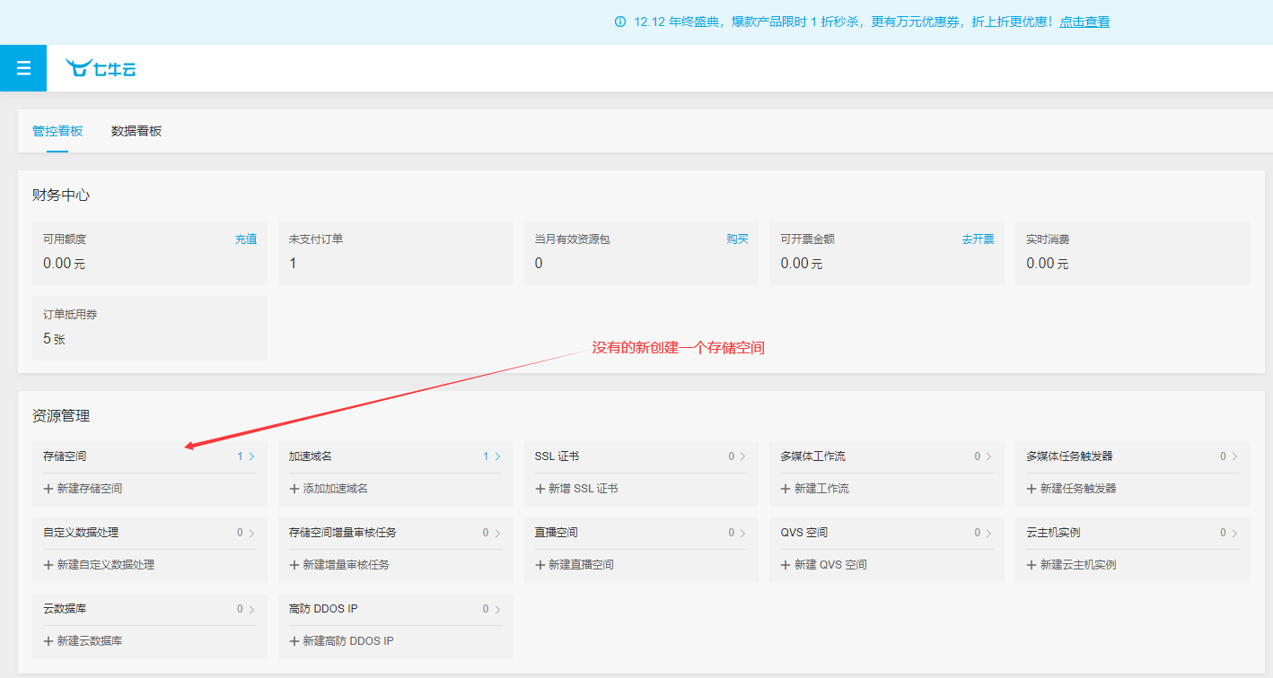
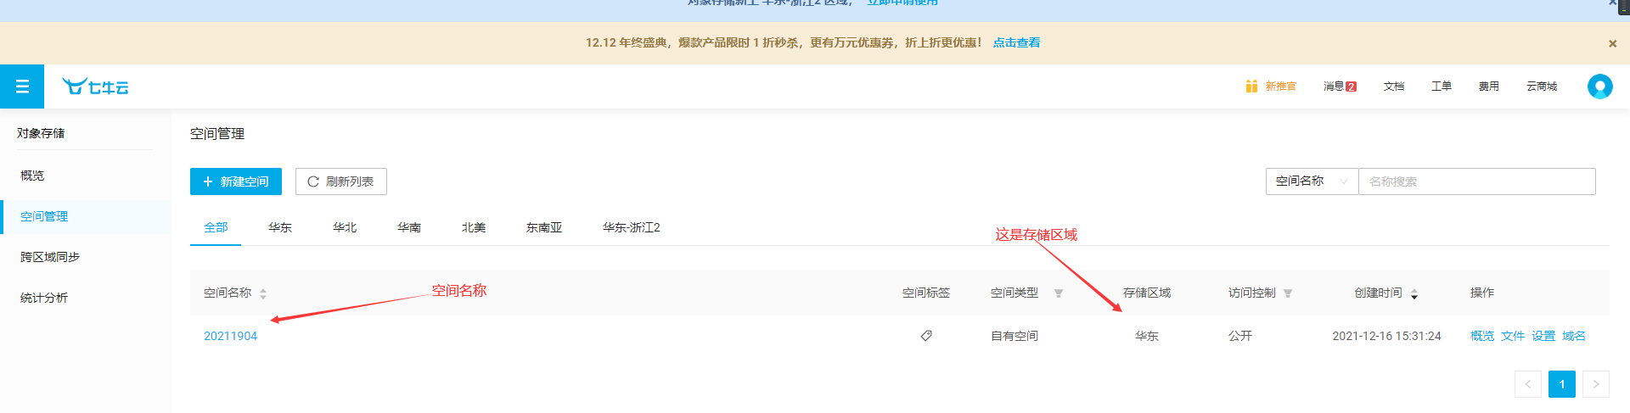

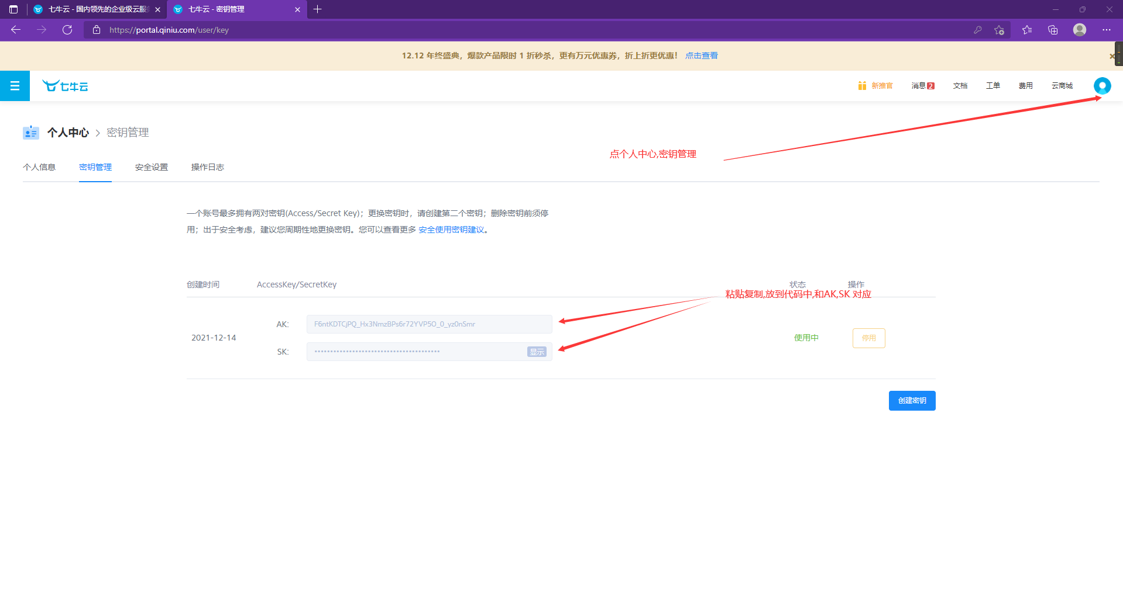
1.NuGet包管理器 安装 Qiniu(最新版本就可以)
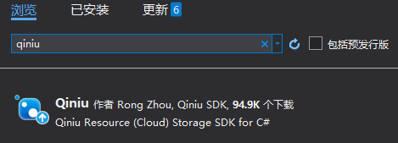
存储区域现在是华东
记得查看自己的存储区域是否和服务器存储区域一样
ZONE_CN_East=华东
ZONE_CN_North=华北
ZONE_CN_South=华南

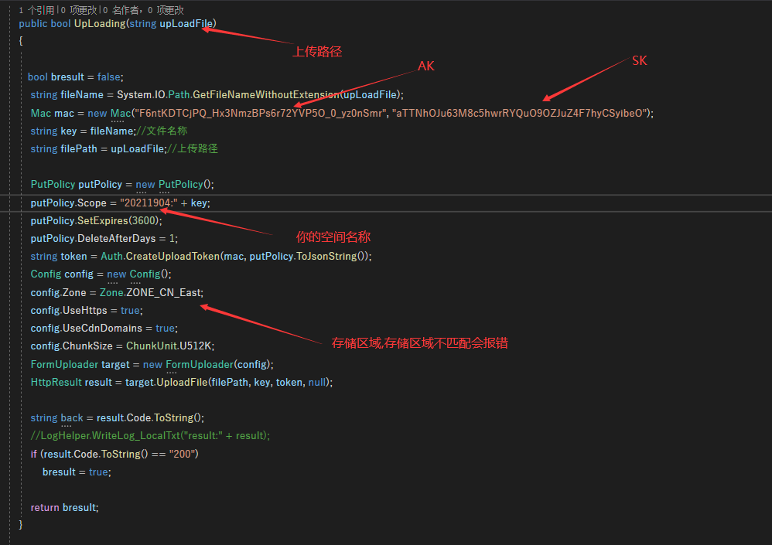

public bool UpLoading(string upLoadFile)
{

bool bresult = false;
string fileName = System.IO.Path.GetFileNameWithoutExtension(upLoadFile);
Mac mac = new Mac("F6ntKDTCjPQ_Hx3NmzBPs6r72YVP5O_0_yz0nSmr", "aTTNhOJu63M8c5hwrRYQuO9OZJuZ4F7hyCSyibeO");
string key = fileName;//文件名称
string filePath = upLoadFile;//上传路径

PutPolicy putPolicy = new PutPolicy();
putPolicy.Scope = "20211904:" + key;
putPolicy.SetExpires(3600);
putPolicy.DeleteAfterDays = 1;
string token = Auth.CreateUploadToken(mac, putPolicy.ToJsonString());
Config config = new Config();
config.Zone = Zone.ZONE_CN_East;
config.UseHttps = true;
config.UseCdnDomains = true;
config.ChunkSize = ChunkUnit.U512K;
FormUploader target = new FormUploader(config);
HttpResult result = target.UploadFile(filePath, key, token, null);

string back = result.Code.ToString();
//LogHelper.WriteLog_LocalTxt("result:" + result);
if (result.Code.ToString() == "200")
bresult = true;

return bresult;
}

