GSQ GML DD&T Roadmap Executive Platform

Business Design Package — Functional Blueprint
Field | Value
Product | GSQ DD&T Roadmap Executive Platform (Single Pane of Glass)
Document type | Business Design Package / functional specification
Version | 1.3
Date | 4 September 2026
Executive sponsor | Joel Vincent
Business sponsor / product lead | Dean Santoro
Owning organization | Global Manufacturing & Labs DD&T
Companion documents | *GSQ DD&T Roadmap Executive Platform MVP v2 Sept 2026* (business case); *Executive Summary*; *TakOS Onboarding Readiness*
Intended readers | Funding approvers, TakOS / Power Platform delivery team, site heads, PMO
Status | Ready for funding package; not a controlled Veeva record

This package is the functional specification the delivery team should implement against. It is written so a developer or TakOS POD should not need to invent business process, navigation, KPI definitions, or executive-reporting behavior.

1. Purpose of this blueprint
Leadership currently prepares business reviews by stitching Jira boards, SPOT investment views, site Power Apps, Power BI trackers, and PowerPoint. The Executive Platform is a single portal of truth: one site-aware shell that presents the 1,000-foot portfolio, then drills into the detailed views that already exist, plus the Budget and Site Head input that are missing today.
This document defines:
- What executives and site heads see in each connected view.
- How drill-down works from the 1,000-foot Power App into detailed Power Apps, Power BI, Jira, and SPOT.
- How information is entered versus how it is displayed.
- The data architecture, integrations, roles, and acceptance criteria.
- The level of effort and people-hours to design, build, and integrate end to end.
This blueprint does not build or integrate the dashboards. It is the specification used with the business-case document to fund a developer resource (TakOS Marketplace and/or Power Platform).
Figures 1–11 are live source experiences captured 4 September 2026 — the UX the developer reuses or embeds. Figures 12–15 are target-state mockups of the new Executive Platform shell (site selector, full tab set, Business Review, Site input). They are labelled TARGET MOCKUP on the image. They are the visual specification for what Band B builds; they are not a live app.

Figures in this package
Figure | What it shows | Used in
1 | Thousand Oaks One pager Power App (1,000-foot shell) | §3.1, §7.1
2 | DD&T MYC Budget 2026 Power App | §3.2, §7.4
3 | Combined Gantt + Budget Power App (target Gantt tab) | §3.3, §7.3
4 | Network Global Roadmap (34 programmes / 573 projects) | §3.4, §7.10
5 | Network Sites roll-up (Americas / APAC / Europe) | §3.4, §7.10
6 | Network Initiatives roll-up (MES, Paperless, ODBR, …) | §3.4, §7.10
7 | Network Regions (DD&T reporting lines) | §3.4, §7.10
8 | Existing Power BI Thousand Oaks Gantt (do not rebuild) | §3.4
9 | Capability Tracker — plant summary (Lexington) | §3.5, §7.7
10 | Capability Tracker — all capabilities (Brooklyn Park) | §3.5, §7.7
11 | Delivery SPOT 1063647 project board | §9.5
12 | Target mockup — One pager in the new Glass (site selector + full tabs) | §6.4, §7.1
13 | Target mockup — Gantt + Budget inside the Glass | §6.4, §7.3
14 | Target mockup — Business Review (new; freeze pack) | §6.4, §7.8
15 | Target mockup — Site input (new write path) | §6.4, §7.9

2. Product hypothesis
If GSQ Manufacturing & Labs leadership can open one site-aware portal that is fed by Jira, SPOT, and EDB, and if site heads can enter the commentary that those systems do not hold, then a business review can run from a maintained system of record instead of a manually assembled deck.
The MVP must prove six things (from the business case):
- Jira holds enough portfolio and delivery data for executive roadmap reporting.
- SPOT holds enough investment and project information for executive reporting.
- EDB holds enough deployment, adoption, utilization, and capability data for value-realization insight.
- A reusable executive experience can be delivered on approved Takeda platforms (Power Platform for the shell; TakOS for the funded product path).
- Executives can obtain portfolio status and business-review insight without multiple PowerPoints.
- The concept creates enough measurable value to justify Releases 1–3.

3. Current-state inventory (what already exists)
The platform reuses these assets as the 1,000-foot experience and as drill-down destinations. They are the UX specification, not disposable sketches.

3.1 Thousand Oaks Strategic Roadmap Power App — 1,000-foot view
Item | Value
Play URL | https://apps.powerapps.com/play/e/13ab3896-86ac-e9d1-8a83-257843921f13/app/83afccd8-23f4-4ba1-9416-9059f69cd304
App ID | 83afccd8-23f4-4ba1-9416-9059f69cd304
Environment | 13ab3896-86ac-e9d1-8a83-257843921f13
Tenant | 57fdf63b-7e22-45a3-83dc-d37003163aae
Layout | Tablet, 1920 × 1080
Local recreation / .msapp | ~/RoadmapExecutivePlatform and takOS/Roadmap Executive Platform

What it already does
- Header branded Thousand Oaks (hard-coded; must become a network site selector).
- Tabs: One pager · Status KPIs · Gantt · Risks · Jira Links.
- Filters: search, fiscal year, North Star platform, status, Big Rock / capability.
- One pager: six Big Rocks across the top; FY2026 / FY2027 / FY2028+ swimlanes; project cards with status dots; drag-and-drop between year × Big Rock cells.
- Project sidecar: owner, description, business value, dependencies, milestones, progress, Jira link, “move project” control.
- North Star rail: SAIL, LPMS, APMS, RTMS, COMOS, Smart QC, LabX, Veeva eQMS, Discoverant, OpsTrakker, SIMCA Online (plus MES / SAP on cards).
- Footer: key challenges (Communication · Change Management · Leadership Engagement) and status legend.
- Open Jira board action.
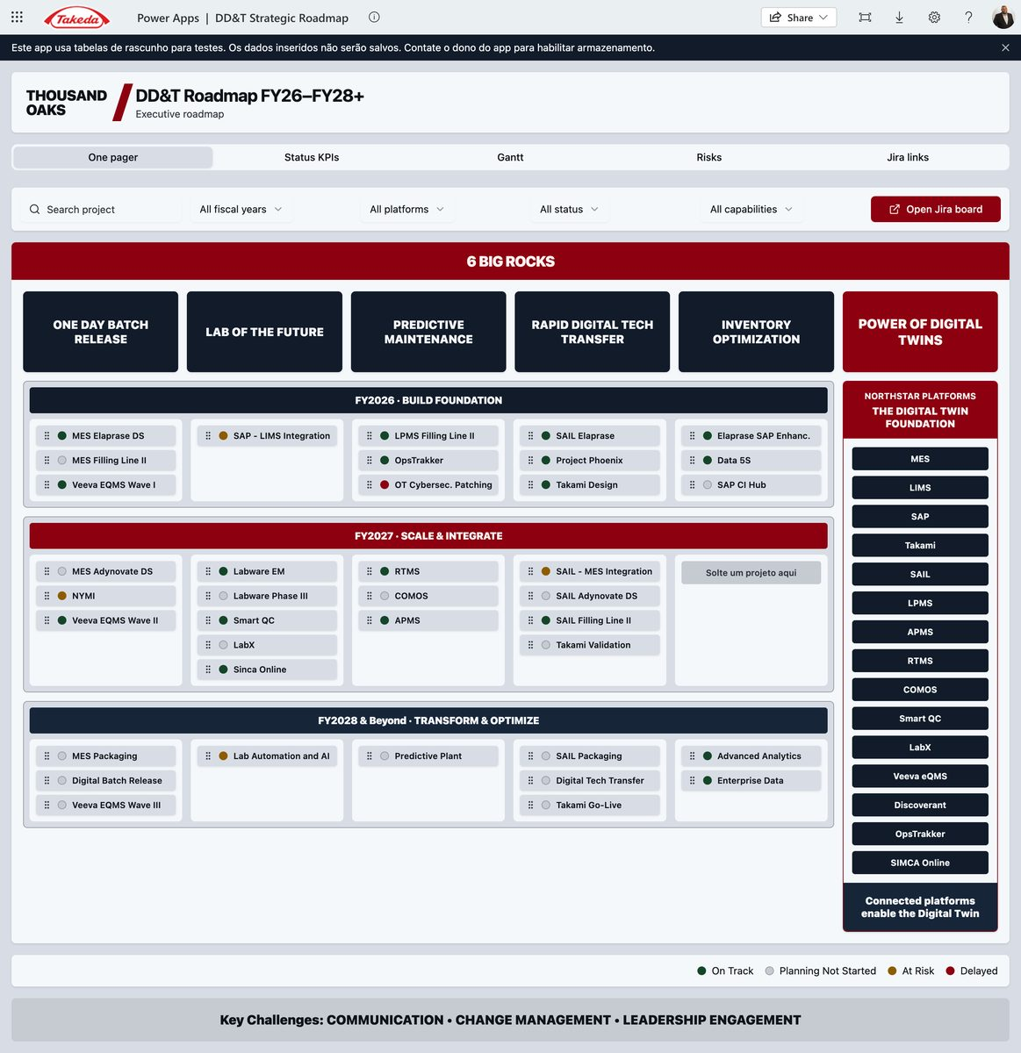
Figure 1. Current 1,000-foot One pager — Thousand Oaks is hard-coded. The red tab row (One pager, Status KPIs, Gantt, Risks, Jira links) and the six Big Rocks × FY swimlanes are the shell the network portal must keep. The site name becomes a drop-down; Budget is added as a tab.
What is wrong or missing for a network portal
- Site is not a filter. All data is Thousand Oaks sample / draft collections (colProjects). Changes do not persist.
- No Budget tab.
- Gantt is year-band only; it is not combined with budget, actuals, or SPOT IDs.
- Status vocabulary does not yet match the global DDT roadmap RAG.
- No Site Head commentary, no audit trail, no role-based edit.

3.2 Budget Power App (missing tab — reuse this pattern)
Item | Value
Play URL | https://apps.powerapps.com/play/e/d99720be-f155-e674-86b3-32acc687394e/app/c683f980-1fb1-4917-b70c-34496646e6d3
Environment | d99720be-f155-e674-86b3-32acc687394e

This is the starting visual for the new Budget tab: investment vs. forecast vs. actual, by initiative / project / fiscal year, for the selected site. Live title: DD&T MYC Budget 2026 (Thousand Oaks mid-year cycle). In the Glass, the same layout is filtered by the header site selector.
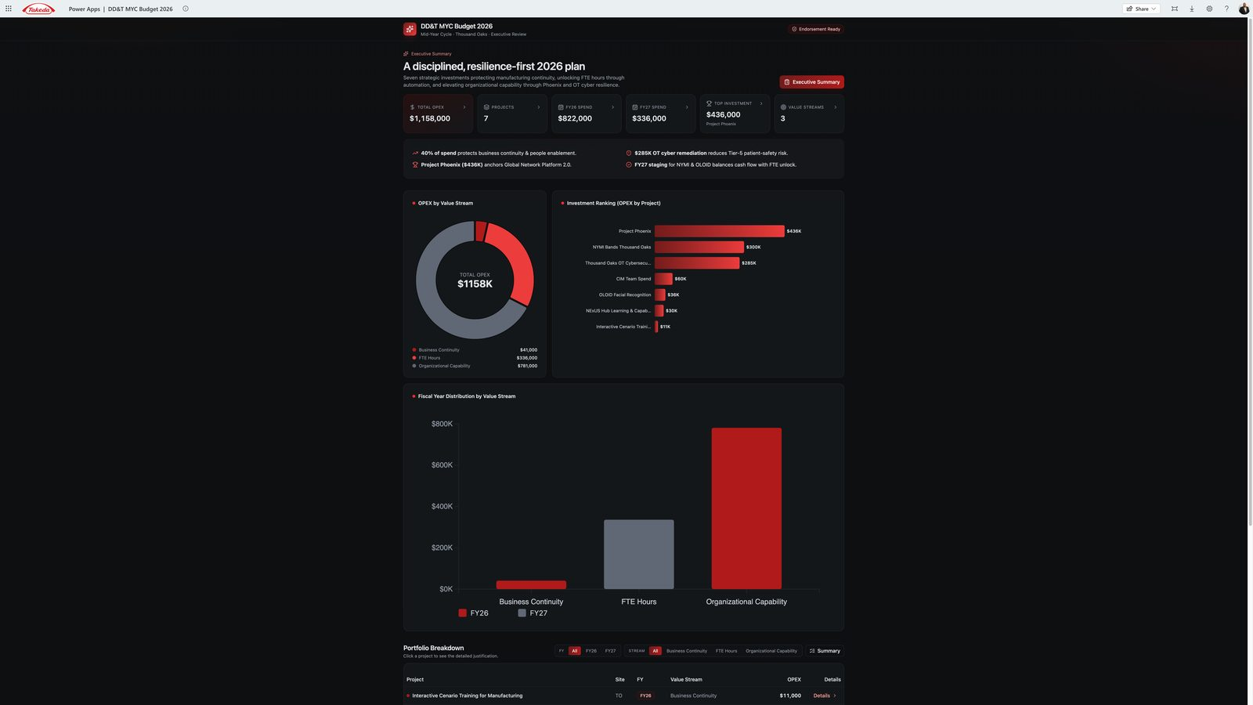
Figure 2. Budget tab source — DD&T MYC Budget 2026. KPI strip, OPEX by value stream, investment ranking, FY split, and a project table with Details drill-down. Reuse this pattern; bind it to SPOT and the selected site.

3.3 Combined Budget + Gantt Power App (target Gantt tab)
Item | Value
Play URL | https://apps.powerapps.com/play/e/d99720be-f155-e674-86b3-32acc687394e/app/5d55a550-7d80-469a-84bc-bee2f53a08b3

The production Gantt tab must look and behave like this app: timeline bars and budget/actuals on the same row, not two disconnected screens. Left = site roadmap by workstream (MES, SAIL, Paperless, …) with SPOT IDs on the bars. Right = the MYC Budget executive panel for the same site.
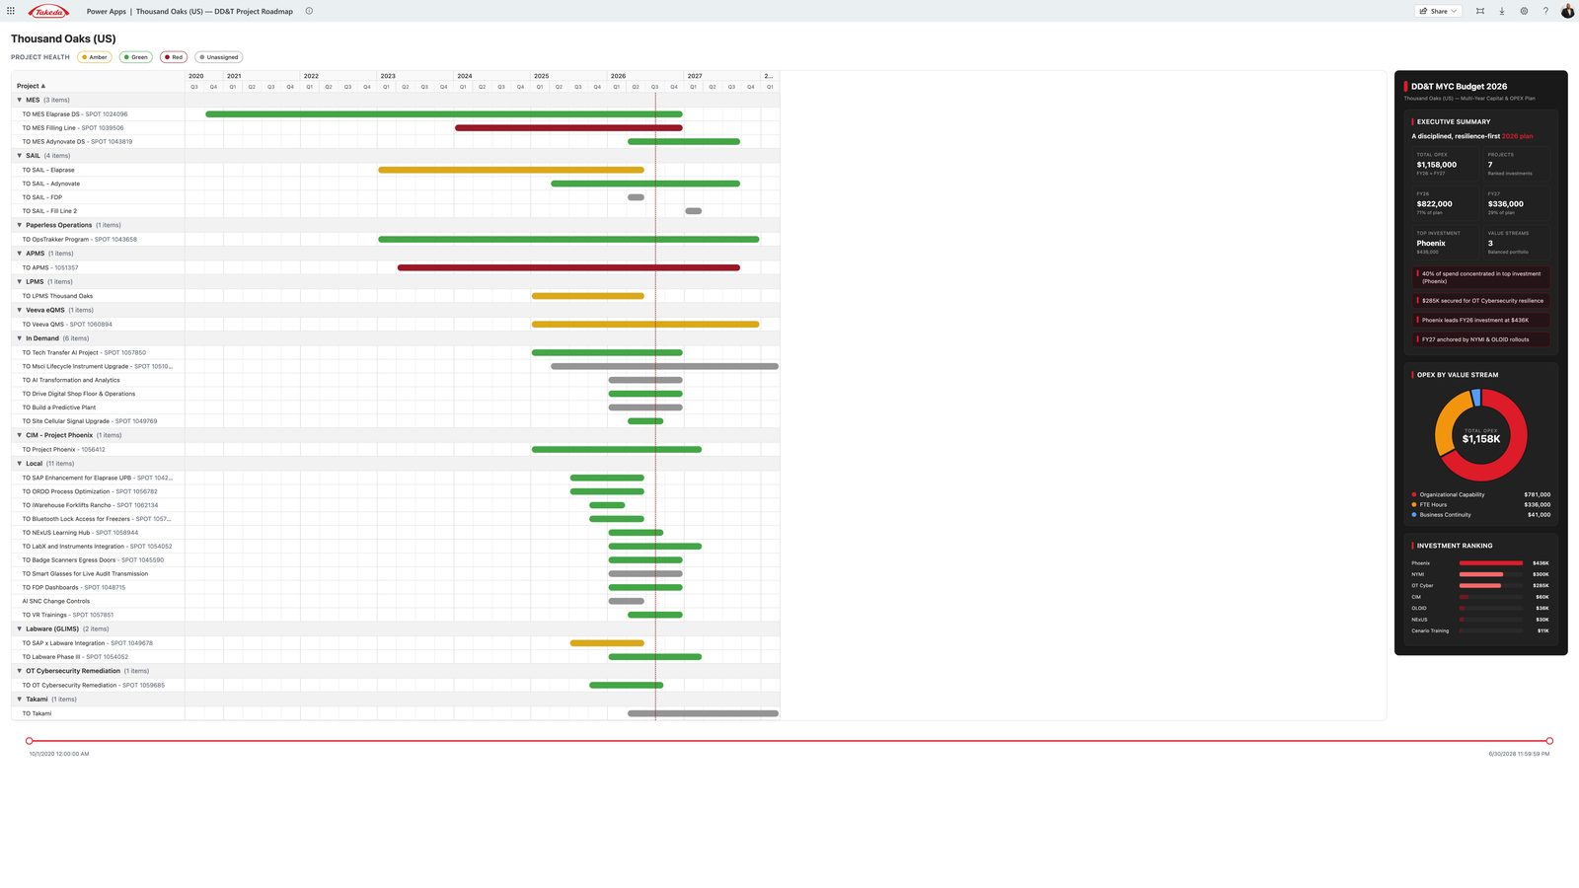
Figure 3. Target Gantt + Budget — Thousand Oaks DD&T Project Roadmap with the MYC Budget 2026 sidebar on the same screen. This is the combined view the thin One-pager Gantt tab must become.

3.4 Global DDT Roadmap (network 1,000-foot evidence)
Prototype URL pattern 100.64.0.2:3000 with tabs Overview · Global Roadmap · Initiatives · Regions · Sites · Data. Snapshot as of 31 Aug 2026:
- 34 programmes · 573 projects · 92 at risk
- Timeline FY24–FY30 with per-site go-lives
- Status glyphs: On Track · Monitor Closely · Leadership Attention Required · Blocked Pending Dependency · No Status · Complete · Cancelled
- Programme health is rolled up from linked projects (no authored initiative RAG in the feed)
- Site-led work is a first-class lane (329+ items), not hidden
This is the network reading of the same portfolio the site Power App shows for one plant. The Executive Platform must be able to show both: one site (business review) and all sites (GSQ leadership). Clicking a site code (THO, LEX, …) sets the Glass site selector.
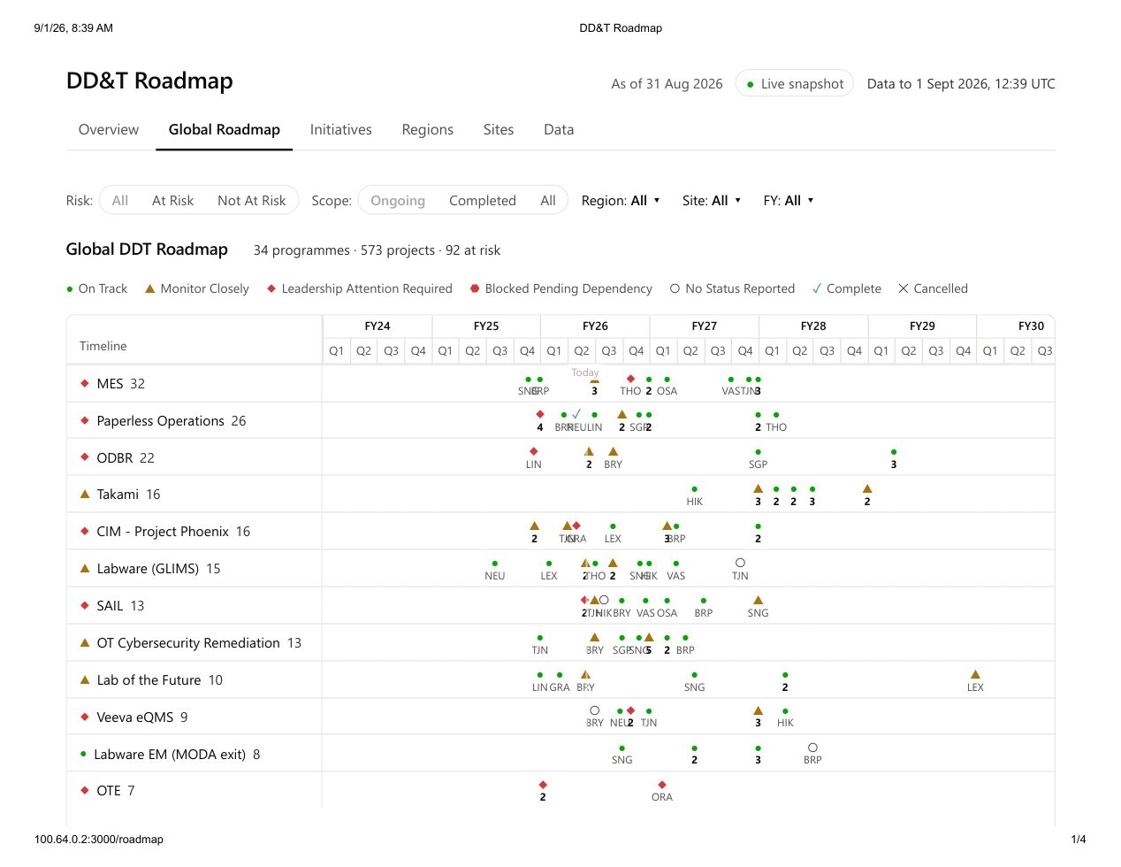
Figure 4. Network Global Roadmap — 34 programmes, 573 projects, FY24–FY30, per-site go-live glyphs. This is the executive Network mode.
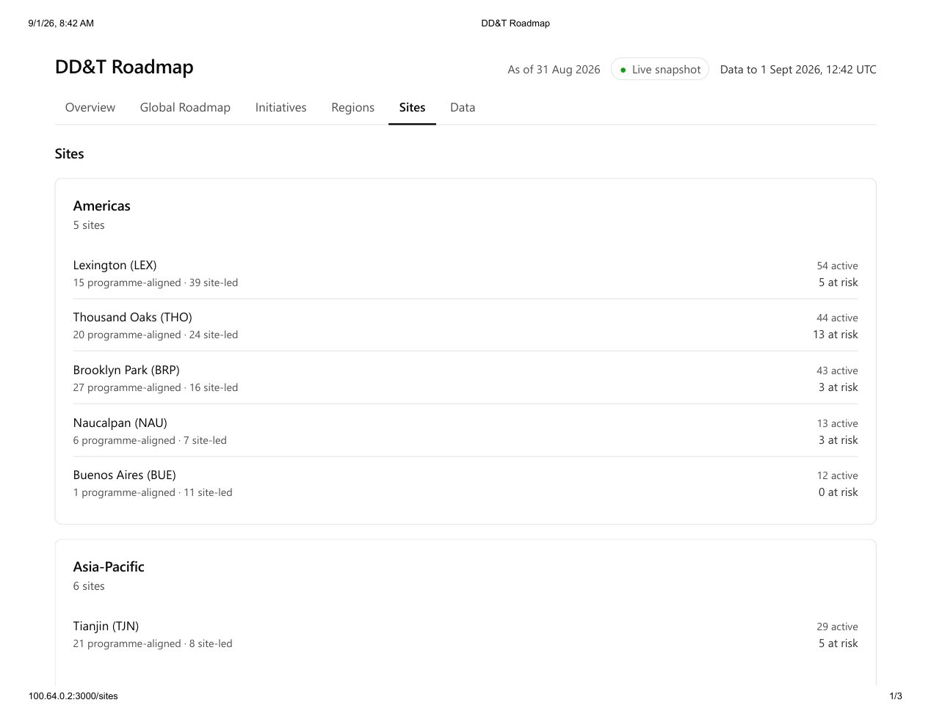
Figure 5. Network Sites roll-up — Americas / Asia-Pacific / Europe with programme-aligned vs site-led counts. THO shows 44 active / 13 at risk.
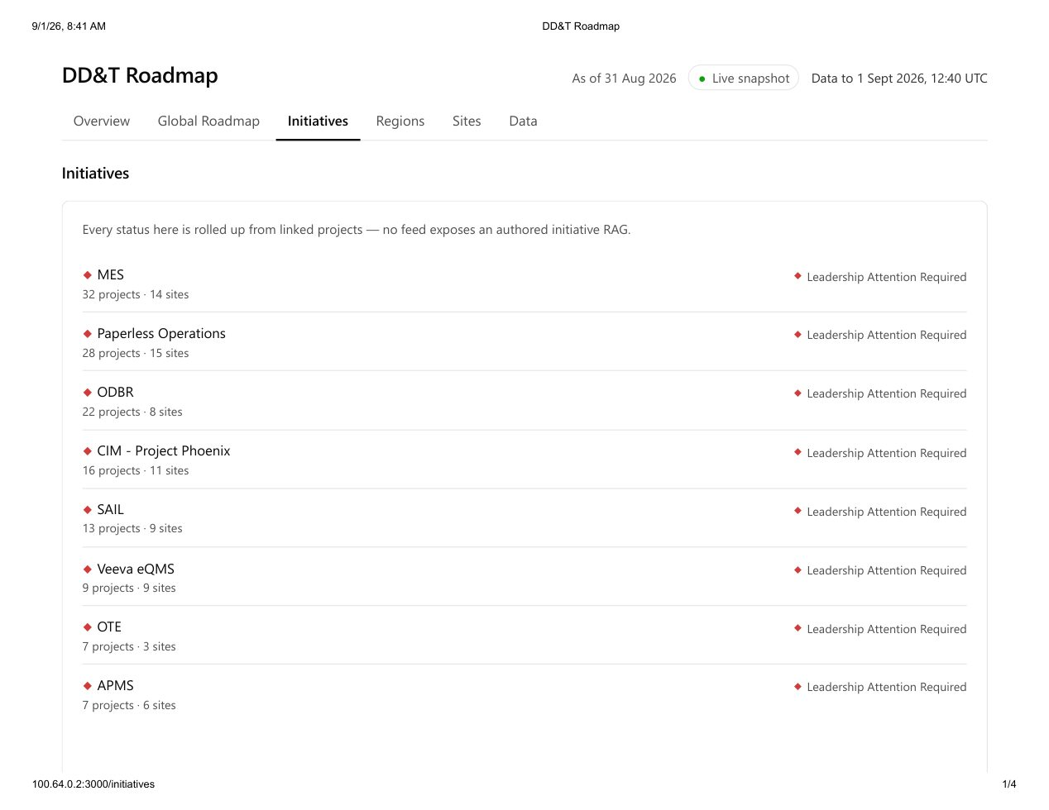
Figure 6. Network Initiatives — every status is rolled up from linked projects. MES 32 / Paperless 28 / ODBR 22 all show Leadership Attention Required.
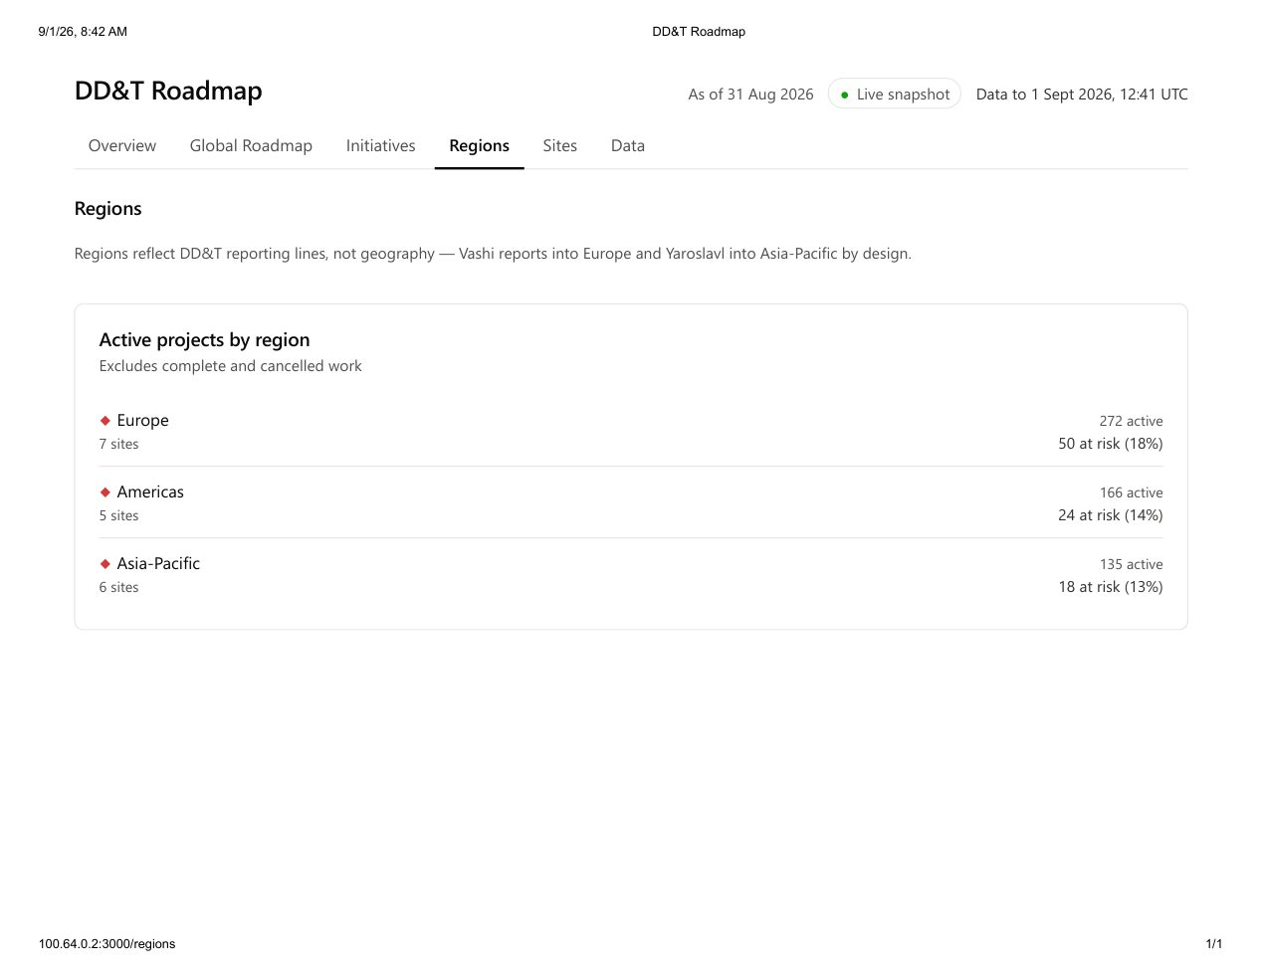
Figure 7. Network Regions — DD&T reporting lines, not geography (Vashi→Europe, Yaroslavl→APAC). Europe 272 active / 50 at risk; Americas 166 / 24; APAC 135 / 18.
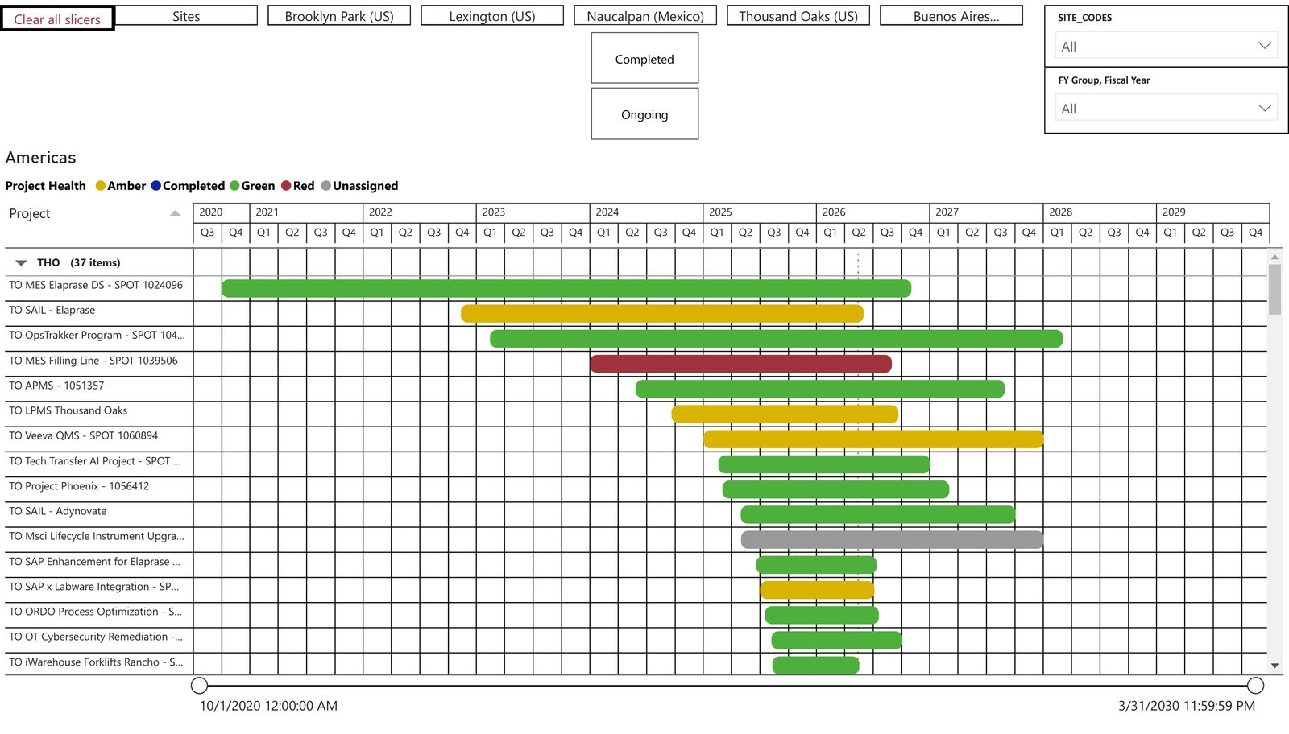
Figure 8. Existing Power BI site Gantt (Thousand Oaks) — the same portfolio the combined Power App in Figure 3 already presents more clearly. Do not rebuild this view.

3.5 Capability Tracker (Power BI) — North Star / EDB-style drill-down
Two screens exist in Capability Tracker.pdf:
Screen A — plant summary (example: Lexington)
- Filters: Plant, Global Initiative Yes/No
- Capability KPIs: 48 total · 31.96% deployed · 26.21% adopted
- Integration KPIs: 23 total · 47.83% deployed · 45.65% adopted
- Donuts: Fully Deployed & Adopted / Pending / Deployed, Not Fully Adopted
- Bar: capabilities on a global initiative vs. local
- Footer: SAIL deployed plants (Brooklyn Park, Lexington, Linz, Osaka, Thousand Oaks)
Screen B — all capabilities (example: Brooklyn Park)
- Site capability score (49.30) and health line: capabilities complete 29/47 · integrations complete 7/19
- Funnel: Total → Fully Deployed → Fully Adopted → Both
- Pending integrations table (e.g. Batch Release: Floor Scales → LabX, LabWare ↔ MES, MES ↔ SAIL, SAP → RTMS, Veeva ↔ SAP)
- Completed capabilities list
This is the system-integration and adoption detail that the 1,000-foot roadmap does not show. The Capability tab embeds this report and passes the Glass plant filter.
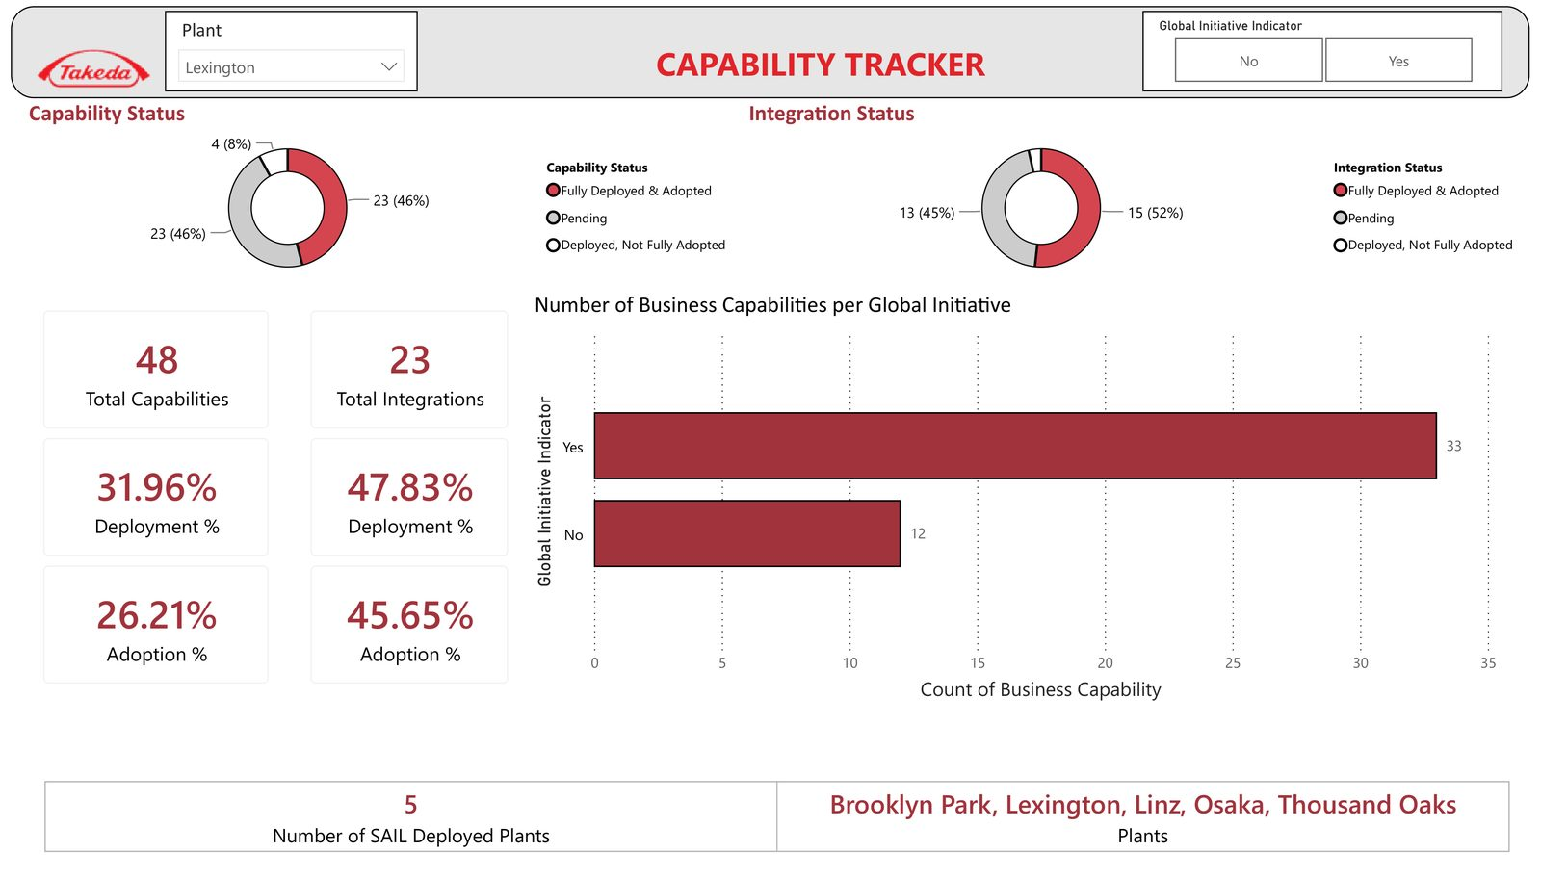
Figure 9. Capability Tracker — plant summary (Lexington). Deploy/adopt KPIs, status donuts, global-initiative split, SAIL deployed plants.
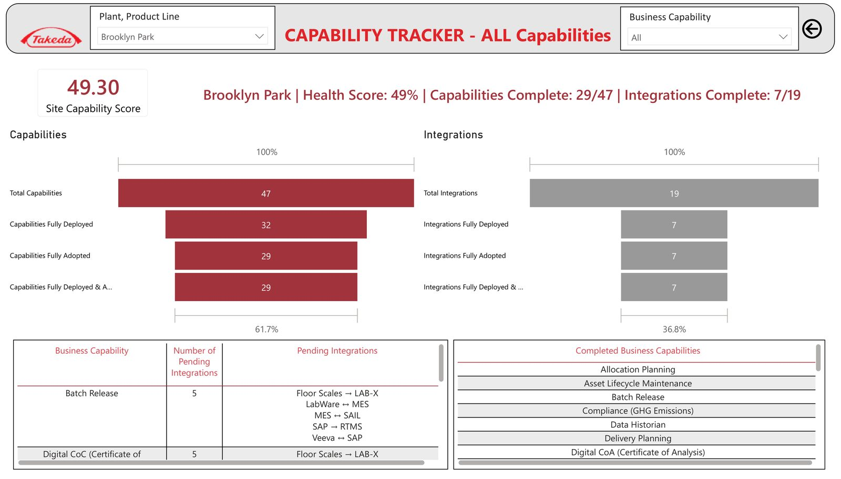
Figure 10. Capability Tracker — all capabilities (Brooklyn Park). Site score, deploy/adopt funnels, pending integration pairs (MES ↔ SAIL, Veeva ↔ SAP), completed capabilities.

3.6 Jira portfolio already in use
DDTGMPORT holds the GSQ initiative set (MES, ODBR, Paperless Operations, Takami, Phoenix, Labware, SAIL, OT Cyber, etc.). Site projects (e.g. DDTTO-*, DDTBP-*) and SPOT IDs (e.g. TO MES Elaprase DS — SPOT 1024096) already exist. That Jira estate is a data source, not the delivery Initiative for *this* platform (see the onboarding companion).

3.7 What “single pane of glass” means
┌──────────────────────────────────────────────────────────────────────────┐
│ EXECUTIVE GLASS (one Power App / later TakOS shell) │
│ Site selector · FY · Big Rock · Platform · Risk · Role │
│ │
│ [One pager] [KPIs] [Gantt+Budget] [Budget] [Risks] [Jira] [Capability] │
│ [Business Review] [Site input] [Network roadmap] │
│ │
│ embeds / launches existing Power Apps, Power BI, Jira, SPOT │
│ writes Site Head commentary to Dataverse (system of record) │
└──────────────────────────────────────────────────────────────────────────┘
│ │ │
Jira / DDTGMPORT SPOT investment EDB / Capability
delivery + RAG $ + milestones deploy / adopt
Executives never leave the portal to “find the other dashboard.” Site context set in the header applies to every tab.

4. Personas, decisions, and RACI

4.1 Personas
Persona | Primary job in the portal | Typical decision
GSQ / GML executive (Joel Vincent and peers) | Network 1,000-foot health, investment vs. delivery, which sites need attention | Escalate, re-prioritize, fund, stop
Site Head (Thousand Oaks first) | Site portfolio, risks, budget burn, capability adoption, BR narrative | Confirm status, accept risk, ask for help
Site DD&T / digital lead (Dean Santoro at TO) | Keep the portal true; own commentary quality; prepare the business review | Correct mapping, unblock data, brief the Site Head
Programme / platform owner (MES, SAIL, Labware, …) | Cross-site programme lane, go-lives, dependencies | Sequence sites, resolve cross-site blocks
PMO / project manager | Data quality, SPOT IDs, milestone dates, RAID | Close gaps before the review
Finance partner | Budget vs. forecast vs. actual, variance | Reallocate, challenge, approve
Delivery engineer (TakOS / Power Platform) | Build, integrate, operate | Not a business-review actor

4.2 RACI (MVP)
Activity | Site Head | Site DD&T lead | Programme owner | PMO | Finance | Executive | Delivery team
Jira status / dates | I | C | A | R | I | I | I
SPOT financials | I | C | C | C | A/R | I | I
EDB deploy/adopt | I | C | A | I | I | I | I
Site commentary / BR narrative | A | R | C | C | I | I | I
Local risk not in Jira | A | R | C | C | I | I | I
Big Rock / FY / platform mapping | I | A | C | R | I | I | I
Portal configuration / security | I | C | I | I | I | I | A/R
Business-review pack freeze | A | R | C | C | C | I | I

Rule: systems of record stay authoritative. The portal does not become a second Jira or a second SPOT. Site Heads write only what those systems cannot hold (narrative, local context, confirmation).

5. Canonical information architecture

5.1 Hierarchy
GSQ Network
└─ Region (Americas / Europe / Asia-Pacific) ← DD&T reporting line, not geography
└─ Site (e.g. Thousand Oaks / THO)
└─ Big Rock (6 strategic capabilities)
└─ North Star Platform (MES, SAIL, Labware, …)
└─ Initiative / Programme (DDTGMPORT-*)
└─ Site project (DDTTO-*, SPOT ID)
└─ Milestone / go-live
└─ Risk / impediment
└─ Budget line (SPOT)
└─ Capability / integration (EDB)
Reporting-line exception (already in the global roadmap): Vashi reports into Europe; Yaroslavl reports into Asia-Pacific. The site master must store reporting_region, not infer it from country.

5.2 Site master (network of 18)
Region | Site | Code | Notes for MVP
Americas | Lexington | LEX | Capability Tracker already live
Americas | Thousand Oaks | THO | Business-review pilot
Americas | Brooklyn Park | BRP | Capability Tracker already live
Americas | Naucalpan | NAU
Americas | Buenos Aires | BUE
Asia-Pacific | Tianjin | TJN
Asia-Pacific | Osaka | OSA | SAIL deployed
Asia-Pacific | Hikari | HIK
Asia-Pacific | Singapore | SGP
Asia-Pacific | Yaroslavl | YAR | Reports to APAC; high site-led share
Asia-Pacific | Bekasi | BEK
Europe | Grange Castle | GRA | Largest site-led volume
Europe | Bray | BRY
Europe | Linz | LIN | SAIL deployed
Europe | Oranienburg | ORA
Europe | Singen | SNG
Europe | Neuchatel | NEU
Europe | Vashi | VAS | Reports to Europe

Header control: Site (required). Optional second control: Network / All sites for GSQ executives. Changing Site re-queries every tab; it does not open a different app.

5.3 Six Big Rocks (One pager columns)
ID | Label | Typical North Star platforms
one-day-batch-release | One Day Batch Release | MES, Veeva eQMS, Smart QC, NYMI
lab-of-the-future | Lab of the Future | Labware (GLIMS/EM), LabX, Smart QC, SIMCA Online
predictive-maintenance | Predictive Maintenance | LPMS, RTMS, APMS, COMOS, OpsTrakker
rapid-digital-tech-transfer | Rapid Digital Tech Transfer | SAIL, Takami, Phoenix
inventory-optimization | Inventory Optimization | SAP, Takami, warehouse / RTMS
digital-twin | Power of Digital Twins | Discoverant, Enterprise Data, SIMCA, digital twin use cases

A project belongs to exactly one Big Rock for the One pager (primary). It may tag additional platforms.

5.4 Canonical status (must map all three current vocabularies)
Canonical | TO Power App today | Global roadmap | Power BI | Color / glyph
on_track | On Track | On Track | Green | Green circle
monitor | At Risk (split) | Monitor Closely | Amber | Amber triangle
leadership | Delayed / At Risk (split) | Leadership Attention Required | Red | Red diamond
blocked | — | Blocked Pending Dependency | Red | Solid red
planning | Planning Not Started | No Status Reported (if no RAG) | Unassigned | Grey hollow
complete | — | Complete | Completed | Blue check
cancelled | — | Cancelled | — | Grey X

Roll-up rule (already proven on the global roadmap, keep it):
- Initiative RAG = worst open child project (Leadership > Blocked > Monitor > On Track).
- Do not allow an authored initiative RAG that contradicts children.
- Complete and Cancelled are excluded from “active” and “at risk” counts.

5.5 Fiscal time
- Fiscal year labels FY26, FY27, FY28+ on the site One pager.
- Network Gantt may span FY24–FY30 (global roadmap already does).
- “Today” marker is required on every Gantt.
- A project’s planning FY (One pager swimlane) and date span (Gantt start / go-live) are different fields. Do not collapse them.

6. Navigation model

6.1 Shell chrome (always visible)
Control | Behavior
Takeda mark + product title | “DD&T Executive Platform”
Site selector | Replaces hard-coded “Thousand Oaks”. Searchable. Shows code + name.
Scope toggle | This site / Network (Network hidden from Site Head role if desired)
As-of stamp | Source freshness: Jira, SPOT, EDB, last Site Head save
Primary tabs | See 6.2
Search | Project / initiative / SPOT / Jira key
Filters | FY, Big Rock, Platform, Risk, Programme vs site-led
Identity | Role, site entitlements, “view as” for support only

6.2 Primary tabs (site mode)
Tab | Source experience | MVP?
One pager | Existing TO Strategic Roadmap One pager | Yes — persist + site-aware
Status KPIs | Existing Status KPIs tab | Yes — live counts
Gantt + Budget | Combined Budget+Gantt Power App | Yes — this replaces the thin Gantt
Budget | Budget Power App | Yes — stand-alone finance view
Risks | Existing Risks tab + Jira impediments | Yes
Jira | Jira Links + live issue list | Yes
Capability | Capability Tracker Power BI | Yes — embed + site filter
Business Review | New, TO pilot | Yes — assembled from the above
Site input | New forms | Yes — write path
Network roadmap | Global DDT Roadmap | Yes for executives; optional for Site Head

6.3 Deep links (do not copy data; pass context)
Every card, bar, and table row must expose:
- siteCode
- jiraKey and/or spotId
- initiativeKey
- tab + entityId
Opening Jira, SPOT, or a child Power BI report preserves site + entity. Closing the child returns to the same tab and selection.

6.4 Target-state mockups (what Band B builds)
These four screens are the new platform, not the current Power Apps. Same Takeda chrome on every tab: product title, site drop-down (replaces hard-coded Thousand Oaks), This site / Network, source freshness, and the full tab row. Live apps in Figures 1–3 are the visual DNA; these mockups show how that DNA sits in one Glass.
What changed versus today
- Site is a control, not a title.
- Tabs add Budget, Gantt + Budget (replaces thin Gantt), Capability, Business Review, Site input, Network.
- Sidecar actions jump inside the Glass (Gantt + Budget, Capability) instead of forcing a second app hunt.
- Business Review and Site input do not exist in the current Power Apps — they are new.
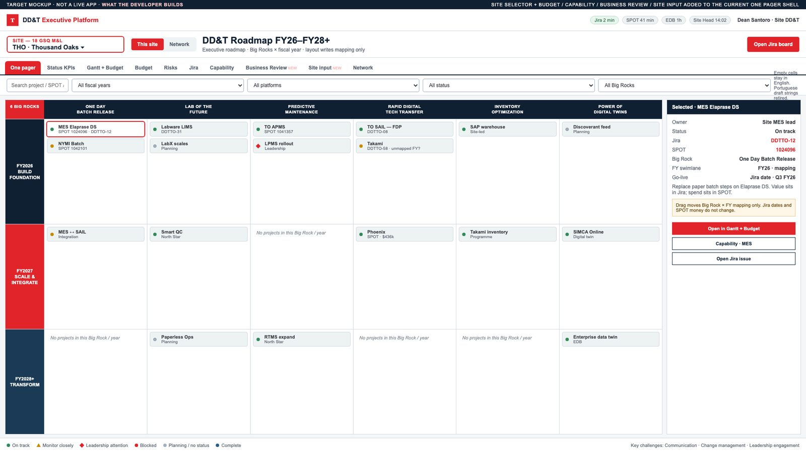
Figure 12. Target mockup — One pager in the Executive Platform. Site selector (THO · Thousand Oaks), This site / Network, full tab row, six Big Rocks × FY26–FY28+, sidecar with Jira + SPOT + Open in Gantt + Budget. Layout writes mapping only.
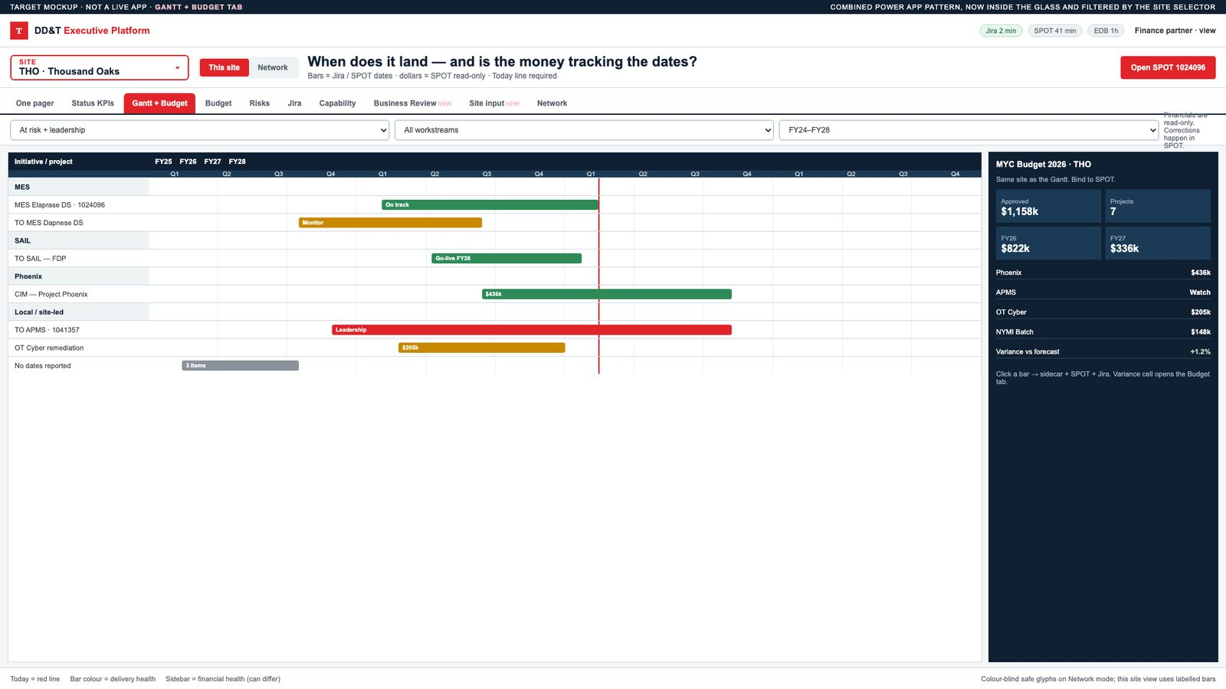
Figure 13. Target mockup — Gantt + Budget tab. Site-filtered timeline with Today line; MYC Budget 2026 sidebar bound to SPOT. Financials read-only.
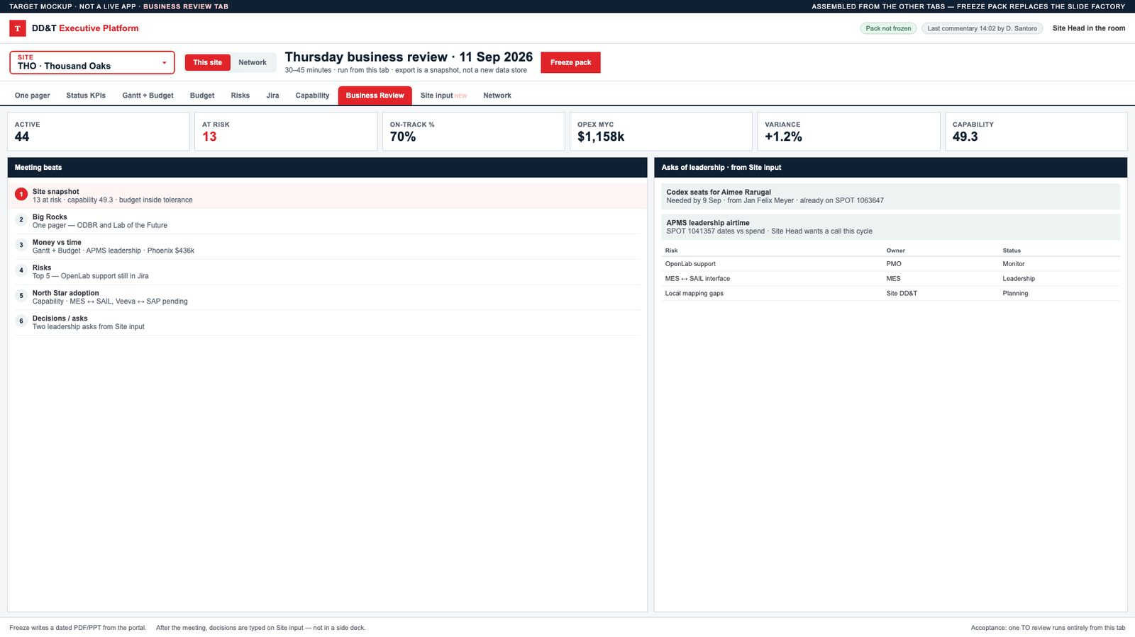
Figure 14. Target mockup — Business Review tab (new). Six meeting beats, KPI strip, leadership asks from Site input, Freeze pack. This is the slide-factory replacement.
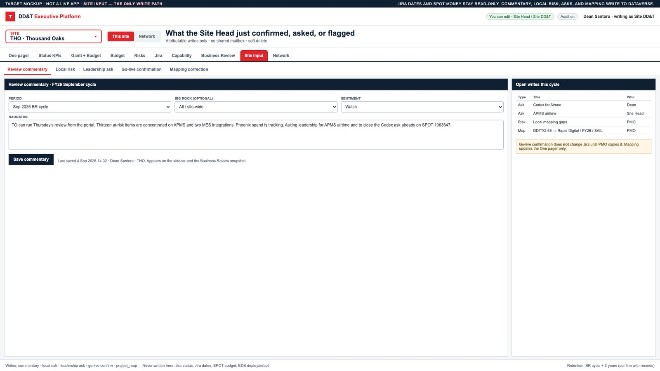
Figure 15. Target mockup — Site input tab (new). The only write path: commentary, local risk, leadership ask, go-live confirm, mapping. Jira dates and SPOT money are never written here.

7. Screen inventory and view specifications
For every screen: purpose, users, data, rules, drill-downs, entry vs display, acceptance.

7.1 One pager — 1,000-foot site roadmap
Purpose. In one screen, show how the selected site’s work sits on the six Big Rocks across FY26–FY28+. The live Thousand Oaks shell (Figure 1) is the visual DNA. Figure 12 is the target: same grid, site is a drop-down, tabs include Budget / Capability / Business Review / Site input / Network.
Figure 1. Current 1,000-foot One pager — Thousand Oaks is hard-coded. The red tab row (One pager, Status KPIs, Gantt, Risks, Jira links) and the six Big Rocks × FY swimlanes are the shell the network portal must keep.
Figure 12. Target mockup — One pager in the Executive Platform. Site selector, This site / Network, full tab row, six Big Rocks × FY, sidecar with Jira + SPOT + in-Glass drill-downs.
Layout (preserve the current Power App)
- Site name (from selector, not a static image).
- Title: DD&T Roadmap FY26–FY28+ / subtitle “Executive roadmap”.
- Pill tabs + filters + Open Jira board (board URL is site-specific).
- Red banner: 6 BIG ROCKS and six navy tiles.
- Three year bands (navy / red / navy) with a 6-column grid under each Big Rock.
- Project cards: grip, status dot, name.
- Right sidecar for the selected project.
- North Star platform rail.
- Footer challenges + legend.
Data required
Field | Source | Display / edit
Project name | Jira summary | Display
Jira key | Jira | Display + link
SPOT ID | Jira custom field / SPOT | Display + link
Status | Jira + mapping table | Display
Big Rock | Mapping table (PMO-maintained) | Edit by Site DD&T / PMO
Fiscal swimlane | Mapping table | Edit by Site DD&T / PMO
Platform | Jira component / mapping | Display
Owner | Jira assignee | Display
Description, value, dependencies, milestones | Jira description + sidecar fields in Dataverse if Jira is empty | Display; Site DD&T may enrich in Dataverse
Progress % | Jira or calculated from milestones | Display
Programme vs site-led | Initiative membership | Display

Business rules
- Cards shown = selected site’s projects only.
- Drag-and-drop does not write to Jira. It updates the mapping table (Big Rock × FY) and writes an audit row. Banner: “Layout changes are planning metadata. Jira dates and status remain the system of record.”
- Empty cell copy: “No projects in this Big Rock / year” (English; retire Portuguese draft strings).
- Selecting a North Star chip filters the grid to that platform.
Drill-down
User action | Destination
Click card | Sidecar (in-page)
Sidecar Jira link | Jira issue in new window
Sidecar Open in Gantt + Budget | Same entity on Gantt tab
Sidecar Capability | Capability tab filtered to related platforms
Open Jira board | Site DDT Jira board

Acceptance
- Switching LEX → THO replaces the entire grid within 3 seconds of data availability.
- A TO reviewer can run a business-review One pager without PowerPoint for the pilot agenda.

7.2 Status KPIs
Purpose. Counts and on-track rate so a Site Head sees heat before reading cards.
Widgets
Widget | Formula
Projects | Count of active (not complete/cancelled) for site + filters
On Track | status = on_track
Planning | status = planning
At Risk (monitor + leadership + blocked) | Combined, with a split on hover
Delayed / leadership | status = leadership
On-track % by FY | on_track / active in that FY swimlane
Programme-aligned vs site-led | Two counts (global Sites view already uses this)
Last Site Head update | Timestamp + author

Drill-down. Clicking a KPI applies that status filter and jumps to One pager or Risks.
Acceptance. KPI totals equal the filtered card count. No “42 here, 39 there.”

7.3 Gantt + Budget (combined) — primary delivery/finance view
Purpose. Answer: *When does this land, what does it cost, and is the money tracking the dates?* The combined Power App (Figure 3) is the visual DNA. Figure 13 is that pattern inside the Glass, filtered by the site selector.
Figure 3. Target Gantt + Budget — Thousand Oaks DD&T Project Roadmap with the MYC Budget 2026 sidebar on the same screen.
Figure 13. Target mockup — Gantt + Budget tab in the Executive Platform. Today line, SPOT IDs on bars, MYC budget sidebar, financials read-only.
Layout (from the combined Power App — see Figure 3)
- Left: initiative / project tree (expand programme → site project).
- Center: Gantt from earliest start to latest go-live; Today line; FY/quarter headers.
- Right or under each bar: budget, forecast, actual, variance, SPOT ID.
- Legend: project health + financial health (can differ).
Data required
Field | Source
Start, finish / go-live | Jira dates; if missing, SPOT milestone
Health | Canonical status
Site code | Jira site field / components
Budget, forecast, actual, currency | SPOT
Variance | actual − forecast and %
Capital vs expense | SPOT cost category
FY allocation | SPOT / finance split

Business rules
- Financials are read-only. Corrections happen in SPOT.
- A bar without dates appears in a No dates reported strip (global roadmap already does this).
- Number-on-glyph means collapsed multi-site go-lives when in Network mode; in Site mode show the single bar.
- Colour-blind safe glyphs, not red/green alone (global roadmap note: ~8% of male viewers).
Drill-down. Bar → sidecar + SPOT project + Jira issue. Variance cell → Budget tab, same project.
Acceptance. A reviewer can explain TO MES Elaprase DS (SPOT 1024096) dates and spend without opening a second tool.

7.4 Budget tab
Purpose. Finance-first view for the selected site (and Network roll-up for executives). Reuse the MYC Budget 2026 pattern (Figure 2); bind it to SPOT and the Glass site selector.
Figure 2. Budget tab source — DD&T MYC Budget 2026. KPI strip, OPEX by value stream, investment ranking, FY split, and a project table with Details drill-down.
Minimum widgets
- Total approved · forecast · actual · remaining · variance
- By FY, by Big Rock, by programme vs site-led
- Table: Initiative, Project, SPOT, approved, forecast, actual, variance %, owner, health
- Filter: over-variance threshold (default 10%)
Entry. None, except a Site Head comment on a variance line (stored in Dataverse, linked to SPOT ID).
Acceptance. Totals reconcile to SPOT for the pilot site within the agreed tolerance (propose ±1% or $1k, whichever greater).

7.5 Risks
Purpose. Only what needs leadership airtime.
Content
- Auto: Jira issues with status in {monitor, leadership, blocked} plus type Impediment (e.g. DDTGMPORT-41 OpenLab Support).
- Manual: Site Head / PMO local risks not yet in Jira (must be promoted to Jira within one cycle or expire).
Card fields. Title, canonical status, owner, due, Big Rock, related projects, last comment, Jira key.
Entry. Site input tab or inline “Add local risk” → Dataverse → optional “Create Jira impediment” action (post-MVP if API write is not approved for MVP).

7.6 Jira tab
Purpose. The working backlog for the site, not a pretty chart.
- Saved filters: site projects, DDTGMPORT children tagged to the site, open impediments.
- Columns: Key, Type, Summary, Status, Assignee, Due, SPOT, Big Rock.
- Actions: open issue, open board, copy link into BR pack.
No dual-write of status. Status edits stay in Jira.

7.7 Capability / North Star (Capability Tracker)
Purpose. Show whether North Star systems are deployed, adopted, and integrated — the question the roadmap Gantt cannot answer. Embed the existing tracker (Figures 9 and 10) and pass the Glass plant filter.
Figure 9. Capability Tracker — plant summary (Lexington). Deploy/adopt KPIs, status donuts, global-initiative split, SAIL deployed plants.
Figure 10. Capability Tracker — all capabilities (Brooklyn Park). Site score, deploy/adopt funnels, pending integration pairs, completed capabilities.
MVP behavior
- Embed the existing Capability Tracker report.
- Pass Plant = selected site (must implement RLS or a plant parameter; Lexington/Brooklyn Park already demonstrate the pattern).
- Second page (All Capabilities) is the drill-down: score, funnels, pending integration pairs, completed capabilities.
EDB target (same MVP boundary as the business case)
Measure | Definition (working; confirm with EDB steward)
Capability deployed | System in production at the site for that capability
Capability adopted | Defined usage threshold met (not merely installed)
Integration deployed | Named interface live (e.g. MES ↔ SAIL)
Integration adopted | Interface used in the business process
Site capability score | Weighted deploy × adopt (tracker already shows 49.30)
SAIL deployed plants | Distinct sites with SAIL = deployed

Drill-down. Pending integration row → related Jira projects on that interface (best-effort mapping table).
Acceptance. For THO, LEX, and BRP, Capability tab matches the published tracker numbers after the same filters.

7.8 Business Review (Thousand Oaks pilot)
Purpose. Replace the manually assembled DD&T business-review slides. Figure 14 is the target screen — it does not exist in the current Power Apps.
Figure 14. Target mockup — Business Review. KPI strip, six meeting beats, leadership asks from Site input, Freeze pack.
Recommended page flow (30–45 minutes)
Beat | View | Owner in the room
1. Site snapshot | KPI strip + at-risk count + budget variance + capability score | Site DD&T
2. Big Rocks | One pager | Site Head
3. Money vs. time | Gantt + Budget, filtered At Risk / Leadership | Finance + PMO
4. Risks | Risks tab, top 5 | Site Head
5. North Star adoption | Capability tab | Digital lead
6. Decisions / asks | Site input “Asks of leadership” | Site Head

Export. “Freeze pack” writes a dated PDF/PowerPoint *from the portal* (or a Power Automate export). The freeze is a snapshot, not a new data store. After the meeting, decision log is typed on Site input.
Acceptance. One TO business review is run entirely from the portal. Slide-building hours for that review drop by ≥70% (baseline captured in week 1).

7.9 Site input (write path)
Purpose. The only place Site Heads *type into* the platform. Figure 15 is the target screen — it does not exist in the current Power Apps.
Figure 15. Target mockup — Site input. Commentary form, attributable save, open writes this cycle. Jira and SPOT remain read-only.
Form | Fields | Who | Writes to
Review commentary | Period, Big Rock (opt), narrative, sentiment (on track / watch / off) | Site Head, Site DD&T | Dataverse site_commentary
Local risk | Title, severity, owner, due, related Jira/SPOT, mitigation | Site Head, PMO | Dataverse local_risk
Go-live confirmation | Project, date confirm / change request, reason | Site DD&T | Dataverse; does not change Jira until PMO copies it
Leadership ask | Ask, decision needed by, $ or people impact | Site Head | Dataverse leadership_ask
Mapping correction | Project → Big Rock / FY / platform | PMO, Site DD&T | Dataverse project_map

Display rules
- Commentary appears on the sidecar and on the Business Review snapshot.
- All writes are attributable (user, timestamp). No shared mailbox accounts.
- Soft delete only; history retained for the BR cycle + 2 years (confirm retention with records).

7.10 Network roadmap (executive)
Purpose. The global 34-programme / 573-project picture, already prototyped.
Tabs: Overview · Global Roadmap · Initiatives · Regions · Sites · Data.
Clicking a site code (THO, LIN, …) sets the shell Site selector and returns to site One pager. That is the primary network → site drill.
Figure 4. Network Global Roadmap — 34 programmes, 573 projects, FY24–FY30, per-site go-live glyphs.
Figure 5. Network Sites roll-up — Americas / Asia-Pacific / Europe. THO 44 active / 13 at risk.
Figure 6. Network Initiatives — status rolled up from linked projects (MES, Paperless, ODBR, Phoenix, SAIL, …).
Figure 7. Network Regions — DD&T reporting lines. Europe 272 active; Americas 166; Asia-Pacific 135.

8. Mock workflows

8.1 Site Head prepares Thursday’s business review
1. Open Executive Glass (Entra SSO).
2. Confirm Site = Thousand Oaks (defaulted by role).
3. Status KPIs: note 13 at risk (global Sites snapshot).
4. One pager: scan red/amber cards on One Day Batch Release and Lab of the Future.
5. Click “TO MES Elaprase DS” → sidecar → confirm Jira + SPOT 1024096.
6. Gantt + Budget: same project — dates vs. spend.
7. Capability: THO plant — pending MES ↔ SAIL, Veeva ↔ SAP.
8. Site input: write two leadership asks; confirm top 5 risks.
9. Business Review: Freeze pack for the meeting date.

8.2 GSQ executive compares two plants
1. Scope = Network. Regions tab: Americas 166 active / 24 at risk.
2. Sites: THO 44 active / 13 at risk vs. LEX 54 active / 5 at risk.
3. Set Site = THO → One pager.
4. Set Site = LEX → Capability (already the tracker’s default example).
5. Decision: ask THO Site Head for the 13 at-risk narrative (already in Site input).

8.3 PMO repairs a mapping
1. Jira tab shows DDTTO-58 TO Takami with no Big Rock.
2. Site input → Mapping correction → Rapid Digital Tech Transfer / FY26 / SAIL.
3. One pager now places the card. Audit row recorded.
4. Jira itself unchanged.

8.4 Programme owner checks MES across sites
1. Scope = Network, Platform = MES (or Initiative = DDTGMPORT-1).
2. Global Gantt: MES 32 projects, leadership attention.
3. Click THO glyph → site Gantt + Budget for TO MES lines.
4. Capability pending integrations involving MES.

9. Data architecture

9.1 Systems of record
Data | System of record | Portal permission
Issue status, assignee, dates, impediments | Jira (onetakeda.atlassian.net) | Read; optional later write for impediments
Investment, budget, forecast, actual, sponsor | SPOT | Read
Capability deploy/adopt, integration pairs | EDB (PostgREST / approved data product) | Read
Site master, Big Rock maps, commentary, local risks, asks, freeze packs | Dataverse (or approved TakOS store) | Read/write by role
Capability visuals | Power BI semantic model | Embed + RLS
Identity | Microsoft Entra ID | SSO

Golden thread: SPOT investment → Jira Initiative/Programme → site project → Dataverse commentary → BR freeze.

9.2 Logical entities (Dataverse / equivalent)
Entity | Key fields
site | code, name, reporting_region, timezone, default_jira_board, default_spot_portfolio, capability_plant_name
user_site_role | user, site, role (executive, site_head, digital_lead, pmo, finance, viewer)
initiative | jira_key (DDTGMPORT-n), name, owner, status_roll_up
project | jira_key, site, initiative, spot_id, name, status_canonical, start, finish, platform, programme_or_local
project_map | project, big_rock, fy_swimlane, updated_by, updated_on
financial | spot_id, fy, approved, forecast, actual, currency, as_of
capability | site, capability_name, global_flag, deployed, adopted
integration | site, capability, source_system, target_system, deployed, adopted
site_commentary | site, period, body, sentiment, author
local_risk | site, title, severity, owner, due, jira_key?
leadership_ask | site, period, ask, needed_by, impact
review_freeze | site, period, created_by, artifact_url
status_map | source_system, source_value, canonical
audit | entity, action, user, timestamp, before, after

9.3 Integration pattern
Jira REST ──┐
SPOT API ──┼──> scheduled sync (15–60 min) ──> Dataverse staging ──> app
EDB API ──┘ │
└── freshness stamp on chrome
Power BI ───────────── embed (no nightly copy of visuals)
Existing Power Apps ─── navigate / embed with query params (site, key)
MVP sync direction: inbound only, except Dataverse writes.
Identity for APIs: application registration + least-privilege; not a personal Atlassian token in the product. (Personal tokens are only for a developer’s agent workflow — see onboarding companion.)

9.4 Jira consumption (working mapping)
Need | Likely source
Programme list | DDTGMPORT Initiatives
Site projects | Project keys DDTTO, DDTBP, DDTBRY, … plus site custom field
SPOT ID | Custom field already visible on many summaries (SPOT 1024096)
Impediments | Type = Impediment
Go-live | Due date / targeted end

A field workshop (8 hours) with PMO in week 1 of build must lock the exact custom fields. The blueprint assumes they exist because the global roadmap and DDTGMPORT_Initiatives.csv already use them.

9.5 SPOT consumption
Need, per project or WBS line: ID, name, site, approved, forecast, actual, FY split, sponsor, PM, team membership, milestones, risk, status.
The delivery of this platform already has its own SPOT project. That record is separate from the *manufacturing* SPOT IDs shown on the Gantt (e.g. 1024096).
Field | Live value (4 Sep 2026)
SPOT ID | 1063647
Name | GSQ DD&T Roadmap Executive Platform MVP
Hub URL | https://tospot.azurewebsites.net/project-hub/78dd4329-ece5-4796-8cab-776d8ce7af17/project-board
State / phase | Active · Plan
Data quality | 100%
Project manager | Santoro, Dean
Sponsor | Vincent, Joel
Execution scope | Global-DD&T PDT & GSQ
Owning organization | DD&T
Type / category | Standard Project / Program · Improvement — General Improvement
Governance | Tier 4 — OpU/Global Function LT
Submitted | 25 Aug 2026 by Dean Santoro
Value capture start | 1 Dec 2026
COP category | Productivity Improvements
Value metric (plan) | FTE hours · Global: FY26 3,000 · FY27–29 9,000/yr · 30,000 hours total
Expected CAPEX (header) | $35,000 — does not match the preliminary CAPEX forecast
Preliminary CAPEX forecast | $168,000 ($42,000 × FY26–FY29)
Approved CAPEX / OPEX | Blank
Funding requests | None yet
Team on the record | Dean (PM), Joel (Sponsor), Aimee Rarugal, Juraj Krivda, Simran Karamchandani, Ivan Fonseca
Board narrative | Status: MetrIQ/TakOS will be used · Accomplishment: Claude tokens provisioned · Next: infra buildout
Open ask | Provision Codex for Aimee Rarugal · from Jan Felix Meyer · 9 Sep 2026
SPOT milestones | Phase 2 Experience Design 18 Sep · Budget Approved 18 Sep · Funding Approval 25 Sep · Execution End 13 Nov · MVP Build 20 Nov · Pilot 11 Dec · Close 22 Jan 2027

Action on this record: file a funding request and make Expected CAPEX, the preliminary forecast, and the Marketplace order the same number. Do not create a second SPOT project.
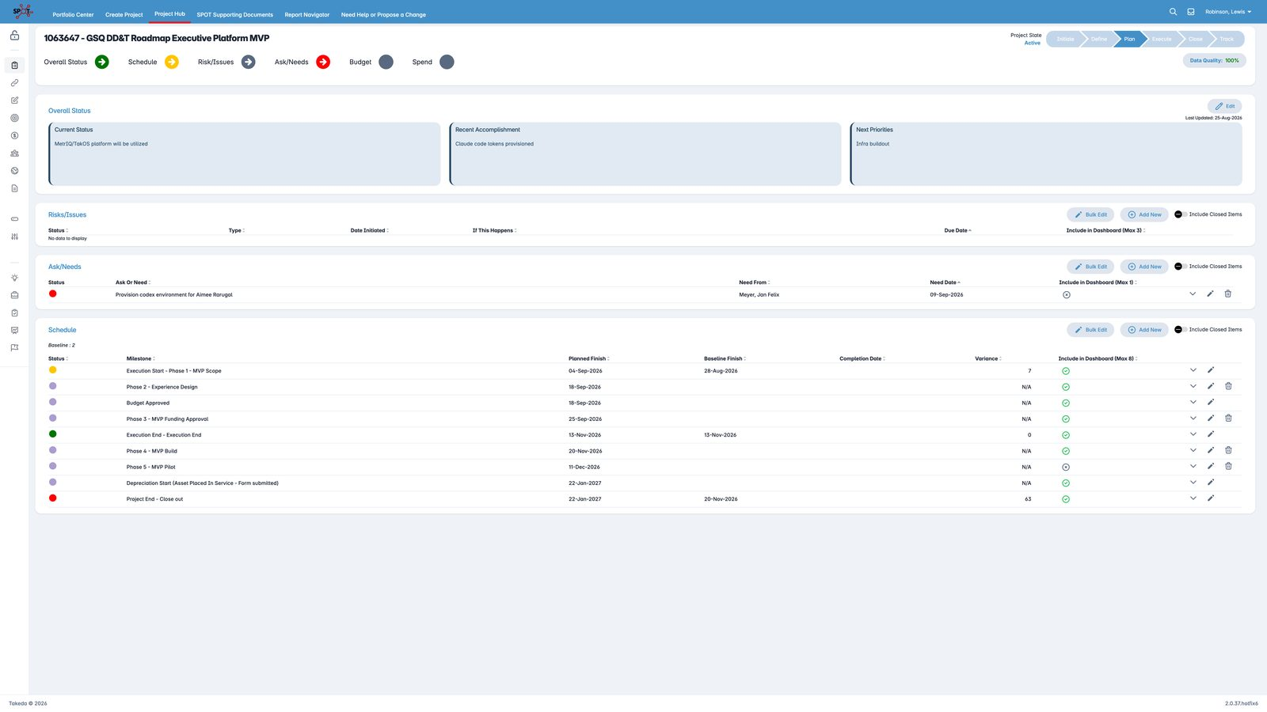
Figure 11. Delivery SPOT 1063647 — GSQ DD&T Roadmap Executive Platform MVP. Active, Plan phase. Overall on track; schedule yellow; Ask/Needs red (Codex for Aimee Rarugal). Milestones for Experience Design, Budget Approved, Funding, Build, and Pilot are already dated.

9.6 EDB consumption
Business case requires EDB in the MVP, not later. Use the published PostgREST style (GET v1-0-0/<table> , bearer token, {data, rowCount}) only through an approved data product. Until the steward names the tables, treat the Capability Tracker model as the semantic contract.

10. Security, classification, and compliance assumptions
These must be confirmed at Intake (FORM / TOOL-235299 four classifications). Working proposal for the portal (not for MES/LIMS themselves):
Dimension | Working call | Why | Confirm with
GxP | No (reporting / decision support; not batch record) | Portal does not release product | QA / Validation
Criticality | Medium | Used in leadership decisions | DPM
SOX | Review — budget figures may be SOX-relevant | Finance data in views | Finance / SOX
PII | Low — names, work emails | No patient or workforce sensitive HR | Privacy

Access
- Default deny. Entitlement by Entra group × site.
- Executives: all sites.
- Site Head / Site DD&T: home site (optional read-only other sites).
- Finance: financial entities only if licensed.
- Embeds inherit Power BI RLS; never pass a plant parameter that bypasses RLS.
Not in MVP: customer data, batch genealogy, lab results content (only capability *status*).

11. Technical architecture options
The business case funds a TakOS-enabled product. The user experience specified here is the existing Power App family. Delivery should not pretend those are different products.

11.1 Recommended path — one experience, two layers
Layer | Role | MVP
Experience layer | Executive Glass shell + tabs described above | Power Apps (fastest reuse of the three live apps) or TakOS UI if the POD is assigned immediately
Data layer | Dataverse (or TakOS store) + Jira/SPOT/EDB sync | Required either way
Presentation reuse | Embed / deep-link Capability Tracker and any report that already works | Required
Future | Rebuild shell in takOS Design System once Pattern-Fit and URS/FDS exist | Release 1 hardening

Do not rebuild One pager from scratch if the existing app can be parameterized by site and bound to Dataverse. Do rebuild storage: draft collections are not production.

11.2 Pattern-Fit working recommendation
Question | Working answer
Track | Product (intended use = executive portfolio + business review)
Reuse | Dashboard / embed / Dataverse patterns if listed in the catalogue; Jira/SPOT connectors if they exist
Likely path | Reuse with PCR or Custom Build for the combined Glass + three-source sync — Architect must complete FORM-316177
Justification if custom | No validated “GSQ executive glass” pattern today; prototypes are evidence, not a Pattern

11.3 Non-functional
NF | Target
Auth | Entra SSO, no extra password
Refresh | ≤ 60 minutes for Jira/SPOT; EDB per data-product SLA; commentary instant
Perf | Site tab interactive < 3 s after data cached
Browser | Edge / Chrome enterprise
Locale | English MVP; no mixed PT/EN strings
ALM | Dev → SIT → Prod solutions; no direct-prod edits
Observability | Sync failures visible on chrome (“Jira stale since …”)

12. MVP boundary and releases

12.1 In MVP (Release 1)
- Site selector across 18 sites (data may be thin outside THO, LEX, BRP).
- All tabs in §6.2 for Thousand Oaks with real Jira + SPOT + Capability embed.
- Combined Gantt + Budget and stand-alone Budget.
- Site input + Business Review freeze for TO.
- Network roadmap read-only for executives (may reuse the existing prototype/API).
- EDB path identified and at least one capability/adoption view populated for pilot plants (business case: EDB is not deferrable).
- English UX, audit trail, role security.

12.2 Out of MVP (Release 2–3)
- Write-back to Jira/SPOT.
- All 18 sites at TO-level mapping quality.
- AI executive briefing / auto-narrative.
- Full Claude Design → TakOS component rebuild of every tab.
- Mobile-native.
- Automated BR deck with video.

12.3 Explicit non-goals
- Replacing Jira, SPOT, or EDB.
- Becoming a GxP execution system.
- Pixel-perfect clone of every historical Power BI page.

13. Level of effort and people-hours
Hours are delivery hours (hands on keyboard + workshops + UAT), not elapsed calendar hours. They assume the business design package (this document) is accepted and a developer is funded. They include integration, not just screens.
Rates are indicative for a blended Takeda contractor / internal fully-loaded cost of USD 140 / hour. Replace with the official Marketplace rate card when the order is placed.

13.1 Estimate bands
Band | What you get | Hours | Calendar | Indicative $
A. Thin shell | Site selector + wrap existing four tabs + Jira deep links; no SPOT, no EDB, no Site input | 280–320 | 5–6 weeks · 1 FTE | ~$40–45k
B. Recommended MVP | Band A + Dataverse persistence + Budget + combined Gantt + Site input + TO Business Review + Jira sync + SPOT read + Capability embed | 1,040–1,160 | 10–12 weeks · ~2.4 FTE | ~$145–162k
C. Business-case full MVP | Band B + EDB data-product integration + network roadmap productionized + 3-site capability parity (THO, LEX, BRP) + UAT/hypercare | 1,360–1,520 | 12 weeks · ~3.0 FTE | ~$190–213k

Alignment to the business case: Section 1 quotes ~$168k, 6–12 weeks. Section 9 quotes ~$40k, 6 weeks. Those are different products. $40k is Band A only and cannot validate Jira + SPOT + EDB together. This blueprint recommends Band B funded at ~$168k, with EDB treated as a gated workstream inside the same engagement (if the EDB API is late, Capability embed still ships and EDB bind is the last increment).

13.2 Work breakdown — Band B (recommended)
ID | Workstream | Hours | Primary role
B1 | Kickoff, field workshop, status mapping, site master load | 40 | BA + PMO + Dev
B2 | Environment, solution, Entra groups, ALM | 32 | Dev
B3 | Dataverse model + audit + security roles | 80 | Dev
B4 | Jira connector + staging + status map | 80 | Dev / integration
B5 | SPOT connector + financial staging | 64 | Dev / integration
B6 | Executive Glass chrome + site selector + filters | 72 | Dev
B7 | One pager bound to Dataverse (replace collections) | 80 | Dev
B8 | Status KPIs live | 32 | Dev
B9 | Combined Gantt + Budget | 96 | Dev
B10 | Budget tab | 48 | Dev
B11 | Risks + Jira tab | 48 | Dev
B12 | Capability embed + plant parameter / RLS | 40 | Dev + PBI
B13 | Site input forms + Business Review + freeze | 88 | Dev
B14 | Network roadmap hookup (reuse prototype) | 40 | Dev
B15 | UX language cleanup, empty/error/stale states | 24 | Dev
B16 | Functional test + data reconciliation | 80 | Dev + BA
B17 | UAT (TO Site Head + sponsor) + defects | 64 | BA + Dev
B18 | Admin guide, 2-week hypercare | 40 | Dev
B19 | PM / coordination | 56 | PM
Total Band B |  | 1,104

13.3 Add-on to reach Band C
ID | Workstream | Hours
C1 | EDB data-product access, contract, first capability/integration views | 120
C2 | Productionize network roadmap (auth, hosting, ops) | 80
C3 | LEX + BRP mapping + capability parity | 48
C4 | Extra UAT / performance / security review | 48
Band C add |  | 296
Band C total |  | 1,400

13.4 Suggested team (Band B, 11 weeks)
Role | Allocation | Hours
Power Platform / front-end developer (lead) | 1.0 | 440
Integration / data engineer | 0.7 | 308
Power BI / embed | 0.2 | 88
Business analyst (GML) | 0.3 | 132
Product lead (Dean) | 0.15 | 66
PM | 0.15 | 70
Total | ~2.5 FTE | 1,104

13.5 Calendar (Band B)
Week | Outcome
1 | Access, site master, Jira field lock, Dataverse first cut
2–3 | Chrome + One pager + KPI on THO live Jira
4–5 | Gantt+Budget + Budget tab + SPOT
6 | Risks, Jira tab, Capability embed
7 | Site input + Business Review freeze
8 | Network view + security + stale states
9 | UAT round 1, data fixes
10 | UAT round 2, admin guide
11 | Pilot BR + hypercare start

Critical path: Jira + SPOT API access (week 1). If either is blocked, the calendar slips one-for-one.

13.6 What is *not* in these hours
- Creating a new SPOT project (1063647 already exists), AIDPG Initiative, Pattern-Fit, URS/FDS, or Marketplace order (business / onboarding — see companion).
- New EDB modeling if no data product exists (that is a data-platform initiative; C1 assumes a consumable API).
- Full TakOS Design System rewrite of every screen (add 400–600 hours / Release 2).
- Rolling mapping quality to all 18 sites (Release 2; ~20–30 hours per site of PMO time, not engineering).

14. Risks (delivery of the platform)
Risk | L | I | Control
Jira/SPOT/EDB incomplete or inaccessible | M | H | Week-1 field workshop; chrome stale banner; Capability embed as EDB fallback
$40k scope assumed by finance vs. $168k needed | H | H | Use this WBS in the Marketplace order; reconcile business-case §9
Site selector ships but mappings only exist for TO | M | M | Pilot acceptance = TO; others show honest empty states
Dual-write temptation (edit Jira in the app) | M | H | Refuse in MVP; mapping table only
Executive non-adoption | M | H | Run one real TO BR from the portal as the exit criterion
Unclear GxP/SOX classification | M | H | Confirm at Intake before Design Gate
Ownership after MVP | M | H | Name product owner + ops alias before hypercare ends

15. Acceptance criteria (MVP)
- A user with TO Site Head role opens the portal, sees Thousand Oaks pre-selected, and can switch to Lexington and get a different One pager.
- One pager, KPIs, Gantt+Budget, Budget, Risks, Jira, Capability, Business Review, and Site input all honor that site.
- TO MES Elaprase DS shows the same Jira key, SPOT ID, and dates in sidecar, Gantt, Budget, and Jira tab.
- Budget totals for the pilot site reconcile to SPOT within agreed tolerance.
- Capability tab for LEX and BRP matches the current tracker after equivalent filters.
- Site Head can save commentary and a leadership ask; both appear on Business Review; audit shows name and time.
- Dragging a card on the One pager does not change Jira; it changes project_map only.
- Freshness is visible; a failed Jira sync does not show silent old data as current.
- One TO business review is completed from the portal; freeze pack stored.
- Security: a BRP-only user cannot see TO financials.

16. Dependencies the delivery team will need on day 1
Dependency | Owner | Needed by
Power Platform environment + premium licenses | DD&T / IT | Week 1
Entra groups per role × site | IAM + Dean | Week 1
Jira project read (DDTGMPORT + site projects) | Jira admin | Week 1
SPOT API / report access for manufacturing IDs and platform SPOT 1063647 | SPOT admin | Week 1
Power BI embed for Capability Tracker | BI owner | Week 2
EDB data-product steward + env | EDB / AI&D | Week 2–3
Site Head (TO) UAT time | Site leadership | Week 9–10
TakOS / Marketplace POD (if that is the funded builder) | Marketplace | After order

17. Open questions (do not block funding; lock in week 1)
- Confirm GxP = No and SOX treatment of budget tiles.
- Exact Jira custom fields for site, SPOT ID, go-live.
- SPOT API vs. extract; currency and FY split grain.
- EDB table names for capability/integration; or stay on the Power BI model for MVP.
- Whether Network mode is in the same app or a linked executive app.
- Who owns project_map after PMO (site digital vs. global PMO).
- Official Marketplace rate card and whether Band B or Band C is the order.

18. Document history
Version | Date | Author | Notes
1.0 | 4 Sep 2026 | GML business design (from MVP v2 business case, live Power Apps, Capability Tracker, global roadmap, TakOS onboarding guide) | First complete Business Design Package
1.1 | 4 Sep 2026 | GML | Recorded live delivery SPOT 1063647 (board, team, value, milestones, CAPEX mismatch)
1.2 | 4 Sep 2026 | GML | Embedded live screenshots of the One pager, Budget, combined Gantt+Budget, network roadmap (Global / Sites / Initiatives / Regions), Capability Tracker, Power BI THO Gantt, and SPOT 1063647, placed in both the current-state inventory and the matching view specs
1.3 | 4 Sep 2026 | GML | Added target-state mockups of the new Executive Platform (One pager with site selector, Gantt + Budget in the Glass, Business Review, Site input)

