GSQ DD&T Executive Platform

Executive design extract — selected sections
Field | Value
Product | GSQ DD&T Roadmap Executive Platform (Single Pane of Glass)
Document type | Executive extract of the Business Design Package
Date | 8 September 2026
Executive sponsor | Joel Vincent
Business sponsor / product lead | Dean Santoro
Owning organization | Global Manufacturing & Labs DD&T
Source | *Design Blueprint* v1.3 — sections 1, 3, 5, 6.4, 12, 13, 15, 16
Status | For leadership review; not a controlled Veeva record

This is the executive cut of the design package: purpose, what already exists (with live screenshots), the information architecture, target-state mockups, MVP boundary, hours, acceptance, and day-1 dependencies. The full blueprint remains the developer specification.

1. Purpose of this blueprint
Leadership currently prepares business reviews by stitching Jira boards, SPOT investment views, site Power Apps, Power BI trackers, and PowerPoint. The Executive Platform is a single portal of truth: one site-aware shell that presents the 1,000-foot portfolio, then drills into the detailed views that already exist, plus the Budget and Site Head input that are missing today.
This extract covers purpose, current-state screenshots, the information architecture, target-state mockups, MVP boundary, hours, acceptance, and day-1 dependencies.
This package does not build the dashboards. It is the leadership cut used with the business-case document to fund a developer resource.
Figures 1–10 are live source experiences captured 4 September 2026. Figures 12–15 are target-state mockups. Figures S1–S3 are executive diagrams.

Figures in this package
Figure | What it shows | Section
1 | Thousand Oaks One pager Power App | §3.1
2 | DD&T MYC Budget 2026 Power App | §3.2
3 | Combined Gantt + Budget Power App | §3.3
4–7 | Network Global / Sites / Initiatives / Regions | §3.4
8 | Existing Power BI THO Gantt (do not rebuild) | §3.4
9–10 | Capability Tracker (Lexington / Brooklyn Park) | §3.5
S1 | Single-pane schematic | §3.7
S2 | Canonical hierarchy | §5
12–15 | Target mockups (One pager, Gantt+Budget, Business Review, Site input) | §6.4
S3 | Effort bands and Band B calendar | §13

3. Current-state inventory (what already exists)
The platform reuses these assets as the 1,000-foot experience and as drill-down destinations. They are the UX specification, not disposable sketches.

3.1 Thousand Oaks Strategic Roadmap Power App — 1,000-foot view
Item | Value
Play URL | https://apps.powerapps.com/play/e/13ab3896-86ac-e9d1-8a83-257843921f13/app/83afccd8-23f4-4ba1-9416-9059f69cd304
App ID | 83afccd8-23f4-4ba1-9416-9059f69cd304
Environment | 13ab3896-86ac-e9d1-8a83-257843921f13
Tenant | 57fdf63b-7e22-45a3-83dc-d37003163aae
Layout | Tablet, 1920 × 1080
Local recreation / .msapp | ~/RoadmapExecutivePlatform and takOS/Roadmap Executive Platform

What it already does
- Header branded Thousand Oaks (hard-coded; must become a network site selector).
- Tabs: One pager · Status KPIs · Gantt · Risks · Jira Links.
- Filters: search, fiscal year, North Star platform, status, Big Rock / capability.
- One pager: six Big Rocks across the top; FY2026 / FY2027 / FY2028+ swimlanes; project cards with status dots; drag-and-drop between year × Big Rock cells.
- Project sidecar: owner, description, business value, dependencies, milestones, progress, Jira link, “move project” control.
- North Star rail: SAIL, LPMS, APMS, RTMS, COMOS, Smart QC, LabX, Veeva eQMS, Discoverant, OpsTrakker, SIMCA Online (plus MES / SAP on cards).
- Footer: key challenges (Communication · Change Management · Leadership Engagement) and status legend.
- Open Jira board action.
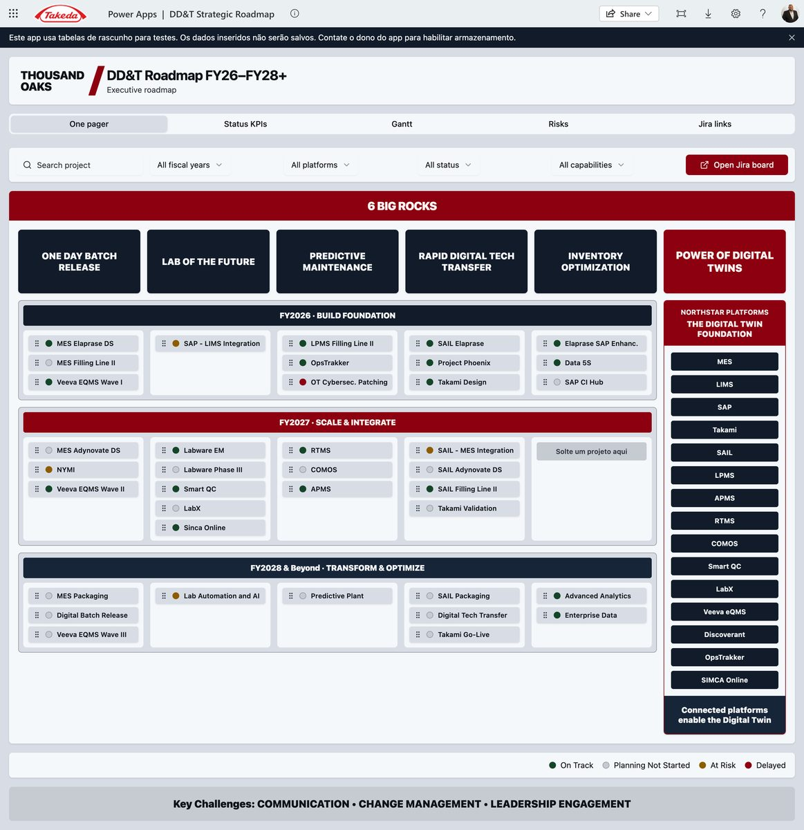
Figure 1. Current 1,000-foot One pager — Thousand Oaks is hard-coded. The red tab row (One pager, Status KPIs, Gantt, Risks, Jira links) and the six Big Rocks × FY swimlanes are the shell the network portal must keep. The site name becomes a drop-down; Budget is added as a tab.
What is wrong or missing for a network portal
- Site is not a filter. All data is Thousand Oaks sample / draft collections (colProjects). Changes do not persist.
- No Budget tab.
- Gantt is year-band only; it is not combined with budget, actuals, or SPOT IDs.
- Status vocabulary does not yet match the global DDT roadmap RAG.
- No Site Head commentary, no audit trail, no role-based edit.

3.2 Budget Power App (missing tab — reuse this pattern)
Item | Value
Play URL | https://apps.powerapps.com/play/e/d99720be-f155-e674-86b3-32acc687394e/app/c683f980-1fb1-4917-b70c-34496646e6d3
Environment | d99720be-f155-e674-86b3-32acc687394e

This is the starting visual for the new Budget tab: investment vs. forecast vs. actual, by initiative / project / fiscal year, for the selected site. Live title: DD&T MYC Budget 2026 (Thousand Oaks mid-year cycle). In the Glass, the same layout is filtered by the header site selector.
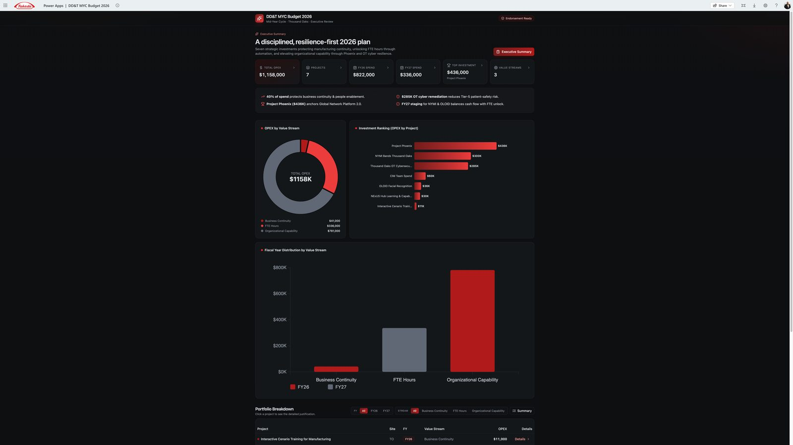
Figure 2. Budget tab source — DD&T MYC Budget 2026. KPI strip, OPEX by value stream, investment ranking, FY split, and a project table with Details drill-down. Reuse this pattern; bind it to SPOT and the selected site.

3.3 Combined Budget + Gantt Power App (target Gantt tab)
Item | Value
Play URL | https://apps.powerapps.com/play/e/d99720be-f155-e674-86b3-32acc687394e/app/5d55a550-7d80-469a-84bc-bee2f53a08b3

The production Gantt tab must look and behave like this app: timeline bars and budget/actuals on the same row, not two disconnected screens. Left = site roadmap by workstream (MES, SAIL, Paperless, …) with SPOT IDs on the bars. Right = the MYC Budget executive panel for the same site.
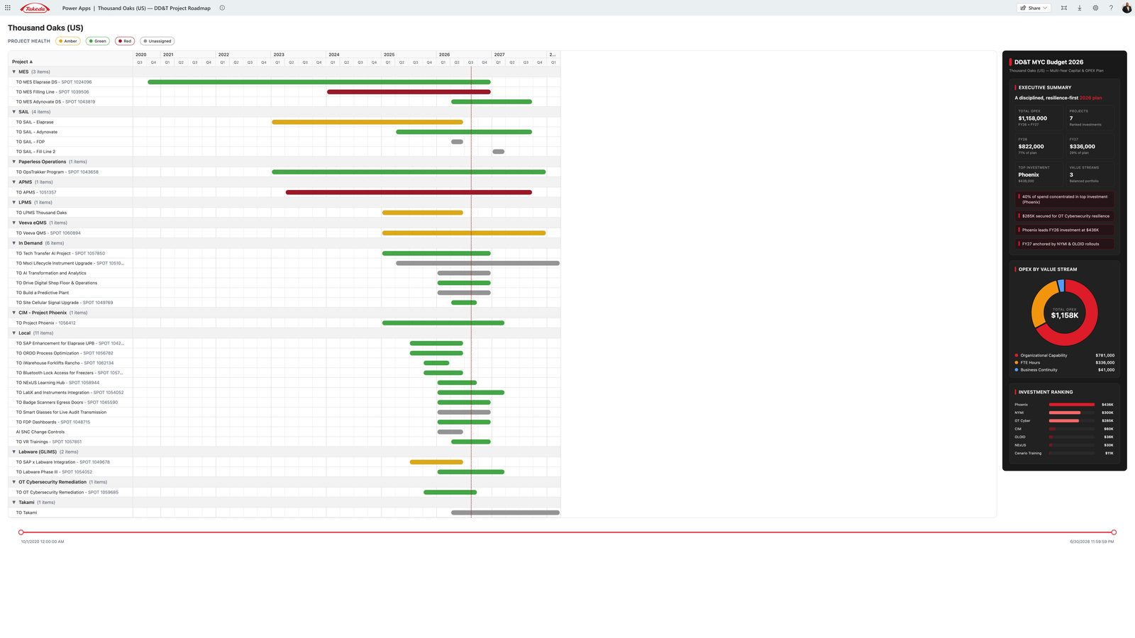
Figure 3. Target Gantt + Budget — Thousand Oaks DD&T Project Roadmap with the MYC Budget 2026 sidebar on the same screen. This is the combined view the thin One-pager Gantt tab must become.

3.4 Global DDT Roadmap (network 1,000-foot evidence)
Prototype URL pattern 100.64.0.2:3000 with tabs Overview · Global Roadmap · Initiatives · Regions · Sites · Data. Snapshot as of 31 Aug 2026:
- 34 programmes · 573 projects · 92 at risk
- Timeline FY24–FY30 with per-site go-lives
- Status glyphs: On Track · Monitor Closely · Leadership Attention Required · Blocked Pending Dependency · No Status · Complete · Cancelled
- Programme health is rolled up from linked projects (no authored initiative RAG in the feed)
- Site-led work is a first-class lane (329+ items), not hidden
This is the network reading of the same portfolio the site Power App shows for one plant. The Executive Platform must be able to show both: one site (business review) and all sites (GSQ leadership). Clicking a site code (THO, LEX, …) sets the Glass site selector.
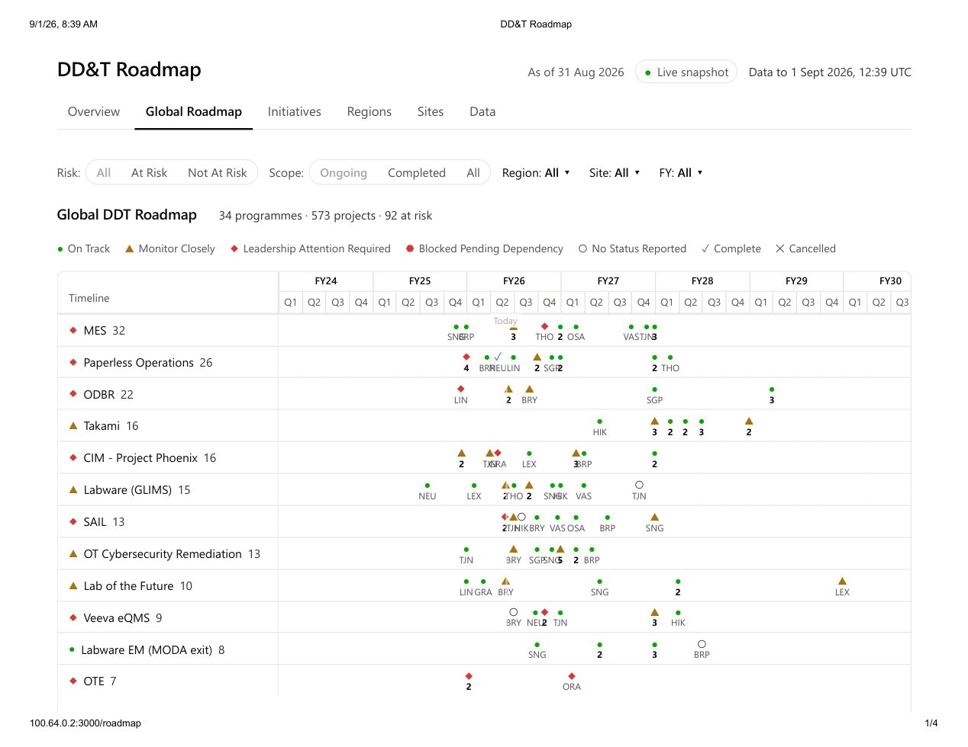
Figure 4. Network Global Roadmap — 34 programmes, 573 projects, FY24–FY30, per-site go-live glyphs. This is the executive Network mode.
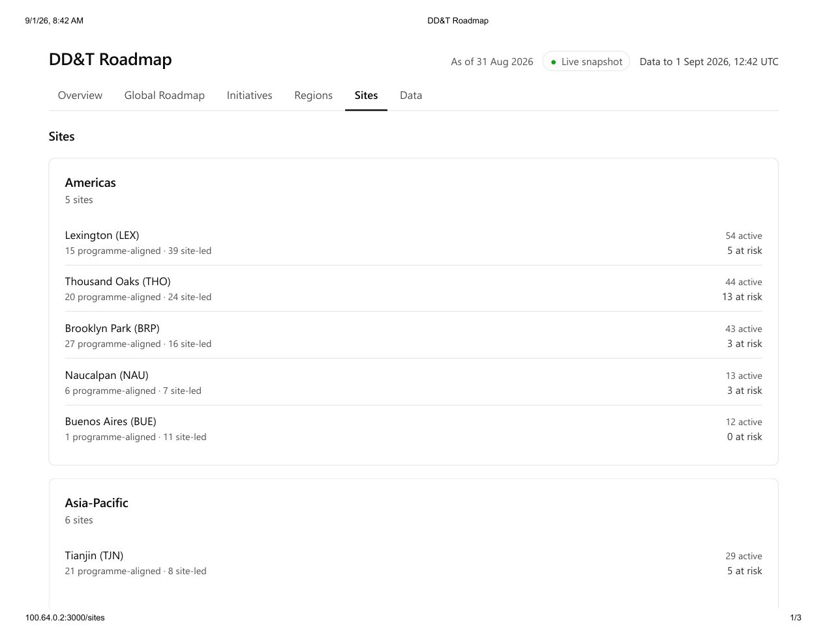
Figure 5. Network Sites roll-up — Americas / Asia-Pacific / Europe with programme-aligned vs site-led counts. THO shows 44 active / 13 at risk.
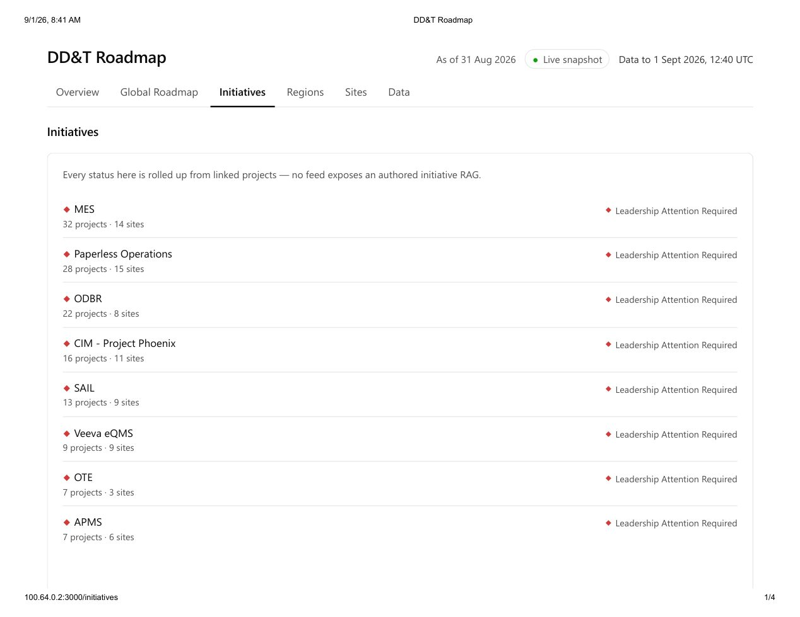
Figure 6. Network Initiatives — every status is rolled up from linked projects. MES 32 / Paperless 28 / ODBR 22 all show Leadership Attention Required.
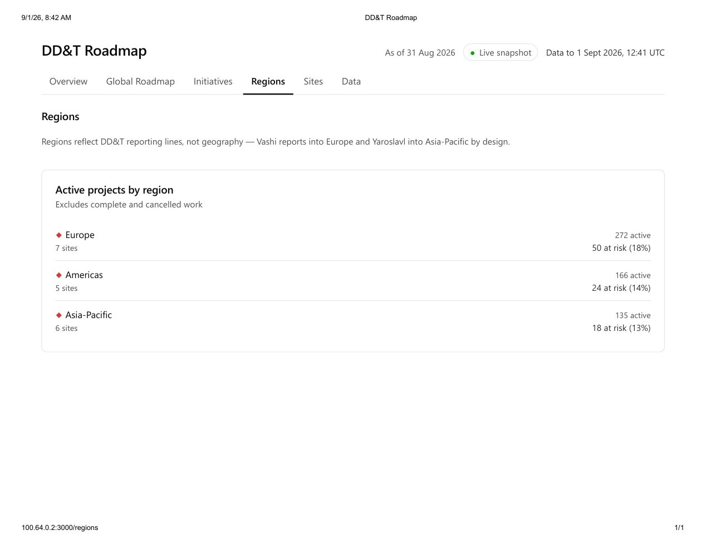
Figure 7. Network Regions — DD&T reporting lines, not geography (Vashi→Europe, Yaroslavl→APAC). Europe 272 active / 50 at risk; Americas 166 / 24; APAC 135 / 18.
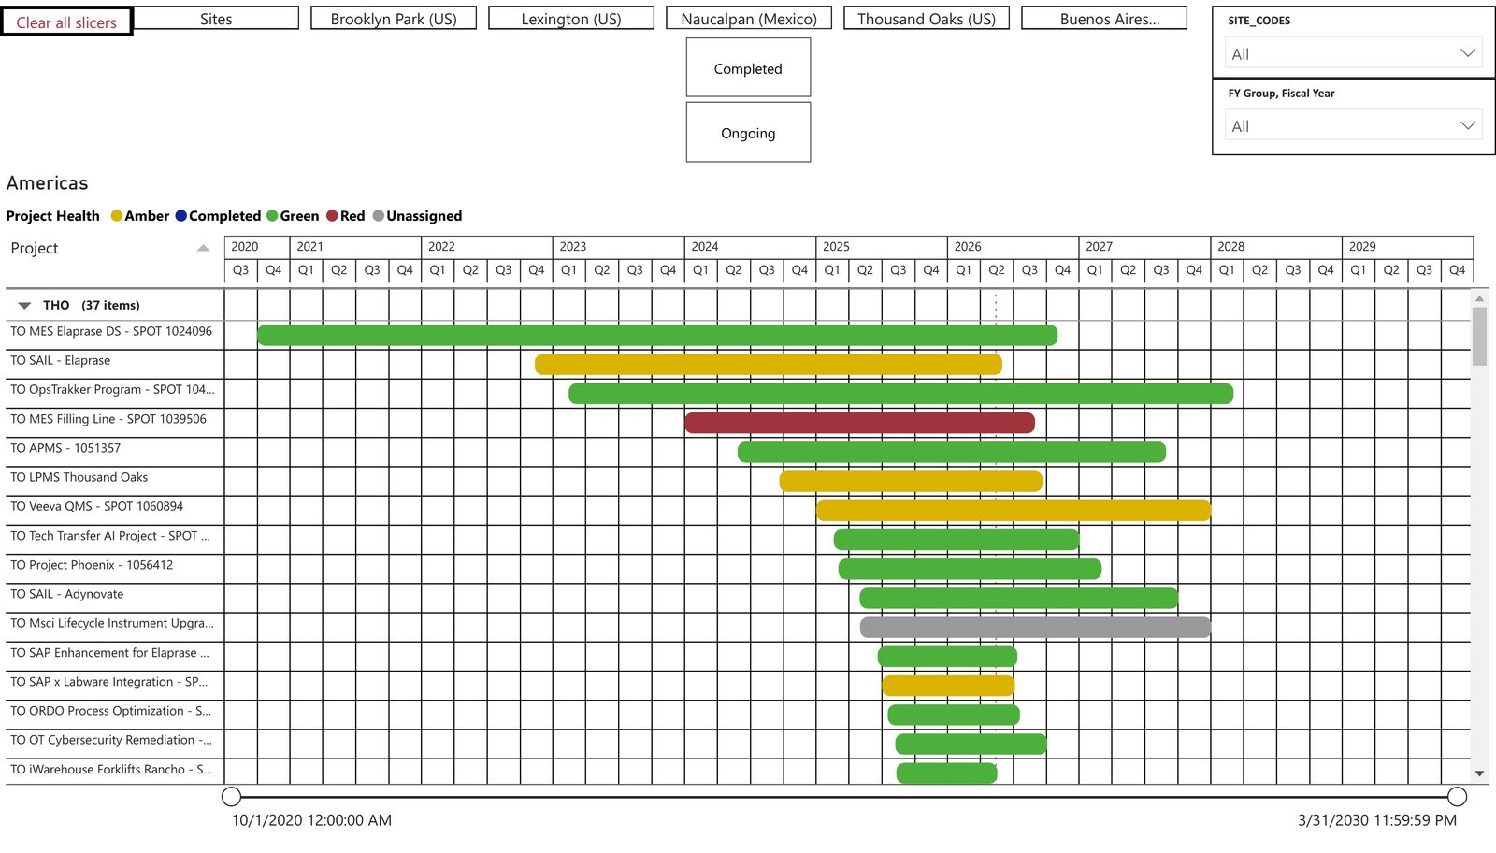
Figure 8. Existing Power BI site Gantt (Thousand Oaks) — the same portfolio the combined Power App in Figure 3 already presents more clearly. Do not rebuild this view.

3.5 Capability Tracker (Power BI) — North Star / EDB-style drill-down
Two screens exist in Capability Tracker.pdf:
Screen A — plant summary (example: Lexington)
- Filters: Plant, Global Initiative Yes/No
- Capability KPIs: 48 total · 31.96% deployed · 26.21% adopted
- Integration KPIs: 23 total · 47.83% deployed · 45.65% adopted
- Donuts: Fully Deployed & Adopted / Pending / Deployed, Not Fully Adopted
- Bar: capabilities on a global initiative vs. local
- Footer: SAIL deployed plants (Brooklyn Park, Lexington, Linz, Osaka, Thousand Oaks)
Screen B — all capabilities (example: Brooklyn Park)
- Site capability score (49.30) and health line: capabilities complete 29/47 · integrations complete 7/19
- Funnel: Total → Fully Deployed → Fully Adopted → Both
- Pending integrations table (e.g. Batch Release: Floor Scales → LabX, LabWare ↔ MES, MES ↔ SAIL, SAP → RTMS, Veeva ↔ SAP)
- Completed capabilities list
This is the system-integration and adoption detail that the 1,000-foot roadmap does not show. The Capability tab embeds this report and passes the Glass plant filter.
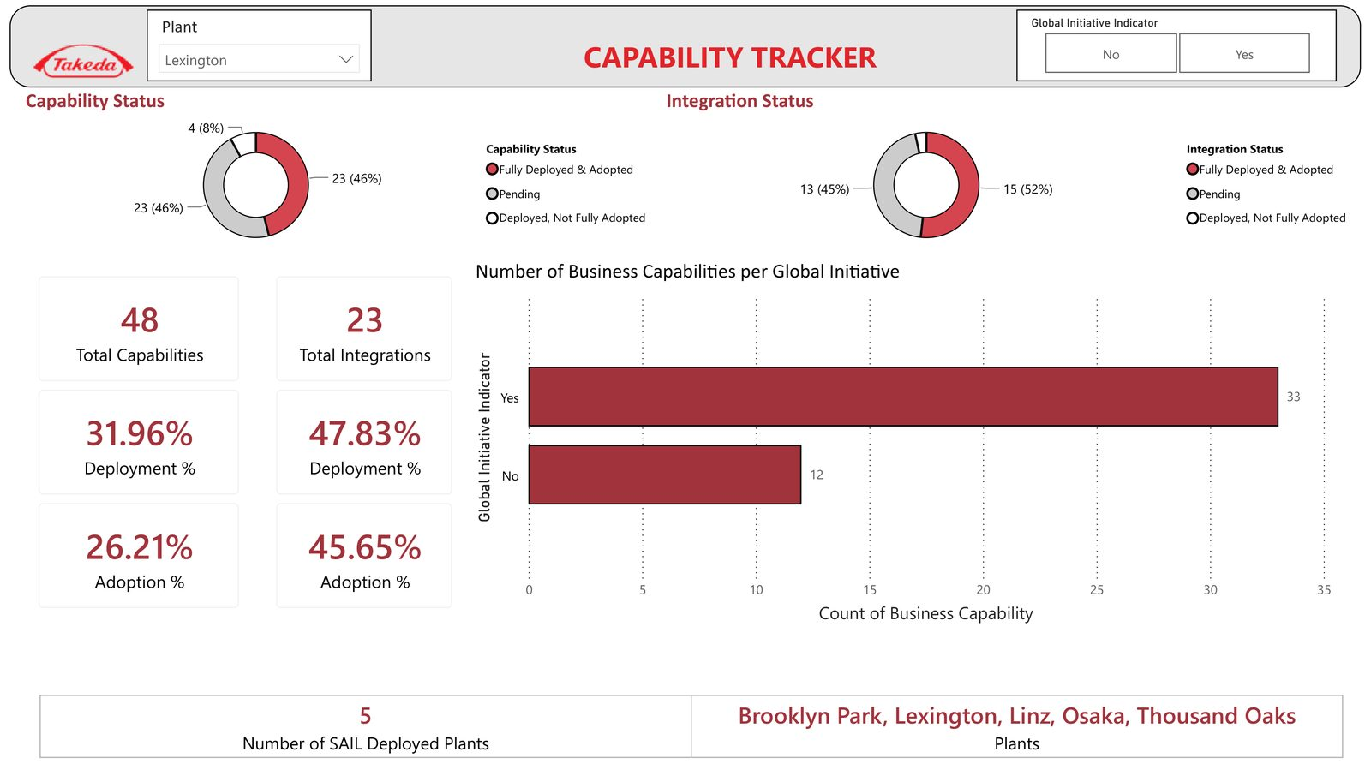
Figure 9. Capability Tracker — plant summary (Lexington). Deploy/adopt KPIs, status donuts, global-initiative split, SAIL deployed plants.
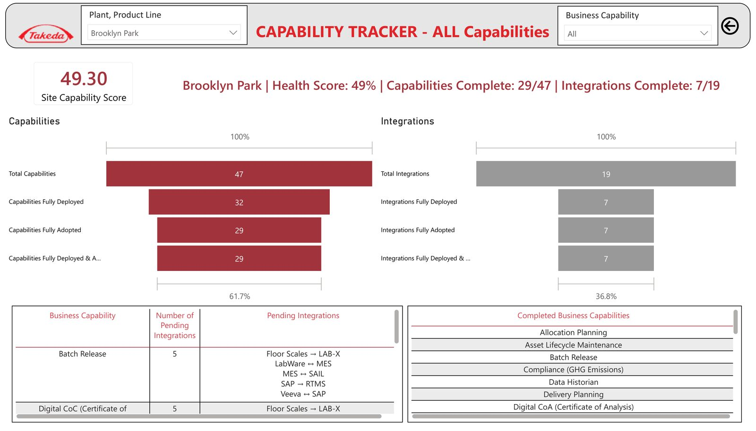
Figure 10. Capability Tracker — all capabilities (Brooklyn Park). Site score, deploy/adopt funnels, pending integration pairs (MES ↔ SAIL, Veeva ↔ SAP), completed capabilities.

3.6 Jira portfolio already in use
DDTGMPORT holds the GSQ initiative set (MES, ODBR, Paperless Operations, Takami, Phoenix, Labware, SAIL, OT Cyber, etc.). Site projects (e.g. DDTTO-*, DDTBP-*) and SPOT IDs (e.g. TO MES Elaprase DS — SPOT 1024096) already exist. That Jira estate is a data source, not the delivery Initiative for *this* platform (see the onboarding companion).

3.7 What “single pane of glass” means
┌──────────────────────────────────────────────────────────────────────────┐
│ EXECUTIVE GLASS (one Power App / later TakOS shell) │
│ Site selector · FY · Big Rock · Platform · Risk · Role │
│ │
│ [One pager] [KPIs] [Gantt+Budget] [Budget] [Risks] [Jira] [Capability] │
│ [Business Review] [Site input] [Network roadmap] │
│ │
│ embeds / launches existing Power Apps, Power BI, Jira, SPOT │
│ writes Site Head commentary to Dataverse (system of record) │
└──────────────────────────────────────────────────────────────────────────┘
│ │ │
Jira / DDTGMPORT SPOT investment EDB / Capability
delivery + RAG $ + milestones deploy / adopt
Executives never leave the portal to “find the other dashboard.” Site context set in the header applies to every tab.
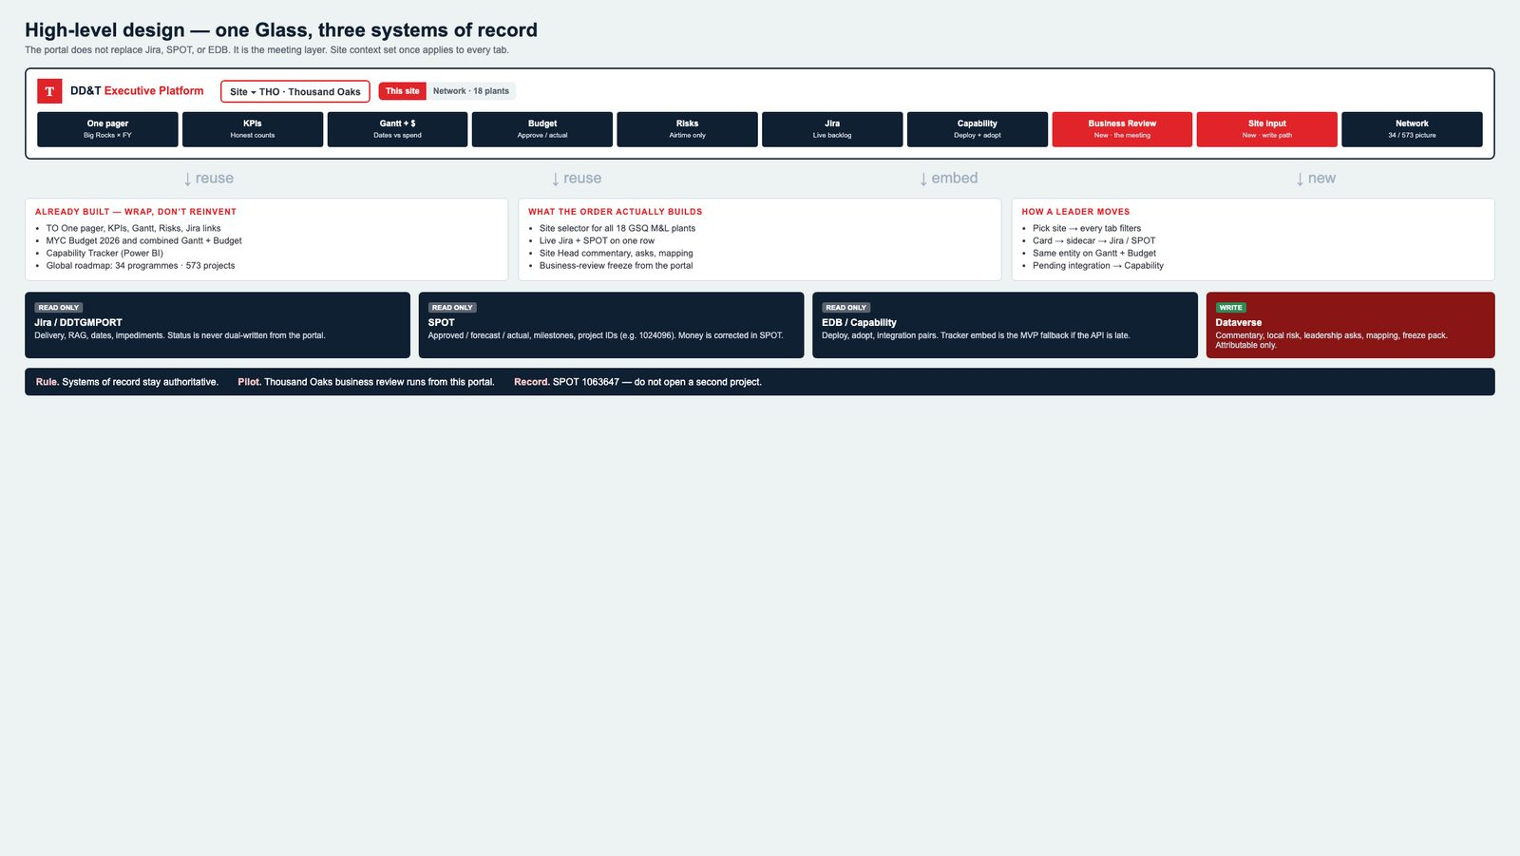
Figure S1. Single pane of glass — one site-aware shell, ten views, three read-only systems of record, one Dataverse write path.

5. Canonical information architecture

5.1 Hierarchy
GSQ Network
└─ Region (Americas / Europe / Asia-Pacific) ← DD&T reporting line, not geography
└─ Site (e.g. Thousand Oaks / THO)
└─ Big Rock (6 strategic capabilities)
└─ North Star Platform (MES, SAIL, Labware, …)
└─ Initiative / Programme (DDTGMPORT-*)
└─ Site project (DDTTO-*, SPOT ID)
└─ Milestone / go-live
└─ Risk / impediment
└─ Budget line (SPOT)
└─ Capability / integration (EDB)
Reporting-line exception (already in the global roadmap): Vashi reports into Europe; Yaroslavl reports into Asia-Pacific. The site master must store reporting_region, not infer it from country.
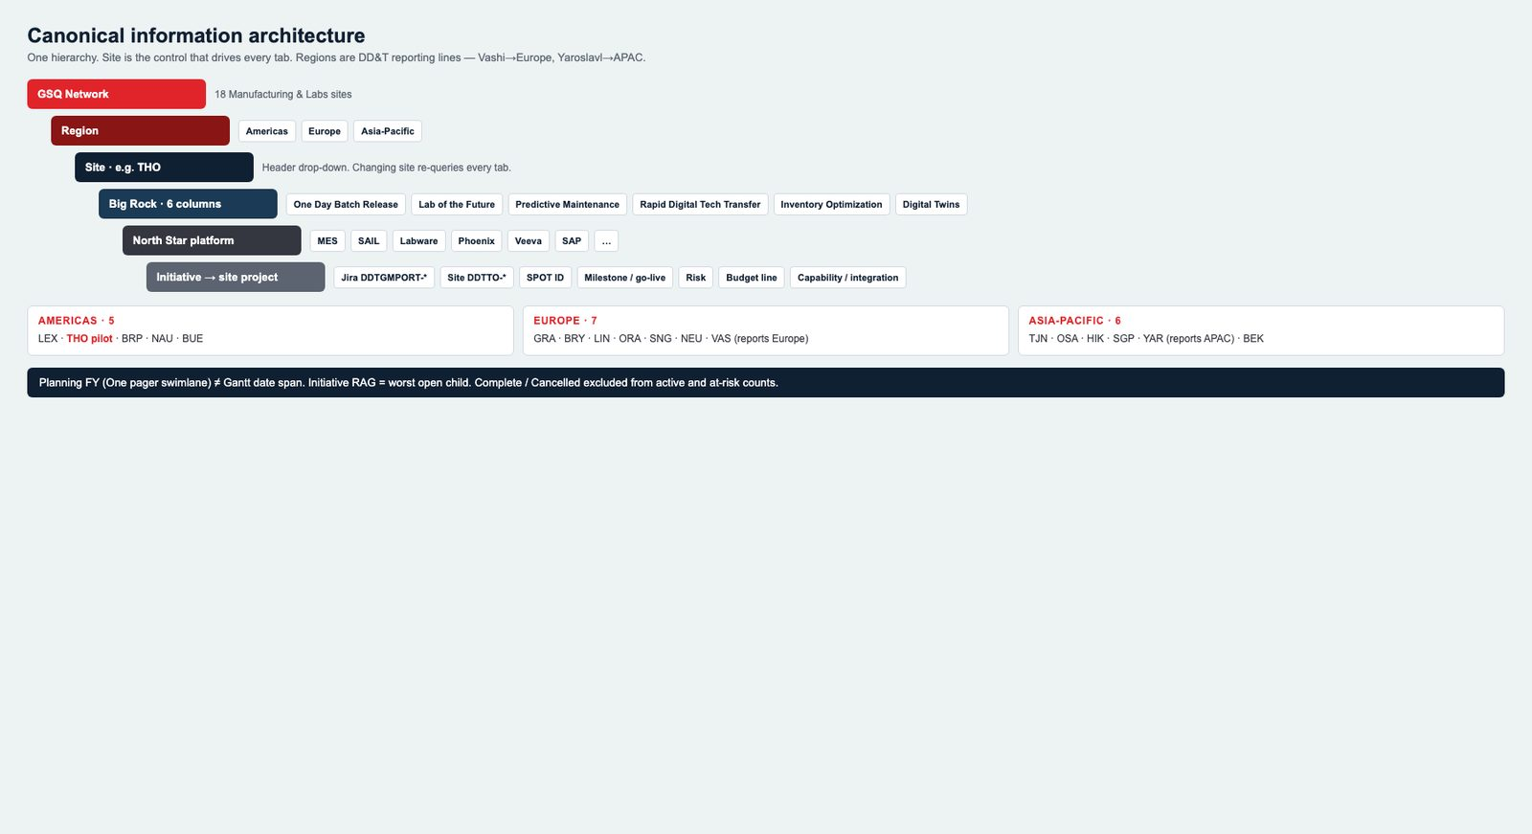
Figure S2. Canonical hierarchy — Network → Region → Site → Big Rock → North Star platform → initiative / site project. THO is the business-review pilot.

5.2 Site master (network of 18)
Region | Site | Code | Notes for MVP
Americas | Lexington | LEX | Capability Tracker already live
Americas | Thousand Oaks | THO | Business-review pilot
Americas | Brooklyn Park | BRP | Capability Tracker already live
Americas | Naucalpan | NAU
Americas | Buenos Aires | BUE
Asia-Pacific | Tianjin | TJN
Asia-Pacific | Osaka | OSA | SAIL deployed
Asia-Pacific | Hikari | HIK
Asia-Pacific | Singapore | SGP
Asia-Pacific | Yaroslavl | YAR | Reports to APAC; high site-led share
Asia-Pacific | Bekasi | BEK
Europe | Grange Castle | GRA | Largest site-led volume
Europe | Bray | BRY
Europe | Linz | LIN | SAIL deployed
Europe | Oranienburg | ORA
Europe | Singen | SNG
Europe | Neuchatel | NEU
Europe | Vashi | VAS | Reports to Europe

Header control: Site (required). Optional second control: Network / All sites for GSQ executives. Changing Site re-queries every tab; it does not open a different app.

5.3 Six Big Rocks (One pager columns)
ID | Label | Typical North Star platforms
one-day-batch-release | One Day Batch Release | MES, Veeva eQMS, Smart QC, NYMI
lab-of-the-future | Lab of the Future | Labware (GLIMS/EM), LabX, Smart QC, SIMCA Online
predictive-maintenance | Predictive Maintenance | LPMS, RTMS, APMS, COMOS, OpsTrakker
rapid-digital-tech-transfer | Rapid Digital Tech Transfer | SAIL, Takami, Phoenix
inventory-optimization | Inventory Optimization | SAP, Takami, warehouse / RTMS
digital-twin | Power of Digital Twins | Discoverant, Enterprise Data, SIMCA, digital twin use cases

A project belongs to exactly one Big Rock for the One pager (primary). It may tag additional platforms.

5.4 Canonical status (must map all three current vocabularies)
Canonical | TO Power App today | Global roadmap | Power BI | Color / glyph
on_track | On Track | On Track | Green | Green circle
monitor | At Risk (split) | Monitor Closely | Amber | Amber triangle
leadership | Delayed / At Risk (split) | Leadership Attention Required | Red | Red diamond
blocked | — | Blocked Pending Dependency | Red | Solid red
planning | Planning Not Started | No Status Reported (if no RAG) | Unassigned | Grey hollow
complete | — | Complete | Completed | Blue check
cancelled | — | Cancelled | — | Grey X

Roll-up rule (already proven on the global roadmap, keep it):
- Initiative RAG = worst open child project (Leadership > Blocked > Monitor > On Track).
- Do not allow an authored initiative RAG that contradicts children.
- Complete and Cancelled are excluded from “active” and “at risk” counts.

5.5 Fiscal time
- Fiscal year labels FY26, FY27, FY28+ on the site One pager.
- Network Gantt may span FY24–FY30 (global roadmap already does).
- “Today” marker is required on every Gantt.
- A project’s planning FY (One pager swimlane) and date span (Gantt start / go-live) are different fields. Do not collapse them.

6. Target-state mockups (what Band B builds)
These four screens are the new platform, not the current Power Apps. Same Takeda chrome on every tab: product title, site drop-down (replaces hard-coded Thousand Oaks), This site / Network, source freshness, and the full tab row. Live apps in Figures 1–3 are the visual DNA; these mockups show how that DNA sits in one Glass.
What changed versus today
- Site is a control, not a title.
- Tabs add Budget, Gantt + Budget (replaces thin Gantt), Capability, Business Review, Site input, Network.
- Sidecar actions jump inside the Glass (Gantt + Budget, Capability) instead of forcing a second app hunt.
- Business Review and Site input do not exist in the current Power Apps — they are new.
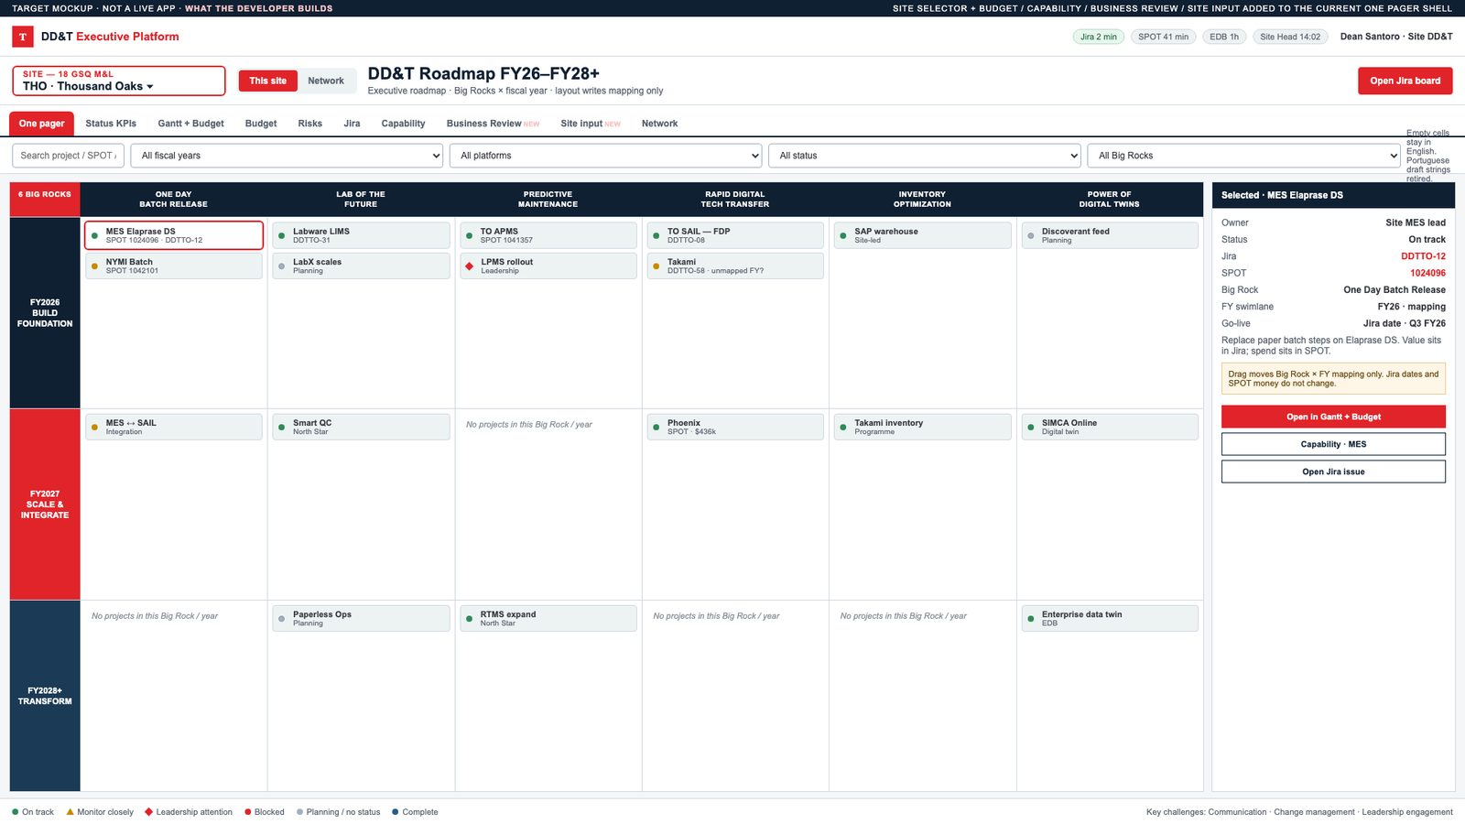
Figure 12. Target mockup — One pager in the Executive Platform. Site selector (THO · Thousand Oaks), This site / Network, full tab row, six Big Rocks × FY26–FY28+, sidecar with Jira + SPOT + Open in Gantt + Budget. Layout writes mapping only.
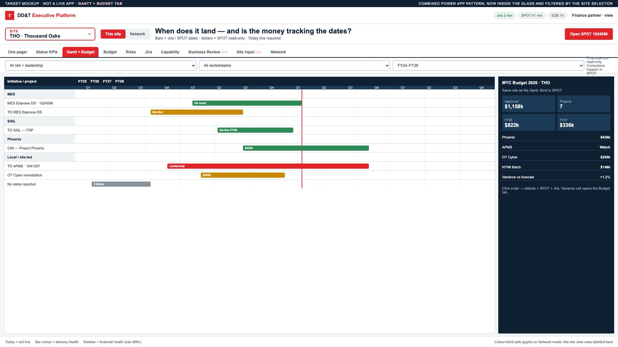
Figure 13. Target mockup — Gantt + Budget tab. Site-filtered timeline with Today line; MYC Budget 2026 sidebar bound to SPOT. Financials read-only.
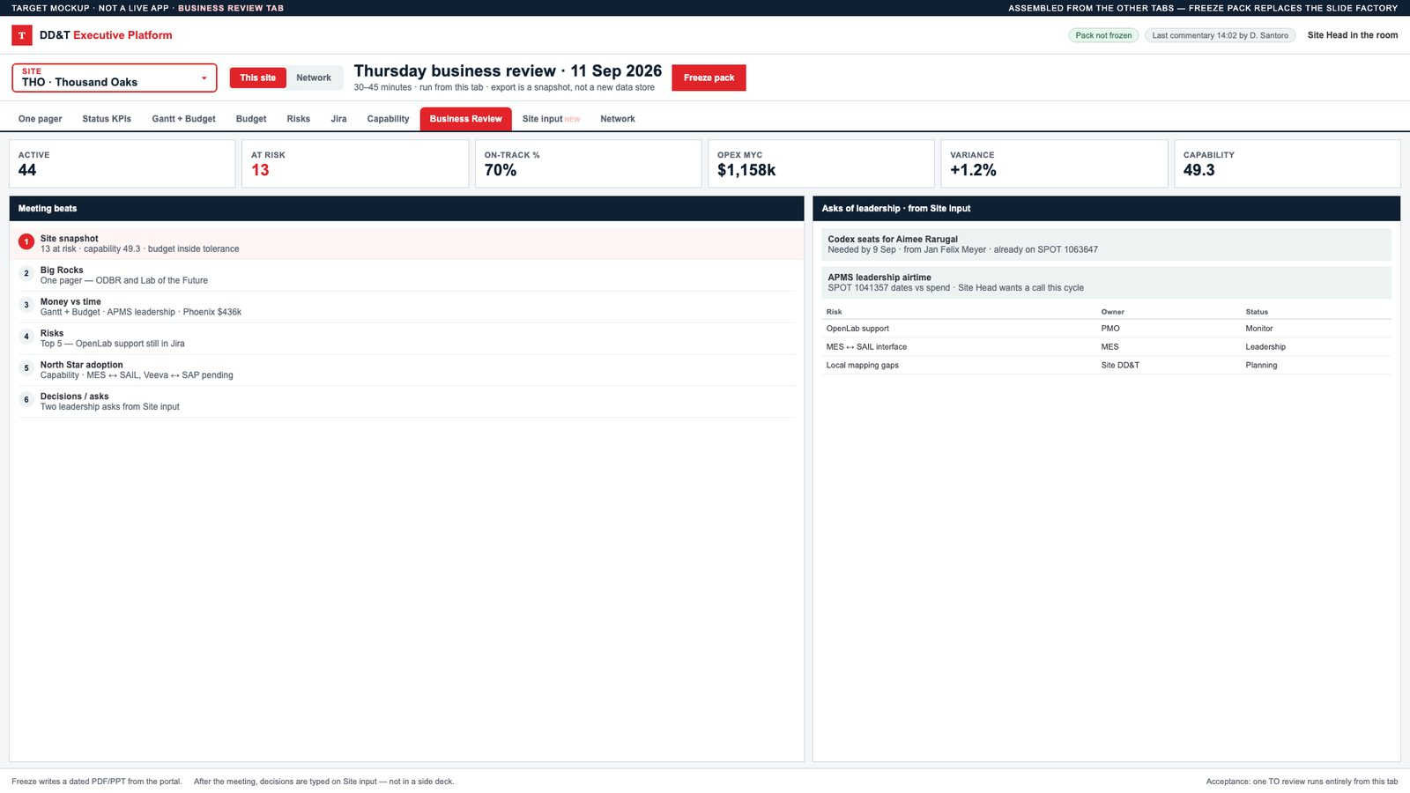
Figure 14. Target mockup — Business Review tab (new). Six meeting beats, KPI strip, leadership asks from Site input, Freeze pack. This is the slide-factory replacement.
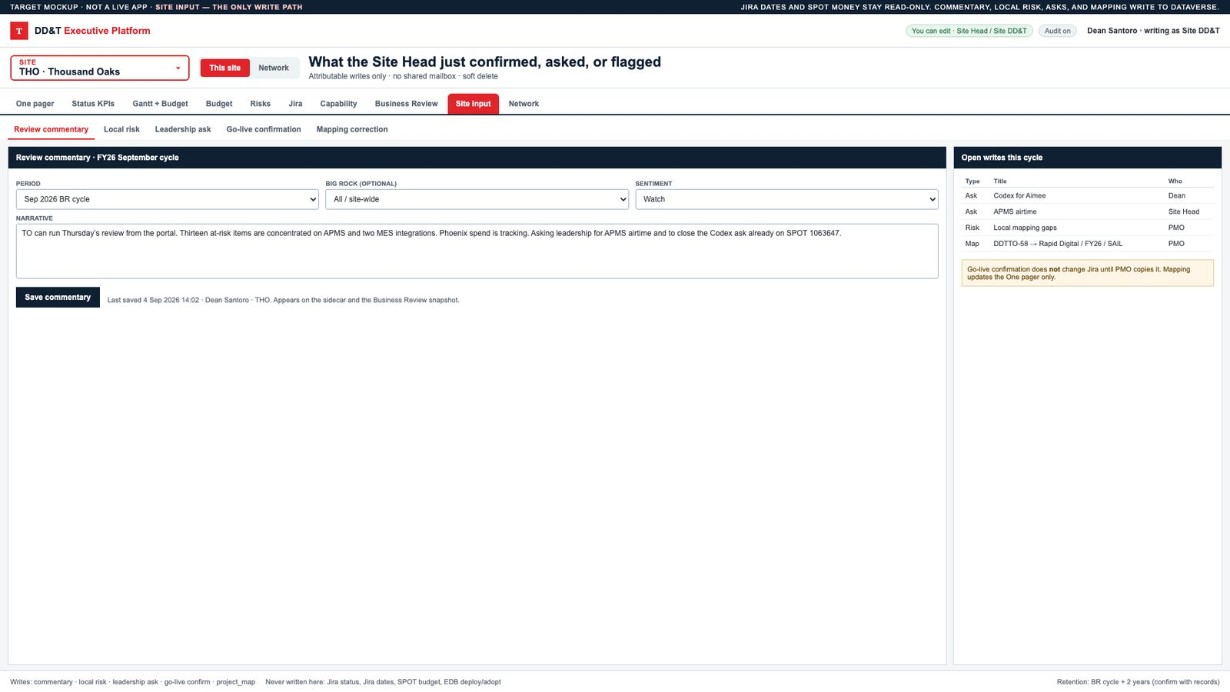
Figure 15. Target mockup — Site input tab (new). The only write path: commentary, local risk, leadership ask, go-live confirm, mapping. Jira dates and SPOT money are never written here.

12. MVP boundary and releases

12.1 In MVP (Release 1)
- Site selector across 18 sites (data may be thin outside THO, LEX, BRP).
- All tabs in §6.2 for Thousand Oaks with real Jira + SPOT + Capability embed.
- Combined Gantt + Budget and stand-alone Budget.
- Site input + Business Review freeze for TO.
- Network roadmap read-only for executives (may reuse the existing prototype/API).
- EDB path identified and at least one capability/adoption view populated for pilot plants (business case: EDB is not deferrable).
- English UX, audit trail, role security.

12.2 Out of MVP (Release 2–3)
- Write-back to Jira/SPOT.
- All 18 sites at TO-level mapping quality.
- AI executive briefing / auto-narrative.
- Full Claude Design → TakOS component rebuild of every tab.
- Mobile-native.
- Automated BR deck with video.

12.3 Explicit non-goals
- Replacing Jira, SPOT, or EDB.
- Becoming a GxP execution system.
- Pixel-perfect clone of every historical Power BI page.

13. Level of effort and people-hours
Hours are delivery hours (hands on keyboard + workshops + UAT), not elapsed calendar hours. They assume the business design package (this document) is accepted and a developer is funded. They include integration, not just screens.
Rates are indicative for a blended Takeda contractor / internal fully-loaded cost of USD 140 / hour. Replace with the official Marketplace rate card when the order is placed.

13.1 Estimate bands
Band | What you get | Hours | Calendar | Indicative $
A. Thin shell | Site selector + wrap existing four tabs + Jira deep links; no SPOT, no EDB, no Site input | 280–320 | 5–6 weeks · 1 FTE | ~$40–45k
B. Recommended MVP | Band A + Dataverse persistence + Budget + combined Gantt + Site input + TO Business Review + Jira sync + SPOT read + Capability embed | 1,040–1,160 | 10–12 weeks · ~2.4 FTE | ~$145–162k
C. Business-case full MVP | Band B + EDB data-product integration + network roadmap productionized + 3-site capability parity (THO, LEX, BRP) + UAT/hypercare | 1,360–1,520 | 12 weeks · ~3.0 FTE | ~$190–213k

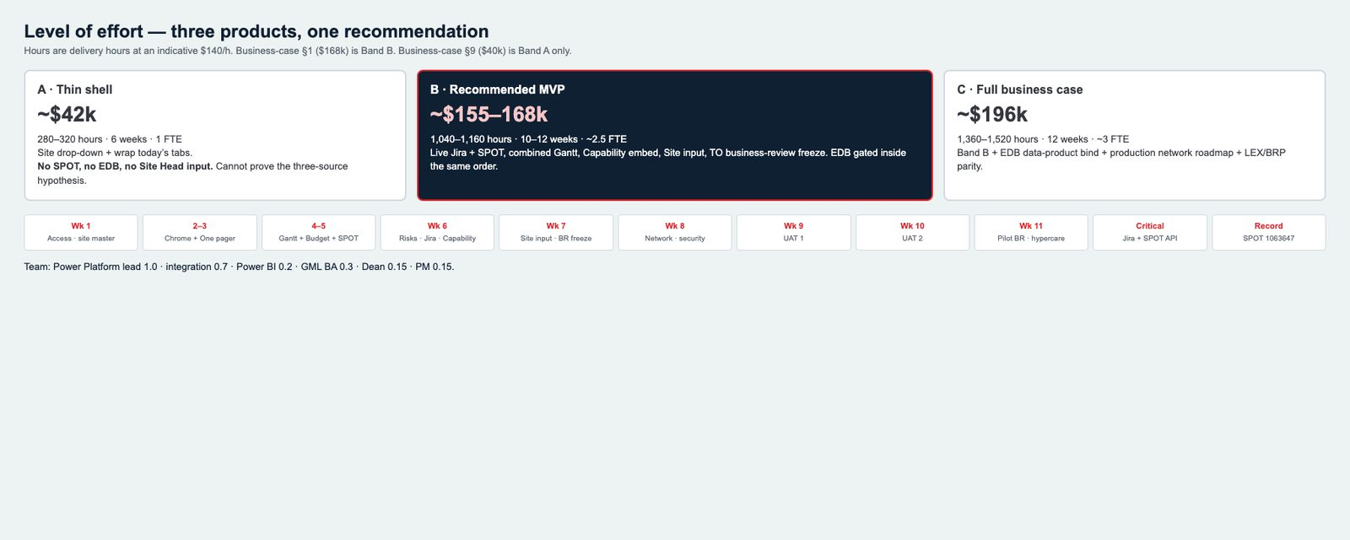
Figure S3. Effort bands and Band B calendar. $40k is Band A only; $168k funds Band B.
Alignment to the business case: Section 1 quotes ~$168k, 6–12 weeks. Section 9 quotes ~$40k, 6 weeks. Those are different products. $40k is Band A only and cannot validate Jira + SPOT + EDB together. This blueprint recommends Band B funded at ~$168k, with EDB treated as a gated workstream inside the same engagement (if the EDB API is late, Capability embed still ships and EDB bind is the last increment).

13.2 Work breakdown — Band B (recommended)
ID | Workstream | Hours | Primary role
B1 | Kickoff, field workshop, status mapping, site master load | 40 | BA + PMO + Dev
B2 | Environment, solution, Entra groups, ALM | 32 | Dev
B3 | Dataverse model + audit + security roles | 80 | Dev
B4 | Jira connector + staging + status map | 80 | Dev / integration
B5 | SPOT connector + financial staging | 64 | Dev / integration
B6 | Executive Glass chrome + site selector + filters | 72 | Dev
B7 | One pager bound to Dataverse (replace collections) | 80 | Dev
B8 | Status KPIs live | 32 | Dev
B9 | Combined Gantt + Budget | 96 | Dev
B10 | Budget tab | 48 | Dev
B11 | Risks + Jira tab | 48 | Dev
B12 | Capability embed + plant parameter / RLS | 40 | Dev + PBI
B13 | Site input forms + Business Review + freeze | 88 | Dev
B14 | Network roadmap hookup (reuse prototype) | 40 | Dev
B15 | UX language cleanup, empty/error/stale states | 24 | Dev
B16 | Functional test + data reconciliation | 80 | Dev + BA
B17 | UAT (TO Site Head + sponsor) + defects | 64 | BA + Dev
B18 | Admin guide, 2-week hypercare | 40 | Dev
B19 | PM / coordination | 56 | PM
Total Band B |  | 1,104

13.3 Add-on to reach Band C
ID | Workstream | Hours
C1 | EDB data-product access, contract, first capability/integration views | 120
C2 | Productionize network roadmap (auth, hosting, ops) | 80
C3 | LEX + BRP mapping + capability parity | 48
C4 | Extra UAT / performance / security review | 48
Band C add |  | 296
Band C total |  | 1,400

13.4 Suggested team (Band B, 11 weeks)
Role | Allocation | Hours
Power Platform / front-end developer (lead) | 1.0 | 440
Integration / data engineer | 0.7 | 308
Power BI / embed | 0.2 | 88
Business analyst (GML) | 0.3 | 132
Product lead (Dean) | 0.15 | 66
PM | 0.15 | 70
Total | ~2.5 FTE | 1,104

13.5 Calendar (Band B)
Week | Outcome
1 | Access, site master, Jira field lock, Dataverse first cut
2–3 | Chrome + One pager + KPI on THO live Jira
4–5 | Gantt+Budget + Budget tab + SPOT
6 | Risks, Jira tab, Capability embed
7 | Site input + Business Review freeze
8 | Network view + security + stale states
9 | UAT round 1, data fixes
10 | UAT round 2, admin guide
11 | Pilot BR + hypercare start

Critical path: Jira + SPOT API access (week 1). If either is blocked, the calendar slips one-for-one.

13.6 What is *not* in these hours
- Creating a new SPOT project (1063647 already exists), AIDPG Initiative, Pattern-Fit, URS/FDS, or Marketplace order (business / onboarding — see companion).
- New EDB modeling if no data product exists (that is a data-platform initiative; C1 assumes a consumable API).
- Full TakOS Design System rewrite of every screen (add 400–600 hours / Release 2).
- Rolling mapping quality to all 18 sites (Release 2; ~20–30 hours per site of PMO time, not engineering).

15. Acceptance criteria (MVP)
- A user with TO Site Head role opens the portal, sees Thousand Oaks pre-selected, and can switch to Lexington and get a different One pager.
- One pager, KPIs, Gantt+Budget, Budget, Risks, Jira, Capability, Business Review, and Site input all honor that site.
- TO MES Elaprase DS shows the same Jira key, SPOT ID, and dates in sidecar, Gantt, Budget, and Jira tab.
- Budget totals for the pilot site reconcile to SPOT within agreed tolerance.
- Capability tab for LEX and BRP matches the current tracker after equivalent filters.
- Site Head can save commentary and a leadership ask; both appear on Business Review; audit shows name and time.
- Dragging a card on the One pager does not change Jira; it changes project_map only.
- Freshness is visible; a failed Jira sync does not show silent old data as current.
- One TO business review is completed from the portal; freeze pack stored.
- Security: a BRP-only user cannot see TO financials.

16. Dependencies the delivery team will need on day 1
Dependency | Owner | Needed by
Power Platform environment + premium licenses | DD&T / IT | Week 1
Entra groups per role × site | IAM + Dean | Week 1
Jira project read (DDTGMPORT + site projects) | Jira admin | Week 1
SPOT API / report access for manufacturing IDs and platform SPOT 1063647 | SPOT admin | Week 1
Power BI embed for Capability Tracker | BI owner | Week 2
EDB data-product steward + env | EDB / AI&D | Week 2–3
Site Head (TO) UAT time | Site leadership | Week 9–10
TakOS / Marketplace POD (if that is the funded builder) | Marketplace | After order

