PAGE 1 · PURPOSE | GSQ GML DD&T · 1 / 5
One portal for how GSQ plants run DD&T
Leadership still prepares business reviews by stitching Jira, SPOT, site Power Apps, Power BI, and PowerPoint. The cost is not software — it is leadership time and inconsistent answers in the same meeting.
Why | What | Who | Where
Purpose  Run the review from a maintained  system of record, not a slide factory. | The Glass  One site-aware portal. Ten views.  Reuse what exists; add what is missing. | Sponsors  Joel Vincent · Executive sponsor  Dean Santoro · Product lead | SPOT 1063647  Already live · Plan phase.  Do not open a second project.

This is  A single pane of glass for 18 GSQ Manufacturing & Labs sites.  Site becomes a drop-down. Budget and Gantt sit on the same row.  Site Heads type commentary and asks in the same portal.  Thousand Oaks is the first business-review system of record. | This is not  A new strategy, a second Jira, or a second SPOT.  The portal does not overwrite dates or money.  The $42k / 6-week figure is a thin shell only —  it cannot prove Jira + SPOT + EDB together.

Companion: Design Blueprint v1.3 · Business case MVP v2 Sept 2026 · TakOS Onboarding Readiness · Confidential

PAGE 2 · BUSINESS CASE | GSQ GML DD&T · 2 / 5
The value is hours back — proven first at Thousand Oaks
9,000 | 42 | $168k | 30,000
hours / year  Total value case · 18 sites  ~500 hours per site per year | hours / site / month  Deck assembly and status chasing  the portal is meant to remove | Cost  10–12 weeks · ~2.5 FTE  Recommended Marketplace order | hours total  FY26 3,000 · FY27–29 9,000/yr  On the SPOT 1063647 record

Investment options — fund the product that can stop the decks
Option | What you get | Time | Indicative cost
A. Thin shell | Site drop-down + wrap today’s tabs. No SPOT, no EDB, no Site Head input. | 6 weeks · 1 FTE | ~$42k
B. Recommended MVP | Live Jira + SPOT, combined Gantt, Capability, Site input, TO review freeze. | 10–12 weeks · ~2.5 FTE | ~$155–168k
C. Full case | Band B + EDB data-product bind + production network roadmap. | 12 weeks · ~3 FTE | ~$196k

Business case §1 already quotes ~$168k / 6–12 weeks. Section 9 quotes ~$40k / 6 weeks. Those are different products. Recommend Band B at the $168k envelope. Do not approve Band A if the test is “executives stop building decks.” EDB binds as a gated increment inside the same order; the Capability Tracker embed is the fallback so the meeting still has an adoption view.
Value hypothesis on SPOT 1063647 · COP = Productivity Improvements · Capture start 1 Dec 2026

PAGE 3 · DESIGN SCHEMATIC | GSQ GML DD&T · 3 / 5
One Glass. Three systems of record. One write path.
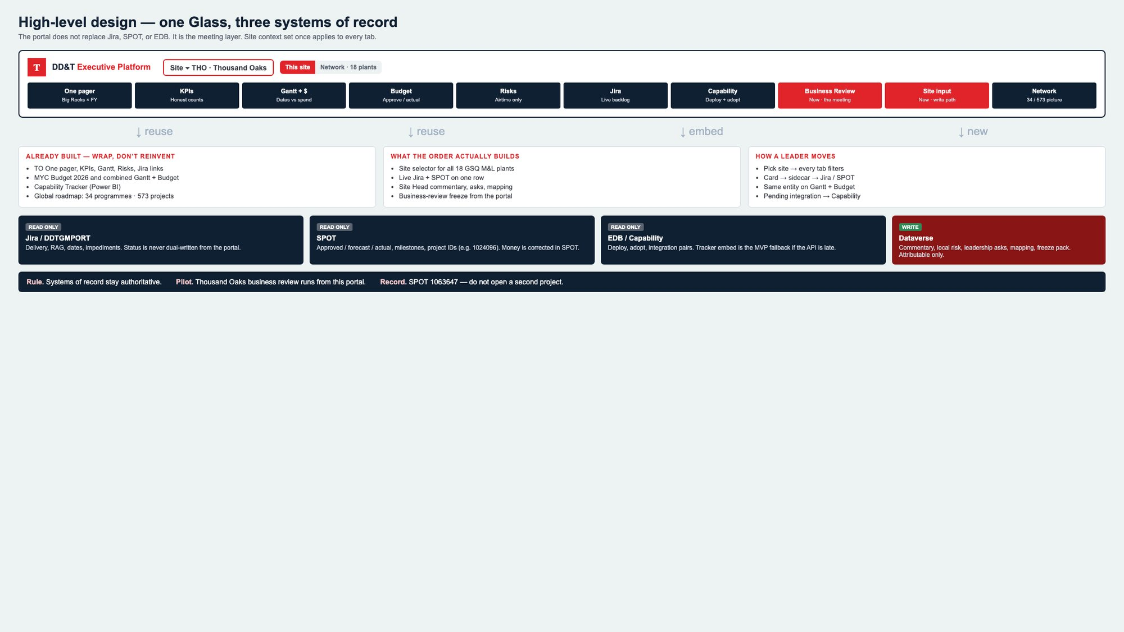
Read-only: Jira · SPOT · EDB/Capability Write: Dataverse commentary, asks, mapping, freeze pack

PAGE 4 · WHAT LEADERS SEE | GSQ GML DD&T · 4 / 5
Same chrome on every tab. Site set once. The meeting runs here.
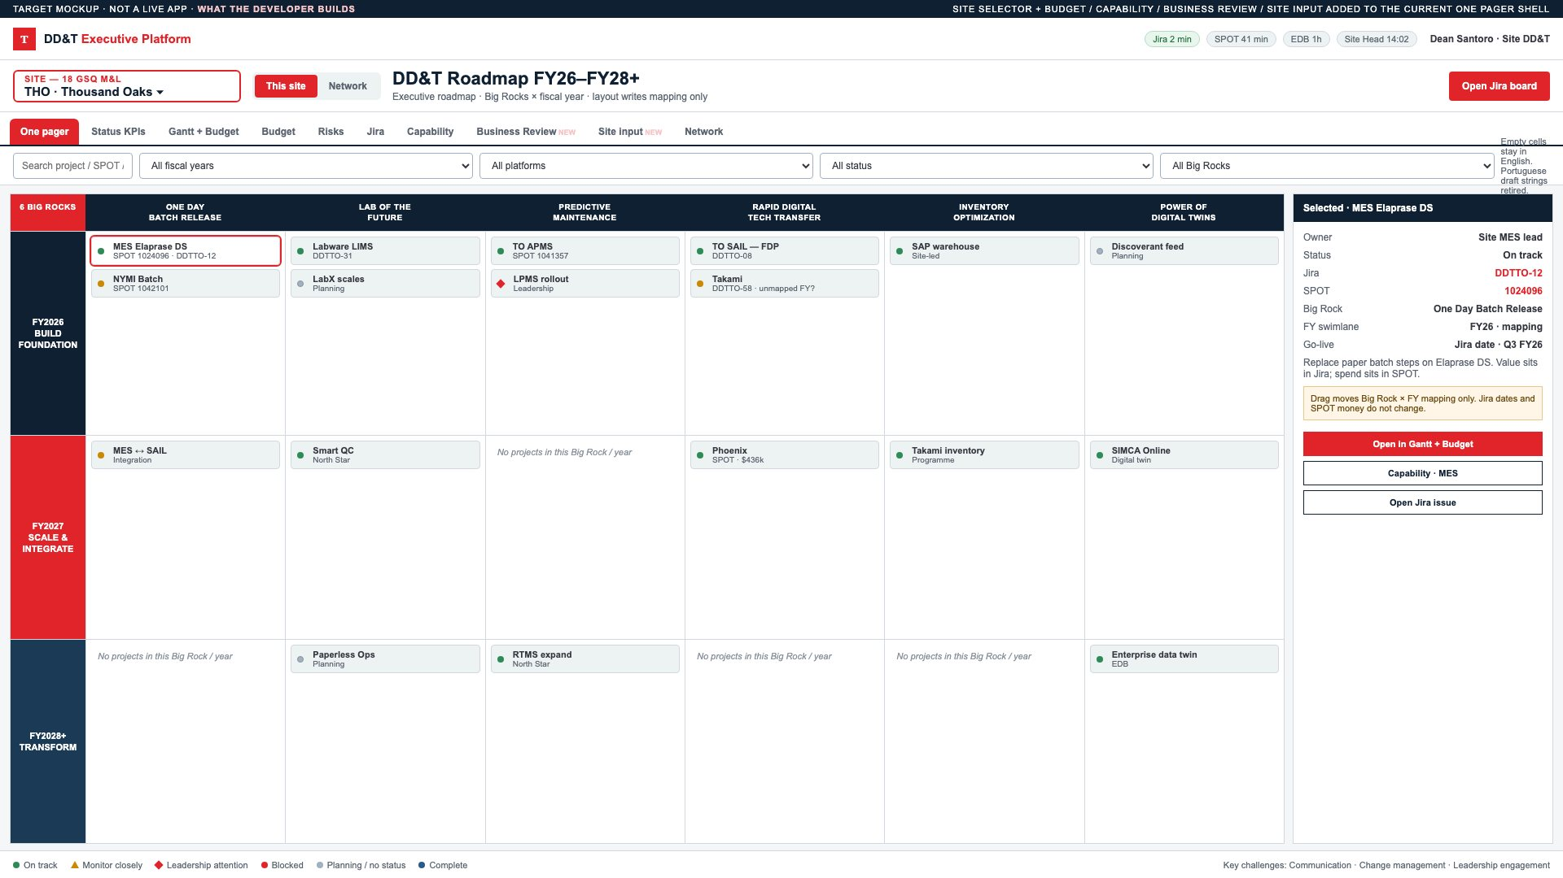
One pager  Big Rocks × FY | Gantt + Budget  Dates vs spend | Budget  Approve / actual | Capability  Deploy + adopt | Business Review  The meeting — new
KPIs  Honest counts | Risks  Airtime only | Jira  Live backlog | Site input  Only write path — new | Network  34 programmes / 573 projects

Target mockup — not a live app. Full view specs and live source screenshots are in the Design Blueprint.

PAGE 5 · DECISION | GSQ GML DD&T · 5 / 5
Pilot at Thousand Oaks. Keep SPOT 1063647.
01 Fund Pilot | 02 Test Business Review Thousand Oaks | 03 Track Value in SPOT 1063647 | 04 Authorize onboarding of other sites
$155–168k · 10–12 weeks  to the design blueprint. | First business-review  system of record. UAT weeks 9–10. | File the funding request here.  Align CAPEX to one number. | AIDPG Initiative → 1063647.  Pattern-Fit · Intake gate.

Go / no-go for Release 2
One TO business review runs from the portal. | Site Head commentary is attributable. | Jira, SPOT, and Capability match in the room. | Leadership agrees the pattern scales.

Next artefact is the AIDPG Initiative pointing at 1063647 — not a second SPOT. Week-1 work is a field workshop with PMO on Jira fields, SPOT access, and mapping quality. API access is the critical path; if it slips, the calendar slips.
Private and confidential. For internal use only. · 8 September 2026 · GSQ GML DD&T

