Using Voxels for Physics Simulation of
Objects in Video Games
Lewis Wakeford
101461823
BSc Computing Science, May 2013
Supervisor: Dr. Graham Morgan
Word Count: 12,078

Abstract
This dissertation researches the viability of using volumetric data to simulate the internal physics of objects in video games.
A brief overview of similar projects and relevant background information is presented, followed by documentation detailing the process of developing a physics system that can model the effects of stress and pressure on objects within a real time simulation. An evaluation of this system's performance and accuracy are provided, as well as the author's proposals for further research in the area.

Declaration
“I declare that this dissertation represents my own work except where otherwise stated.”
Signed: _______________________
Dated: _______________________

Table of Contents
Table of Contents
Using Voxels for Physics Simulation of
Objects in Video Games 1
Abstract 2
Declaration 3
Table of Contents 4
Chapter 1: Introduction 6
1.1: Introduction 6
1.2: Structure of this Dissertation 6
1.2.1: Chapter Breakdown 6
1.2.2: Note on Formatting 6
1.3: Definition of Problem 6
1.4: Hypothesis 6
1.5: Aims and Objectives 7
1.5.1 Aim 7
1.5.2 Objectives 7
Chapter 2: Background 8
2.1: Introduction 8
2.2: What are Voxels? 8
2.3: State-Based Destruction 8
2.4: Voxel-Based Subtractive Destruction 9
Chapter 3: Research 10
3.1: The Marching Cubes Algorithm 10
3.2: Bullet Physics 11
3.3: Similar Work 11
3.3.1: Atomontage Engine 11
3.3.2: Battlefield: Bad Company 2 11
3.3.3: Nvidia's APEX Destruction 12
Chapter 4: Design and Implementation 13
4.1: Introduction 13
4.2: Terminology 13
4.3: Marching Cubes 13
4.4: Integration with Bullet Physics 14
4.5: Convex Decomposition on Voxel Fields 15
4.4: Destruction Algorithms 18
4.4.1: Required Behaviour 18
Requirement One 19
Requirement Two 19
4.4.2: Test Scenarios 19
Scenario 1 19
Scenario 2 19
4.4.3: Common Implementation Details 20
4.4.4: Filtering out Trivial Collisions 22
4.5: First Algorithm – Iterative Approach 22
4.5.1: Algorithm Design and Theory 22
4.5.2: Algorithm Implementation 24
4.5.2.1: Energy per Voxel 24
4.5.2.2: Transferring Energy between Objects 24
4.5.2.3:Transfer Maps 26
4.5.2.4: Direct Transfer 27
4.5.2.5: External Transfer 28
4.5.2.6: Indirect Transfer 29
4.5.3: Analysis 31
4.6: Second Algorithm – Approximate Approach 32
4.6.1: Algorithm Design and Theory 32
4.6.2: Algorithm Implementation 32
4.6.2.1:Transferring Energy between Objects 32
4.6.2.2: Direct Transfer 32
4.6.2.3: Indirect Transfer 33
4.6.3: Analysis 33
4.7: Comparison of Implemented Algorithms 33
4.8 Fulfilling Requirements 33
4.8: Processing Results: Decomposing Objects 34
4.8.1: Materials 34
4.8.2: Creating Breaks 35
4.8.3: Finding Sub-Shapes 36
4.8.4: Conserving Momentum 37
Chapter 5: Conclusion and Project Evaluation 38
5.1: Introduction 38
5.2: Conclusion 38
5.2.1: Satisfaction of the aims and objectives. 38
5.2.2: Overall conclusion. 38
5.3: Further Work 38
5.3.1: Build an algorithm that analyses the structure of objects upon generation. 38
5.3.2: Modify the system to allow for collisions to be broken down into several sub collisions. 39
5.3.3: Implement a fully custom physics system 39
5.3.4: Integrate GPU Accelerated Marching Cubes more Efficiently 39
5.3.5: Re-factor the system to use multiple threads and CPU cores 39
5.3.6: Build a version of the system that runs on CUDA or OpenCL 40
Appendix A: Supplementary Material 41
Using the Demo Application 41
Appendix B: References 42

Chapter 1: Introduction

1.1: Introduction
This chapter will outline the structure of this dissertation, as well as the definition of the problem and how this project attempts to solve it.

1.2: Structure of this Dissertation

1.2.1: Chapter Breakdown
Chapter One outlines the Problem this project attempts to solve, a hypothesis suggesting what the solution could be, and a list of Aims and Objectives that must be met to solve this problem.
Chapter Two contains some general background information that is necessary to understand this project.
Chapter Three is the compilation of Initial Research into the technologies and concepts this project explores. As well as research on similar work.
Chapter Four details the Design and Implementation of the project. Detailing how each sub system of the solution was designed and implemented.
Chapter Five analyses whether the project meets the Aims and Objectives set. It will also analyse the failures and successes of the project's development and provide suggestions for future work in similar areas.

1.2.2: Note on Formatting
Any text written in a mono-space font with a dark highlight is a code exert.
For example:
std::cout << “Hello World!” << std::endl;
Citations are written in superscript like so^{[n]}. Check Appendix B for a list of sources.

1.3: Definition of Problem
In video games and other real-time simulations, such as training simulators, the internal structure of objects and its effect on their behaviour is only roughly approximated. This means that when real-time modification of an objects shape occurs, such as in a building being destroyed or a tree knocked down, it is often predetermined in which way this will occur. In many cases this is acceptable and within the scope of what the designer wants to achieve. However games with a more open-ended approach to play may prefer this sort of environmental modification to be at the hands of their players. Currently there are a very limited selection of tools available to implement real-time modification of the game world and it's objects in arbitrary ways.

1.4: Hypothesis
Volumetric Data, in the form of Voxel Fields, can be used to create a pseudo-realistic simulation of the effects of stress and pressure on virtual objects while running at an acceptable real-time speed.

1.5: Aims and Objectives

1.5.1 Aim
Build a physics simulation system that simulates the internal and external physics of objects and the interaction between these two simulations with acceptably realistic accuracy.
The system does not need to be a perfect reflection of reality, but it should come close enough that the majority of people would not notice the inaccuracies.

1.5.2 Objectives
Below are the objectives outlined in the project proposal for this dissertation before the project was started. As such, some of them may not have been met.
Objectives:
• Create an efficient implementation of an algorithm such as Marching Cubes that converts
volumetric data into vertex shells. The algorithm must be able to generate these vertex shells at
real-time speed.
• Integrate a 3rd party rigid body physics engine (such as Bullet Physics) into the system.
• Implement or create algorithms that simulate the internal physics of objects on volumetric data.
• External forces should have an effect on an object's internal physics.
• Internal forces should have an effect on an object's external shape.
• There must be robust editing tools that allow realtime modification of the simulation, including
altering timescale and the effect of gravity.
• Analyse the performance of the system, research what optimizations could possibly be made to improve this performance.
• Explore whether it is feasible for such a system to perform efficiently enough to be used in a
modern video game using modern hardware.

Stretch Goals and Optional Objectives
• Implement a bone-based animation system. This can be used to allow for objects to “bend” as
well as to allow for animation of characters. To clarify, the animation will not take place on the
volumetric data, but on the polygonal meshes based upon them.
• Implement the system in a simple video game demo.
• Implement support for mutli-texturing and texture blending to allow for voxel fields composed
of more than one type of material. For example, sand and grass.

Chapter 2: Background

2.1: Introduction
The following chapter contains a summary of all background information helpful to the understanding of this project. Background information can be differentiated from research in that this information is considered common enough knowledge to not need citation, however evidence for the correctness of any definitions in the following chapter is provided.

2.2: What are Voxels?
A Voxel is a a Volumetric Pixel. Essentially a 3D point, generally aligned in a grid. What separates a Voxel Field from regular point cloud data is it's structure. It is built like a bitmap image, where each elements location in space can be deduced from it's location in memory. The Edinburgh Online Graphics Dictionary defines a Voxel as: “[a] Volume element. A single datum in 3D volume data.”^{[1]}

In the scope of this project a Voxel Field is used to represent the approximate shape of an object. Where the voxel field contains an integer in each memory address, with a value of 1 giving a full voxel and a value of 0 giving an empty one.

2.3: State-Based Destruction
State-Based Destruction is the name by which this dissertation refers to the De Facto standard for destruction simulation employed in the vast majority of video games. Destructible objects simply have at least two “states” of being, each with a different visual representation and a different way of interacting with the physical world, although visual effects may hide the state transition to the player and create the illusion of more physically realistic simulation.
For example a wooden crate may have an Intact state where it is represented by a single mesh, after being hit by a player's weapon the crate's state will change to Destroyed and it will be deleted from the game world. Smaller debris objects may spawn, with some splinter particle effects, to mask the simple state change.
States can be altered in a number of ways, but usually force above a certain threshold or being within the radius of an in-game explosion or other destructive force will cause a state change.

2.4: Voxel-Based Subtractive Destruction
Voxel data lends itself well to modification as it's structure and, unlike vertex based destruction, does not require complex floating point math to establish which parts of the shape are within a certain area. For this reason simple destruction effects can be generated by projecting a simple shape, such a sphere, through the voxel data and removing (or rather, changing the value of) the voxels that fall within that volume. This destruction can be masked in a similar way to traditional state-based destruction, using particle effects of smaller models to represent debris. The most popular example of this sort of destruction can be found in the 1995 video game Worms. The game used 2d data instead of 3d data, but the principles remain the same.
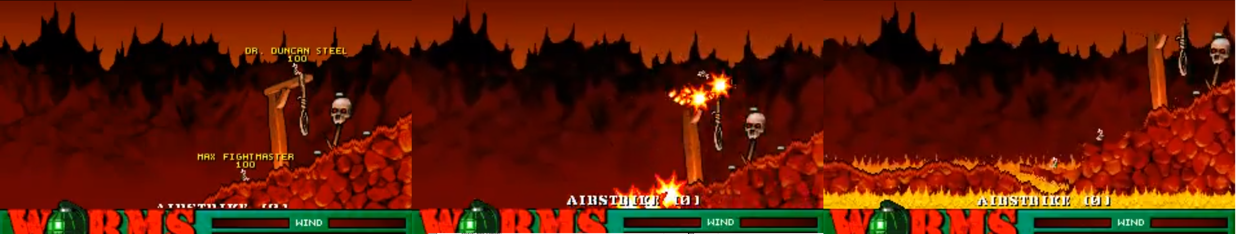
A 2D example of subtractive destruction in Worms(1995)

Chapter 3: Research

3.1: The Marching Cubes Algorithm
Marching Cubes is a “Triangle Soup” algorithm that can generate a 3d vertex mesh from Voxel Data. The Marching Cubes implementation found within this project is based upon the implementation found in GPU Gems 3^{[2]}, converted into GLSL and C++ with some modifications.
Marching Cubes works by grouping each 8 adjacent Voxels into a single “Cell” that forms a cube. By comparing the values (full or empty in this project) of these 8 corners to a reference table, a prefabricated mesh can be generated consisting of a handful of triangles. This process is repeated for each set of 8 adjacent voxels until all meshes have been generated. The result is a mesh that roughly resembles the outline of the Voxel Field.
Figure 3.1.1: Different Combinations of corner values creates different sub meshes.
Image courtesy of Nvidia: http://http.developer.nvidia.com/GPUGems3/gpugems3_ch01.html
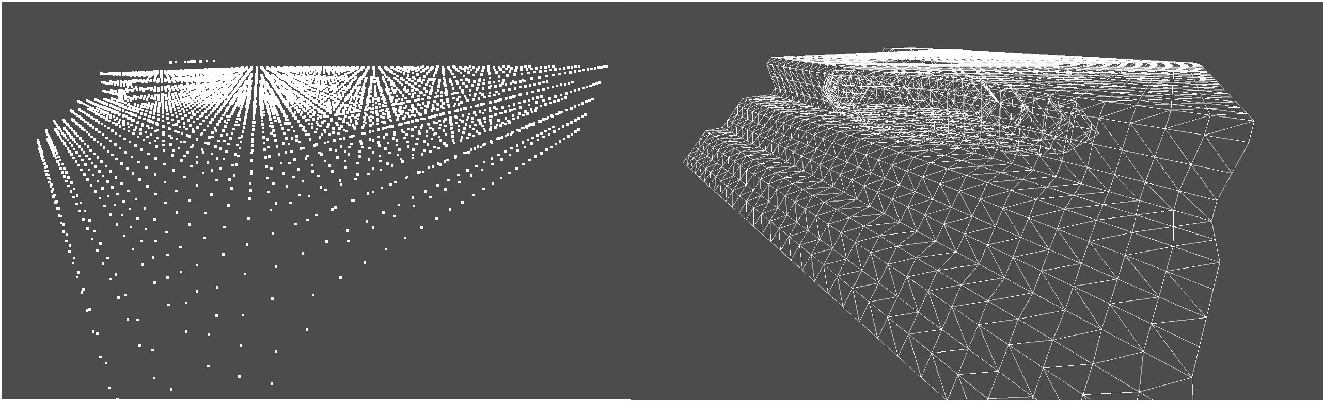
Figure 3.1.2: A shape before and after conversion by marching cubes.
In the pure implementation of Marching Cubes, Cells are not required to have any knowledge of their neighbours. Each Cell only needs access to the shared Voxel Data that the algorithm is using as a source. This makes it highly parallel and an excellent algorithm to be sped up by multi-core processors or GPUs.

3.2: Bullet Physics
Bullet Physics^{[3]} was chosen to serve as the rigid body physics engine for this project. It was chosen over the other physics engine considered, Nvidia's PhysX because of it's open source nature. Although it seemed unlikely that modification of the source code would be necessary, in the event of a fatal flaw or design limitation that blocked progress on the project there would be an opportunity to resolve the issue with modifications to Bullet itself instead of working around that flaw.
Having access to the source code also makes it easier to debug, as debuggers can trace exceptions and segmentation faults within the physics library, returning the exact location in the code they originate from.

3.3: Similar Work

3.3.1: Atomontage Engine
The Atomontage Engine^{[4]} is a real time 3D engine that makes heavy use of Voxels. It includes the capacity for modifiable environments, however from the available evidence in screen-shots and videos of the engine this seems to be subtractive destruction.
Atomantage displaying it's Destructible Geometry feature. Image courtesy of Atomontage: http://www.atomontage.com/sshots/atomontage_bui4.jpg

3.3.2: Battlefield: Bad Company 2
Battlefield: Bad Company 2 is a video game that demonstrates a convincing use of state-based destruction. It constructs large structures of of many smaller state-based destructible objects. These smaller objects can be destroyed by players, and if a certain percentage of all the supporting objects in a structure are destroyed the structure itself will experience a state change. The game makes good use of dust-clouds and additional debris objects to mask the state changes.^{[5]}
A building being destroyed in Battlefield: Bad Company 2. Image courtesy of the Battlefield Wiki: http://images.wikia.com/battlefield/images/0/08/BFBC2_House_collapsing_destruction.jpg
There is also a limited amount of terrain deformation. This is implemented by simply displacing the vertices of the terrain downwards when near to an explosion.

3.3.3: Nvidia's APEX Destruction
Nvidia have recently built a tech demo showcasing their real time destruction engine APEX^{[6]}. This engine focuses on fracturing objects around the point of contact on collision. What is impressive about this engine is how quickly it performs decomposition of the fracturing objects into a large number of smaller debris objects, which is probably due to its use of GPU rigid bodies. The key difference Nvidia's project from the project outlined in this dissertation is that it does not simulate the effect of the collision on the parts of the object outside of the immediate impact point.
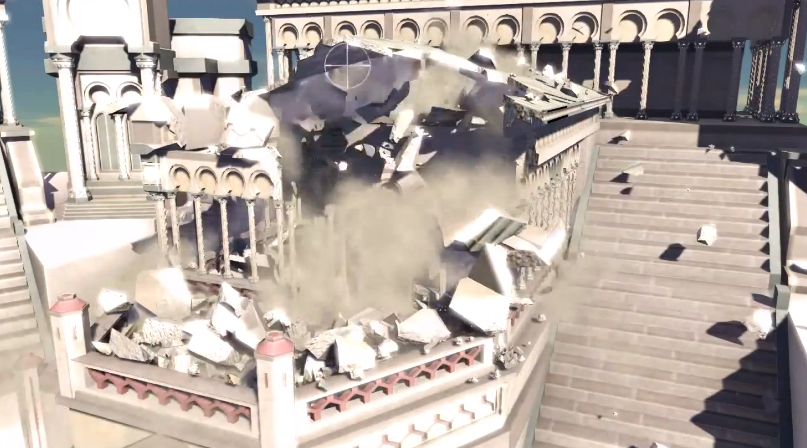
Screen-shot from Nvidia's tech demo. Find the full video here, courtesy of GamesHQMedia: http://www.youtube.com/watch?v=O04ErnJ8USY

Chapter 4: Design and Implementation

4.1: Introduction
This chapter will document the project's progress and details of how various milestones where implemented, noting their importance to the overall system. The chapter begins with an explanation of some unique terminology used within the scope of the project. Towards the end of the chapter the two different algorithms for simulating internal physics will be detailed, explaining the strengths and weaknesses of each approach and exploring the suitability of each for real time simulation.

4.2: Terminology
Whenever this dissertation makes reference to Internal Physics, it is referring to the physical state of an object's internal structure. The most significant elements of Internal Physics simulation as defined by this dissertation are the simulation of stress and pressure throughout the structure of an object, and the rendering of the results of this simulation.
A single virtual object in the system is known as a Matter Object. A matter object is composed of several different parts: A Field of Voxel Data representing its internal structure, a Bullet Physics Rigid Body representing its external structure and a triangle mesh used as a more “photogenic” visual representation of the Mater object. How each of these components is used is detailed in the remainder of this chapter.
A Material is a type of Matter. All Matter Objects with the same Material have the same per-voxel physical attributes: Resistance to Pressure and Strain, Density (used to calculate mass), Strength and Variance in Strength.
Pressure and Stress are scalar quantities somewhat based upon their real life equivalents, however no effort is made to make these values match up with reality in either behaviour or scale.

4.3: Marching Cubes
The marching cubes algorithm was implemented based upon code found within GPU Gems 3^{[2]}. The original implementation was intended for procedural input, and was written in Cg. This project makes use of two separate versions, one written in C++ that can run on the CPU, and another written in GLSL that can run on the GPU. Reference tables where adapted from those provided by Eric Lengyel for use in his Transoxel Algorithm^{[7][8]}.
The GPU implementation of the algorithm was limited to a 32x32x32 Voxel Field as input (fed to the GPU as a texture), to deal with the fixed memory requirements of GPUs. This was inherited from the original GPU games implementation. The CPU implementation was originally intended to work on arbitrary sizes of Voxel Field, however this was a low priority and due to time constraints it remains a basic emulation of the GPU code.
When comparing performance, it was found that the GPU implementation could build meshes much more quickly than the CPU implementation. However, the GPU implementation creates some overhead elsewhere in the system, resulting in overall poorer performance than the CPU implementation. The GPU implementation is reliant on OpenGL transform feedback being supported to operate correctly.

.vox File | test_small_cube.vox | house.vox | donut.vox
Number of Voxels | 3712 | 1784 | 178
Number of Vertices | 9876 | 7044 | 2340
Mesh Generation Time on CPU (s) | 0.023749 | 0.019347 | 0.007645
Mesh Generation Time on GPU (s) | 0.001606 | 0.003951 | 0.001853
Performance Gain | 1478.78% | 489.67% | 412.13%
Fig 4.3.1
Figure 4.3.1 shows the significant performance increase when using GPU Marching cubes. Generally, it is generally about ten times faster than the CPU implementation, however with smaller shapes the performance gain falls off probably due to the overhead in printing the voxelfield to a texture . For some as yet unknown reason the first execution of GPU marching cubes takes approximately tens times longer than subsequent executions. Though as this does not interfere with the simulation after initialisation, time has not been spent resolving this issue.
The Marching Cubes algorithm was abstracted within a class called the VoxelDecomposer. This sub-system of the application would be responsible for processing a 3d array of voxel data and pushing the results to a triangle mesh. Depending on whether GPU acceleration was available it would perform this task using either the CPU or the GPU, and output the results directly into a vertex buffer. This is especially helpful when using GPU mode, as the vertices do not actually need to leave GPU memory at any point.
Whenever an object's shape is modified, a new mesh is built from scratch using the new voxel data. A possible optimization to the system would be to only regenerate the smallest possible section of the vertices, though this optimization would not help in the worst case.

4.4: Integration with Bullet Physics
Bullet Physics handles the rigid body component of the physics simulation. For each Matter object in the system, a corresponding Rigid Body of similar (though not identical) shape is constructed and passed to Bullet Physics. As well as shape, the physical properties of the Rigid Body are determined by the voxel data and the Material of the Matter object it represents. These physical properties include Mass and Center of Mass, as well as Friction and Restitution values.
No modification to Bullet's source code was necessary for correct integration. Instead, two separate per-tick callbacks are used. Bullet's per-tick callback functionality allows for a user defined function to be called before and/or after each physics simulation tick, making it possible to detect collisions between objects and extract relevant data such as velocity of rigid bodies.
In the pre-tick callback, each Rigid Body outputs its current linear velocity to its parent Matter object. In the post-tick callback, all collisions that occurred in the tick are scanned. If a collision is found to involve two or more Matter Objects (as opposed to other static geometry like the “floor”) then Internal physics simulation is run on the involved objects to check for any kind of permanent modification. Pre-tick velocity needs to be recorded so that it can be used when calculating values within the internal physics simulation, but Bullet may have already changed the velocity of the shape during the physics tick. Recording the velocity instead of intercepting the collision makes it much easier to resume the Bullet Physics simulation normally if no destruction occurred.
When destruction occurs and a Matter object is broken into several smaller Matter objects each adds a new rigid body to the Bullet Physics simulation that inherits a certain portion of its parent's velocity based on how the internal physics simulation went.

4.5: Convex Decomposition on Voxel Fields
For efficient Rigid Body physics, Bullet should be given convex shapes. This causes an issue with generating rigid bodies from Matter objects, as they can often have concave shapes. Initial experimentation was done with the HACD^{[9]} convex decomposition algorithm (bundled with Bullet Physics) by running the triangle mesh of each Matter object through it, however it's completion time was no-where near real time, with the largest meshes taking minutes to complete. This was probably due in part to the high number of redundant vertices generated by this project's implementation of Marching Cubes, however, even the smallest Matter objects processed unacceptably slowly. This approach also conflicted with GPU accelerated marching cubes, as it necessitated the somewhat expensive operation of extracting vertex data from GPU memory.
It was instead decided to decompose the Matter objects using the voxel field with a custom algorithm. This algorithm had two main phases. The first phase was to group voxels into several approximately convex shapes. This was accomplished using an algorithm that worked something like a 3D equivalent of the flood-fill algorithm used in image editing software, however it had limits of its expansion to try and ensure a convex shape was preserved.
Essentially, the algorithm picks the top-left-back most voxel that doesn't already belong to a sub-shape and uses this as the first node in the expansion. Every node in the graph expands in one the of the 6 axis aligned directions (other than up) and adds it's neighbour in that direction to the graph. Node's inherit information about when it is safe for them to expand from their parents for example if a node knows there is a node to its left when it expands downwards, it will tell its child to look for its left hand sibling before expanding downwards again, otherwise a concave shape may be created. As all nodes expand at once before direction is changed, it is possible to detect concave shapes being created. For example if a node with neighbours to the left and right cannot expand forward the entire expansion phase will fail, as this could create a concave “alcove”.
When the graph can no longer expand, these voxels are said to belong to a particular hull, this information is saved and expansion continues with a new hull.

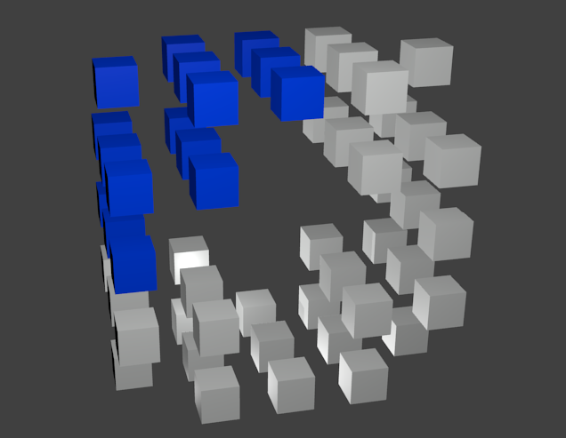
Fig 4.5.1 Illustration of Convex Decomposition Algorithm on Voxels.

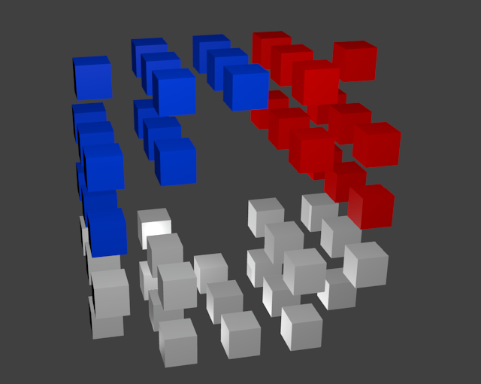
Fig 4.5.2 Illustration of Convex Decomposition Algorithm on Voxels.
Figure 4.5.1 and 4.5.2 are illustrations (not application screen shots) showing how the algorithm is expected to behave when expanding.
A nodes ability to expand is represented by 6 “states”, one for each face of the cube, which are represented as integers in-code. Each face can have one of the following states as a value:
- Unknown (-1) – It is unknown what is in the voxel behind this face. Can expand in this direction.
- Should-Be (-2) – There should be a sibling node here. Check before expanding perpendicular to it.
- Guaranteed (-3) – There is a node here. Do not expand in this direction.
- Can't Expand (0) – Cannot expand in this direction, but children might be able to.
- Can Expand (1) – Can expand a maximum of one time.
- Can't Expand (2) – Cannot expand in this direction, children also cannot.
- Must Expand (3) – Before expanding in any other direction, must first make sure the node can expand in this direction.
There are a number of operation performed on these states to find if a node can expand in a particular direction. When a node expands, it clones its states to the child node, modifying them with the function strafe() if the state was on a face perpendicular to the direction of expansion, and with the function walk() if the state was on the face in the direction of expansion. The face pointing back to the parent is always -3 (guaranteed).

int walk(int i)
{
if(i == -1) return i;
if(i == 1) return 0; //We expanded “forwards” and now cannot expand again.
if(i == 3) return -1; //We expanded in the direction we need to, and now return to normal behaviour.
return -3;
}

int strafe(int i)
{
if(i == -1 || i == -2 || i == 2 || i == 3) return i;
if(i == -3) return -2; //There should be a node here, as our neighbour should have expanded also.
if(i == 0 || i == 1) return 1; //We can gain the ability to expand in a direction by moving perpendicular to it.
return -3;
}

This process repeats until every voxel in the Matter Object belongs to a collision hull. The second phase of the algorithm takes place during the Marching Cubes conversion of the Matter Object. For each possible cell of 8 voxels considered by MC, a “Cell Normal” has been precomputed like so:
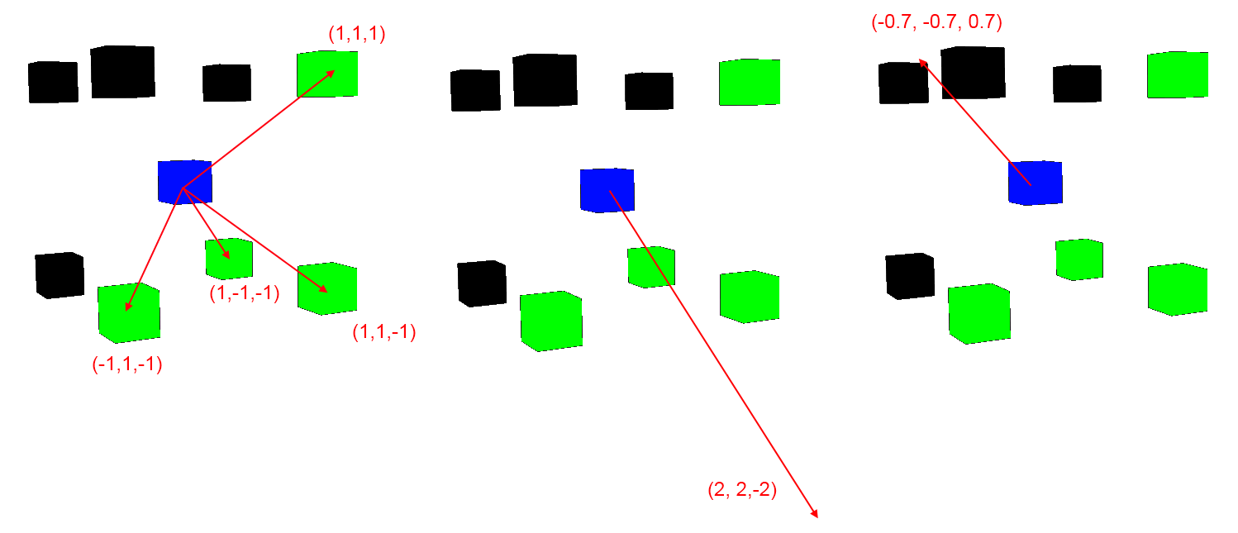
Fig 4.5.4 Diagram showing how to compute cell normals. The green cubes represent full voxels, the black cubes represent empty voxels, and the blue cube represents an imaginary centre of the cell.
Figure 4.5.4 demonstrates how each Cell Normal was computed. Firstly, a direction vector representing the displacement from the centre of the cell to each full corner is found. Secondly, these vectors are summed together. Finally, the vector is inverted and normalised to give the Cell Normal. Note how in Figure 4.5.4 the Cell Normal points in roughly the same direction
During (or before, in the case of GPU Marching Cubes) Marching Cubes when a cell is processed each voxel is added to a collection of vertices representing its Hull. To create the voxels object-space coordinate in the hull, the voxel's memory address is converted into a grid-aligned 3 coordinate. This coordinate is then offset by the Cell normal of that cell multiplied by the fixed space between voxels. Each voxel may be processed up to 8 times, and each time it may be added to the hull again after being translated by a different Cell Normal. Figure 4.5.5 shows how an obviously concave shape is broken down into many smaller convex shapes.

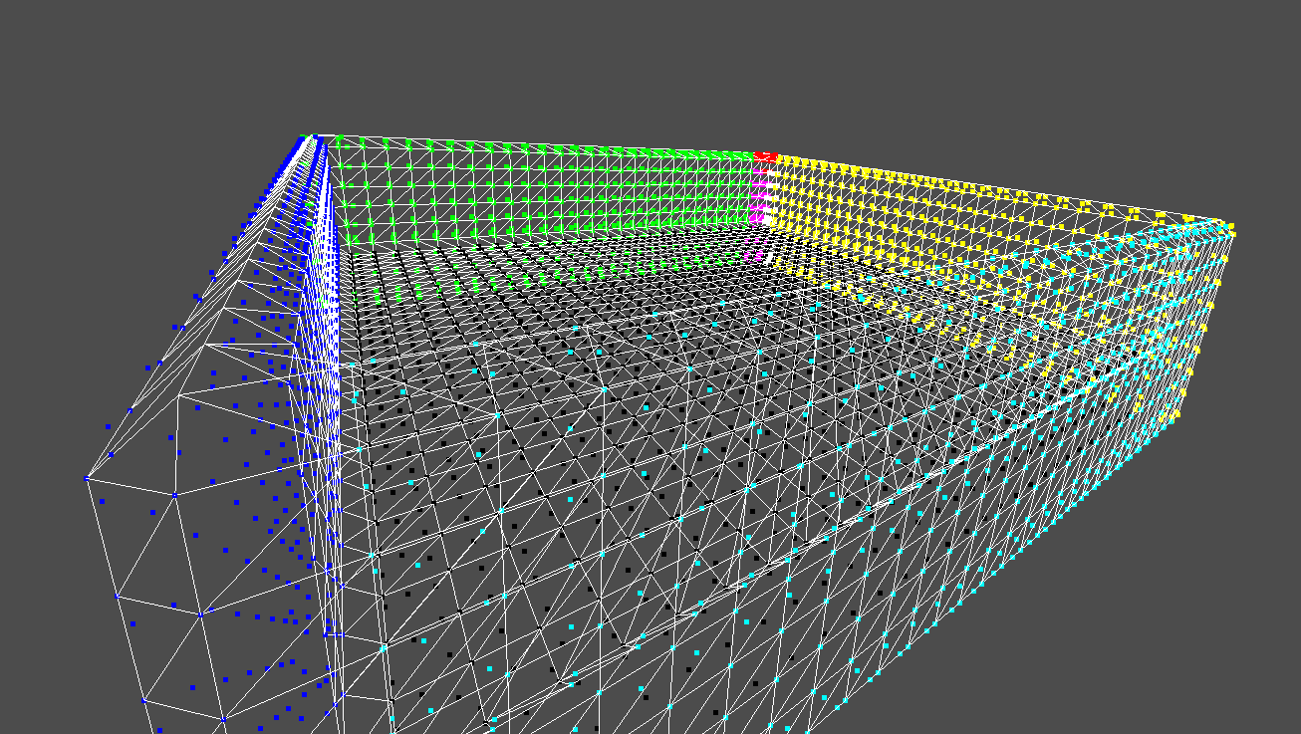
Fig 4.5.5 Screen-shot of an open-topped-box shape after being broken down into convex hulls. Different colors represent different hulls.

Each of these hulls can be added to a single Compound Shape^{[10]} in bullet physics, providing efficient collision geometry. Using the same .vox input files used in the marching cubes profiling gives the following results:

.vox File | test_small_cube.vox | house.vox | donut.vox
Number of Voxels | 3712 | 1784 | 178
Decomposition Time (s) | 0.203745 | 0.039138 | 0.015472
First Phase Time (s) | 0.003216 | 0.017259 | 0.002968
Second Phase Time(s) | 0.200529 | 0.021879 | 0.012504
Fig 4.5.6

Some of these speeds are a little bit too slow for real time performance. However, it may be possible to use GPU acceleration on the second phase of the algorithm, which also happens to be the most expensive, as it is effectively parallel. A GPU accelerated version of bullet is available, it may be possible to have rigid body simulation without the vertices ever leaving the GPU.

Note that the decomposition algorithm does occasionally produce anomalies. For example curved shapes may occasionally have a hull that “cuts corners” and is slightly larger than the visible geometry. However these occurrences are fairly rare and it was decided the issue was not high enough priority to fix, especially when it is still unclear whether the algorithm performs well enough to be useful in the future.

4.4: Destruction Algorithms

4.4.1: Required Behaviour
For the system's behaviour to approximate reality to a satisfactory degree two requirements must be met.

Requirement One
The magnitude of destruction caused by a collision should be roughly proportional to both the difference in velocity of the objects involved in the collision and the masses of the objects involved.
Essentially:
- Heavier shapes cause more damage.
- Objects with a greater difference in velocity will cause more damage to each other.

Requirement Two
Destruction should be heavily influenced by the structure of the colliding objects and the points at which they collide.
For example:
- A roughly round or cuboid shape will be much “stronger” than one which is elongated.
- A tube shape will be much more resistant when collision occurs with the narrow part than when collision occurs with the wide part.

4.4.2: Test Scenarios
Two test scenarios where designed to see if the system behaves in the required manner. Given these inputs, the system should produce something similar to the expected output.

Scenario 1
Setup: Two Matter Objects of equal size and material.
Process: Collide the two objects at an flat angle. With the objects having different velocities.
Expected Result: Destruction should be roughly equal in magnitude and pattern in both objects.
What this shows: That destruction is roughly proportional to force applied. Newton's third law states that every force applied has an equal and opposite reaction force. This means destruction is relative and does not give priority to objects that are faster or slower within Bullet's absolute reference frame.

Scenario 2
Setup: One Matter Object with a main body and a thinner, longer “branch” coming of it. One roughly round Matter Object.
Process: Collide the two objects, making sure that the round object hits the other one in the thin branch area. Then collide the objects again making sure it hits the main body.
Expected Result: When the branch is hit, it will disconnect from the main body of its parent or be totally obliterated, when the main body is hit, the branch will remain connected and destruction will be reduced overall.
What this shows: That the internal physics simulation takes the structure of a Matter Object into account when calculating destruction, and hitting distinctly different parts of the object has equally distinct effects.

4.4.3: Common Implementation Details
During the development of this project several different Algorithms where implemented to model destruction. The remainder of this chapter will be spent detailing the theory and design behind these algorithms, their implementation details, and analysis of how they perform.
Each Algorithm is based loosely upon Kinetic Energy transfer. When a collision is detected the mass and velocity of each object is built into an “Energy Vector” like so:
speed = velocity.length;
energyVector = (0.5 * mass) * (velocity.normalised() * (speed * speed));
This equation is basically the same as the traditional equation for kinetic energy:
K = ½ mv²
Note that in reality Kinetic Energy is a scalar value, not a vector. However, this representation can be though of as compacting the amount of energy with the direction of its transfer. The energy vectors of two colliding objects are the primary input to the destruction algorithms, as well as the voxel data.
Destruction is always carried out between a single pair of Matter Objects. If a Matter Object collides with more than one other Matter Object in a single physics tick then each pair is run through the destruction algorithm in sequence, with some information carrying over from one pair to the next. The order collisions are processed During the destruction process, a pair of colliding Matter Objects are known as Collision Partners.
Each algorithm creates special EnergyGrid objects that managed all the data involved with destruction. These objects are created when collision occurs, one per Matter Object, and are deleted after all destruction for that physics tick has resolved. The energy grid objects store a three dimensional array of per-voxel destruction data, using the same coordinate system. The per-voxel destruction data consists of:
Energy in Projected Direction
Energy in Receiving Direction
Pressure
Stress
Whether the voxel has been snapped or destroyed
Strength
Here is a code exert:
class VoxelData
{
public:
float mStrength;
float mEnergyInProjectedDirection;
float mEnergyInRecievingDirection;
float mPressure;
float mStress;
bool mGraphed; //Used in indirect transfer.

bool mDestroyed; //Caved into pressure.
bool mSnapped; //Snapped under stress.

bool mFull; //Voxel is full
};
The strength of a voxel is a randomised value, usually between 0.5 and 1.5, depending on the material of the object. Energy Grids assign each voxel with a random strength value upon creation initialisation. Strength is also determined by the number of adjacent voxels:
float EnergyGrid::getStrength(int x, int y, int z)
{
int adjanctVoxels = 0;
Vector3i coord(x,y,z);
for(int i = DIRECTION_START; i < INVALID_DIR; i++) //Iterate over all directions
{
const Vector3i& directionVector = getDirectionVector(i);
Vector3i adjanctCoord = coord + directionVector;
if(voxelIsFull(adjanctCoord.x, adjanctCoord.y, adjanctCoord.z) == 1) adjanctVoxels++;
}

//Create a value between min and max strength
float strength = (float(rand100())/100.0f *
(material->getMaxStrength() - material->getMinStrength()))
+ material->getMinStrength();

return strength + (strength * adjanctVoxels * material->getBondStrength()));
}
When determining the effects of stress and pressure upon a voxel, the strength of that voxel plays an important role, as explained in Section 4.8.1.
The Energy Vector of each Matter Object is decomposed into two per-voxel energy values, one value is the energy in the direction of the object, and the other is the energy in the direction of the object collided with. During the destruction algorithm these values are processed and changed, and afterwards they are transformed back into per-object energy vectors which may be different than the original values. In this way, per-voxel energy does not carry over between different pairs of Matter Objects; only per-object energy does.
During each collision, both objects have a chance to act as both a projector and a receiver of energy. The fastest object acts as a projector first, but this is simply an arbitrary distinction. After that, the second object has a chance to act as a projector, if it has enough energy remaining.
Vector3 fastestEnergy;
Vector3 slowestEnergy;

Vector3 fastestDirection = fastestEnergy.normalized();
//Get the amount of energy in the slower object that is “opposed” to the energy in the faster one.
float slowestEnergyRelative = dot(fastestDirection, slowestEnergy);

//Projector, Reciever, Projector Energy, Reciever Energy
performEnergyTransfer(fastest, slowest, fastestEnergy.length(), slowestEnergyRelative);

float remainingEnergyRatio = slowestEnergyRelative/slowestEnergy.length();
Vector3 remainingEnergy = remainingEnergyRatio * slowestEnergy;

preformEnergyTransfer(slowest, fastest, remainingEnergy.length(), 0);
This creates the effect that when objects are travelling in opposite directions, one of them will appear to have “negative energy”, which really just causes more destruction due to a greater energy difference. If the objects are moving perpendicular to one another, each will have their own separate energy vectors.
The pressure, stress and other data is retained until the end of the physics tick, meaning that destruction accumulates over different interactions within the same tick.

4.4.4: Filtering out Trivial Collisions
The destruction algorithms are quite computationally expensive, however many collisions will not result in any visible destruction. This becomes especially problematic when a large number (upwards of 100) of small debris objects break off two larger colliding bodies, upwards of about 10 significant collisions per physics tick (on the author's machine) will slow the system to a completely non-interactive frame rate.
Because of this, it is important to filter out “trivial” collisions early, before the expensive destruction algorithms are executed. This is a difficult and complex problem in and of itself as the structure of an object and the location of the collision on this structure is incredibly important to whether a particular collision is trivial or not.
For example, a collision with an elongated “tube” shaped object's narrow face would be unlikely to cause any destruction while a collision into the broad face might snap the object in two. One collision is trivial, the other is not, but determining that would seem to require almost as much computation as the destruction algorithms themselves.
This problem was not completely solved during the course of this project, and so several areas for future research are included in the concluding chapter. A temporary solution is used in this projects implementation. Each Material type is given a minimum number of voxels and minimum amount of energy per voxel that a particular object must possess before being considered significant enough to cause destruction. These values are hand tweaked instead of being computed to allow for more control over collision filtering.

4.5: First Algorithm – Iterative Approach

4.5.1: Algorithm Design and Theory
The first attempt at modelling destruction uses a naïve iterative approach. It is based upon the idea that each molecule of a moving object must have a certain amount of kinetic energy. When this molecule's velocity is changed, it has gained or lost kinetic energy. If the bonds of molecules to their neighbours can be thought of as springs, as a molecule changes velocity the bonds will either be stretched or compressed based upon the velocity of the neighbours in an attempt to bring them to the same velocity as well. This is a core idea behind soft body physics simulation.
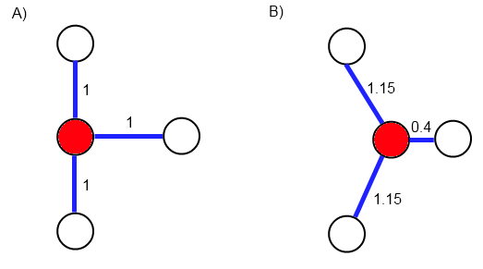
Fig 4.5.1.1 As the red molecule changes velocity, the “spring” like bonds are stretched or compressed because it's neighbours have not also changed velocity yet. The bonds are labelled with their length in arbitrary units of measurement. Diagram not scaled.
This concept can be applied to voxels as well, which can be thought of as giant approximations of molecules or atoms. Compressing a bond can be thought of as generating Pressure, while stretching a bond can be thought of as generating Stress.
During a collision, the total amount of kinetic energy (ignoring that which is lost due to waste) should remain roughly the same. This means that by looking at the energy in each voxel prior to collision and comparing to it the amount that should be in each voxel after collision, it is possible to determine how much energy each voxel would transfer during the collision.
If the direction of transfer can also be determined, then the amount of stress and pressure generated can be derived from the direction of transfer and the direction the voxel was travelling in prior to collision. This can be explained as voxels that are not in the direct vicinity of the collision attempting to continue their forward movement, and their bonds absorbing their kinetic energy to try and slow them down them, while voxels that are directly affected by the collision will be squashed against those in-front of and behind them as they attempt to slow down.
When two objects have very different velocities, the amount of energy needed to be transferred to “balance the system” will be much greater. Meaning more stress and pressure will be generated, fulfilling requirement number one.
As not every voxel tat needs to transfer energy will be able to do so directly, it will need to pass energy through intermediate voxels to get the energy to its destination. This means that energy “bottlenecks” will form at certain points of the shape, generating natural points of high stress and high pressure in areas where it would make sense for them to be.
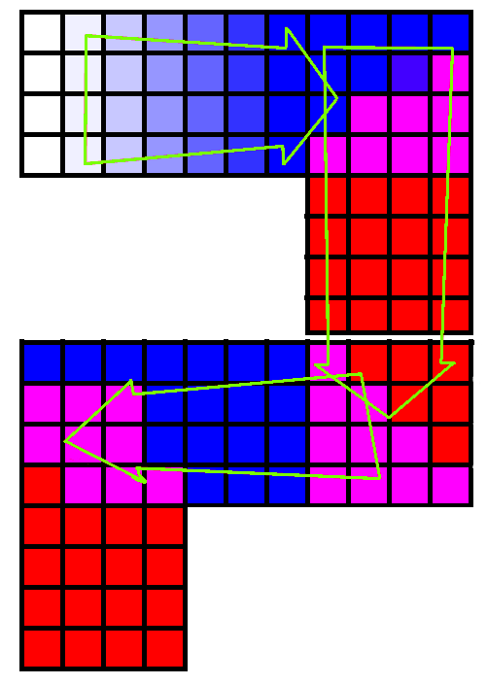
Fig 4.5.1.2 As the upper shape collides with the lower one areas of high stress (shown as blue) are created by energy transfer perpendicular to the original velocity of the shape and areas of high pressure (shown as red) are created by energy transfer parallel to the original velocity of the shape.
This fulfils requirement number two.

4.5.2: Algorithm Implementation
Unless otherwise stated, the iterative algorithm makes use of all features listed under common implementation details.

4.5.2.1: Energy per Voxel
The concept of this algorithm is heavily based upon balancing the amount of energy in the system formed by a pair of colliding Matter Objects. This means that each voxel in each object will need an initial amount of energy and a target amount of energy. The initial amount of energy can be calculated like so:
initial_energy_per_voxel = energy_in_shape / voxels_in_shape;
While the target energy per voxel can be calculated with:
target_energy_per_voxel = energy_in_both_shapes / voxels_in_both_shapes;
These values are important later in the algorithm.

4.5.2.2: Transferring Energy between Objects
Voxels are grid aligned within their local field, however when two objects collide it is incredibly unlikely for their grids to seamlessly align. Instead, voxels on each Matter Object are flagged as Bridges. Each Bridge has a local, grid-aligned point using the Matter Object's local coordinate system and an external, non-grid aligned point using the Collision Partner's local coordinate system.
Bridges are built at the start of collision using a two phase approach. Firstly, a list of potential bridges is found in each object. This is achieved by translating the energy vector of the projecting object into local space and rounding each element to either 1 or -1 to describe its direction. If a particular element is positive then all voxels facing the local negative of that axis are added as potential voxels, and vice versa. In the collision partner, the opposite sides are chosen.
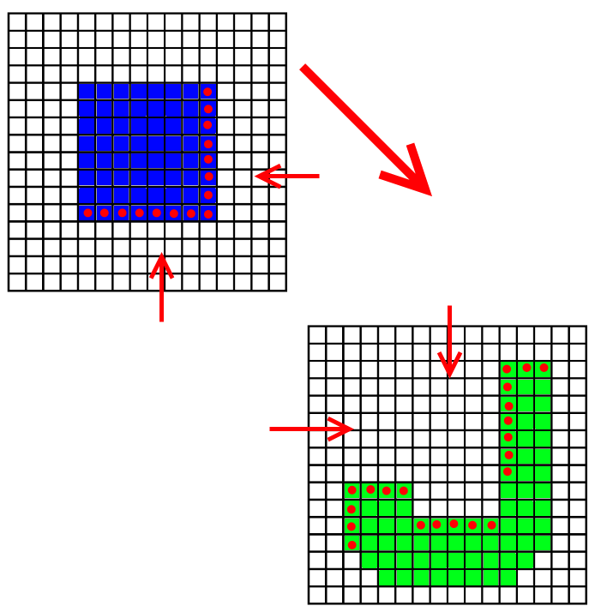
Fig 4.5.2.2.1 shows a 2D example of how potential bridges are found.
In the second phase, these potential bridges are transformed into global space, and each bridge is tested to see whether it lies within its partner's bounding box. Those that pass the test are checked for proximity with their partner's bridges, if two bridges from opposing objects are found to lie within a certain radius of each other, then they are both promoted to full Energy Bridges.
A bridge is stored as a pairing of an integer (which is the 3 local coordinates of the bridge compressed into one 18 bit integer) with a 3 component floating point vector (the external point). Every Bridge has an equivalent and opposite bridge in the Collision Partner.

if(bridgeInFirst.distance(bridgeInSecond) < closeRadius)
{
Vector3f localPointFirst = first.transformToLocal(closeBridgesSecond[i]);
Vector3f localPointSecond = second.transformToLocal(closeBridgesFirst[i]);
first.addBridge(bridgeInFirst.localCoord, localPointSecond);
second.addBridge(bridgeInSecond.localCoord, localPointFirst);
}

void EnergyGrid::addBridge(Vector3i voxel, Vector3f point)
{
int key = voxelCoord.x << 12 | voxelCoord.y << 6 | voxelCoord.z;
mBridges.insert(std::pair<int, Vector3f>(key, point));
}
Bridges are used later in this algorithm, and a modified version is used for the Approximate algorithm.

4.5.2.3:Transfer Maps
Transfer maps are based on the idea that each voxel had up to 26 adjacent voxels, and when a voxel attempts to transfer the energy stored within it, it passes it to some of these “neighbours” with varying degrees of pressure or stress generated. The amount of energy transferred to each neighbour, and the amount of pressure and/or stress generating by transferring that energy to them are determined by a Transfer Map.
Each Energy Grid stores two transfer maps, one for receiving energy from it's Collision Partner and one for transferring energy through itself to that partner.
Transfer Maps are generated prior to processing any data. Each possible neighbour direction is given a predefined normalised 3d “direction vector”. For example, forward is (0,0,1) while forward, up and left is (-0.33,0.33,0.33). The relevant energy vector is translated into local object space and normalised then the dot product of the energy vector with each of the 26 direction vectors is added to the transfer map, which can be visualised like so:

Energy Vector: (0,-1,1)
DOWN(z = -1) | LEFT(x = -1) | x = 0 | RIGHT(x = 1)
FORWARD(y= 1) | -0.42 | -1 | -0.42
y = 0 | -0.42 | -0.66 | -0.42
BACK(y=-1) | 0 | 0 | 0

z = 0 | LEFT(x = -1) | x = 0 | RIGHT(x = 1)
FORWARD(y= 1) | -0.42 | -0.66 | -0.42
y = 0 | 0 | INVALID | 0
BACK(y=-1) | 0.42 | 0.66 | 0.42

UP (z = 1) | LEFT(x = -1) | x = 0 | RIGHT(x = 1)
FORWARD(y= 1) | 0 | 0 | 0
y = 0 | 0.42 | 0.66 | 0.42
BACK(y=-1) | 0.42 | 1 | 0.42

Each of these dot products can be thought of as the Pressure Ratio associated with that direction. If energy is transferred from any voxel to a neighbour along that direction, the Pressure generated will be given by the equation:
Pressure Generated = Energy Transferred x | Pressure Ratio |
The stress generated from such a transfer is given by the equation:
Stress Generated = Energy Transferrred x (1 – | Pressure Ratio |)
Note that pressure ratio is absolute.
This means that energy transfer in the same direction as the energy vector will generate mostly or only pressure, while energy transfer perpendicular to the energy vector will generate mostly or only stress.
As mentioned earlier in this section, each Energy Grid stores two transfer maps. The first is generated using the Energy Vector of the Energy Grid in question, this is known as the Projecting Transfer Map the second is generated using the Energy Vector of the Collision Partner and is known as the Receiving Transfer Map.

4.5.2.4: Direct Transfer
The algorithm is split into two distinct phases. Direct Transfer and Indirect Transfer. In the direct transfer stage every voxel in the projecting object is given the correct amount of starting energy, using the value calculated earlier.
A Direct Transfer Map is then generated using the Projecting Transfer Map. Each positive Pressure Ratio in the Projecting Map is duplicated into the Direct Map and then divided by the sum of all positive pressure ratios. The result is something like this:
Energy Vector: (0,-1,1)
DOWN(z = -1) | LEFT(x = -1) | x = 0 | RIGHT(x = 1)
FORWARD(y= 1) | 0 | 0 | 0
y = 0 | 0 | 0 | 0
BACK(y=-1) | 0 | 0 | 0

z = 0 | LEFT(x = -1) | x = 0 | RIGHT(x = 1)
FORWARD(y= 1) | 0 | 0 | 0
y = 0 | 0 | INVALID | 0
BACK(y=-1) | 0.08 | 0.14 | 0.08

UP (z = 1) | LEFT(x = -1) | x = 0 | RIGHT(x = 1)
FORWARD(y= 1) | 0 | 0 | 0
y = 0 | 0.08 | 0.14 | 0.08
BACK(y=-1) | 0.08 | 0.2 | 0.08

Note that this results in a map where all the values will roughly sum up to 1.0.
Every voxel with more energy than the required amount is then added to a list and processed. With each pass, voxels found to have more than the required amount of energy spread it amongst their neighbours as the Direct Transfer Map directs. The amount of the free energy transferred to each neighbour is proportional to the transfer maps value in that direction.
If the transferring voxel is an Energy Bridge then a different process is used as described below, using the amount of energy and the Bridge's external point on the Collision Partner as input.
If the voxel attempts to transfer energy to an empty space or invalid coordinate, that energy is added to a separate pool in the voxel, known a untransferred energy. Within the scope of the Direct Transfer phase, this Energy no longer exists. However it becomes relevant later in the Indirect Transfer phase.

4.5.2.5: External Transfer
In the Iterative algorithm. External transfer occurs when a voxel defined as a bridge attempts to project energy. As the voxel cannot pass energy to voxels in the collision partner in the regular way, it instead invokes a special external transfer method on the collision partner's energy grid with the energy to transfer and the bridge's external point as input.
A line is drawn from the external point in the direction of the current energy vector. Depending on which component of the energy vector is most significant, the line is checked for intersection with each plane formed by the Matter Objects grid in that direction. The four closest voxels on that plane to point of intersection are each given a certain portion of energy based on their distance from the point, this continues through the object, spreading energy at each plane until there is not enough to continue.
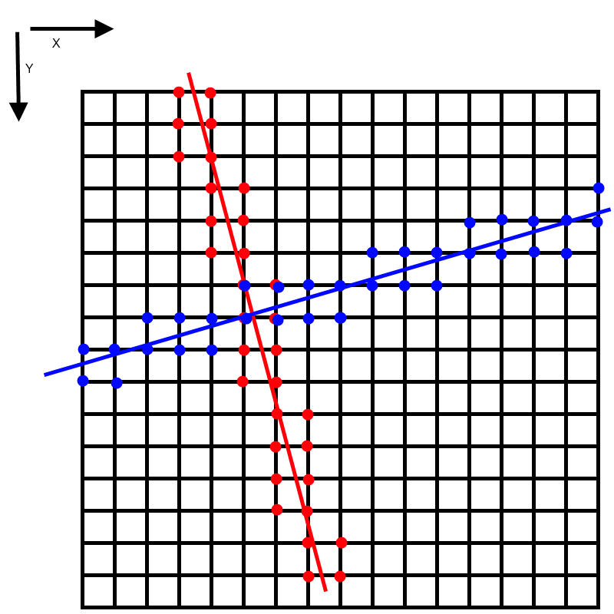
Fig 4.5.2.5.1 shows how two different energy vectors projected through the Matter Object behave. Coloured pips show the location of voxels that receive energy from these vectors.
Fig. 4.5.2.5.1 above shows how the blue vector's most significant element is X so it is checked for intersection with the planes formed by the X coordinates of the Matter Object's voxel grid. The red vector's most significant element is Y, and so it is checked for intersection by planes formed by the Y coordinates. This translates into 3d quite easily.
Voxel's are weighted like so:
for(int k = 0; k < closestVoxels.size(); k++)
{
/*
Note: Within the code, the two non significant elements of a vector are referred to as “Up” and “Left”. The .get() function returns these elements from a vector using those labels.
*/
float verticalDistance = closestVoxels[k].get(mExternalTransferUp) - pointOfIntersection.get(mExternalTransferUp);
float horizontalDistance = closestVoxels[k].get(mExternalTransferLeft) - pointOfIntersection.get(mExternalTransferLeft);

//NOTE: fabs returns the absolute value of a float.
float weight = (1-fabs(verticalDistance)) * (1-fabs(horizontalDistance));
closestVoxelWeights.push_back(weight);
}

4.5.2.6: Indirect Transfer
After the Direct Transfer phase, not all voxels will be at the target energy level. Some of the voxels in the receiving Matter Object will not have received enough energy, while some of the voxels in the projecting Object will have some untransferred energy left over from the Direct Transfer phase.
Energy must travel from the voxels with high energy to those with low energy to balance the energy in the system. Though keeping track of every single unit of energy would be too demanding. Instead, it is assumed that high or low energy voxels only needs to find their way to a voxel with the correct amount of energy. Using this rule, the path of energy can be calculated, applying stress and pressure along its length. This fulfils requirement two of the system.
This requires the construction of a Transfer Graph. Nodes in the graph are the Voxels in the Matter Object, the initial nodes in the Graph are those Voxels that are at the correct energy level already. For every iteration of the graph building process each node in the current generation will attempt to expand and add it's neighbours to the graph if they have not already been added. Apart from the original “source” nodes, every node has a parent, the node that added it to the graph. When two nodes attempt to add the same voxel to the graph in the same iteration the one with the highest Transfer Priority is granted parent hood. Transfer Priority is given by the equation:
Transfer Priority = 1 – |PressureRatio(Direction)|
Where Direction is the direction from the potential parent node to the potential child node. The parent nodes are referred to as feeders in the code.
What follows is the pseudocode for generating the Transfer Graph:

buildTransferGraph()
{
startOfStep = 0;
endOfStep = 0;

vector TransferGraph
TransferMap[32][32][32] = ...initialise to -1

//Add source voxels to graph
for(x = 0 to 31)
{
for(y = 0 to 31)
{
for(z = 0 to 31)
{
voxel = theVoxelData[x][y][z];
if(voxel.energy >= targetEnergyPerVoxel)
{
TransferGraph.push_back(TransferNode(Vector3i(x, y, z)));
mTransferGraph.back().mGeneration = 0;
mTransferMap[x][y][z] = mTransferGraph.size()-1;
endOfStep++;
}
}
}
}

oldSize = 0;
newSize = endOfStep;

generation = 1;

//Expand graph
while(oldSize != newSize) //End if no new voxels are added to graph.
{
oldSize = newSize;
endOfStep = newSize;

//Add adjanct nodes to map.
for(i = startOfStep to endOfStep)
{
currentNode = TransferGraph[i];
coord = currentNode.VoxelCoord;

//Get coords of adjanct nodes
for (each direction k in direction set)
{
adjanctCoord = coord + getDirectionVector(k);
if(validCoord(adjanctCoord))
{
nodeIndex = TransferMap[adjanctCoord.x][adjanctCoord.y][adjanctCoord.z];

//Node has already been added to graph, but is "younger" than this node.
if(nodeIndex >= 0 && nodeIndex > endOfStep)
{
adjanctNode = TransferGraph[nodeIndex];
previousFeederDirection = getReverseDirection(adjanctNode.FeederDirection);
previousFeederPriority = 1.0 – abs(mCurrentMap[previousFeederDirection]);
priority = 1.0 - abs(mCurrentMap[k]);

//If this voxel is a better feeder, then use it instead of the //previous one.
if( priority > previousFeederPriority)
{
adjanctNode.Feeder = i;
adjanctNode.FeederDirection = getReverseDirection(k);
}
}
else if(nodeIndex < 0)
{
//Node has not been added, must check it is full.
voxel = mVoxelData[adjanctCoord.x][adjanctCoord.y][adjanctCoord.z];
if(voxel.mFull && !(voxel.mDestroyed || voxel.mSnapped))
{
mTransferGraph.push_back(TransferNode(false, adjanctCoord));
mTransferMap[adjanctCoord.x][adjanctCoord.y][adjanctCoord.z] = mTransferGraph.size()-1;
newNode = mTransferGraph.back();
newNode.mFeeder = i;
newNode.mFeederDirection = getReverseDirection(k);
newNode.mGeneration = generation;
}
}
}
}
}

newSize = mTransferGraph.size();
startOfStep = endOfStep;
generation++;
}
}
Once the transfer graph has been completely built, all nodes are processed once more. This type a recursive function is invoked where the amount of energy required to bring a voxel up or down to the correct level is requested from that voxels feeder. The feeder then requests that energy from their feeder, creating a feedback chain of stress or pressure depending on the direction the energy takes.
After the Indirect Transfer phase, the Voxels should all have their final stress, pressure and energy values and so can be processed by the Breaking Algorithm detailed in a later chapter.

4.5.3: Analysis
The Iterative Algorithm underperformed because the amount of data that needed to be processed in the Direct Transfer phase was enormous. Not only that, but in each pass many voxels where re-energised by their neighbours, meaning the worst case performance was dreadful. It was possible that the end of the first pass, only one voxel would have been removed from the list, and only 4 or so removed in the second pass. This lead to computation times exceeding several seconds, which was obviously unacceptable.
Due to the large amount of detail, however, it did achieve very convincing simulation destruction results, if the enormous delay between collision and visible results is ignored.
By comparison the External and Indirect transfer algorithms worked relatively quickly which influenced the design of the later algorithms. Though both would still need optimization to work within an acceptable time scale. The External Transfer algorithm was called once every time new energy reached a bridge voxel, which happened almost every iteration.

4.6: Second Algorithm – Approximate Approach

4.6.1: Algorithm Design and Theory
The idea behind the second algorithm was to reduce the detail of the simulation by using much simpler rules for creating stress, pressure and energy values. The theory being that most of the complex interactions between voxels could be replaced with simple equations that gave very similar results. For example, the levels of pressure around the point of impact between two matter objects would show an almost linear falloff, despite those results being generated by a great number of calculations. It was believed that most of the discrepancies would not be noticeable to the average observer.

4.6.2: Algorithm Implementation

4.6.2.1:Transferring Energy between Objects
Benchmarks showed that the process of building bridges between shapes was relatively fast and not a major bottleneck of the system, so this element remained basically the same. However, instead of mapping an internal grid-aligned coordinate to an external non-grid-aligned coordinate bridge's now mapped an internal grid-aligned coordinate to an external grid-aligned coordinate. This meant that there was a slight offset at the collision points between two objects when their grids where not aligned correctly, however it meant that transferring energy between objects was much faster.
if(bridgeInFirst.distance(bridgeInSecond) < closeRadius)
{
first.addBridge(bridgeInFirst.localCoord, bridgeInSecond.localCoord);
second.addBridge(bridgeInSecond.localCoord, bridgeInFirst.localCoord);
}

void EnergyGrid::addBridge(Vector3i localVoxel, Vector3i remoteVoxel)
{
int localHash = localVoxel.x << 12 | localVoxel.y << 6 | localVoxel.z;
int remoteHash = remoteVoxel.x << 12 | remoteVoxel.y << 6 | remoteVoxel.z;
mBridges.insert(std::pair<int, int>(localHash, remoteHash));
}

4.6.2.2: Direct Transfer
The main difference with the second algorithm where the changes to the Direct Transfer algorithm. Instead of iterating over all the voxels in a Matter Object a large number of times a vector based algorithm was used similar to the External Transfer phase used as part of the Iterative approach. As both Direct and External transfer work almost identically within the second algorithm they will both be detailed at once here.
The reverse of the current energy vector was projected through local space and the number of voxels in it's path counted. Unlike the previous external transfer algorithm only the closest of the voxels on the intersection line where considered part of the path, rather than the 4 closest. After the vector reached an invalid point (where the nearest voxel was empty or the vector had left the Matter Object) every voxel in the path was processed with the following equation:
EnergyProjectedPerVoxel = StartingEnergyPerVoxel – TargetEnergyPerVoxel
Pressure = (1 + 2*(maxDistance – voxelDistance ) ) * EnergyProjectedPerVoxel
Where maxDistance is the distance from the bridge of the furthest voxel in the path, while voxelDistance is the distance form the bridge of the voxel in question. The resulting pattern was that pressure was greatest nearest to the point of collision, and then fell off at a rate of about ( StartingEnergyPerVoxel – TargetEnergyPerVoxel) every layer further away.
The external transfer algorithm worked in a similar way, except that the non-inverted current energy vector was used to determine the path. A slightly different equation was also used:
EnergyAbsorbedPerVoxel = TargetEnergyPerVoxel - StartingEnergyPerVoxel;
Pressure = (2*energy) - ((2*voxelDistance + 1) * EnergyAbsorbedPerVoxel)
Where energy is the amount of energy transferred to the bridge. Note that starting energy is different in the two different objects. This gives a very similar linear falloff pattern. Two objects of roughly equal mass and of the same material and structure that collide will produce a mirror-like destruction pattern. Where the amount of destruction due to pressure on one shape is equal and opposite to the destruction on the other.

4.6.2.3: Indirect Transfer
Indirect Transfer remained mostly unchanged. The main difference from the first algorithm was that as the graph was built stress was accumulated as a simple integer value in each voxel. When a node was added to the graph, it incremented it's parents stress counter by 1, which did that same to it's parent and so on. After the graph was built this stress value was multiplied by the approximate amount of energy required to be lost or gained by each non-energised voxel:
Stress Mutliplier = |Target Energy per Voxel – Starting Energy per Voxel|
This gave slightly faster performance that performing the recursion with floating points directly.

4.6.3: Analysis
The Approximate Approach saw significant performance gains, with similar results in simulation to the iterative approach. The main bottleneck is now the Indirect Transfer phase, which only saw a minor performance increase. Potential Alternative approaches and possible optimizations will be discussed in the concluding chapter of this dissertation.

4.7: Comparison of Implemented Algorithms
Both the above algorithms create similar results in terms of quality of simulation. The iterative approach has slightly less anomalies in obscure scenarios, however.
The Approximate Approach is completely superior in terms of performance, and is the only one of the two that could be considered viable. It's performance in it's current state is still too slow to really be considered acceptable for real time simulation, however it is a move in the right direction that can be built upon in the future.
Algorithm | Iterative | Approximate
Process Time | Between 6 and 12 seconds. | Approximately 0.01 seconds.
Simulation Results | Very Detailed | Less Detailed

4.8 Fulfilling Requirements
The system behaves within the defined required behaviour to an acceptable degree.
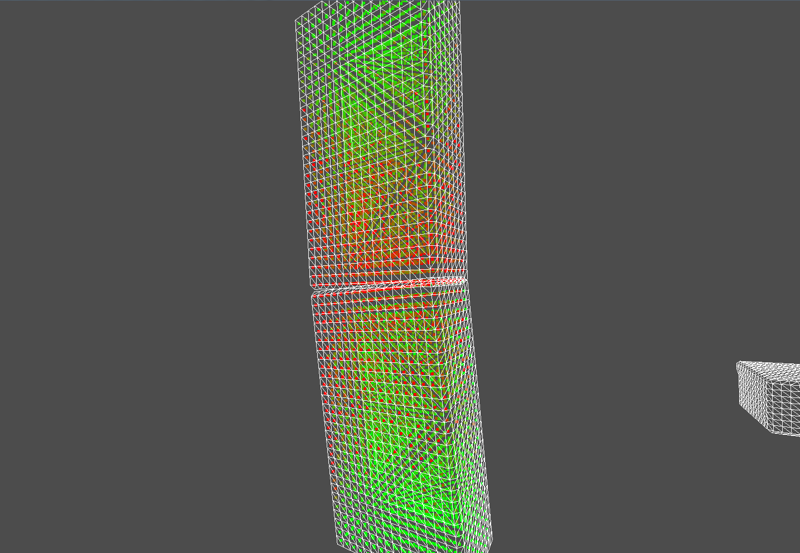
Destruction between two equal shapes is roughly equal and opposite, considering that they collided at a flat angle.

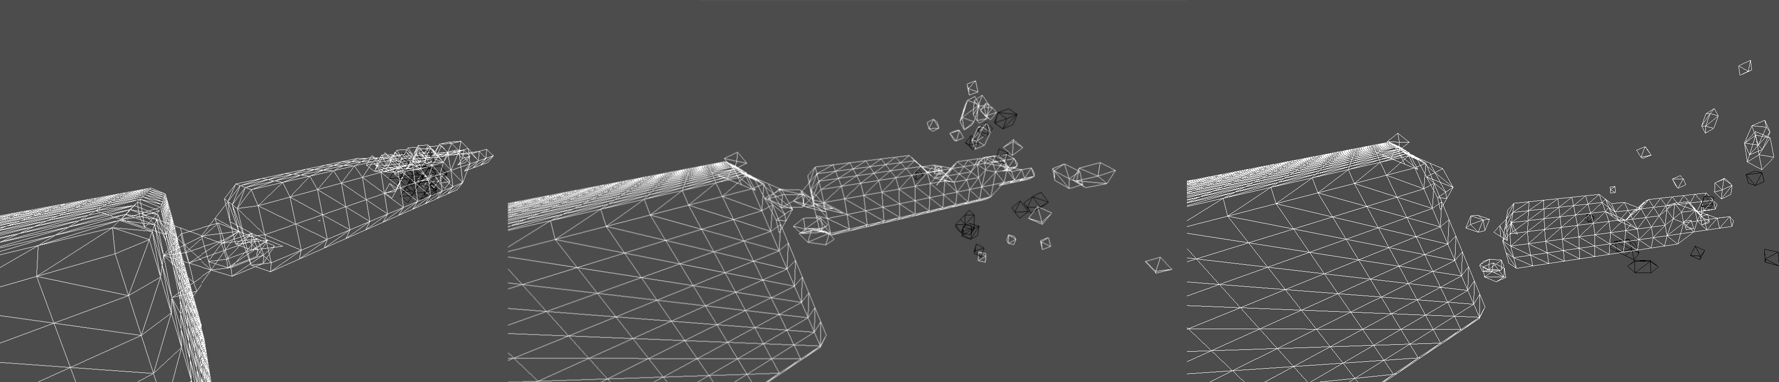
Collision with a object with an obvious weak-point causes more breaking around the weak-point.

4.8: Processing Results: Decomposing Objects

4.8.1: Materials
Materials have been mentioned several times throughout this document, and can be described as a collection of properties for a particular type of matter. Material's effect the physical behaviour of any object that uses them. For example a “Brick” material will behave differently to a “Wood” material.
The table below summarizes the full list of Material properties and their purpose.
Property | Purpose
Density | Mass of each voxel with this material. An object's mass is:  number of voxels * density
Pressure Limit | The amount of pressure a voxel can withstand before being considered “broken”.
Stress Limit | The amount of stress a voxel can withstand before being considered “snapped”.
Pressure Grouping | When a piece of an object breaks off due to pressure, higher pressure grouping will cause less fragmentation.
Stress Grouping | When a piece of an object breaks off due to stress, higher stress grouping will cause less fragmentation.
Debris Pressure Limit | When a piece of an objects breaks off due to pressure, the total amount of pressure in a fragment cannot exceed this.
Debris Stress Limit | When a piece of an objects breaks off due to stress, the total amount of stress in a fragment cannot exceed this.
Min Strength/Max Strength | All voxels have a random strength factor between min and max strength. This value is multiplied with pressure/stress limit to make the voxel more or less resistant to stress and pressure.
Friction | A value used in Bullet Physics rigid bodies representing objects of this material.
Restitution | A value used in Bullet Physics rigid bodies representing objects of this material. Restitution is essentially the “bounciness” of an object.
Trivial Threshold | The minimum amount of energy per voxel in an object before it is considered significant enough to be involved in destruction.
Trivial Mass | The minimum number of voxels in an object before it is considered significant enough to be involved in destruction.
Color | The color the visual elements of objects are rendered with. In a more sophisticated system, this might be replaced with textures.

4.8.2: Creating Breaks
Whenever a Voxel has stress or pressure applied to it, the following functions are used:
void pressureVoxel(Vector3i voxelCoord, float pressure)
{
if(validCoord(voxelCoord) && pressure > 0)
{
VoxelData& voxel = voxelData[voxelCoord.x][voxelCoord.y][voxelCoord.z];
voxel.pressure += pressure;

float pressureLimit = material()->getPressureLimit()*voxel.strength;
if(voxel.pressure > pressureLimit)
{
voxel.destroyed = true;
destructionOccured = true; //Object-Wide Flag.
}

}
}

void stressVoxel(Vector3i voxelCoord, float stress)
{
if(validCoord(voxelCoord) && stress > 0)
{
VoxelData& voxel = voxelData[voxelCoord.x][voxelCoord.y][voxelCoord.z];
voxel.stress += stress;

float stressLimit = material->getStressLimit()*voxel.strength;
if(voxel.stress > stressLimit)
{
voxel.snapped = true;
snappingOccured = true; //Object-Wide Flag.
}

}
}
As can be seen, the strength of a particular voxel has a large effect on whether or not it breaks or snaps. This creates more uneven and rough patterns during destruction, to emulate the natural inconsistencies and imperfections present in most materials. These properties will be useful when breaking the object down due to destruction.

4.8.3: Finding Sub-Shapes
After the destruction algorithms have identified which voxels can be considered as snapped or destroyed, the Matter Objects need to be broken down into smaller fragments.
An arbitrary voxel is chosen as a “master” voxel, which then expands in the 6 primary grid aligned directions (no diagonals) and adds any valid voxels to a new sub-shape. These voxels can themselves expand to increase the size of the shape.
The process continues with another master voxel until all voxels have been added to a new shape.
Depending on the state of the master voxel, the rules for expanding the sub-shape may be different.
If a destroyed voxel is selected:
- Only adjacent voxels that are also destroyed may be added to the shape.
- The difference in pressure between a parent voxel and its child cannot exceed the Material's pressureGrouping property.
- Total Pressure of all voxels in the shape cannot exceed the Material's debrisPressureLimit Property.
If a snapped voxel is selected:
- Only adjacent voxels that are also snapped may be added to the shape.
- The difference in stress between a parent voxel and its child cannot exceed the Material's stressGrouping property.
- Total Stress of all voxels in the shape cannot exceed the Material's debrisStressLimit Property.
If an intact voxel is selected:
- Any adjacent voxels that are not destroyed may be added to the shape.
- Snapped voxels may be added to the shape, but will not expand.
- There is on limit of size of shape.
By modifying the properties of a material, different behaviours can be created. For example, a Material with low bond strength but a high pressure and stress limits will be very resistance to having its outer layer “chipped” away but a significant enough collision may shatter it entirely. While a Material with the opposite properties may shed large chunks of its outer layer in any collision but the damage will rarely penetrate the shape too deeply.

4.8.4: Conserving Momentum
The system uses a very rudimentary system for conserving momentum after a collision. The result looks somewhat realistic to the casual observer, but if someone where to analyse the way objects behave in any great detail the inaccuracies would be revealed.
As a Matter Object fragments, the amount of energy in each shape is summed up. After fragmentation an impulse is applied to each fragment using the following functions:

Vector3f energyVector = mEnergyVector.normalized() * projectedEnergy; //TOTAL of all energy in projecting direction.

energyVector += (mCollisionPartner->getEnergyVector().normalized() * recievingEnergy); //TOTAL of all energy in receiving energy.

float speed = sqrtf((2 * energyVector.length())/mMatter.getMass());

setInitialForce(energyVector.normalized() * speed * mMatter.getMass());
This is essentially the inverse of the equation that converted velocity and mass into energy, with the addition of being multiplied by mass to create force.
Force = Mass * Velocity
The issue with this equation is that it assumes all forces should be applied to the fragment's centre of mass. Which isn't always the case.

Chapter 5: Conclusion and Project Evaluation

5.1: Introduction
In this chapter the Author will provide retrospective and evaluation on the execution of the project. Whether or not the project met its aims and objectives will be analysed, as well as a conclusion on the original Hypothesis' validity.

5.2: Conclusion

5.2.1: Satisfaction of the aims and objectives.
The project was completed to the basic level specified in the original proposal although none of the optional extra goals have been met and demonstration and editing tools are severely limited. Bullet Physics is well integrated into the system and the simulation of pressure and stress works to a satisfactory level of detail with an acceptable level of realism. Marching cubes was implemented on both the CPU and GPU, and works correctly. All the projects sub-systems interact with each other in the expected manner.
However, performance is fairly low during destruction simulation. The system, on the day of submission, is too slow for use in a real time simulation with large amounts of moving objects. Despite this, much progress was made towards building a system that began to approach the original performance requirements, especially considering the complete lack of similar algorithms to build upon.
At this point it is unclear if the performance goal could potentially have been met by implementing more efficient algorithms, or what effect a multi-threaded implementation would have on performance. As far as background research indicates, this particular usage of voxels had not been attempted before and so it is hard to gauge whether the goal was attainable to begin.

5.2.2: Overall conclusion.
Although the system does not fulfil the performance objective set in the project proposal, it does build a solid base for future research and implementation attempts in this area. This project revealed what approaches would not work and where the bottlenecks in a system such as this will arise, while making it clearer how to take advantage of the properties of voxels to build more efficient algorithms.

5.3: Further Work
Below are some suggestions for future work in this area or extensions to the system implemented in this project.

5.3.1: Build an algorithm that analyses the structure of objects upon generation.
The major bottleneck in the destruction algorithm is the Indirect Transfer phase, which essentially analyses the objects structure quickly to find points of high stress. However these weak points are always going to be in roughly the same place, given the collision occurs in roughly the same spot on the object.
If an algorithm could find these weak points during object generation (this means it must be very quick, as new objects are generated whenever destruction occurs) then stress would only need to be calculated on these weak-points, instead of on the entire shape.
This would also allow for much more effective and accurate filtering of trivial collisions as information on the shapes structure would always be available without the need for expensive computations.

5.3.2: Modify the system to allow for collisions to be broken down into several sub collisions.
The current system handles all energy transfer in the system as near instantaneous, it performs energy transfer on two Matter Objects and then processes the results. The problem with this approach is that there are not many opportunities for realistic effects such as part of an object being snapped off without severely damaging the rest of the structure.
The system could be modified to split the amount of energy in a collision into several smaller amounts, then run the simulation several times. The destruction results from each previous simulation may effect the current one, for example energy may no longer pass through a snapped voxel.

5.3.3: Implement a fully custom physics system
Transforming all voxels into rigid body geometry for use by Bullet is one of the big performance bottlenecks of the system. It may be possible to build a completely custom physics system that can perform collision detection on voxel objects without converting them to convex hulls first. An alternative approach would be to implement a custom collision detection algorithm that can be plugged into Bullet Physics, as its modular nature allows for this.
This physics system could use a method similar to the bridge-building method to detect collisions, though obviously it would need to be optimized to be work faster.

5.3.4: Integrate GPU Accelerated Marching Cubes more Efficiently
GPU Marching Cubes executes much quicker than CPU Marching Cubes, however the performance gains in faster Marching Cubes are cancelled out by performance issues caused elsewhere in the system. This means that overall, performing Marching Cubes on the CPU leads to better performance.
It should be feasible to create a “smart” Voxel Converter that places all new Conversions for that frame into several different groups. If there is a great deal of conversion to be performed, objects can be batched into a single texture before being shipped to the GPU, and then be assigned different ranges of the resulting Vertex Buffer. If a particular batch is small, then CPU processing should be used instead.
This among, with a greater deal of research into where the performance bottlenecks of GPU marching cubes are arising, should speed the system up greatly.

5.3.5: Re-factor the system to use multiple threads and CPU cores
The current system uses only one CPU, despite many parts of it being suitable for parallelisation; CPU-side Marching Cubes, for example, could be improved by processing each object on a separate thread, the parallel nature of marching cubes means that a single execution of marching cubes could also benefit from using multiple threads within itself.

5.3.6: Build a version of the system that runs on CUDA or OpenCL
The current system runs too slowly to be considered real time. If it proves difficult to increase performance to an acceptable level by optimization or modification of the system, a possible solution may be to utilise the huge processing power granted by using a Parallel Computing Platform.

Appendix A: Supplementary Material
After extracting this projects supplementary material from the included .zip archive you should have access to the following supplementary material:
- All project source code and assets. Note that if you wish to build the project yourself you will need to acquire Bullet Physics yourself, as the library was too large to include.
- A statically linked VoxelPhysics.exe executable that will run the demo application. With two .bat files to run the demo with or without GPU acceleration enabled.

Using the Demo Application
The demo takes a single command line argument.
-forceCPU
The included .bat files will set this argument for you. When -forceCPU is included in the programs command line arguments GPU acceleration will be disabled regardless your computer's GPU capabilities. For best performance, it is recommended to do this.
The demo application is a console application, after starting you will be required to type any characters into the console to start the system.
The controls for the demo application are listed below:
Key | Action
W | Move Camera Forward
S | Move Camera Backward
A | Strafe Camera Left
D | Strafe Camera Right
Q | Roll Camera Anti-Clockwise
E | Roll Camera Clockwise
Left Arrow | Yaw Camera Anti-Clockwise
Right Arrow | Yaw Camera Clockwise
Up Arrow | Pitch Camera Up
Down Arrow | Pitch Camera Down
Spacebar | Move Camera Up
Ctrl | Move Camera Down
R | Fire a “Cannonball” Forwards
P | Reset Scene (handy for getting rid of excess rigid bodies)
Esc | Quit

Appendix B: References
- Edinburgh Online Graphics Dictionary http://homepages.inf.ed.ac.uk/rbf/GRDICT/grdict.htm#entryvox
- Ryan Geiss, Nvidia, GPU Gems 3 Chapter 1. Generating Complex Procedural Terrains Using the GPU
http://http.developer.nvidia.com/GPUGems3/gpugems3_ch01.html
- Bullet Physics
http://bulletphysics.org/wordpress/
- Atomontage Engine
http://www.atomontage.com/
- Forum Post by Den Kirson explaining Battlefield Bad Company 2's destruction mechanics
http://denkirson.proboards.com/index.cgi?action=display&board=nonsense2&thread=2757&page=1#43105
- Nvidia APEX
https://developer.nvidia.com/apex-destruction
- Eric Lengyel, Transvoxel Algorithm
http://www.terathon.com/voxels/
- Eric Lengyel, Marching Cubes reference tables
http://www.terathon.com/voxels/Transvoxel.cpp
- Khaled Mamou's HACD: Hierarchical Approximate Convex Decomposition Algorithm
http://kmamou.blogspot.co.uk/2011/10/hacd-hierarchical-approximate-convex.html
- Bullet Physics Documentation for Compond Shape
http://www.bulletphysics.org/mediawiki-1.5.8/index.php/Collision_Shapes#Compound

