

**Advanced Web Technology Coursework 1 Report**

Lewis Brockie [40270307@live.napier.ac.uk](mailto:40270307@live.napier.ac.uk)

Edinburgh Napier University – Advanced Web Technology (SET09103)

# Introduction to Coursework

The purpose of this coursework was to develop a prototype web application about that demonstrates my understanding of the Python Flask micro-framework and included user interaction through navigation URL. The subject is my choice, something that interests me. I need to design a URL hierarchy that is appropriate for finding and retrieving information through navigation.

# Title

## The title for my web application is “Big Cats of the World”.

# Introduction to Web Application

## The web application provided users with information about big cats that live on Earth. It focuses on the 7 main big cats, which are as followed:

## Lion

## Tiger

## Cheetah

## Leopard

## Jaguar

## Snow Leopard

## Puma/Cougar

## The reason why I choice this form of subject was because I have always loved animals, especially big cats, from a very young age. They are also among the most famous and well known of the carnivorous mammals

# The application allows users to visit the 3 continents in the world that big cats like on which are Africa, Asia and America, find out which cats live there and view information such as habitat, diet and interesting facts.

# Additionally, as I thought it would be a great addition to the website, I added a page with information about some prehistoric big cats related to current big cats to make my website a bit more interesting.

# Images of cats will also be included to insure the web application isn’t empty and included only full text. This form of media is always a big element in web application as it makes them more eye catching and draws users in. I won’t however overload pages with images, I will only use a certain number.

# Home Page Storyboard

# 

# Home Page Screenshot

# 

# Design

# I developed the application using Linux, SSH and Vim, run through Python Flask and uploaded using Git. Bootstrap library templates were downloaded and used to for creating the web pages and adding style.

# The overall design of my web application is like any basic web app. It includes a Home Page that serves as the central page of the application as it links to all the other pages.

# App Pages

# Home Page: Main page that welcomes the user to the application and what information they will gain from it.

# Continents Page: Information about the 3 continents and provides new navigation HTTP links in the bar as well as additional command buttons.

# Africa Page: Information on Africa’s big cats.

# Asia Page: Information on Asia’s big cats

# America Page: Information on America’s big cats

# Prehistoric Cats Page: Information on 4 prehistoric big cats.

# Templates Folder

# My templates folder is where I store the HTML templates for my pages,

# Using Flask they are rendered and returned to the users using “the render template function”.

# Statics Folder

# This is where I store downloaded Bootstrap library templates, all my images, CSS files and fonts.

# URL Navigation

# All main links to other pages are in the Navigational Bar at the top of the page the user is on. The user accesses the other pages by clicking the hierarchical hyperlink text that will transfer them to the appropriate page.

# When the “Continents” hyperlink is clicked, the navigational bar changes when the “Continents” page is opened. It expends by introducing 3 new hyperlinks titles “Africa”, “Asia” and “America”. These only appear when either the “Continents” page is open or if the user is on 1 of the 3 pages.

# An additional form of navigation I used was command buttons in the “Continents” page which will navigate the users to the pages for each continent. My reason for including command buttons was if someone who didn’t have much experience with web apps was looking for simple navigation to other pages, this was the best choice.

# If any of these navigation links failed to work, then the user would be met with an error page, but all my links functioned correctly.

# URL Hierarchy Navigational Map

# 

# Enhancements

# Images

# As mentioned previously I intended to add images to my web app, but after multiple attempts at trying to display them, I was unable to. This is the no 1 future enhancement I would make.

# I did store all my intended images into the “img” folder inside the “static” directory folder. Here is 1 of my intended images (which I created myself):

# 7Cats.JPG

# Additional form of User Interaction and Response (Type in and Search Box)

# I was wanting to include a Type in and Search Interaction Box in my Home Page that would have allowed the user to type in a continent and be transferred to the right page. If they had entered invalid text, they would be taken to an error page.

# Individual Pages for Each Cat

# This is a key future enhancement I would add. It would be to give each cat its own individual page, therefore allowing more information and images to be added.

# If I did do that, I would use a similar navigational style I used for the “Continents Page and the 3 individual continent pages where once the user is on the “Africa”, “Asia” or “America” page, more links would be displayed in the nav bar that would link to a page on an individual cat. This could also be done for the prehistoric cats.

# Another form of expansion is including other cat species such as Ocelot, Caracal, Lynx, etc.

# Other Media

# In future, other media elements like videos of cats or even audio of cat sounds could be added.

# Critical Evaluation

# In evaluation, I have built a basic functioning web application made using imported Bootstrap templates that provides views with information about Earth’s big cats.

# What Worked Well

# Navigation

# My app’s navigation was the primary functioning process I wanted to insure worked correctly. It was successful and all my navigational links whether they were in the navbar or command buttons worked and linked to the designated page. Plus, whenever a user is on a page, whichever page they are on is highlighted in the navigation bar.

# Navigation is arguably the most important feature in web applications because if you’re website can’t navigate through designated routes to other pages, then the whole application can just fall apart.

# Text

# I made great use of text within my application. Appropriate size and fonts were used such as “Header” for titles.

# I made sure that all my text was readable and had an appropriate size, so it was all visible of viewers.

# What Worked Poorly

# No Images

# As mentioned previously, I intended to use images but was unable to get them to display within my application.

# If images were included, it would have made my information pages more eye catching and created gaps between the text.

# All my intended images were clear, nut fuzzy and I would have restricted it to at least 2 pictures of each cat.

# These can however be added in future development.

# Personal Evaluation

# It has been just under 2 years since I last created a web app, and I was slightly worried at the start of this coursework that I might struggle. However, I proved to myself that I was still capable and has the skills for creating a basic functions website. I did have experience with Bootstrap Libraries as I had used them when doing past web projects in college.

# In the past I have used developing software like Adobe Dreamweaver and Visual Studio to create web-based applications, but I had rarely used the likes of Python, SSH and Linux. I had also only used GitHub once in my life for uploading work.

# Using a Workbook during practical classes, I got the hang of using all these new software’s and I found myself enjoying them quickly. It did take me a bit of time to get the feel of using them but I used some useful online tutorials as assistance.

# I have to say I have enjoyed using these new software’s, and I would defiantly use them again in the future whenever I’m making an online website or anything similar. Even although I’m still new to these forms of software, I can still further my skills and knowledge.

# Overall, I am proud of my performance in this coursework, even although I was unable to get some features like images working, and I believe I have covered what was required. I created a basic working website that has more than 1 form of user interaction in terms of URL navigation between pages, and all forms of navigation function as intended.

# Even although there is much more I wish I could have added or expanded on, I am pleased with myself that I did manage to get a website created.

# References

# All my intended images were obtained from “Google Images”.

# Most of the information and facts on Big Cats came from my own general knowledge, but I did use sites like “Wikipedia” as well.

# Useful websites used for assistance

# <https://anandology.com/python-practice-book/>

# <https://www.w3schools.com/>

# Appendices

# Screenshots

# Home Page

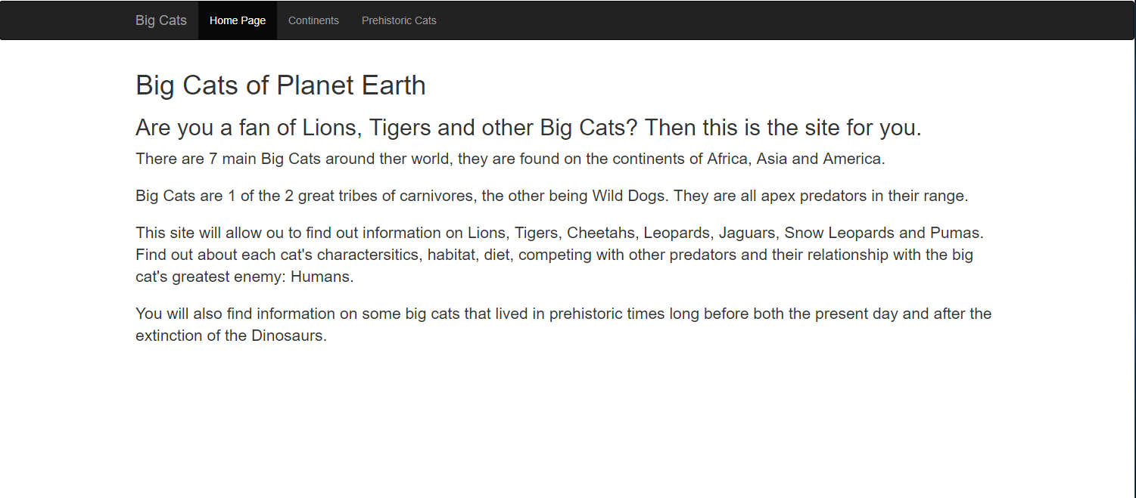

Continents Page

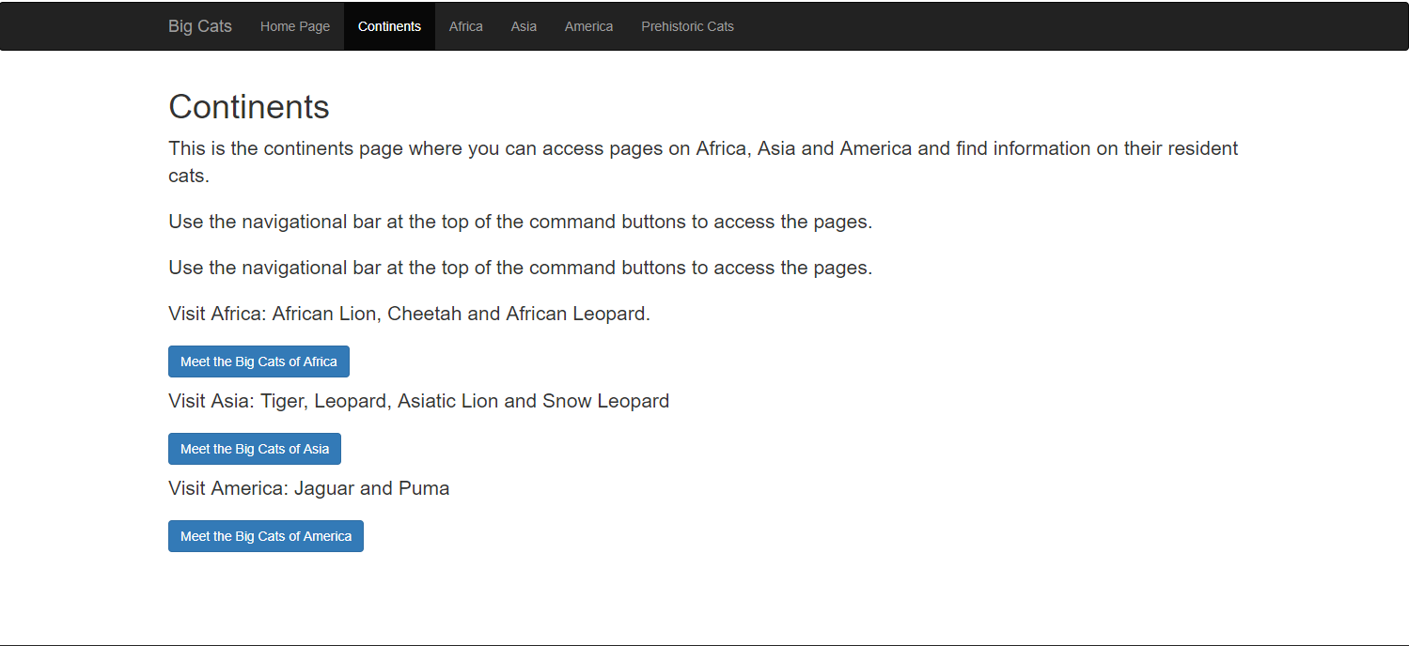

Africa Page

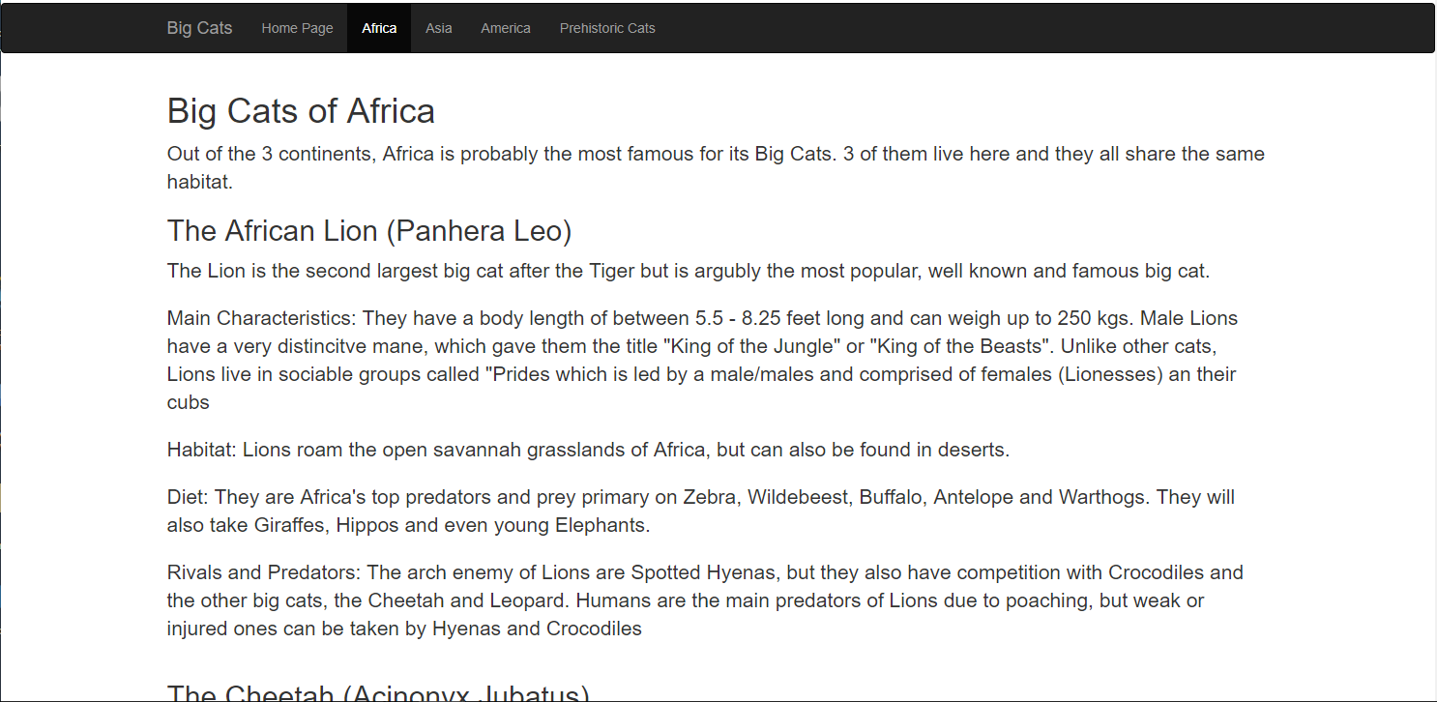

Asia Page

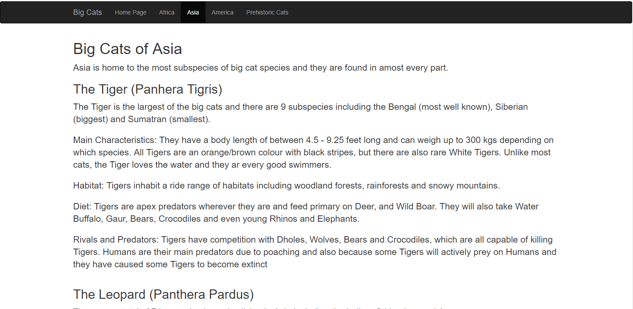

America Page

# 

# Prehistoric Cats Page

# 