

**Advanced Web Technology Coursework 2 Report**

Lewis Brockie [40270307@live.napier.ac.uk](mailto:40270307@live.napier.ac.uk)

Edinburgh Napier University – Advanced Web Technology (SET09103)

# Introduction to Coursework

The purpose of this coursework was to develop a prototype web application about that demonstrates my understanding of server-side web development and mastery of the Python Flask micro-framework.

# Title

## The title for my web application is “iFilm”.

# Introduction to Web Application

## The web application provides users with information on some of the world’s highest grossing films and upcoming movies going to be released in 2019.

## Users are required to register an account and then login in order to view the page’s main content.

# Information on highest grossing films include their rank, title year released and total worldwide gross. As for upcoming 2019 movies, information includes its release date and a brief summary of the movie’s plot.

# Additionally, there is a page of trailers that have been released for movies coming out in 2019.

# Home Page Storyboard

# 

# Highest Grossing and Animated Pages Storyboard

# 

# Design

# I developed the application using Linux, SSH Vim, run through Python Flask and uploaded using Git. Sqlite3 was used for creating databases, while Bootstrap library templates were downloaded and used to for creating the web pages and adding style.

# The overall design of my web application is like any basic web app. It begins with a register page asking the user to register an account. Once they have either created an account or are already registered, they will be required to Login. Once logged in they are taken to a Home Page that serves as the central page of the application as it links to all the other pages.

# App Pages

# Register Page: The user registers an account with a Username, Password and Email.

# Login Page: User uses their registered username and password to login to the main website.

# Home Page: Main page that welcomes the user to the application and what information they will gain from it.

# Highest Grossing Movies Page: A table with the top 15 highest grossing movies of all time.

# Highest Grossing Animated Movies Page: A table with the top 15 highest grossing animated movies of all time

# All Years/Individual Pages (2000-2018): A table with the top 10 highest grossing movies from that year depending on which page the user is on.

# Coming Soon Page: Information on upcoming movies coming in 2019.

# Trailers Page: Trailers for upcoming 2019 movies.

# Logout Page: User logs out and returns to “Login” page.

# Templates Folder

# My templates folder is where I store the HTML templates for my pages,

# Using Flask, they are rendered and returned to the users using “the render template function”.

# Statics Folder

# This is where I store downloaded Bootstrap library templates, all my images, CSS files and fonts.

# Var Folder

# All my created databases for the tabled information are stored here

# URL Navigation

# The Navigational Bar at the top of each page serves as the main form of navigation as all links to other pages are accessed from here. Other pages are accessed by clicking the hierarchical hyperlink text that will transfer them to the designated page.

# The Navigational Bar is different depending where the user is. If they are on either the “Register” or “Login” pages, the bar only has 2 links that link to these pages respectively.

# Once the user has registered and logged in to the main website, the navbar expanded to include more links that link to the other main pages.

# “All Years” is a dropdown that displays a list of links to all individual year pages (2000-2018) that are also accessed by clicking the text. This is a much more appropriate way of displaying these links instead of just a very long navigation bar full of over 20 links.

# When the “Coming in 2019” hyperlink is clicked, the navigational bar changes when the “Coming Soon” page is opened. It expends by introducing a new link titled “Trailers”. This is known as a “dynamic URL” and it only appears when the user is on either the “Coming Soon” or “Trailers” pages.

# I also made use of Command Buttons for extra forms of navigation.

# URL Hierarchy Navigational Map

# 

# Databases

# Databases were created using “sqlite3”, a relational database management system that is already. The creating of the table and insertion of its content were done through Python and then the rest is done in Flask.

# In Flask, the database is unitized through a “schema” file that deleted any existing table of the same name and creates a new one. The “init_db” function is then executed to initialize a new database.

# If none of these were used, then the contents of the database would not be displayed.

# Images

# On my application’s home page, I displayed images in a Carousel. A Carousel is component that acts almost like a slideshow, it either automatically scrolls through images or by the user clicking on a left/right error. Each image is fitted with a command button which links to a page the image represents. Links go to the “Highest Grossing”, “Animated” and “Coming Soon” Pages.

# The images that made up the Carousel I created myself using images of movie posters copied from “Google Images”.

# I made primary use of images on my “Coming Soon” page each information box had an image of the movie’s poster.

# Tables

# When storing the contents from the databases for each “Year” page, I displayed them on screen inside a table, with all information sorted into ascending order by the movies “Rank”.

# The reason why I chose to use tables is because it’s the most effective way for showing this kind of detailed information. When is first created the table, it was very small, and the text was barely readable. Using my stylesheet, I changed the tables layout and text size.

# Videos

# Videos were only used in the “Trailers” page. I displayed them using an “iframe” tag. Iframe is used to embed videos or other documents into an application. All the videos I used were movies trailers embedded from YouTube using code like in the example below:

# 

# Information Boxes

# My “Coming Soon” page was made up entirely of information boxes. The boxes are made up of the movie’s title, a poster, a brief summary, the movie’s release date and a command button.

# The Command Buttons transfer the users to the “Trailers” page when clicked but not all of them carry out this functionality. Because some of the 2019 movies have yet to have a trailer released, Buttons that say “Trailer has not been released for this movie yet” will not navigate the user to the next page. They are here just to inform users that they will not be able to watch a trailer for this movie.

# Enhancements

# Register Page Working Correctly

# Even although I got a Register page to display and allow users to register, whenever the “Sign Up” button is clicked, it does not transfer the users to the “Login” page.

# I kept trying to fix this problem but was unable to. This was the only error I encountered in my program.

# User can Review Films

# This was an idea I was going to incorporate into my application where logged in users would be given the option to write a review of any film they have seen, giving it a rating out of 10 and comments.

# I was unable to do this due to spending so much time making all my databases and getting all navigation to work.

# A Logo

# I was intending to design my own logo using Adobe Photoshop but decided not to, so I could focus more on the more important aspects and features of the website. But this is something that can be done in the future.

# Individual Movie Information Pages

# This is a big enhancement as it would take a lot of time to do. Each movie, whether it was an already released or upcoming would have its own individual page with images and information such as its plot, cast and characters and reception.

# The reason why I didn’t do this was because it would have taken me hours, or even days to make individual pages for movies.

# Better looking Login and Register Pages

# A key enhancement I would do is make the text and input boxes later slightly bigger and more readable. I would also put the input boxes in a column rather than a row.

# Critical Evaluation

# In evaluation, I managed to create a website that allows a user to register an account and login, despite some minor errors in some of the navigation functionality

# What Worked Well

# Navigation in Main Website

# My app’s navigation was the primary functioning process I wanted to insure worked correctly. It was successful and all my navigational links whether they were in the navbar or command buttons worked and linked to the designated page. Plus, whenever a user is on a page, whichever page they are on is highlighted in the navigation bar.

# Navigation is arguably the most important feature in web applications because if you’re website can’t navigate through designated routes to other pages, then the whole application can just fall apart.

# Use of Databases

# I have not had much experience in using sqlite3 and databases in Python. I have used databases for web development in the past, but this was using different software.

# Despite my initial struggle with getting it to work, I was eventually successful in getting my databases to work. All the content in the movie tables displayed and were in the correct order, and registered details were stored in the “Users” database.

# Text

# All text in my main website were readable and had appropriate font sizes and styles.

# Media Elements

# All my images and videos displayed, and all the videos played.

# What Worked Poorly

# Navigation between Register and Login Pages

# As mentioned previously, even although I managed to get m application working so a user could register and login, navigation between the two pages through the “Sign Up” command button did not function correctly as it just remained on the register page.

# This is a problem that can be overcome in future development

# Personal Evaluation

# This is only the second time (this year in fact) that I have used this software for creating a website. I am still getting used to using them all, but I am extremely proud of myself of the work I have put into to this coursework.

# Even although I did have some minor navigation functionality problems, I was unable to fix, the rest of my navigation worked correctly and once the user has successfully logged into the website, all navigation through the main pages functioned as intended.

# I did initially struggle with certain areas of my website, especially when it came to making databases and displaying the in tables. But with the help of a workbook used in practical classes and online tutorial websites, I succeeded, despite the time it took to make all the databases for the “By Years” pages.

# In the past I have had a lot of trouble with creating online register and login systems and this still proves to be a challenge for me sometimes. Despite the small error I came across with the “Register” page, I am extremely pleased that I managed to get the Login part working.

# I do have to say that through doing this project my web developing skills have improved and I still use all my creative ideas to insure it’s a great piece of work. I do intend to use all the software I used for this coursework in future projects and I would recommend them to anyone who has the skills to use and understand them.

# References

# All my images were obtained from “Google Images”.

# Videos were embedded from YouTube

# Information about movies were found on Wikipedia

# Useful websites used for assistance

# <https://anandology.com/python-practice-book/>

# <https://www.w3schools.com/>

# <https://www.tutorialspoint.com/flask/>

# https://getbootstrap.com

# 

# Appendices

# Screenshots

# Login Page

# 

Home Page

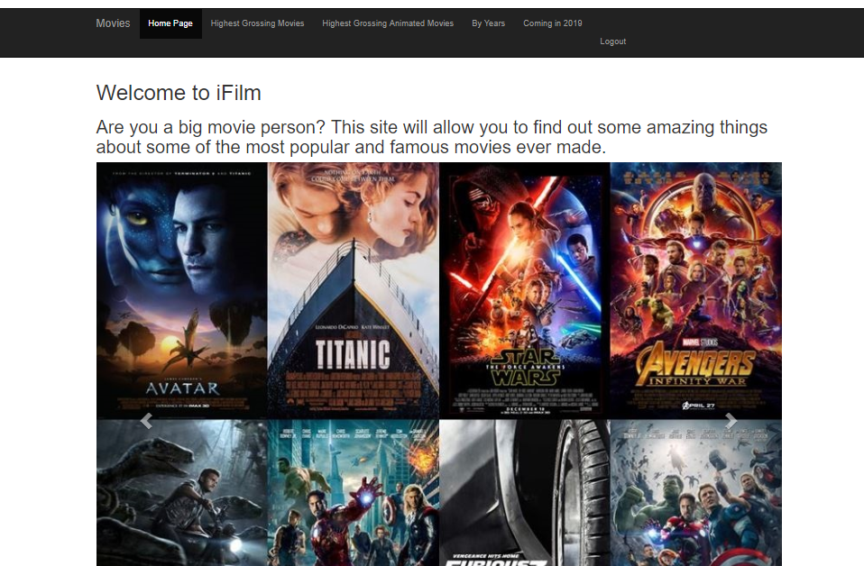

Highest Grossing Page

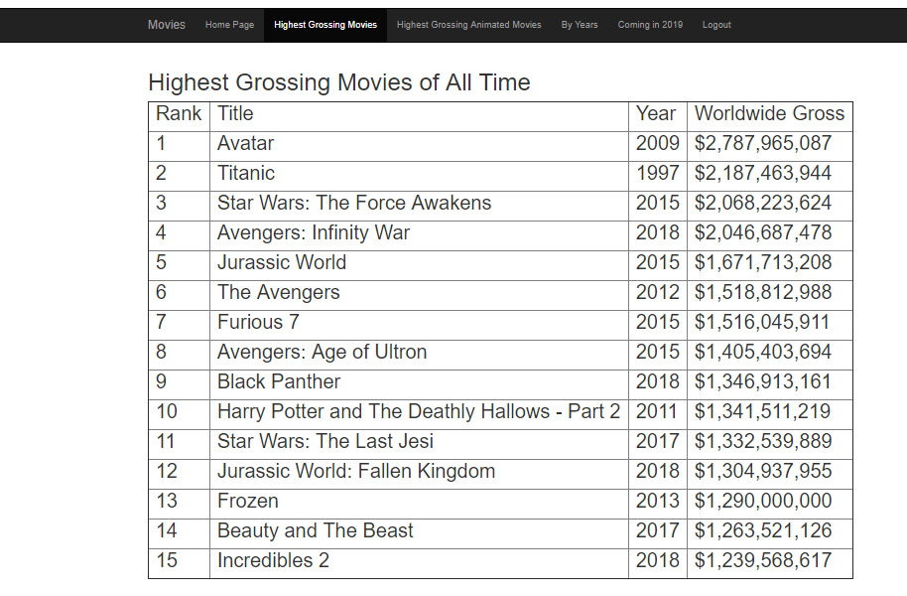

Coming Soon Page

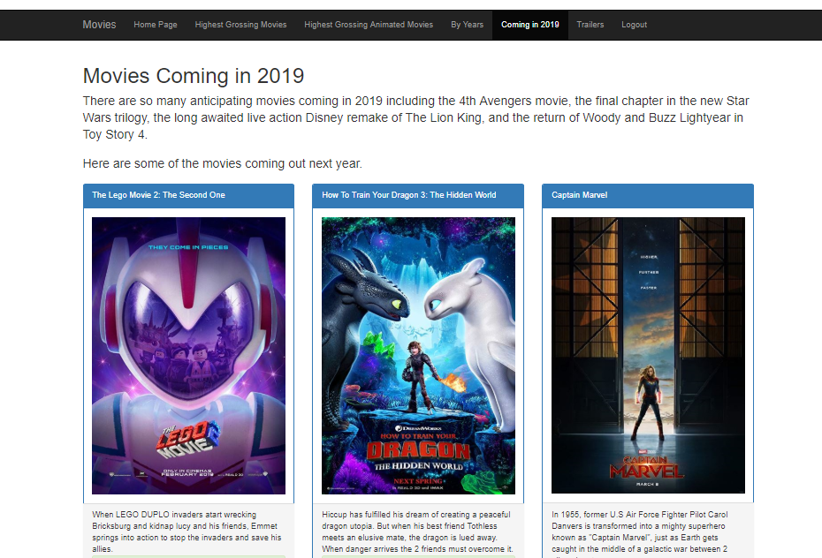

America Page

# 

# Testing Login and Register Pages

# Error message appears if box is left blank

# 