38772151448378386



**{sex}**

**{zhenghao}**

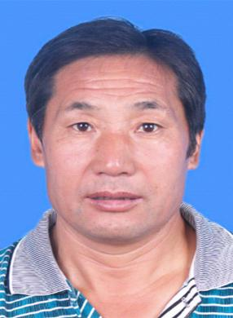 **{xingming}**

**{zuoyeleibie}**

**{zhuncaoxiangmu}**

 **{chulingriqi}**

**{youxiaoqixian}**

**{fushenriqi}**

20170711182828