**Pi Gamma Phi Information System with SMS Notification**

**Client Manual**

**Step 1:**

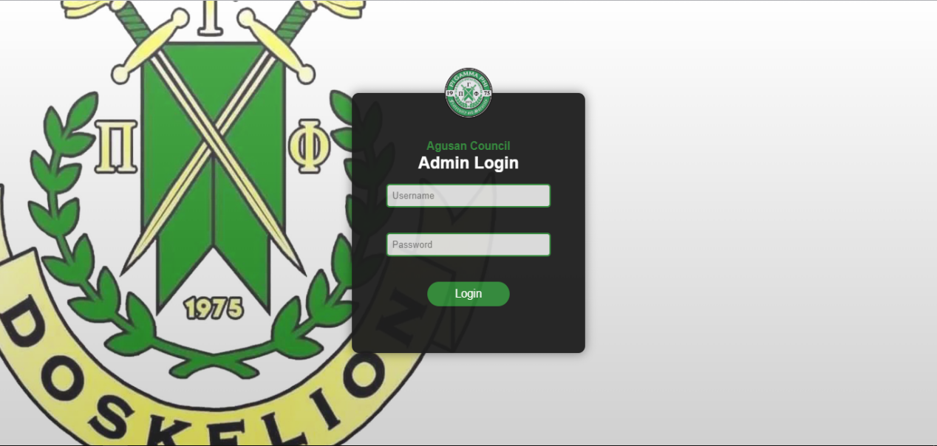

In using the system, Pi Gamma Phi Information System with SMS Notification first the admin should log in by a username and password. The system makes sure that only authorized users are able to access it by requiring users to enter secret passwords in addition to unique identifiers (such as usernames or email addresses). Logging in essentially serves as a virtual gatekeeper, limiting access to the system's resources to only those with validated credentials.

**Step 2:**

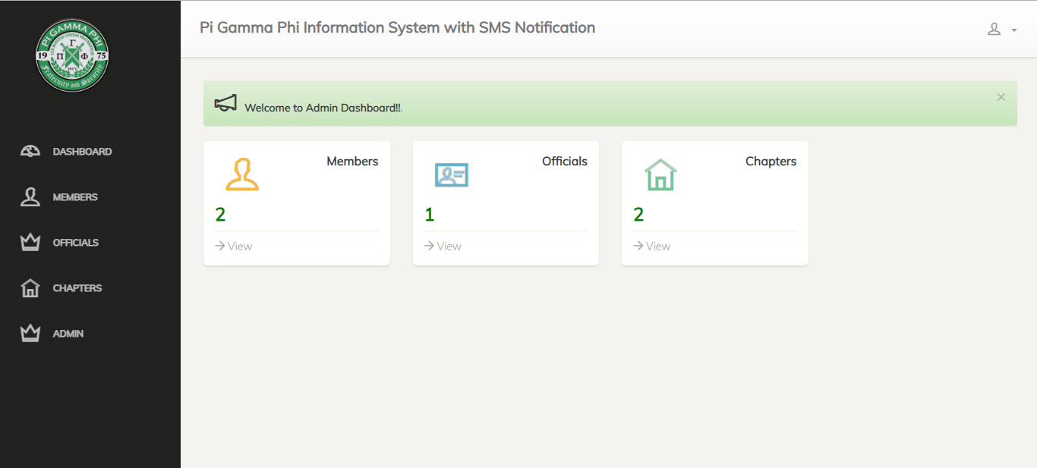

After logging in you will proceed to the dashboard. A dashboard is an information management tool that provide data visualizations. It typically offers high-level information in one view that end users can use to answer a single question. The admin has the view of overall functionality of the system. He/she will know the total number members, the officials who are incharge, and the total number of chapters.

**Step 3:**

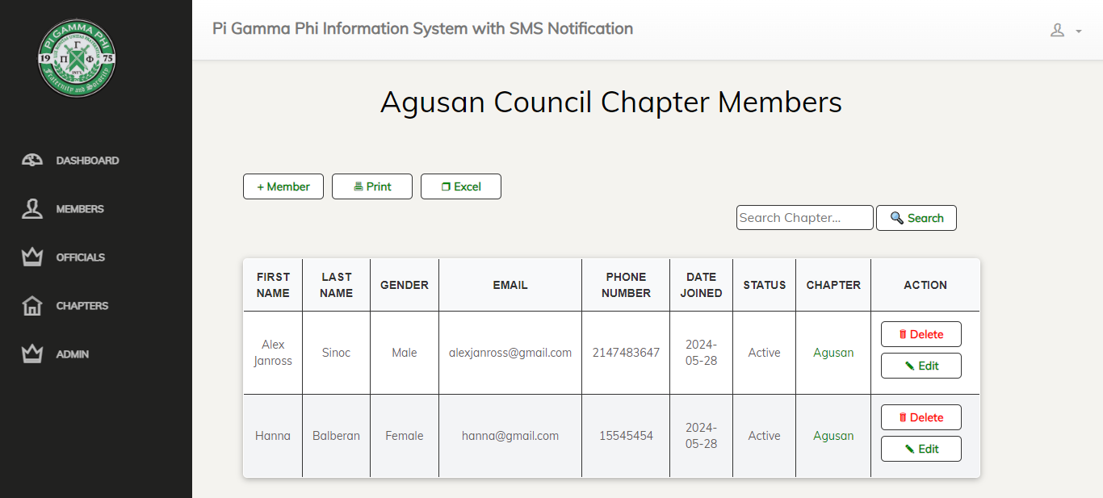

When clicking the Member button he/she will see a list of members that is being categorized by : First Name, Last Name, Gender, Email for easier tracking if phone number is not available, Phone Number to directly message or notify a specific member, Date Joined, status wither he/she is active or in active, Chapter the specific place where the member belong and action is to edit the member’s personal data.

**Step 4:**

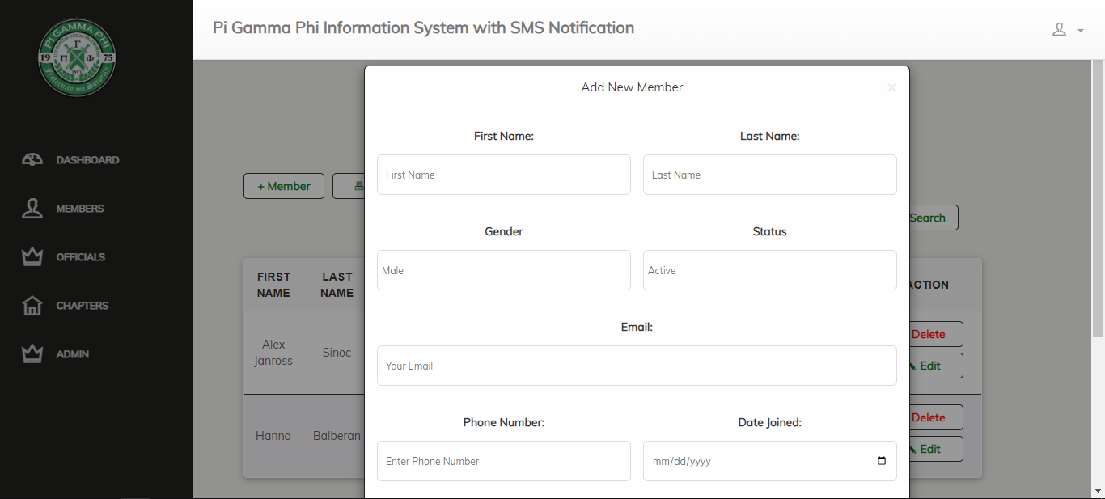

This will pop in if the admin click the +Member button. And the admin can fill it in so that the profile can be added on the list.

**Step 5:**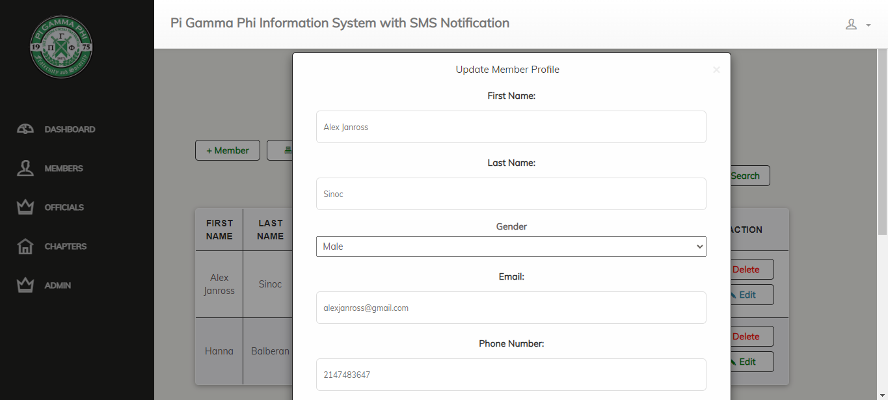

And here if the members change their name or some personal information need to be change then the admin can click the Edit button to update member profile.

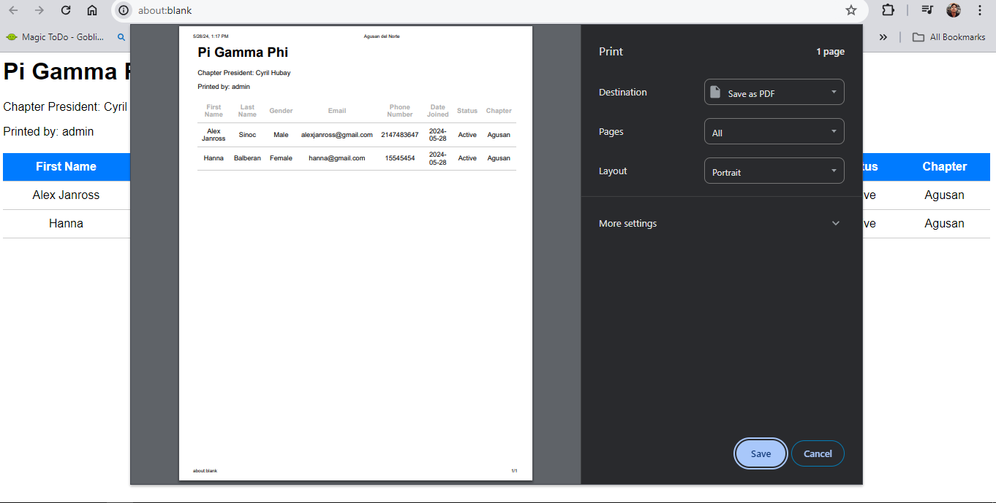

**Step 6:**

Print the member’s information by clicking Print. You can also use the shortcut key Ctrl+P to have a list of members.

**Step 7:**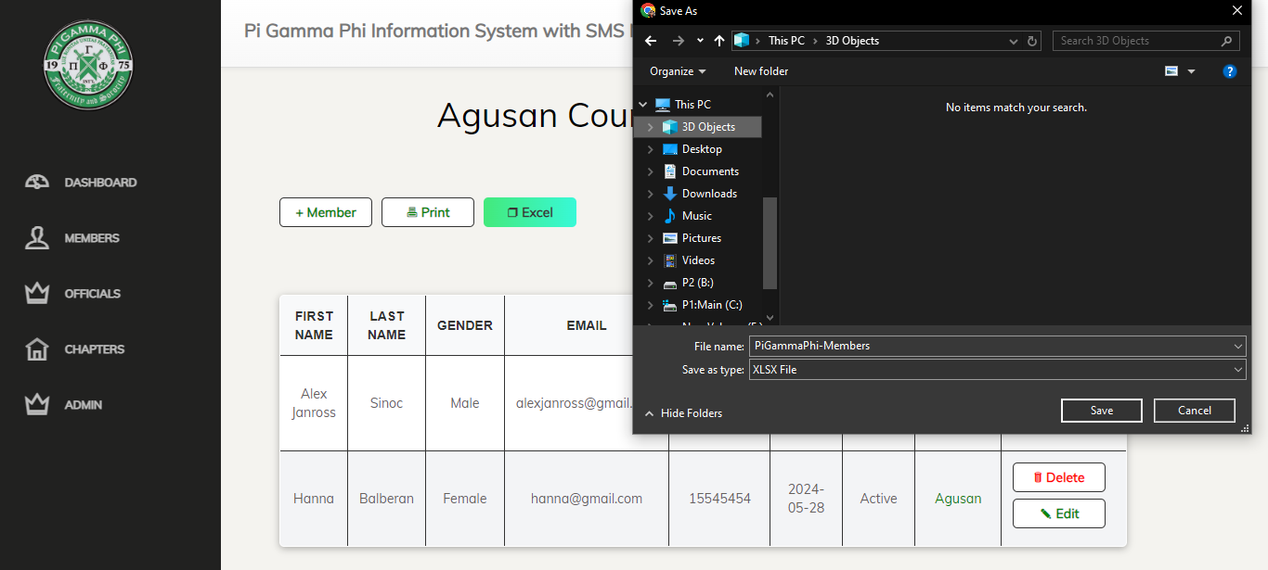

If the admin wants to see the list of members in an Excel format the he/she will click the Excel, also if the admin wants to get or see the status of a specific member in order to do that conveniently just click the search button type the name or chapter and it will show the information you needed.

**Step 8:**

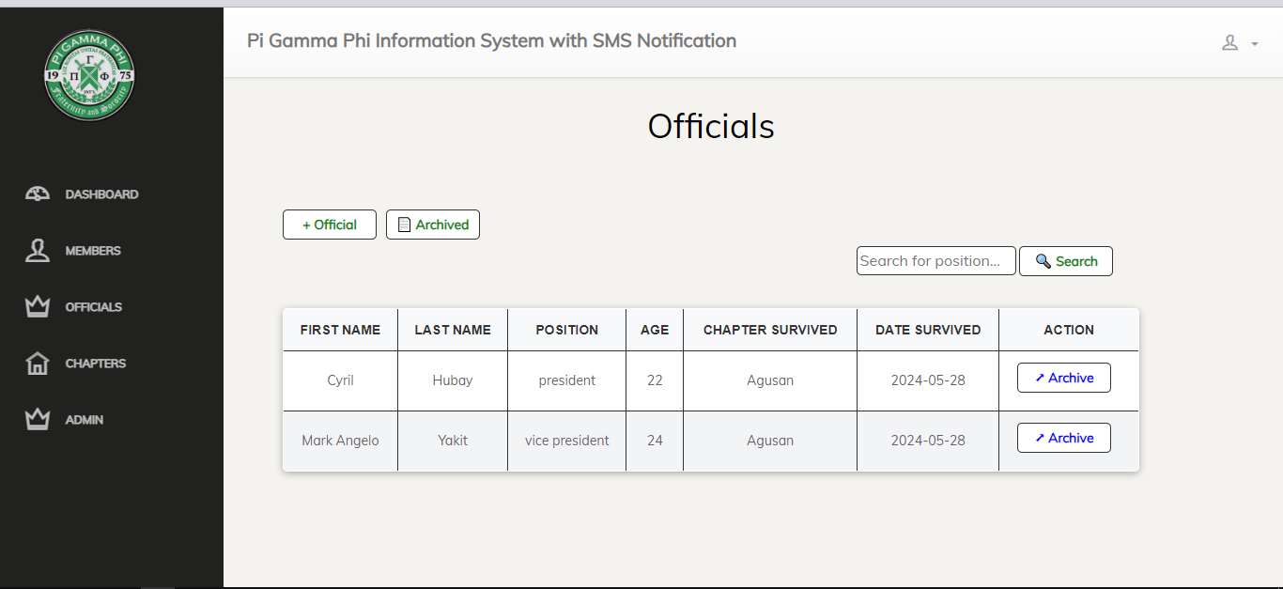

You will see the officials of the Pi Gamma Organization by clicking the officials button. The admin can add officials by clicking +Official, and it can be hidden by clicking Archived. If the officials are to many to count, and if your looking for a specific official you can use the search button, to search it immediately. This is the interface when you click Officials.

**Step 9:**

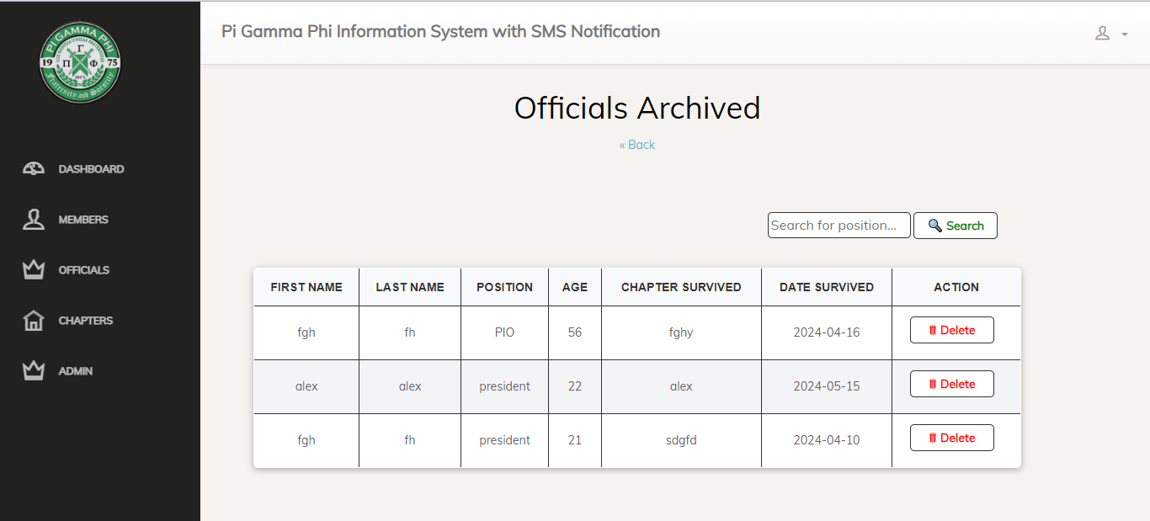

When you click the archived, you will see different hidden officials that should be deleted in the system because their term maybe are done.

**Step 10:**

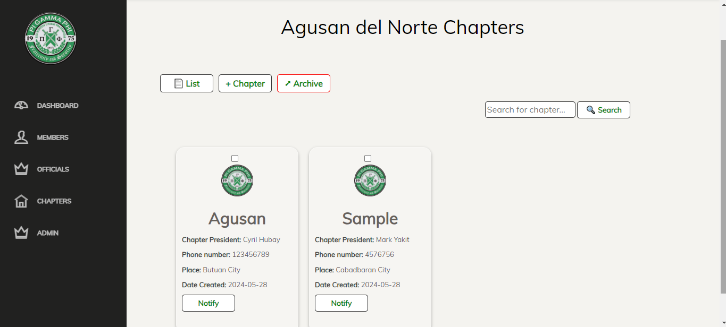

When you click the CHAPTERS you will see the list, +Chapters and Archived. First is the list when you click it this is the result, you will see the over all list of the different chapters with the chapter president, phone number, place and date created. In this area if a specific member or chapter is inactive or having an important meeting, the admin could easily inform or notify the president.

**Step 11:**

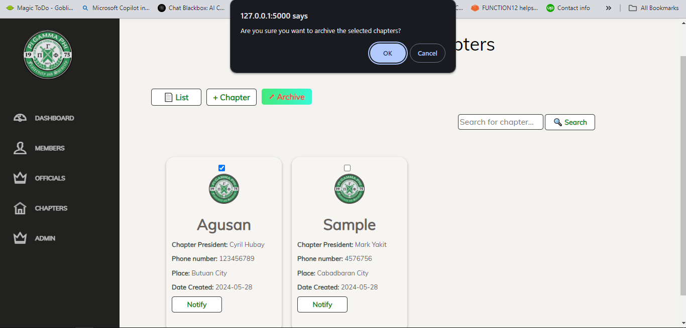

If the specific chapter are in active and not complying to their duties then the admin can archived the chapter.

**Step 12:**

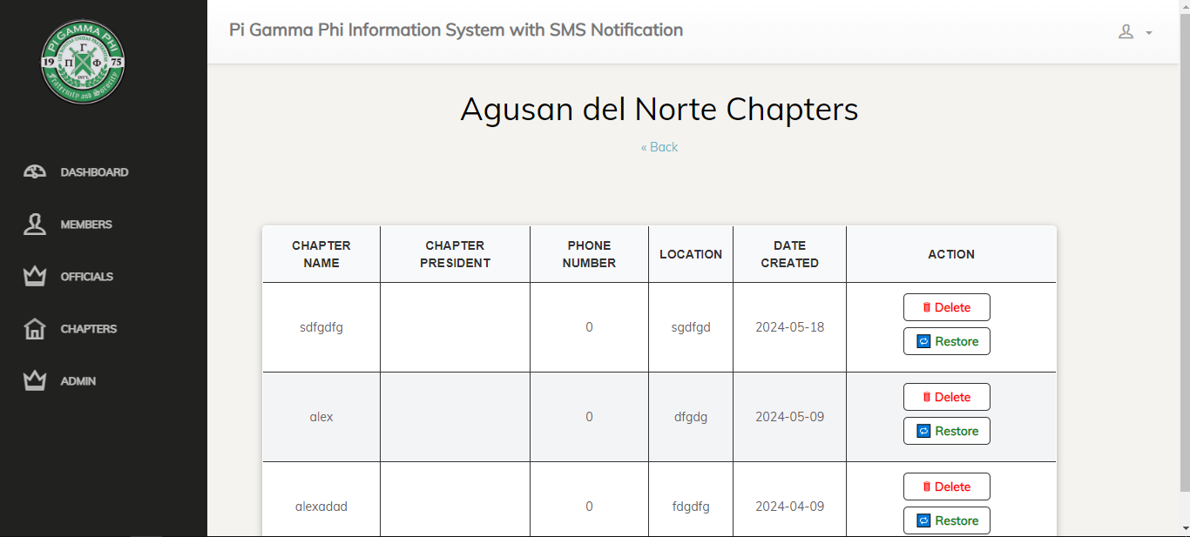

After clicking archived, it will proceed to this area. If the chapters is not really complying and not doing their responsibilities and duties as part of the organization, then the admin can delete that specific chapter name. The admin can restore also if and only if that chapter complies to their requirements and duties.

**Step 13:**

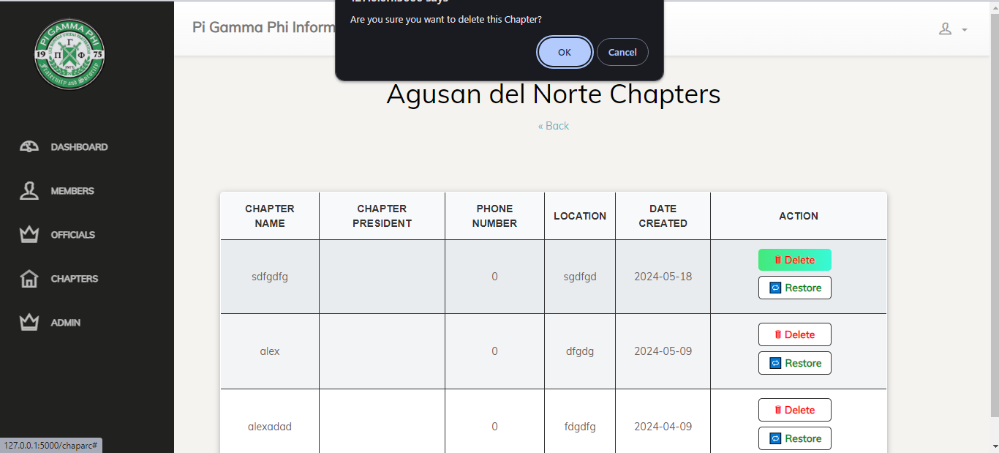

If the admin decided to delete the chapter, this will pop in to warn and on the other hand to not totally delete the chapter if the admin accidentally click the delete button.

**Step 14:**

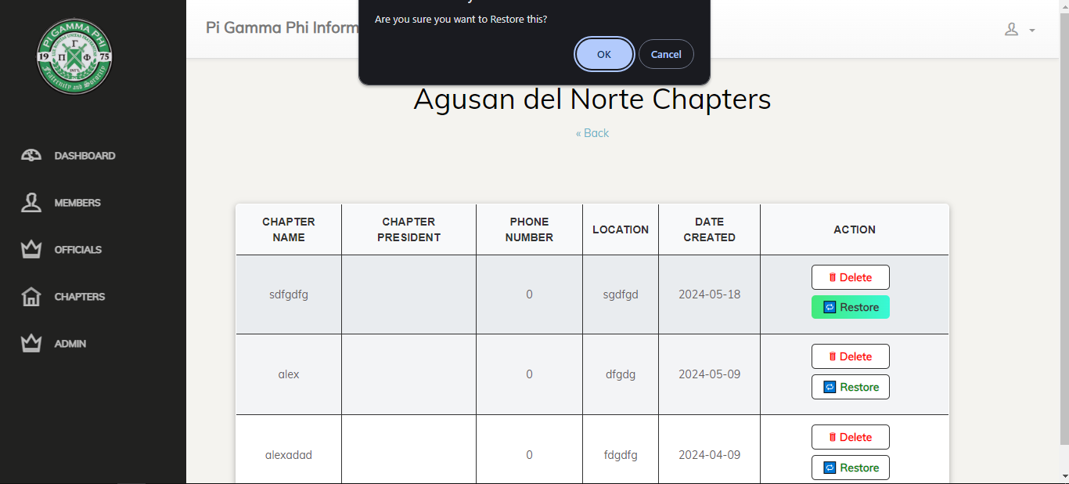

The same as If the admin decided to restore the chapter, this will pop in to warn and on the other hand to make sure that the chapter is not easily restored if the admin accidentally click the restored button.

**Step 15:**

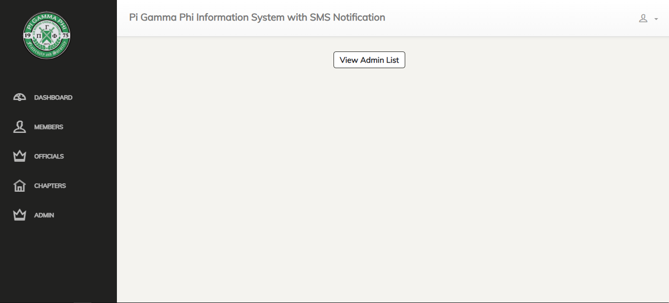

This is the admin list where you will see the username and password of the admin using this system.

**Step 16:**

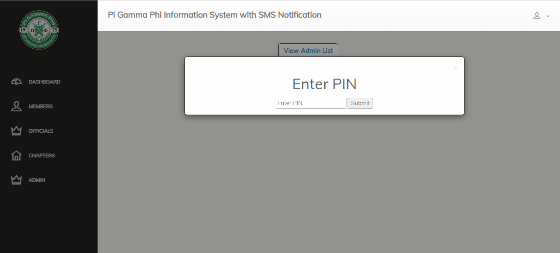

The upcoming admin must know the current pin, so that he/she can easily change the username and password that he/she will be using to access the system.

**Step 17:**

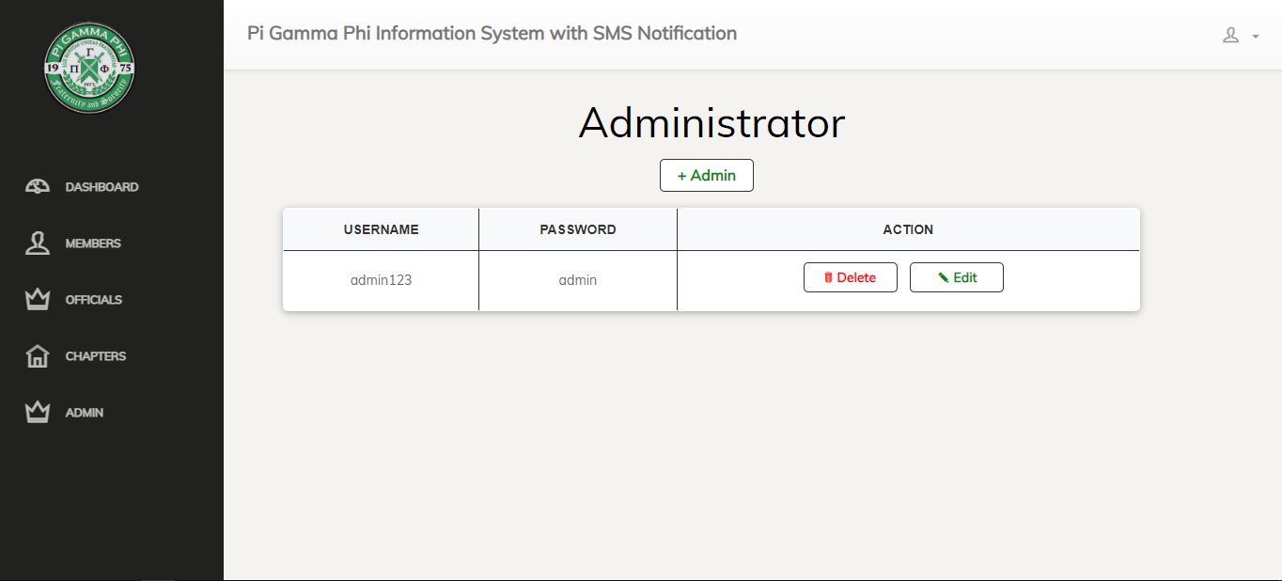

After entering the previous pin, the new admin can now delete the last username and password of the admin, and create new for him/her to use while accessing the system. He/she can delete or edit the username and password.

**Step 18:**

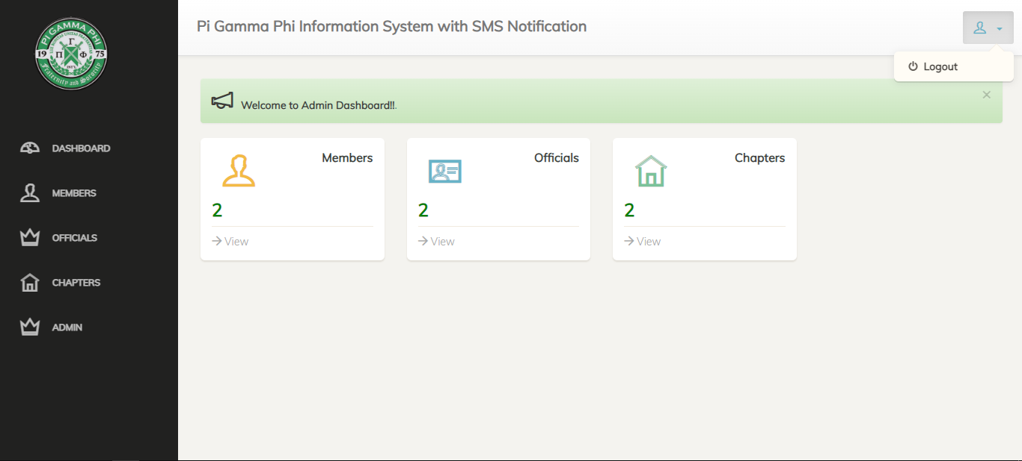

And if the admin done with his/her work he can now log out bu clicking the log out button, in the upper right corner. So that the information inside the system will not be access by the unauthorized personnel and also to protect the personal information of the members, chapters and officials.