Pi Gamma Phi Information System with SMS Notification

Submitted by:

Balberan, Hana Loren

Dagani-Monta, Dresel Jean

Hubay, Cyril

Sinoc, Alex Janross R.

Yakit, Mark Angelo

**Application Description**

The system’s primary purpose is to manage Pi Gamma Phi Members and Chapters. A database must be established and securely maintained that stores all of the details and monitor the status of every Members in every chapters here in Agusan Del Norte. This System will be specifically deployed in Brgy. Pequeno, Butuan City.

**Functionalities:**

* Store Pi Gamma Members Information
* Send SMS Notification
* Can Add/Input New Members
* Create, Display, Update and Delete Information
* Display Chapter Activity Records
* Display Pi Gamma Phi Officers
* Dashboard displays Reports
* File export through MS Excel

**Additional Features:**

* Admin Access Only
* Adding admin
* Printable Records

**Requirements Analysis**

**Data Gathering Process:**

*March 9, 2024 at 03:00 PM***:**

The meeting was held in Brgy. Ong Yiu but the system will be deployed in Brgy. Pequeno, our group introduce the system, that could help their organization, we explained the system with a hardcopy of system flow, proposed title on creating a final project system. The Pi Gamma Phi President ask for a prototype for them to able to visualize the concept and purpose of the system.

*Comments from organization:*

* Requesting for a prototype.
* They demand a security feature to protect their personal ang their member’s information.
* The system could help them, in daily basis they manually send and get hard copies to distant Member’s places but instead of hard copies, they will be able to send and get the information online because it can be exported to excel.
* The president and other Members were satisfied to the presentation of system, its functionalities, flow and title that is being proposed.

**Method:**

The methods used during the data gathering is direct interview, offering a comprehensive understanding of the client's system requirements, functionalities, and design preferences. Through interviews, we discuss the references, additional features, and preferred designs, enabling us to tailor our approach accordingly.

**Tools:**

- The tools used during the interview: - Pen and Paper: This was used to write down any comment and suggestion of the client. - Phone: It was used to record video and audio of the comments and suggestion.

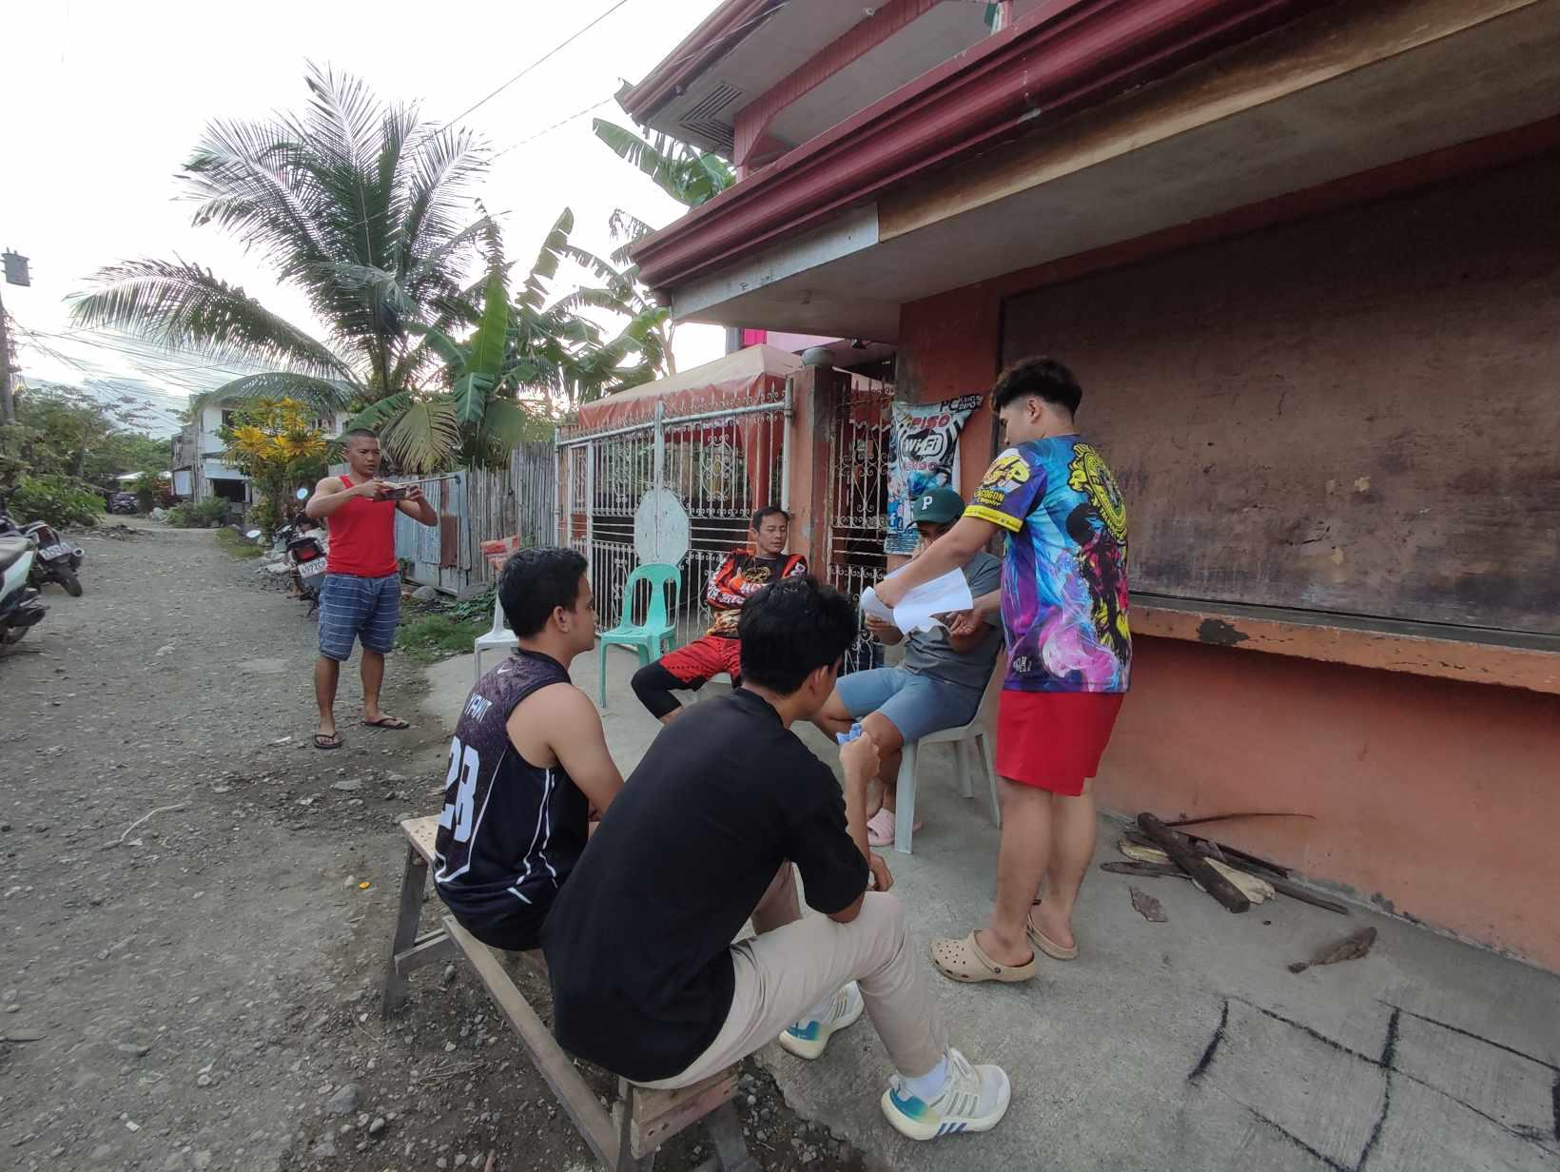**Images:**

*Figure 1.1*

Figure 1.1 shows the actual picture of the interview that happened last March 9, 2024 in Brgy. Ong Yiu, Butuan City. The group discuss the possible system design and its functionalities to the President of Pi Gamma Phi with his 2 members.

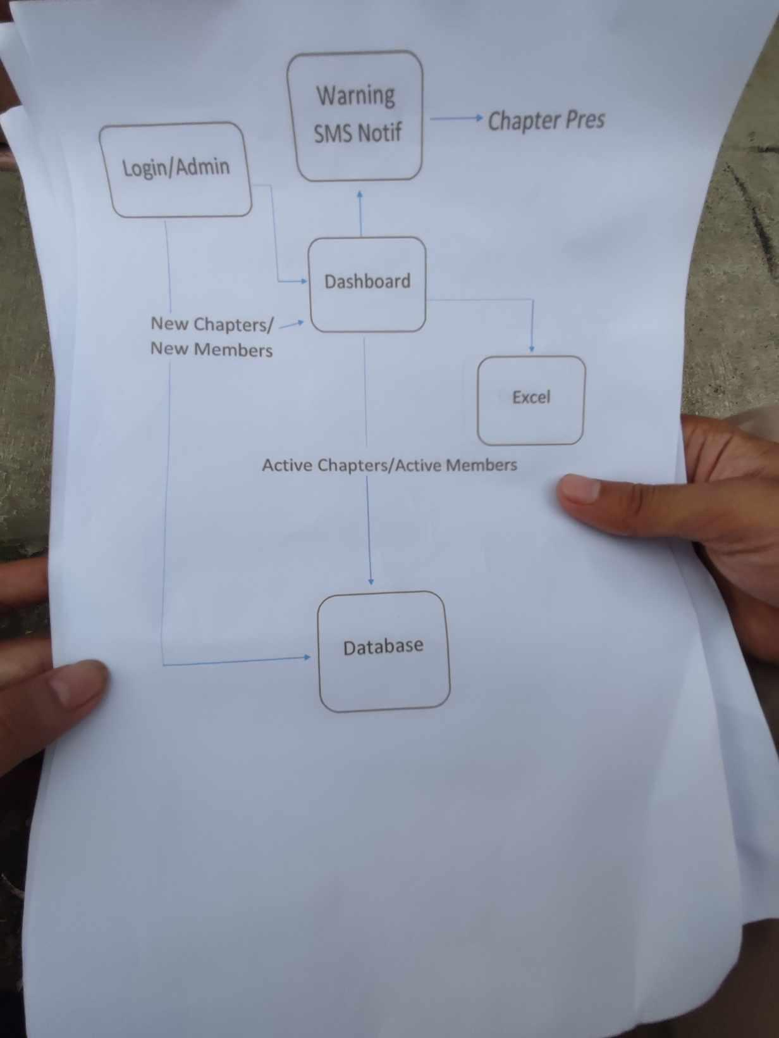

*Figure 1.2*

Figure 1.2 show the possible system design, the flow and some of its functionalities. Also the image show how the system will be managed by the admin, and what are the needed data for the system.

**Design**

**Wireframe:**

A *wireframe* is a basic visual representation of the design and functioning of a digital product. the placement and setting of text, graphics, buttons, and interactive components in an interface. Usually created in the early stages of design, these wireframes define the information flow and map out the user interface. This the Wireframe of the System:

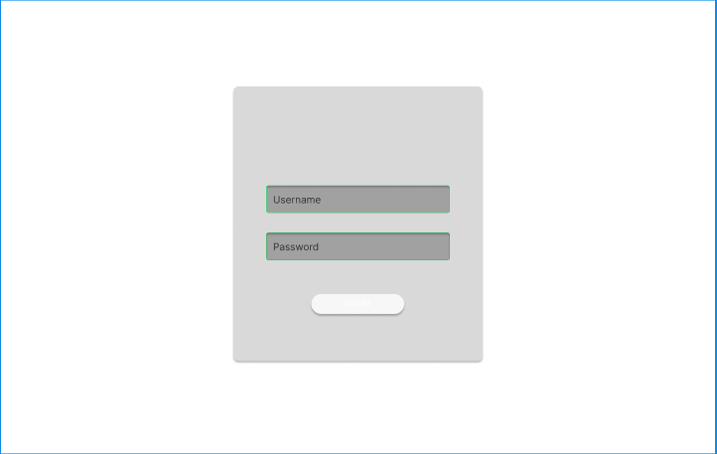

*Figure 2.1 Log in Wireframe*

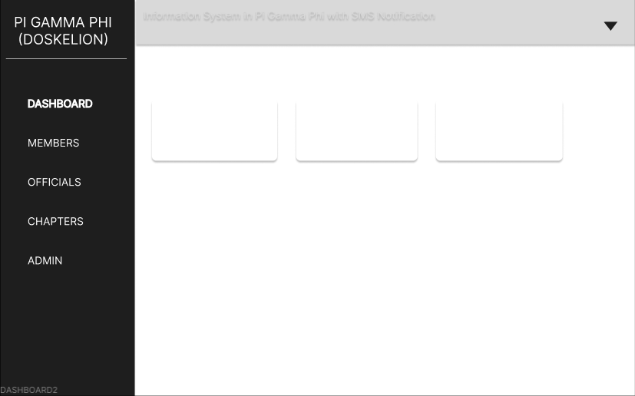

*Figure 2.3 Dashboard Wireframe*

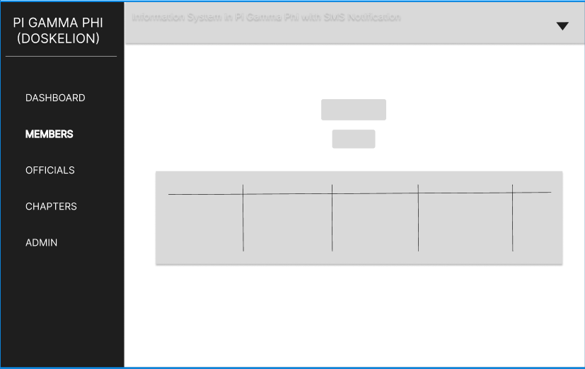

*Figure 2.3 Members Wireframe*

**User Interface (UI):**

The User Interface (UI) refers to the visual elements and interactive components that users engage with when interacting with a digital product. It encompasses everything from buttons and menus to forms and navigational elements, all designed to facilitate user interactions and enhance usability. This the User Interface of the System:

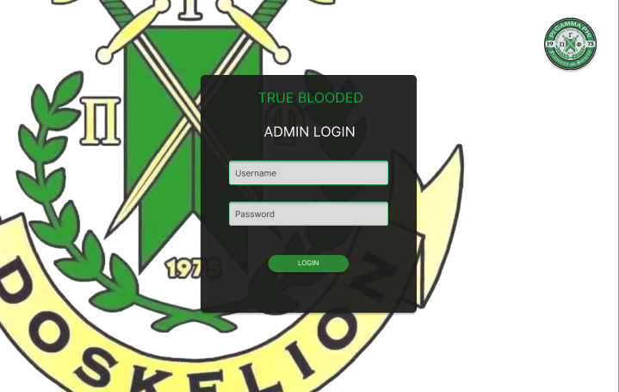*Figure 3.1 Log In Page*

**Log In Page**:This is a security feature that it can only be accessed by authorized person, that the personal Information of the user’s client can only be display data by the user’s control.

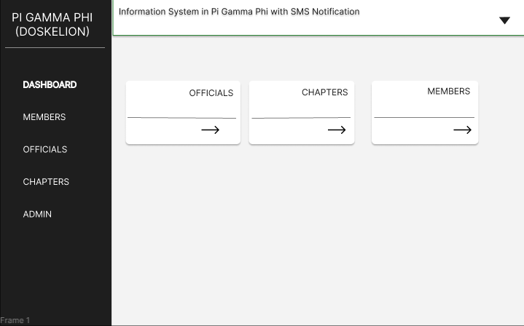

*Figure 3.2 Admin Dashboard*

**Dashboard:** This section it displays Chapters,Official, Members and Report Record.

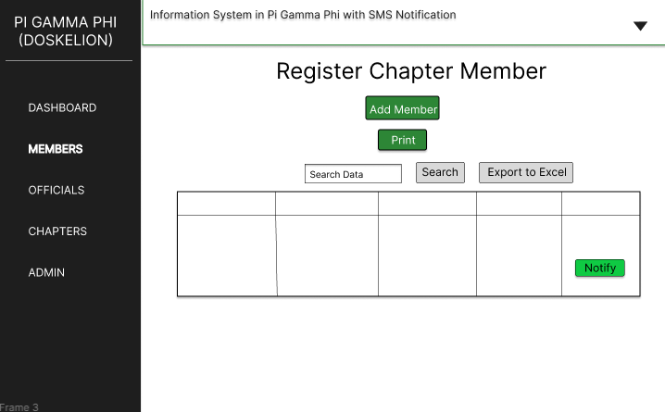

*Figure 3.3 Members Display*

**Members:** This display member information to the database. It can Also perform an Update, Add and Delete Data. It can export to excel the display information and notify member based on member status.

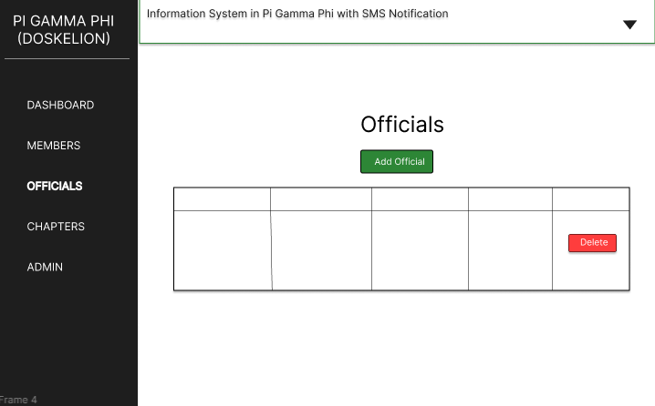

*Figure 3.4 Official’s Display*

**Officials***:*This displays all the Official information . Can perform Add and Delete Official.

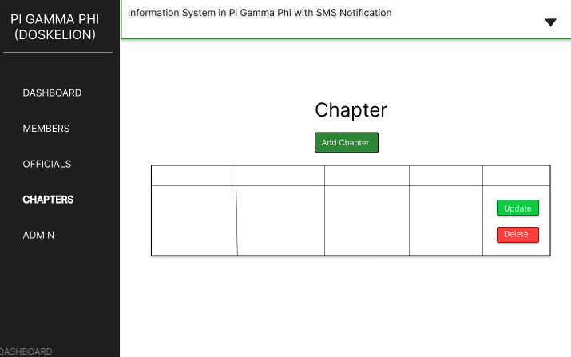

*Figure 3.5 Chapter Display*

**Chapters***:*This displays all the Chapters information . Can perform Add, Update and Delete.

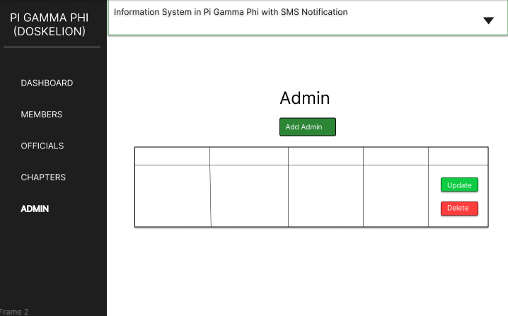

*Figure 3.6 Admin Display*

**Admin:** Display authorized person that can access in system, the Authorized personal Information can be display, Add, Update and Delete Data.

**Implementation**

**Equipment :** PC / Laptop /

**IDE** **:**  Visual Studio Code

**Prototyping :**  Figma

**Database** **:** MySQL

**Language :** Python

**Framework :** Flask

**Method of development :** Agile Development Model

**System Architecture:**



*Figure 4.1 System Architecture*

System architecture serves as the blueprint for organizing and integrating various hardware and software components, defining how they interact and function together to achieve specific objectives. First is Members submitting the data to the Admin to input into the system. Then after the admin inputted data, the system stored data to the database.The data can be exported into excel to file sent to admin office and The Members receive SMS Notification from the system based of their status.

**USE CASE:**

 *Figure 5.1 Use Case*

In the diagram the New/Old Member submit BioData to the Admin to be inputted into the system. After logging in, the Admin inputs the data that the Members provided into the system. The system and admin can now perform its functionalities, delete data to remove information in the database, add data to the database, update information, display records, print records and provides a printable format.

**CLASS DIAGRAM:**

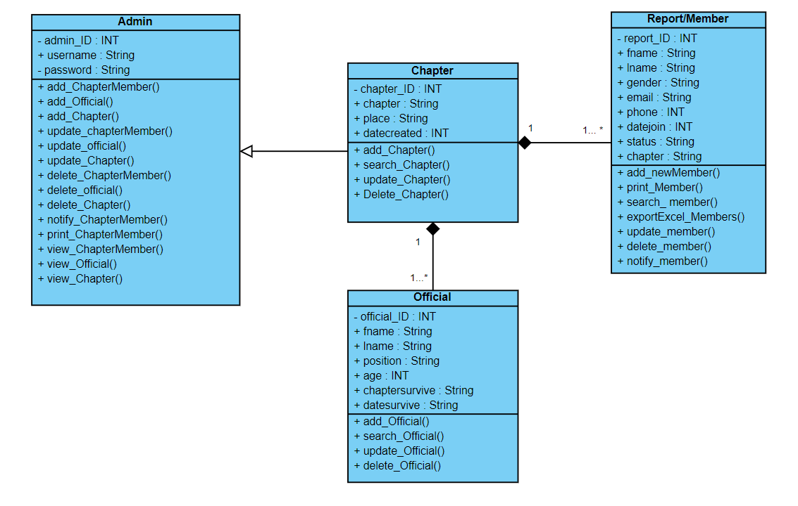

*Figure 6.1 Class Diagram*

**ERD DIAGRAM:**

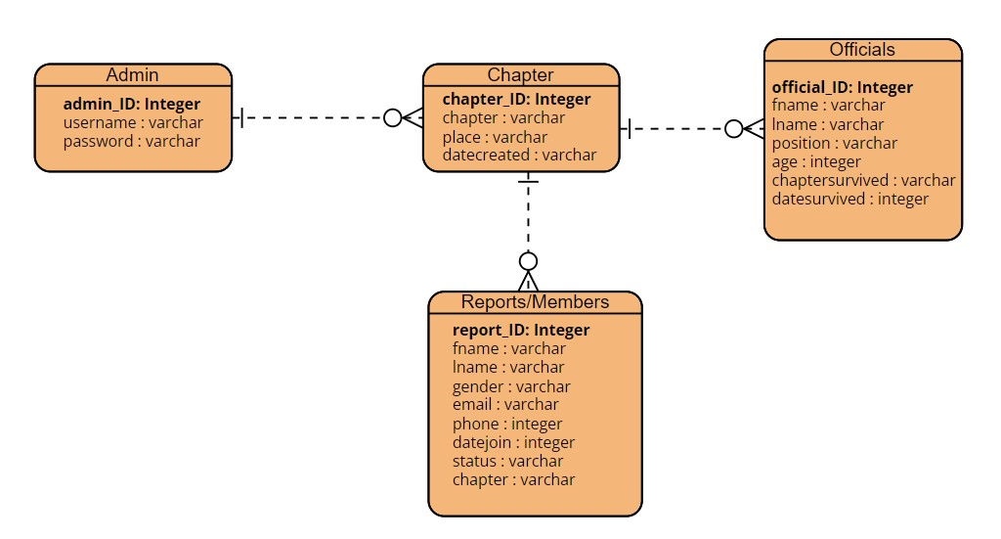

*Figure 7.1 Entity Relationship Diagram*