GIT Guide
This guide will take you through using GitHub Desktop for version control.

Table of Contents
Installing GitHub Desktop 1
Cloning a repository 1
GitHub Desktop Overview 1

Installing GitHub Desktop
1. Download GitHub Desktop from here.
2. Install it onto your computer.
3. Login with your GitHub account.
4. You will be brought to the main page once you’ve logged in.

Cloning a repository
1. Open GitHub Desktop
2. Click File > Clone Repository > URL
3. Enter the repository URL: https://github.com/LexPew/JourneyMan2025.git
4. Choose a local folder to save the project
5. Click Clone
6. Once cloning has finished you may get a pop up about Git LFS, click Initialize Git LFS, this is used for handling larger assets like .psd, .uasset, etc.

Simple GitHub Desktop Overview
1. Current Repository: Displays the active repository.
2. Current Branch: Shows the branch you're working on.
3. Fetch Origin: Updates your local repository with changes from GitHub.
4. Changes Tab: Lists files that have been modified, added, or deleted.
5. History Tab: Shows the commit history for the current branch.

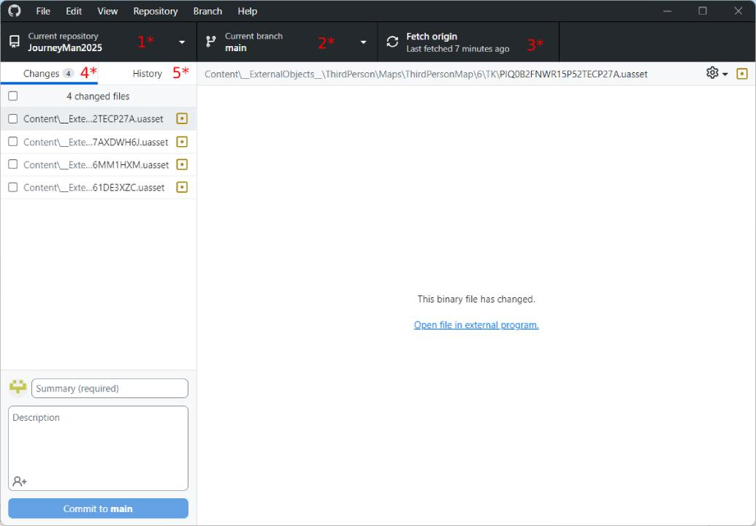

Work Flow

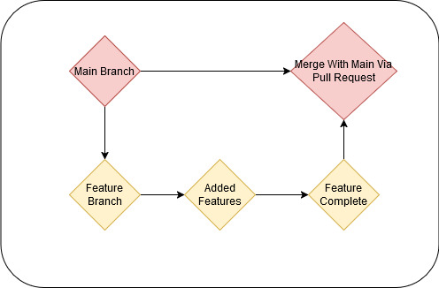
Above is a visual representation of the work flow for GitHub.

1. Click Current Branch in GitHub Desktop.
2. Click New Branch.
3. Name your branch using the following naming conventions:
- feature/feature-name (e.g., feature/add-main-menu)
- fix/bug-name (e.g., fix/crash-on-startup)
- art/asset-name (e.g., art/new-character-model)
4. Click Create Branch.

Committing Changes

1. In GitHub Desktop go to the Changes tab.
2. Check the boxes next to the files you want to commit.
3. Write a commit message describing your changes e.g. “Added Coin Model”.
4. Click Commit to [branch-name].

Syncing With The Main Branch
1. Click Fetch Origin to check for updates. (Anything on Main Should be complete and safe)
2. If there are updates, click Pull Origin to sync your branch with main .

