Apache License
Version 2.0, January 2004
http://www.apache.org/licenses/

TERMS AND CONDITIONS FOR USE, REPRODUCTION, AND DISTRIBUTION

1. Definitions.

"License" shall mean the terms and conditions for use, reproduction,
and distribution as defined by Sections 1 through 9 of this document.

"Licensor" shall mean the copyright owner or entity authorized by
the copyright owner that is granting the License.

"Legal Entity" shall mean the union of the acting entity and all
other entities that control, are controlled by, or are under common
control with that entity. For the purposes of this definition,
"control" means (i) the power, direct or indirect, to cause the
direction or management of such entity, whether by contract or
otherwise, or (ii) ownership of fifty percent (50%) or more of the
outstanding shares, or (iii) beneficial ownership of such entity.

"You" (or "Your") shall mean an individual or Legal Entity
exercising permissions granted by this License.

"Source" form shall mean the preferred form for making modifications,
including but not limited to software source code, documentation
source, and configuration files.

"Object" form shall mean any form resulting from mechanical
transformation or translation of a Source form, including but
not limited to compiled object code, generated documentation,
and conversions to other media types.

"Work" shall mean the work of authorship, whether in Source or
Object form, made available under the License, as indicated by a
copyright notice that is included in or attached to the work
(an example is provided in the Appendix below).

"Derivative Works" shall mean any work, whether in Source or Object
form, that is based on (or derived from) the Work and for which the
editorial revisions, annotations, elaborations, or other modifications
represent, as a whole, an original work of authorship. For the purposes
of this License, Derivative Works shall not include works that remain
separable from, or merely link (or bind by name) to the interfaces of,
the Work and Derivative Works thereof.

"Contribution" shall mean any work of authorship, including
the original version of the Work and any modifications or additions
to that Work or Derivative Works thereof, that is intentionally
submitted to Licensor for inclusion in the Work by the copyright owner
or by an individual or Legal Entity authorized to submit on behalf of
the copyright owner. For the purposes of this definition, "submitted"
means any form of electronic, verbal, or written communication sent
to the Licensor or its representatives, including but not limited to
communication on electronic mailing lists, source code control systems,
and issue tracking systems that are managed by, or on behalf of, the
Licensor for the purpose of discussing and improving the Work, but
excluding communication that is conspicuously marked or otherwise
designated in writing by the copyright owner as "Not a Contribution."

"Contributor" shall mean Licensor and any individual or Legal Entity
on behalf of whom a Contribution has been received by Licensor and
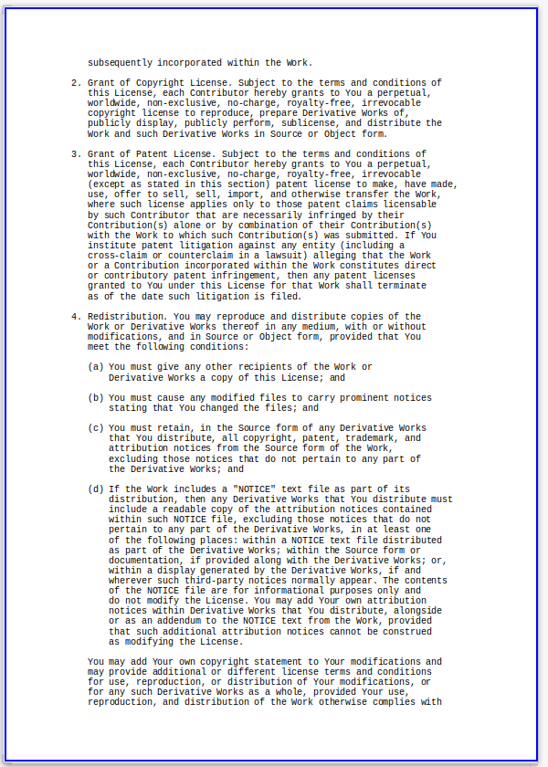
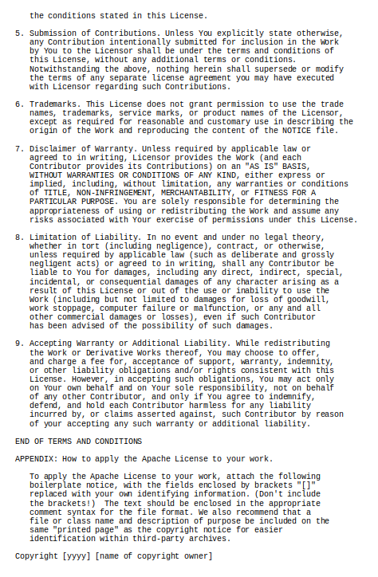

Licensed under the Apache License, Version 2.0 (the "License");
you may not use this file except in compliance with the License.
You may obtain a copy of the License at

http://www.apache.org/licenses/LICENSE-2.0

Unless required by applicable law or agreed to in writing, software
distributed under the License is distributed on an "AS IS" BASIS,
WITHOUT WARRANTIES OR CONDITIONS OF ANY KIND, either express or implied.
See the License for the specific language governing permissions and
limitations under the License.

