# **Introducing to Testing**

## **Test Strategy Part 1**

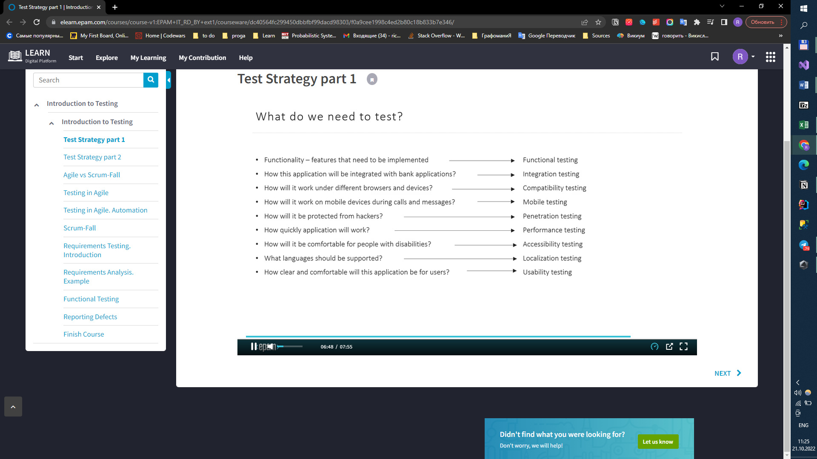

## **Test Strategy Part 2**

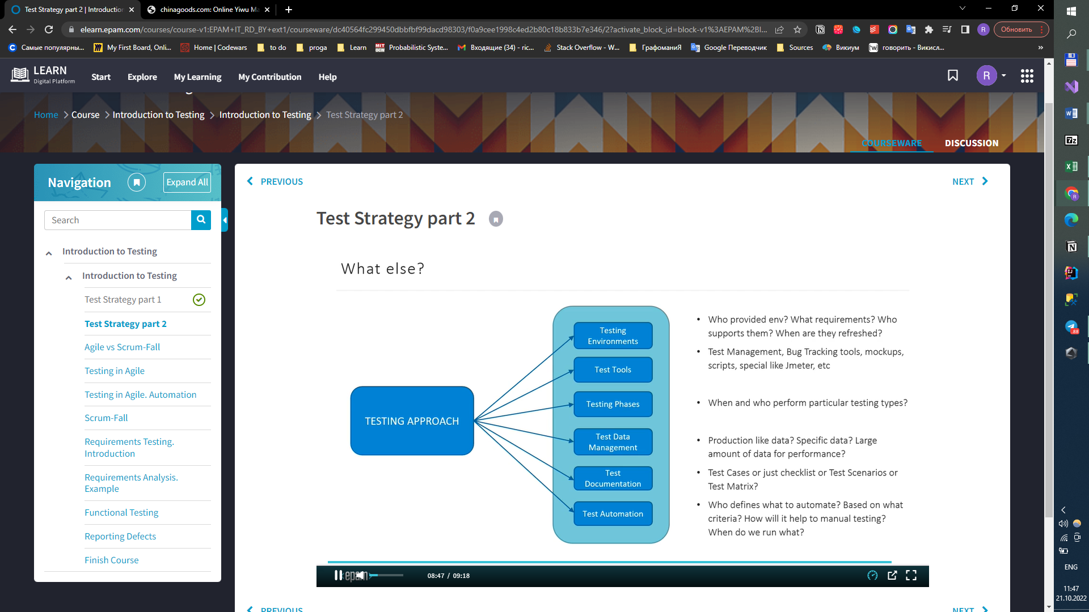

## **Agile Vs Scrum-Fall**

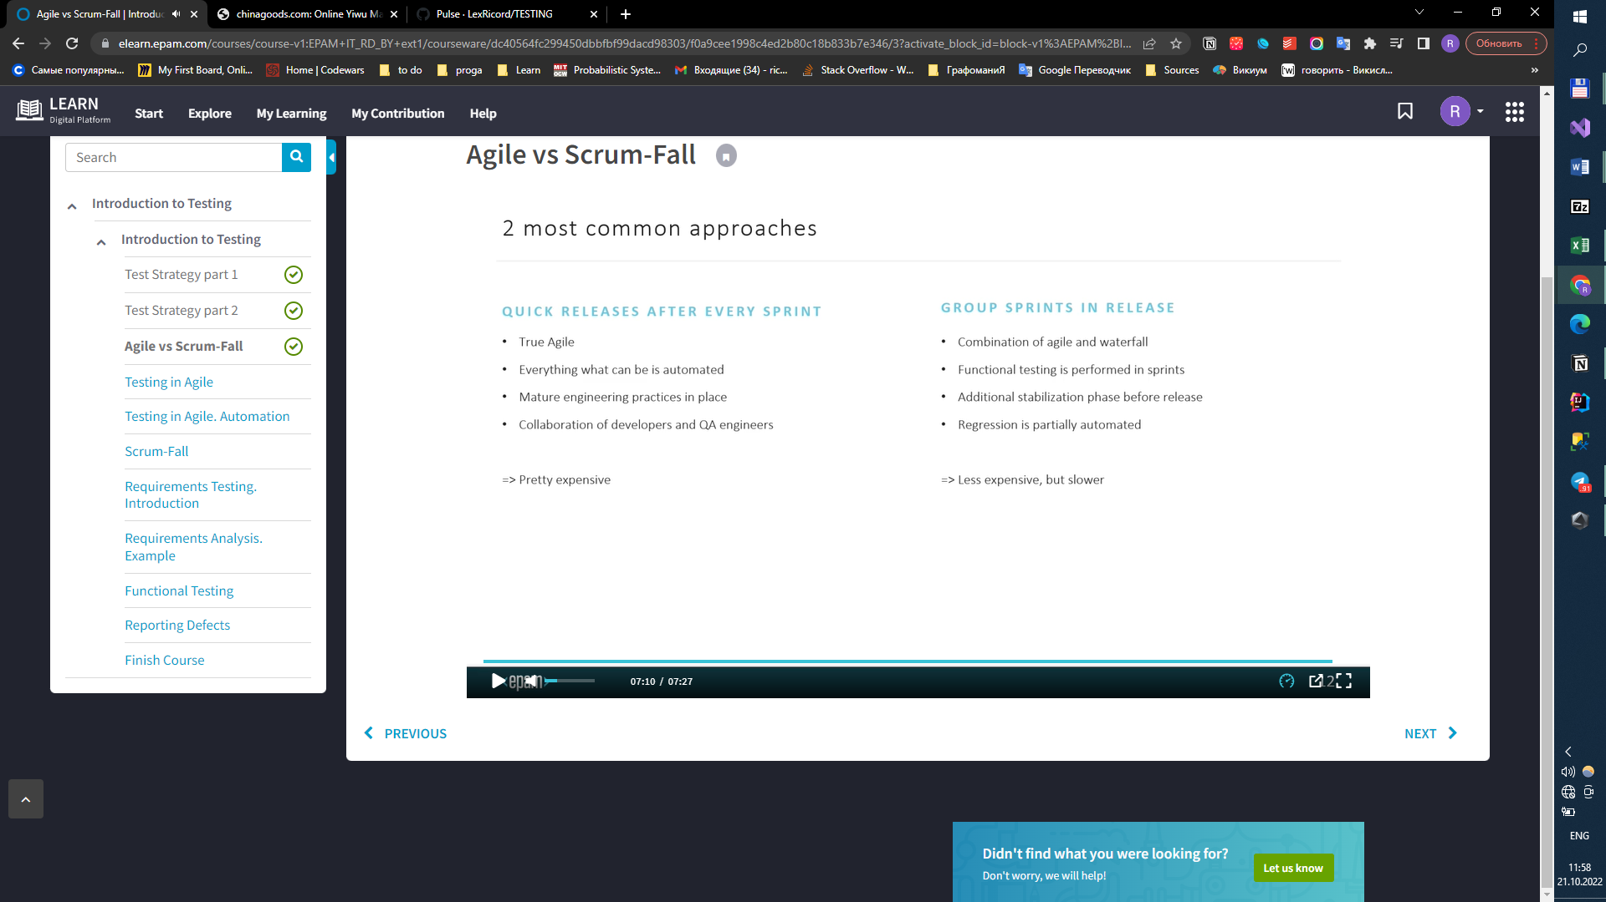

## **Testing in Agile**

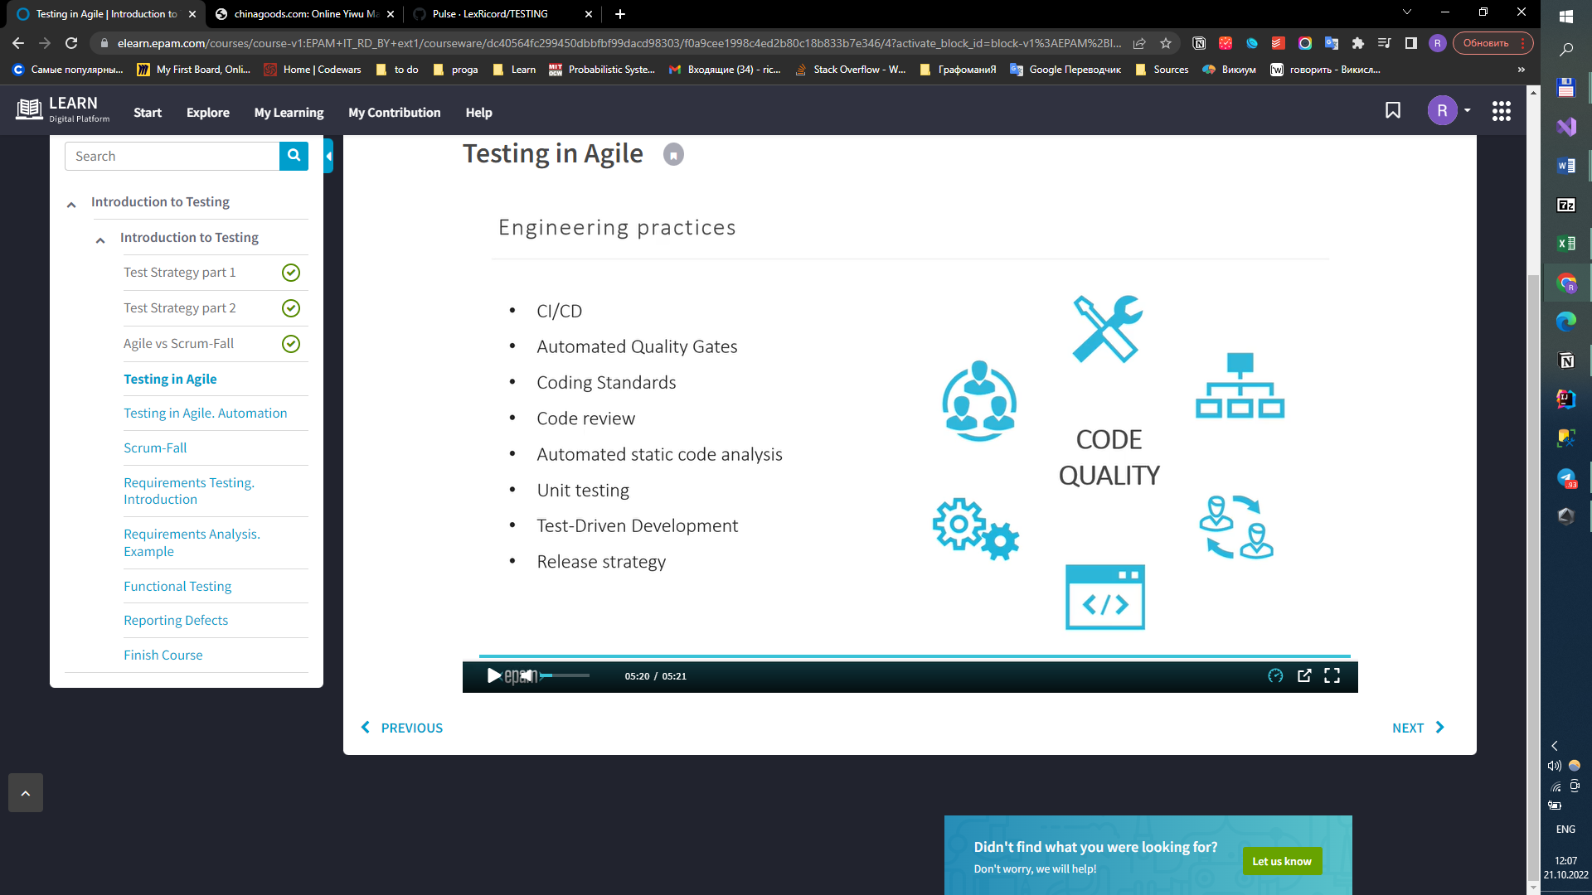

## **Testing in Agile. Automation**

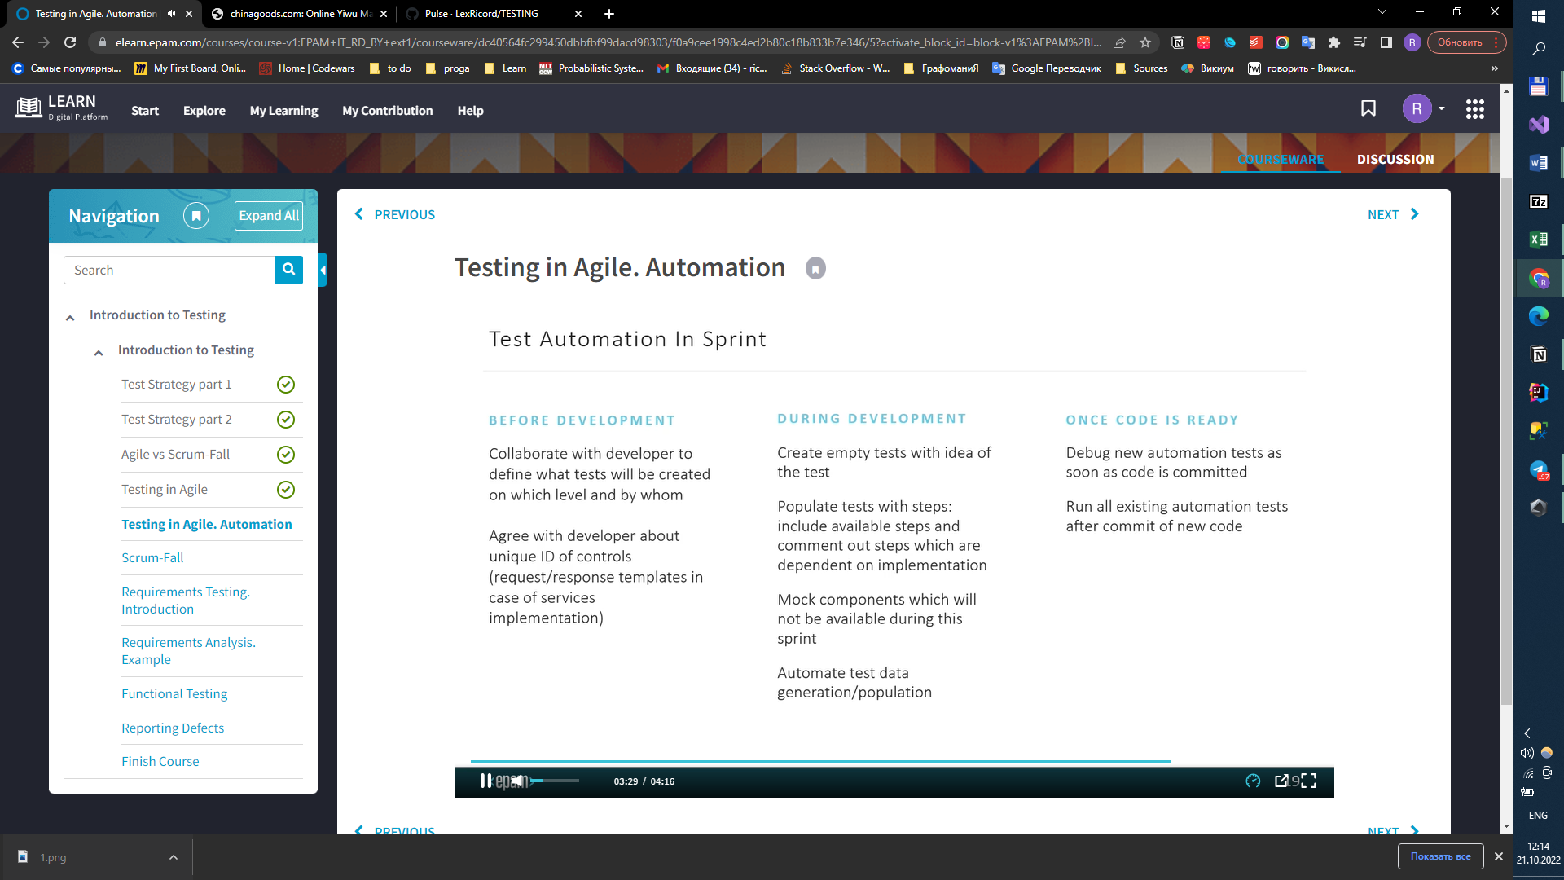

## **Scrum-Fall**

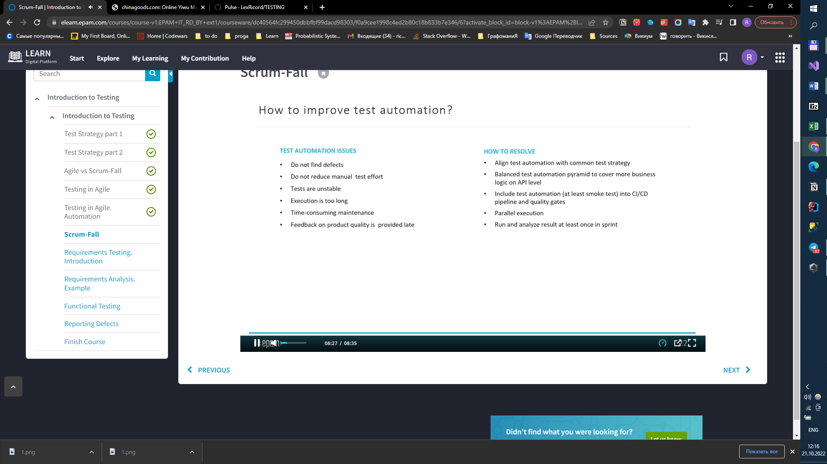

## **Requirements Testing. Introduction.**

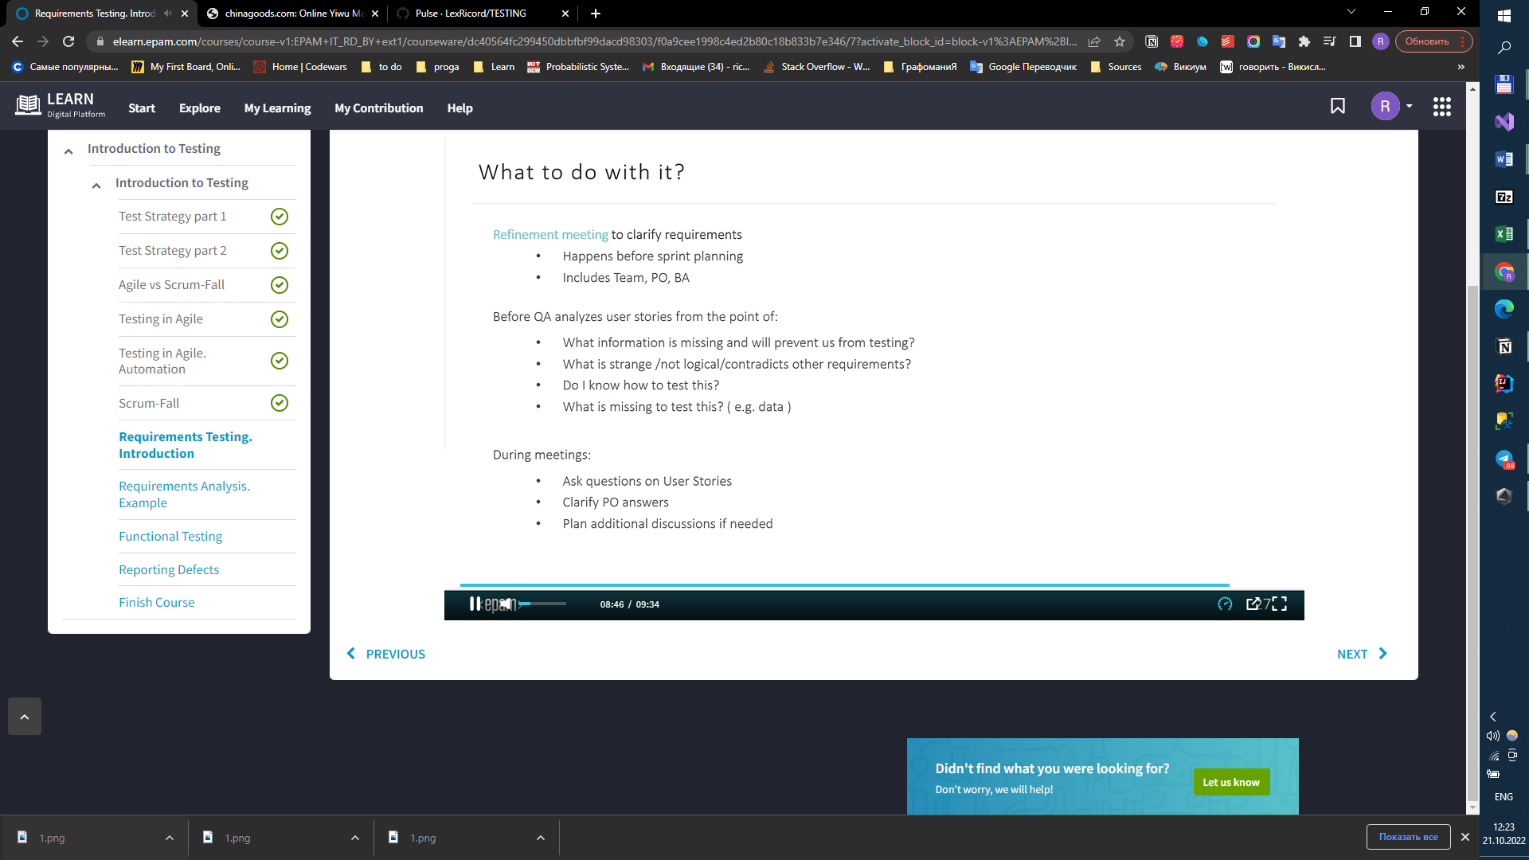

## **Requirements Analysis. Example.**

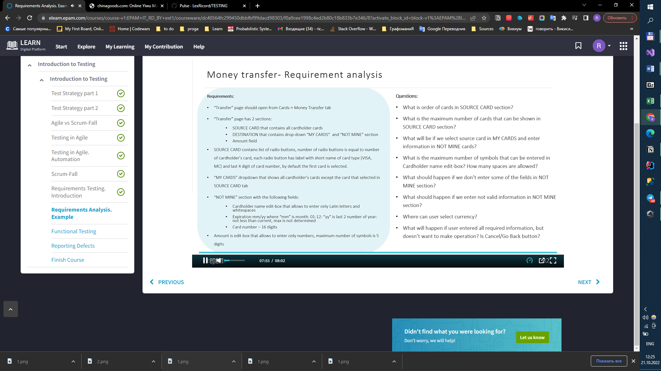

## **Finish Course**

