# Testing №3

**Test subject:** https://wap.chinagoods.com/?gclid=Cj0KCQjwhsmaBhCvARIsAIbEbH7gLMloqeDXKc4a-pnGmGQ3blsGRN-f40LvXPEe-KEsBdzbjhKbL94aAtIOEALw_wcB#&utm_campaign=CG-WAP-search&utm_source=google_search&utm_medium=cpc&utm_term=&utm_content=

## **Test case №1. Checking the adaptability of the search string.**

1. Follow the link https://wap.chinagoods.com/?gclid=Cj0KCQjwhsmaBhCvARIsAIbEbH7gLMloqeDXKc4a-pnGmGQ3blsGRN-f40LvXPEe-KEsBdzbjhKbL94aAtIOEALw_wcB#&utm_campaign=CG-WAP-search&utm_source=google_search&utm_medium=cpc&utm_term=&utm_content=;
2. Press

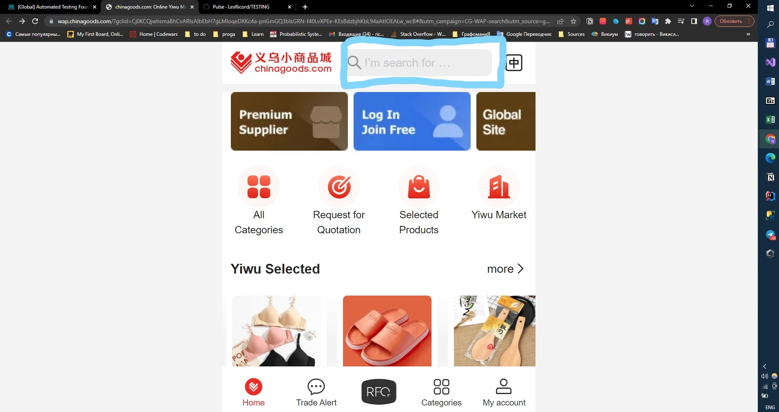

1. Try to enter more then 200 characters;

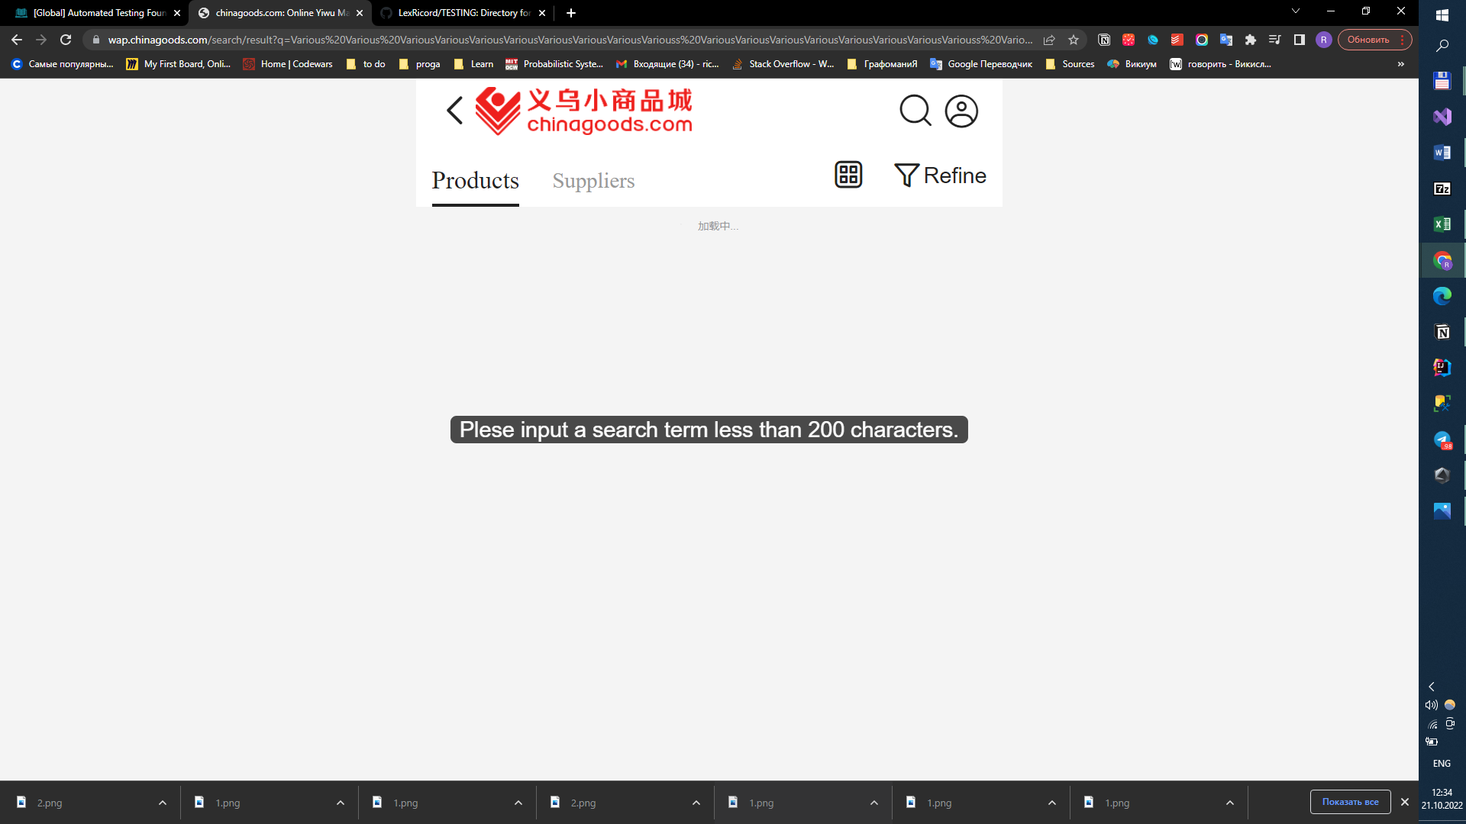

|  |  |
| --- | --- |
| Excepted result : | The search string adapts to the entered text |
| Actual result : | **The search string doesn’t adapts to the entered text** |
| Test Result : | **Not passed** |

**Test case №2. Checking the adaptability of the site to the size of the browser screen**.

1. Follow the link https://wap.chinagoods.com/?gclid=Cj0KCQjwhsmaBhCvARIsAIbEbH7gLMloqeDXKc4a-pnGmGQ3blsGRN-f40LvXPEe-KEsBdzbjhKbL94aAtIOEALw_wcB#&utm_campaign=CG-WAP-search&utm_source=google_search&utm_medium=cpc&utm_term=&utm_content=;

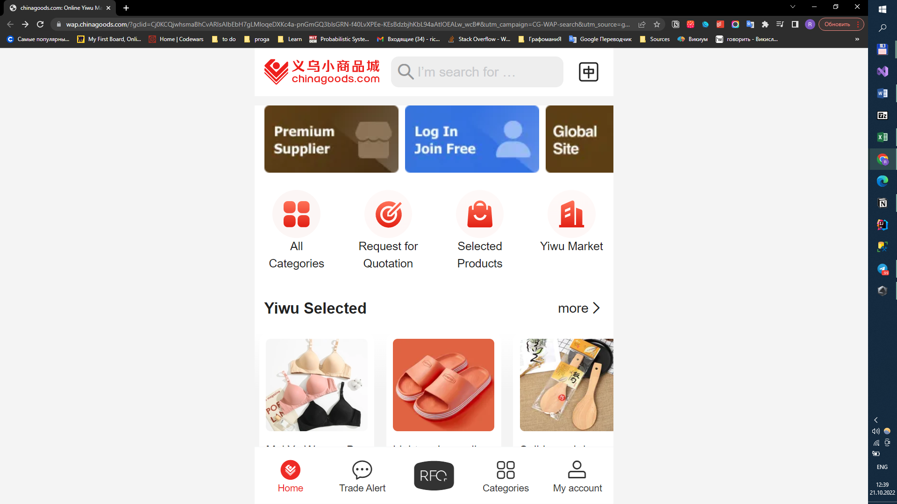

1. Try changing the size of your browser window

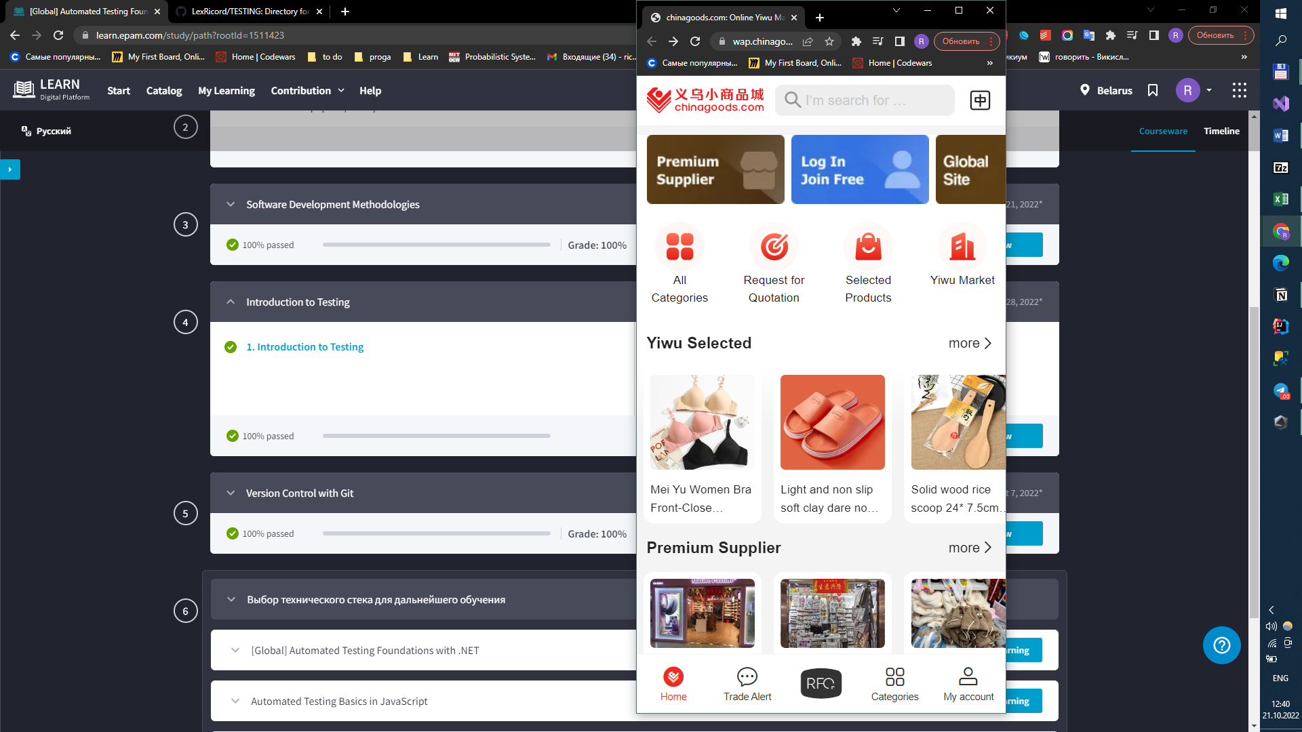

|  |  |
| --- | --- |
| Excepted result : | The site adapts to the size of the browser screen. |
| Actual result : | **The site adapts to the size of the browser screen.** |
| Test Result : | **Passed** |