

GUILDWARS 2 Ascalonian Catacombs Story Mode Guide

all useful things need to know about the Ascalonian Catacombs story mode.

By Leksa Km Trikru AKA Larissa

Guardian of the united[gotu] guildLeader   EU based

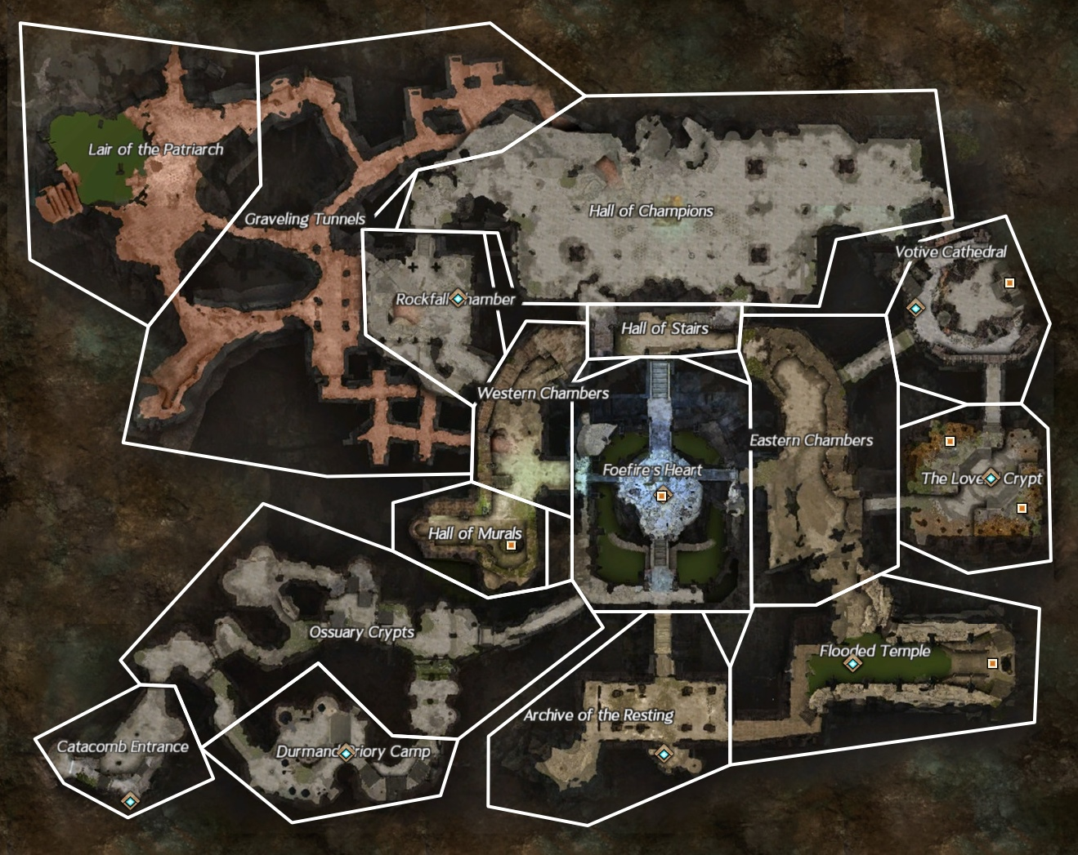

The Ascalonian Catacombs Dungeon can be found in Plains of Ashford. The dungeon offers 2 different modes:

* Story mode ( level 30 Required ) can be solo done if you know what you do and have a very good character. Otherwise 2-3 persons in recommended
* Explorer mode ( level 35 required ) recommended 5 players.

In this guide we focus on story mode.

IMPORTANT !!

* Need much ranged combat since many traps/npcs that need to be destroyed from far, easy dying with melee combat.

Story Mode

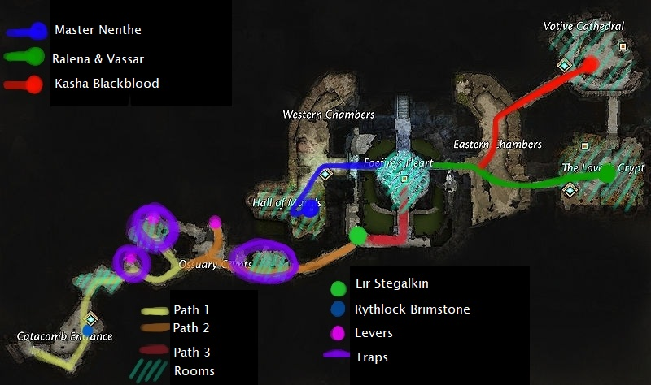

At enter talk to Rythlock Brimstone (red/orange Dot) to start the dungeon. Objective: find Eir Stegalkin.

At the first room you see lots of coffins interact with them to find the key (gate Guardian) for the door at the end. Upon interaction there spawn enemies so do not spam the coffins this may get you killed fast. If you kill the gate guardian the door opens and you can proceed. Beware for the traps behind the door you can deactivate them by pulling the lever on the left side. There will be standing ghosts with lots of Aoe on those traps so use ranged to kill them if haven’t activated traps yet.

The second room on the left side if you follow the yellow path of the picture contains lots of traps. You can deactivate them if you walk against the wall on the left side to reach the lever across the room. (those traps instant kill you)

Pick up the boulders on the ground and carry them along path orange and drop them on the pressure plates to deactivate next traps that cover the route. (don’t use skill 1 for that just click the green button on left side of skill bar)

In the Ossuary crypts you get turrets that shoot fire bolts. You can walk toward the lever on the left side upstairs to deactivate the next traps on the route. Those turrets will keep firing bolts unless you destroy them.

At the third room there’s a statue in the middle if you walk toward that an graveling burrow will spawn. You have to destroy this to proceed. This burrow will spawn lots of ‘’skelks’’ so best to focus first on the burrow than the skelks that spawned.

Proceed the route and you will find Eir on the end. There is a ghost captain near her you need to kill before you can speak with her.

Follow the red path until you come across the next room with an big boss in the middle. Kill his helpers before you focus on him to make it easy for yourself. Use cc on him at the blue bar to DPS him fats when that turns orange. After his death King Adelbern will spawn talk to him and you get 3 other objectives to kill

Light blue route = master Nenthe (ranger with an beast that cripples) (drains life, and gives fear so best to kill ranged mode) spawn near an chest at defeat

Pink route = Ralena & Vassar ( Vassar Mesmer needs to be killed first to easy kill Ralena Elementalist, these 2 become stronger the closer they are next to each other so keep them apart) on your way to them you will trigger an bonus event.

Dark Green route = Kasha Black blood Necromancer. CC than DPS. She does apply many conditions so make sure you got an condition cleanse skill equipped. Beside that minions spawn that can be killed easily.

2 bonus events can spawn random place

* Champion Troll 🡪 use CC and than DPS
* Graveling Burrow 🡪 fast kill with Aoe it does spawn many gravelling’s at same time

After having killed each one of them return to Foefires Heart to kill King Adelbern. You can use the closest waypoint to get there fast. Use CC and DPS to kill him fast (melee may be best here).