**Table of Contents**

|  |  |  |
| --- | --- | --- |
| Definition of the appraisal problem | ...................................................................... | 5 |
| Purpose of appraisal | ...................................................................... | 5 |
| Intended user of appraisal | ...................................................................... | 5 |
| Legal description | ...................................................................... | 5 |
| Type of appraisal report | ...................................................................... | 5 |
| Definition of market value | ...................................................................... | 6 |
| Property rights appraised | ...................................................................... | 6 |

1





**APPRAISAL REPORT OF**   
**VACANT LAND LOCATED AT**

**V/L QUEEN STREET**   
**ESSEX (HARROW), ONTARIO**

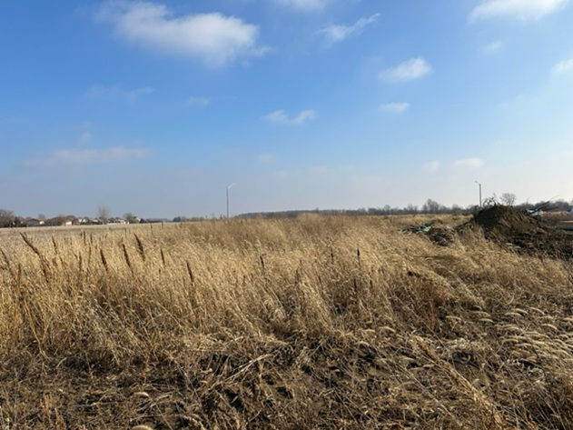

**PREPARED FOR:**

**BMO**   
**200 Ouellette Avenue**   
**Windsor, ON**   
**N9A 1A5**

**DATE OF VALUATION:**

**January 9, 2023**

**PREPARED BY:**

**Ryan Mancini, B.Comm, Msc., AACI, P.App.**

2



Renaissance Valuations Limited   
5060 Tecumseh Rd East, Suite 700   
Windsor, ON   
N8T 1C1

January 20, 2023

BMO   
200 Ouellette Avenue   
Windsor, ON   
N9A 1A5

Attention: Jimmy Wong

Email: jimmy1.wong@bmo.com

Re: V/L Queen Street, Essex (Harrow), Ontario

Reference/File No.: #2023-WE-002

_____________________________________________________________________________

Dear Mr. Wong:   
In accordance with the confirmed engagement dated January 9, 2023, we have appraised the above referenced property and provide an:   
Estimate of Current Market Value of: $2,380,000   
With an Effective date as of: January 9, 2023   
Inspection Date: January 9, 2023   
The purpose of the report is to develop an estimate of current market value of the subject property for the intended use of a private current estimate of land value.

The estimate of value is as of the effective date and is subject to the authorized intended use, assumptions and limiting conditions included in the report to which the reader’s attention is specifically directed. The report is enclosed and must be read in its entirety.

No person or party other than the authorized intended user specifically identified herein can rely on this report without first obtaining written authorization from the author(s) of this report.

Such authorization is at the discretion of the author(s), and may only be issued with permission from the client of this report.

The report is prepared in accordance with the Canadian Uniform Standards of Professional Appraisal Practice (CUSPAP).

3



Yours truly,   
RENAISSANCE VALUATIONS LIMITED

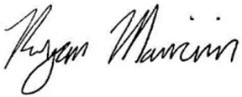

Ryan Mancini, B.Comm, Msc., AACI, P.App.   
AIC Membership #: 909678

4



**DEFINITION OF THE APPRAISAL PROBLEM**

**Purpose of Appraisal**

To estimate the current market value of the fee simple estate on a free and clear basis as of January 9, 2023. The only intended use of this report is to provide a current market value estimate for conventional primary financing not to exceed 75% loan to value ratio for BMO. All other uses are denied without written permission.

**Intended User of Appraisal**

The intended user is BMO. The use of this report by any lender or any other user or party is not permitted without a Letter of Reliance.

**Legal Description**

PART LOTS 7 AND 8, PLAN 202, PARTS 1 AND 2, PLAN 12R-28780 TOWN OF ESSEX

**Type of Appraisal Report**

Appraisal types include:

• Full Narrative - comprehensive and detailed;

• Short Narrative - concise and briefly descriptive.

• Form - a standardized format combining check-off boxes and narrative comments.

In this instance, the report is a Short Narrative that is intended to comply with the reporting requirements set forth under Definitions of the Canadian Uniform Standards of Professional Appraisal Practice. Supporting documentation concerning the data, reasoning, and analyses is retained in the appraiser's file. The information contained in this report is specific to the needs of the client and for the stated intended use.

See “Scope” regarding the procedures and data collected to undertake this report

5



**Definition of Market Value**

The following is the definition of “Market Value” according to CUSPAP 2022:

*The most probable price, as of a specified date, in cash, or in terms equivalent to cash, or in precisely revealed terms, for which the specified property rights should sell after reasonable exposure in a competitive market under all conditions requisite to a fair sale, with the buyer and the seller each acting prudently, knowledgeably, and for self-interest, assuming that neither is under duress.*

Implicit in this definition are the consummation of a sale as of a specified date and the passing of title from seller to buyer under conditions under which:

 Buyer and seller are typically motivated;

 Both parties are well informed or well advised, and each acting in what he considers his own best interests;

 A reasonable time is allowed for exposure in the open market;

 Payment is made in terms of cash in Canadian dollars or in terms of financial arrangements comparable thereto; and

 The price represents the normal consideration for the property sold unaffected by special or creative financing or sales concessions granted by anyone associated with the sale

**Property Rights Appraised**

Fee Simple is defined as:

*An absolute fee; a fee without limitations to any particular class of heirs or restrictions, but subject to the limitations of eminent domain, eschet, plice power and taxation.*

The ownership interest being appraised is 100% of the fee simple estate or interest. There are no fractionla interests being considered or valued in this assignment.

k;alksjdf;lsjdf;lksdjf;slkdfs;ldfkjsd;lfjsdf;lsjdf;sldfkjdfasdfsdfsadfsdfsdfsdfsdfsdfsdfsdf

6



1   
2   
3   
4   
5   
6   
7   
8   
9   
10   
11   
12   
13   
14   
15   
16   
17   
18   
19   
20   
21   
22   
23   
24   
25   
26   
27   
28   
29   
30   
31   
32

7



This is the first paragraph asdfsdf   
Normal enter   
This is a shif enter

8

