Table of Contents



APPRAISAL REPORT OF VACANT LAND LOCATED AT

V/L QUEEN STREET ESSEX (HARROW), ONTARIO

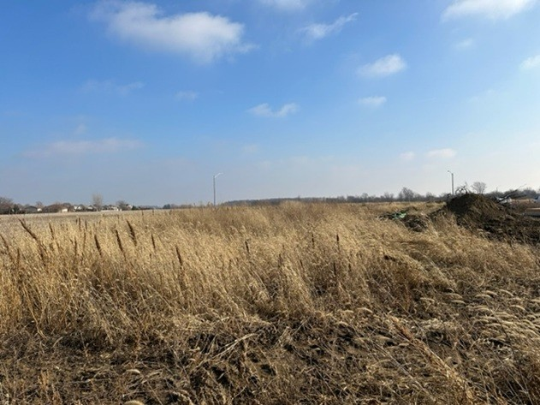

PREPARED FOR:

BMO

200 Ouellette Avenue Windosor, ON

N9A 1A5

DATE OF VALUATION:

January 9,2023

PREPARED BY:

Ryan Mancini, B.Comm, Msc., AACI, P.App.