# **Lab 5 Report**

1. Name: Student ID:
2. Proof of your lab work
3. Screenshot 1: website main page (20%)

Ex:

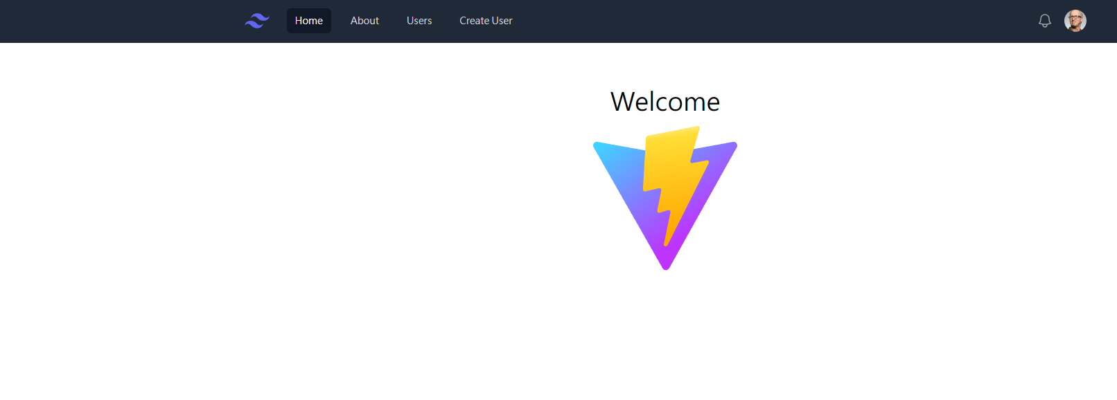

1. Screenshot 2: website about page (20%)

Ex:

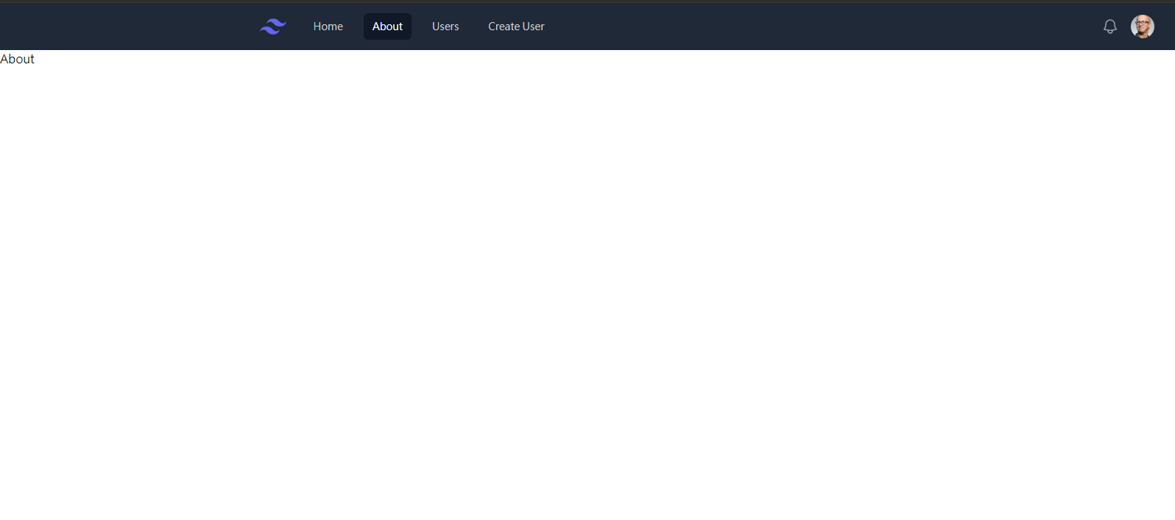

1. Screenshot 3: website User page (30%)

Ex:

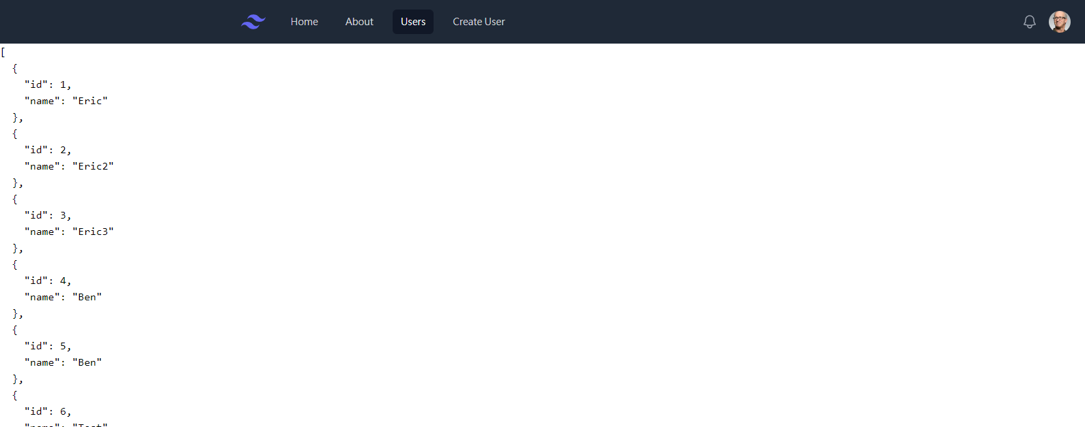

1. Screenshot 4: website Create User page (30%)

Ex:

