**The Temporal and Sectoral Effects of Federal Funds Rate Changes on U.S. Employment: A Multi-Industry Analysis (1990-2024)**

1. **Introduction and Motivation**

This study examines the complex relationship between Federal Reserve monetary policy and employment across different sectors of the U.S. economy from 1990 to 2024. Understanding this relationship is crucial for policymakers, economists, and market participants, as employment outcomes represent a key channel through which monetary policy affects economic welfare. While previous research has largely focused on aggregate employment effects, this analysis provides a granular investigation of how interest rate changes impact various industries differently, considering both temporal and sectoral dimensions.

The research is motivated by several critical factors that have shaped modern monetary policy and labor markets. First, understanding heterogeneous employment responses across industries represents a crucial area of investigation, as different sectors may exhibit varying degrees of sensitivity and adjustment patterns. Second, the study examines both immediate and delayed effects of interest rate changes on employment, recognizing that monetary policy transmission mechanisms may operate with different time lags across sectors. Additionally, the analysis takes on particular significance given the evolution of this relationship over multiple tightening cycles, including unique periods like the 2008 financial crisis and the post-COVID recovery.

Recent economic events have highlighted the importance of understanding sectoral differences in policy responses. The unprecedented nature of the post-2020 recovery, characterized by rapid employment rebounds despite aggressive monetary tightening, raises questions about structural changes in how different industries respond to policy shifts. The study employs a multi-faceted analytical approach, combining correlation analysis, sectoral employment tracking, and income sensitivity measurements to provide a comprehensive view of the monetary policy-employment relationship. By examining both temporal aspects and structural characteristics of different industries, this research aims to identify patterns that can inform more effective policy implementation, contributing to our understanding of how monetary policy transmission mechanisms vary across sectors of the economy.

1. **Aggregate Employment Rate and Federal Funds Rate Analysis**
   1. **Correlation Analysis**

This study examines the dynamic relationship between monetary policy, represented by the federal funds rate, and labor market performance through employment rates using monthly data. The correlation analysis spans across different time horizons, with lag periods ranging from 1 to 30 months, providing insights into how changes in interest rates correlate with subsequent employment patterns.

**Table 1.** Correlation Between Employment Rate and Federal Funds Rate (Monthly Leads)

| **Lead (Monthly)** | **Correlation** | **Lead (Monthly)** | **Correlation** |
| --- | --- | --- | --- |
| 1 | 0.411 | 16 | 0.069 |
| 2 | 0.393 | 17 | 0.045 |
| 3 | 0.373 | 18 | 0.023 |
| 4 | 0.352 | 19 | 0.003 |
| 5 | 0.330 | 20 | -0.017 |
| 6 | 0.308 | 21 | -0.036 |
| 7 | 0.285 | 22 | -0.056 |
| 8 | 0.262 | 23 | -0.073 |
| 9 | 0.236 | 24 | -0.089 |
| 10 | 0.210 | 25 | -0.099 |
| 11 | 0.185 | 26 | -0.108 |
| 12 | 0.160 | 27 | -0.118 |
| 13 | 0.138 | 28 | -0.130 |
| 14 | 0.117 | 29 | -0.139 |
| 15 | 0.094 | 30 | -0.145 |

The results reveal several notable patterns in the relationship between interest rates and employment rates. First, the strongest positive correlation (0.411) is observed at a one-month lag, indicating that current employment rates are most strongly associated with the previous month's federal funds rate. This correlation gradually diminishes as the lag length increases, displaying a consistent downward trend. The relationship remains positive but weakens substantially through the first 19 lags, eventually turning negative at the 20-month mark (-.0168). The negative correlation continues to strengthen modestly through the remaining lags, reaching -.145 at the 30-month lag. This pattern suggests that while monetary policy changes show immediate positive correlation with employment rates, this relationship not only weakens but reverses direction over longer time horizons. However, it's crucial to note that these correlations may not necessarily indicate causation. The positive short-term correlation could reflect the Federal Reserve's responsive policy-making - raising rates during periods of strong employment rather than higher rates directly promoting employment. Additionally, the eventual negative correlation at longer lags might align with traditional economic theory regarding the delayed effects of monetary tightening on economic activity. These findings contribute to our understanding of the complex temporal relationship between monetary policy and labor market outcomes, though further research controlling for other economic factors would be necessary to establish causal relationships.

* 1. **Historical Trends and Patterns**

This figure examines the temporal relationship between monetary policy and labor market conditions in the United States from 1990 to 2025, with a particular focus on Federal Reserve tightening cycles. The visualization overlays the employment rate (blue line) with a one-month-ahead federal funds rate (red line), while highlighting major monetary tightening periods (shaded orange areas). The one-month lead in the federal funds rate is specifically designed to investigate the short-term leading relationship between monetary policy changes and employment outcomes.

**Figure 1.** Employment Rate and Future Federal Funds Rate with One-month Lead

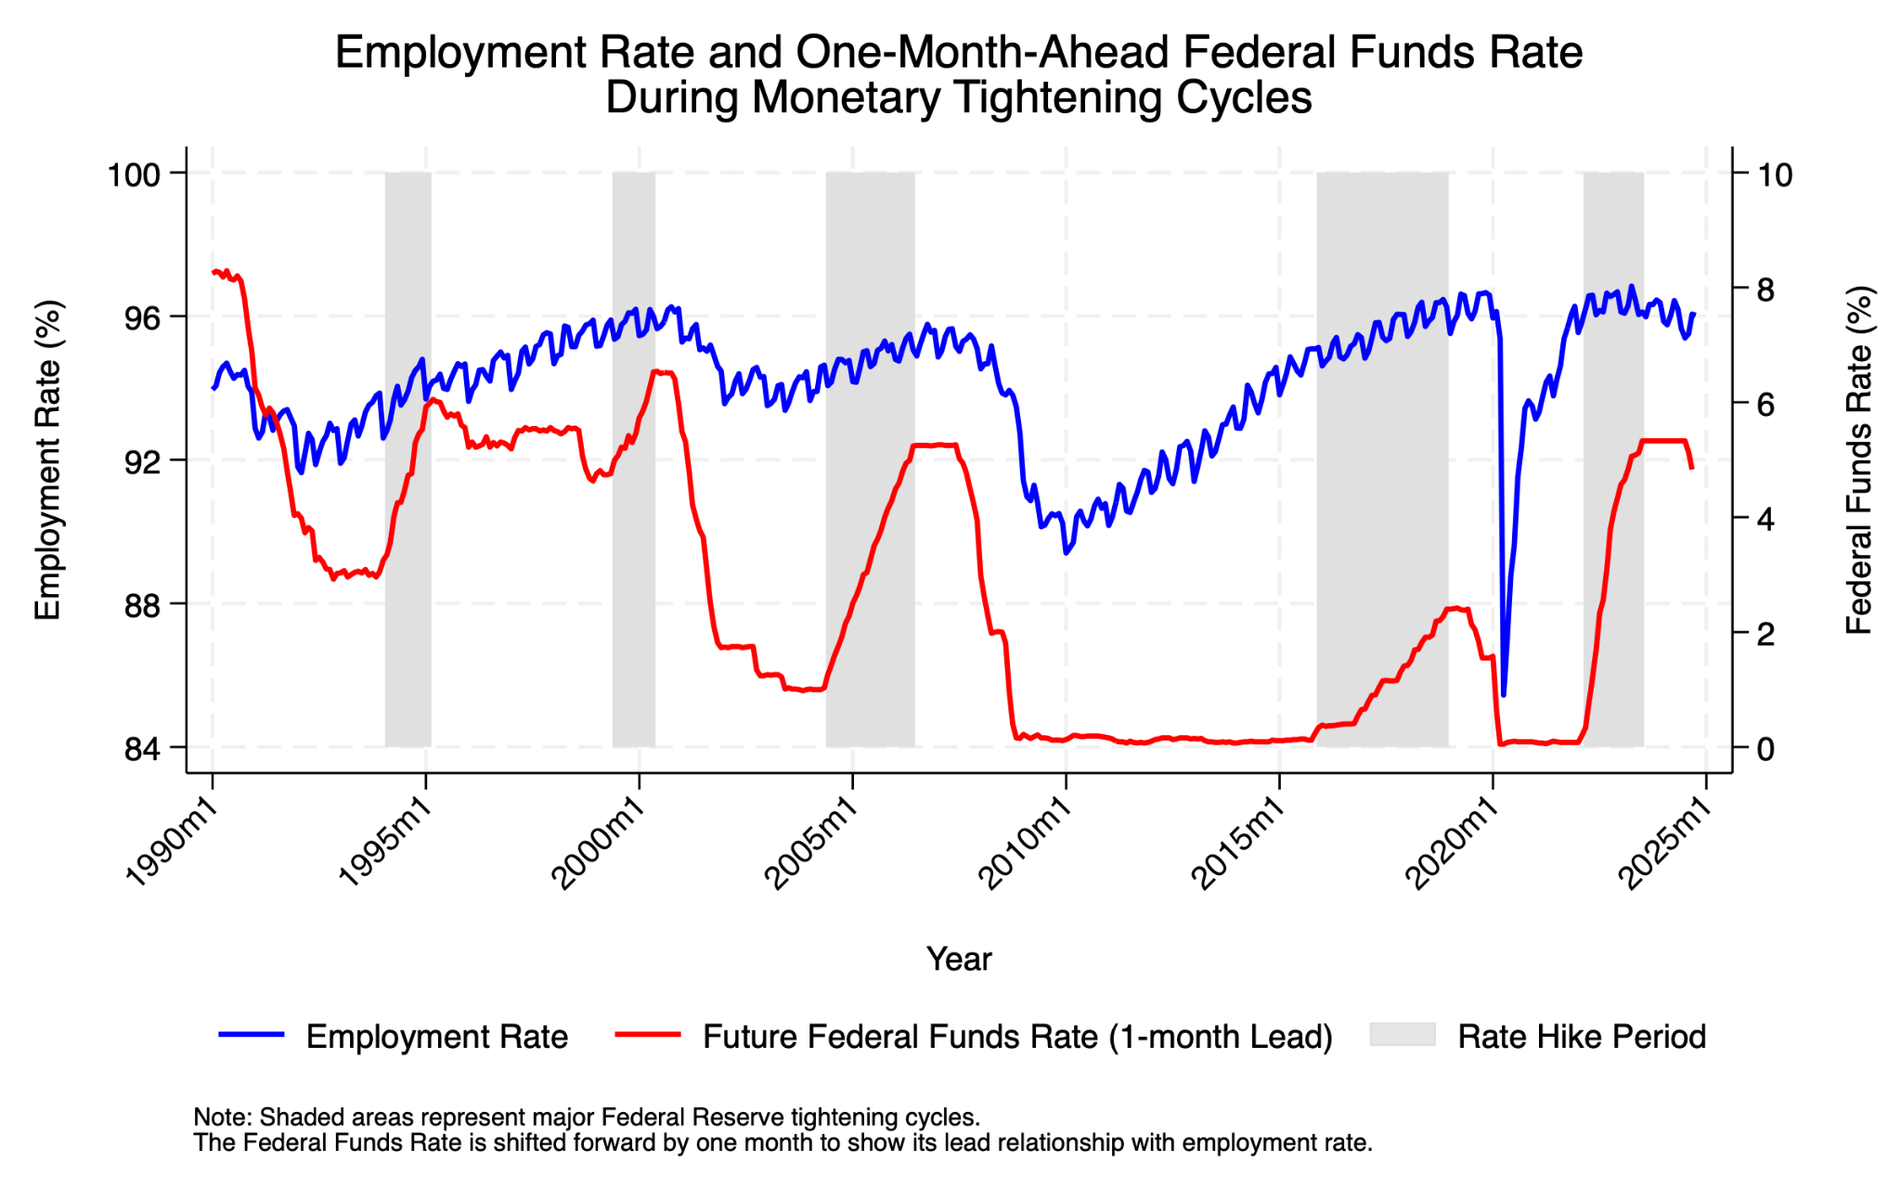

Analysis of the data reveals several significant patterns in the dynamic relationship between interest rates and employment. First, during the five major tightening cycles (Pre-Tech Boom, Dot-Com Bubble, Housing Boom, Zero-Rate Exit, and Post-COVID Tightening), employment rates demonstrate notable resilience in the immediate aftermath of rate increases. The Pre-Tech Boom (1994-1995) well exemplifies the fact that, when appropriately calibrated, monetary policy can affect a "Pre-Tech Boom," where the labor market is kept fairly intact with an employment rate of about 94%. Blinder (2023) states that unemployment steadily declined in the following years, reaching a low of 3.8% in 2000, showcasing minimal disruption to the labor market. Furthermore, the financial crisis of 2008 presented a distinctive situation. Despite the introduction of an expansionary monetary policy, the sharp decline in employment continued, reaching approximately 90%. The post-2020 period is also a special case, with an uniquely sharp drop in employment to around 85%, the lowest from 1990 to 2024. However, this is followed by a remarkably rapid recovery, despite the subsequent aggressive tightening cycle in Post-COVID Tightening (2022-2023). The contrasting recovery speeds from these two periods suggest that the monetary policy we are studying may represent only a minor factor in the labor market's adjustment following a severe economic shock. While this period demonstrates the limited capacity of the labor market to recover quickly in the context of a severe economic crisis, even when monetary policy serves as a stabilizing force, it also highlights that interest rate adjustments, though potentially effective, are not entirely or directly tied to fluctuations in the labor market.

By shifting the interest rate data one month forward, we can see that the market reacts quickly to monetary policy changes, but labor market adjustments tend to take longer. Moreover, the data shows an asymmetric relationship between policy tightening and employment: sharp rate hikes may align with job recovery, while rapid rate cuts, like in 2008, often do not.

**Figure 2.** Employment Rates Before and After Hike Periods

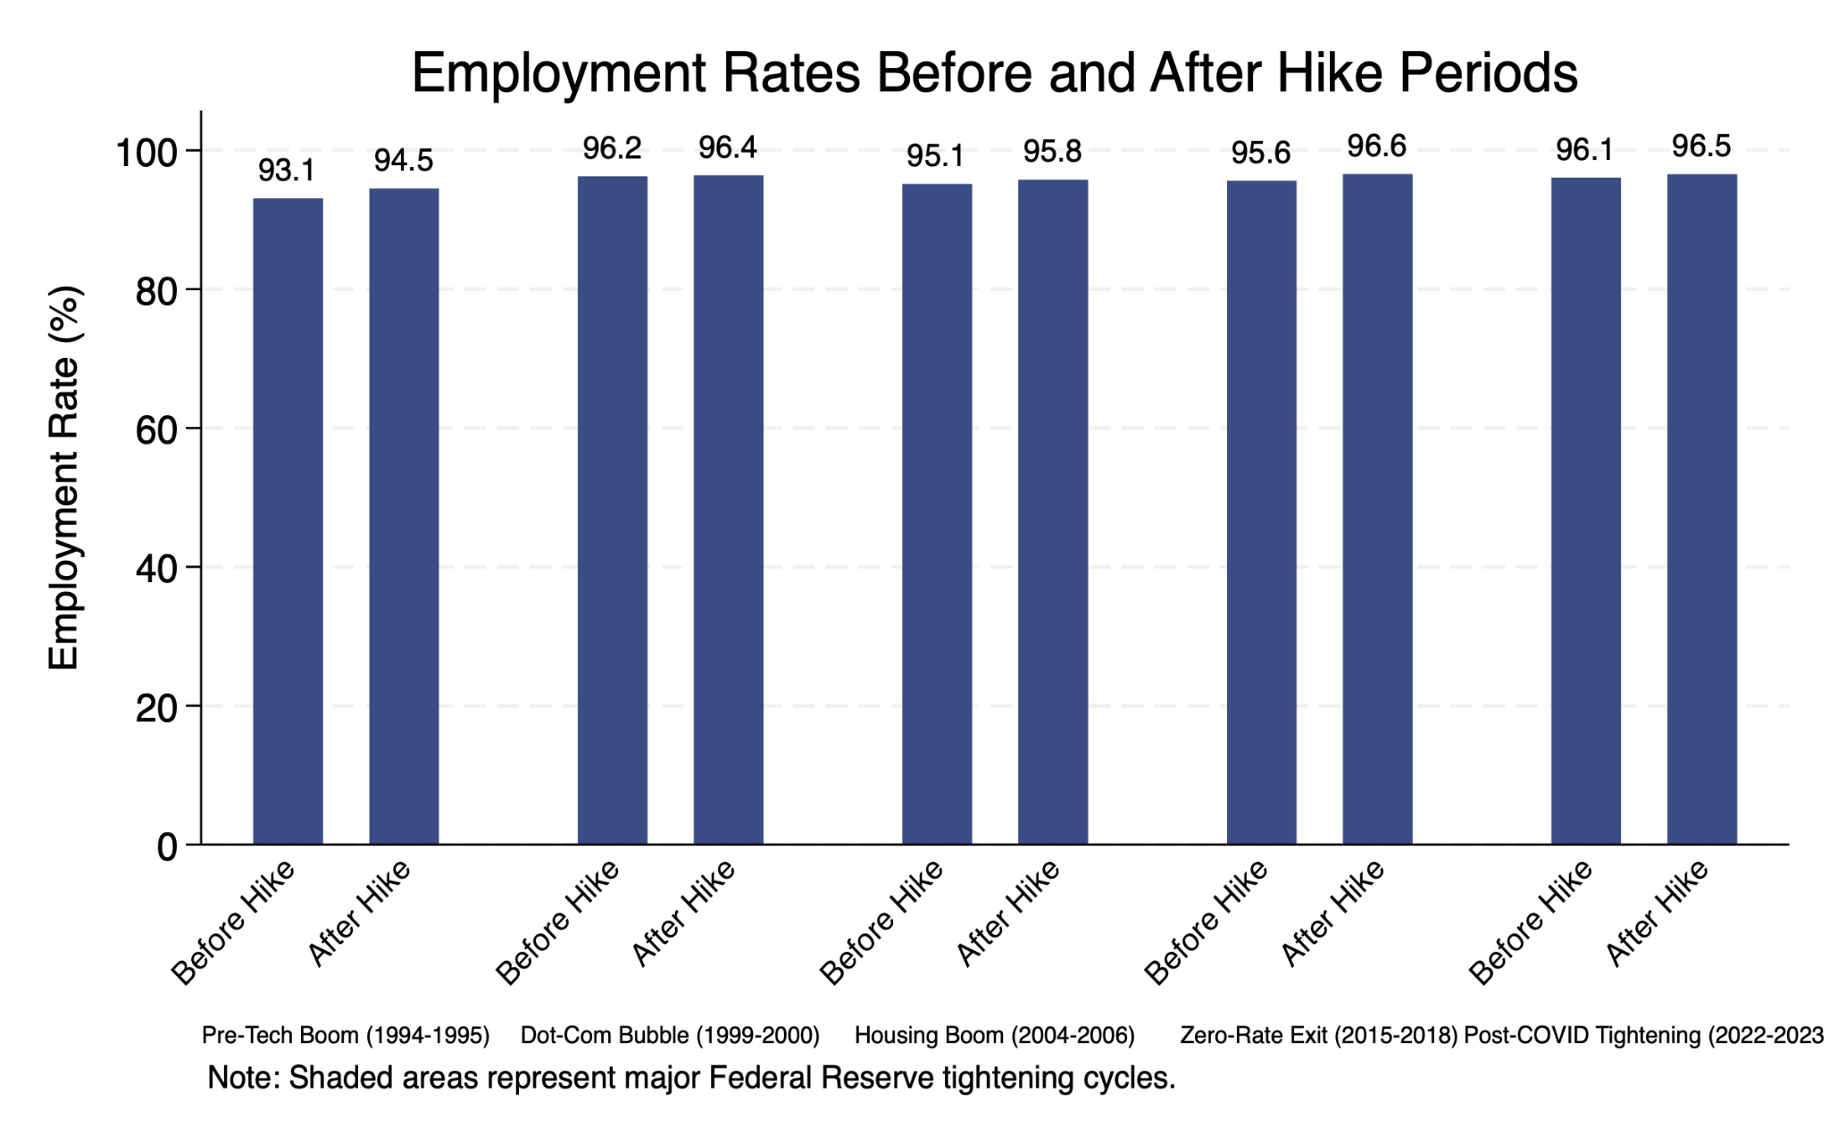

We analyzed employment rates during interest rate hike periods and found that in six of eight cases (excluding 2024 due to incomplete data), employment was higher before the hikes. This supports our hypothesis that labor markets often respond positively to monetary tightening, mitigating low employment periods. Additionally, it suggests that rate hikes can foster short-term improvements in labor market conditions, reinforcing the broader view of monetary policy's role in balancing labor market performance.

The varying sensitivity of employment to interest rate changes across different economic conditions suggests that policymakers must consider not only the magnitude of rate adjustments but also the broader economic context in which these changes occur. The persistence of relatively strong employment rates during recent tightening cycles might indicate either improved monetary policy communication, enhanced labor market resilience, or structural changes in how employment responds to monetary policy interventions in the modern economy.

1. **Industry-Specific Analysis**
   1. **The Evolution of Industry-Specific Employment Rate**

This figure examines the heterogeneous patterns of employment rates across different industries in the United States from 1990 to 2024, with particular attention to industry-specific responses during Federal Reserve tightening cycles. The visualization overlays annual employment rates for ten major industry sectors while highlighting five significant monetary tightening periods (1994-1995, 1999-2000, 2004-2006, 2015-2018, and 2022-2023) through shaded areas, enabling analysis of sector-specific labor market resilience during monetary policy transitions.

**Figure 3.1.** Trends in Industry-Specific Employment Rates in the United States (1990–2024)

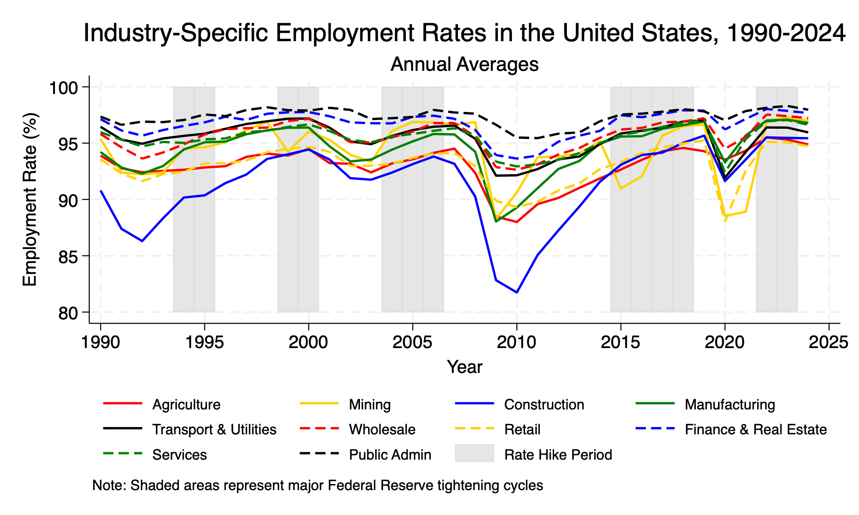

**Figure 3.2.** Supplementary Industry-Specific Employment Trends During Federal Reserve Tightening Cycles (1990-2024)

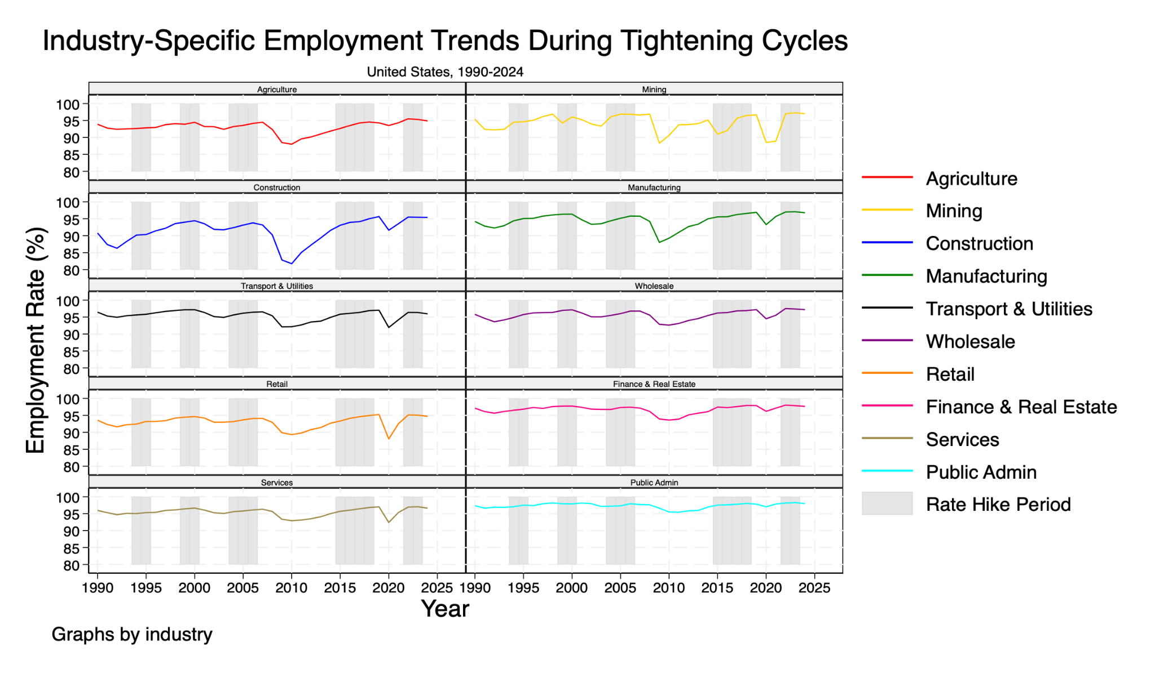

Analysis of the data reveals several notable patterns in how different industries respond to monetary tightening cycles. First, there is substantial heterogeneity in employment stability across sectors, with Public Administration, Finance & Real Estate, and Services consistently maintaining higher and more stable employment rates (95-98%) throughout the observed period. This stability in these sectors suggests their relative insulation from monetary policy changes, possibly due to factors such as stable government funding (in Public Administration), high profit margins (in Finance), and essential nature of services in the modern economy. In contrast, Construction and Mining exhibit greater volatility and sensitivity to economic cycles, particularly evident in their sharp employment declines during the 2008-2009 financial crisis, with Construction employment falling to around 82% - the lowest among all sectors.

A key question that emerges from this data is: "How has the sensitivity of different sectors to monetary tightening evolved over time?" The evidence suggests significant changes in these relationships. During the 1994-1995 "soft landing" tightening cycle, most sectors demonstrated remarkable resilience, with employment rates remaining stable or even improving. This success story contrasts with later periods. The 2004-2006 tightening cycle preceded the financial crisis, during which Construction and Manufacturing showed early signs of vulnerability. The 2015-2018 tightening cycle revealed an evolving pattern: Finance & Real Estate and Services sectors demonstrated enhanced resilience, maintaining strong employment rates above 96%, while traditional industries like Mining experienced notable volatility.

The post-2020 period presents perhaps the most intriguing case study. The unprecedented synchronous drops across all sectors during the pandemic were followed by an equally remarkable recovery during the 2022-2023 tightening cycle. This recent experience raises important questions about structural changes in the economy. Even traditionally sensitive sectors like Construction have shown unusually strong resilience during the most recent tightening cycle, maintaining employment rates above 94% despite aggressive rate hikes. This could indicate either a fundamental change in how industries respond to monetary policy or the presence of other dominant factors (such as supply chain reorganization, technological adaptation, or changed labor market dynamics) that have altered traditional industry-monetary policy relationships.

Based on the observed sectoral resilience in the post-2020 period, a very interesting analysis is the speed of recovery across industries in different monetary tightening cycles. One remarkable feature is the difference between the speed of recovery of sensitive sectors, such as construction and mining, and more stable sectors, such as public administration and services. This aligns with findings from the White House Council of Economic Advisers, highlighting the strong labor market recovery post-2020, though recovery rates varied significantly across industries. The U.S. government also utilized expansionary policies, including federal funds rate adjustments, to promote full employment while maintaining price stability (White House, 2024).

While other sectors of the economy recovered almost immediately, during the financial crisis of 2008-2009, the construction sector was hit particularly hard, with employment falling by around 82% and taking years to fully recover to pre-crisis levels. By contrast, the 2022-2023 tightening cycle has not experienced this. Industries have never been so synchronized in a recovery. Moreover, even traditionally sensitive sectors are maintaining employment rates above the 94% seen during the crisis. This suggests that structural changes and the appropriate monetary policy may have helped economically vulnerable industries become more resilient.

The data shows sectoral convergence over time. Before 2000, employment rates varied widely across industries (86% to 98%). Since 2015, they have converged to 92%-98%, with occasional outliers during shocks. This trend likely reflects advances in business practices, technology, and labor market institutions reducing sectoral vulnerabilities to monetary policy.

These findings suggest that the transmission of monetary policy to employment outcomes varies substantially across economic sectors and has evolved over time, necessitating more nuanced and perhaps sector-specific policy considerations. The increased resilience of many sectors to monetary tightening in recent years might also indicate that the Fed has greater flexibility in pursuing anti-inflationary policies without causing severe sector-specific employment dislocations.

* 1. **Industry Sensitivity to Interest Rate Changes**

This analysis examines the temporal relationship between federal funds rate changes and industry-specific employment rates in the United States, utilizing annual data across ten major industry sectors. The methodology employs a comprehensive lead-lag correlation analysis, examining relationships up to five years before and after interest rate changes, to understand both the anticipatory responses and delayed effects of monetary policy on sectoral employment.

**Table 2.** Contemporaneous and Short-term Correlations Between Federal Funds Rate and Industry Employment

| **Industry** | **Contemporaneous Correlation** | **Lead 1 Year** | **Lag 1 Year** | **Lag 2 Years** |
| --- | --- | --- | --- | --- |
| Construction | 0.27 | 0.33 | 0.04 | -0.21 |
| Manufacturing | 0.39 | 0.44 | 0.11 | -0.21 |
| Wholesale trade | 0.44 | 0.45 | 0.16 | -0.18 |
| Public administration | 0.45 | 0.45 | 0.32 | 0.18 |
| Finance, insurance, and real estate | 0.48 | 0.48 | 0.20 | -0.04 |
| Retail trade | 0.50 | 0.45 | 0.22 | -0.09 |
| Agriculture, forestry, and fishing | 0.46 | 0.51 | 0.21 | -0.05 |
| Mining | 0.51 | 0.51 | 0.25 | -0.01 |
| Services | 0.49 | 0.52 | 0.25 | -0.03 |
| Transportation and public utility | 0.63 | 0.62 | 0.38 | 0.12 |

Analysis of contemporaneous and short-term correlations reveals significant heterogeneity in industry responses to interest rate changes. The transportation sector demonstrates the strongest immediate relationship (correlation = 0.63) and notably maintains positive correlations through subsequent periods (lag1 = 0.38, lag2 = 0.12), suggesting sustained resilience to monetary policy tightening. Finance and Services sectors both exhibit strong contemporary relationships (0.51) with interest rates, while also showing substantial leading correlations (lead1 = 0.51 for both), indicating their employment patterns might anticipate monetary policy changes. Construction, in contrast, shows a weaker immediate correlation (0.27) but displays interesting dynamics with a stronger leading indicator (lead1 = 0.33), suggesting employment adjustments occur in anticipation of rate changes rather than in response to them. Manufacturing presents a particularly notable pattern, with a moderate contemporaneous correlation (0.39) but significant deterioration in later periods (lag2 = -0.21, lag3 = -0.33), suggesting delayed negative effects of rate increases on employment in this sector.

**Table 3.** Maximum Correlation and Timing Across Industries

| **Industry** | **Maximum Correlation** | **Best Lag\*** |
| --- | --- | --- |
| Construction | 0.33 | -1.00 |
| Manufacturing | 0.44 | -1.00 |
| Wholesale trade | 0.45 | -1.00 |
| Public administration | 0.45 | -1.00 |
| Finance, insurance, and real estate | 0.48 | -1.00 |
| Retail trade | 0.50 | 0.00 |
| Agriculture, forestry, and fishing | 0.51 | -1.00 |
| Mining | 0.51 | 0.00 |
| Services | 0.52 | -1.00 |
| Transportation and public utility | 0.63 | 0.00 |

*Note: Negative values indicate leading relationships

Examination of maximum correlations and their timing (Table 2) reveals deeper insights into the dynamic relationships between monetary policy and employment across sectors. Transportation maintains the strongest overall relationship (0.63, contemporaneous), suggesting immediate and direct sensitivity to monetary conditions. The financial sector shows its peak correlation (0.51) one year ahead of rate changes, consistent with the sector's forward-looking nature and sophisticated monetary policy anticipation. Agriculture demonstrates surprisingly strong sensitivity (maximum correlation = 0.52, lead1), possibly reflecting the sector's responsiveness to broader economic conditions that typically precede rate changes. Public administration shows moderate but persistent correlations (maximum = 0.45, lead1), indicating the government sector's employment patterns may be influenced by anticipated policy changes.

The retail and wholesale trade sectors exhibit similar patterns (maximum correlations of 0.48 and 0.45 respectively, both with lead1), suggesting these related sectors adjust employment in anticipation of monetary policy changes. Mining presents an interesting case with a strong contemporaneous correlation (0.50) but relatively weaker leading and lagging relationships, indicating immediate rather than anticipatory or delayed responses to rate changes. Manufacturing's pattern (maximum correlation = 0.44, lead1) coupled with its negative lagged correlations suggests initial anticipatory adjustments followed by potentially adverse longer-term effects of rate increases.

The variation in timing and magnitude of responses across sectors suggests monetary policy operates through multiple channels with varying effectiveness. Service-oriented sectors (Finance, Services) demonstrate more forward-looking employment adjustments, possibly due to greater labor market flexibility and sophisticated policy monitoring. Traditional industries (Manufacturing, Construction) show more complex response patterns, with initial positive correlations followed by negative relationships, suggesting potential longer-term adverse effects of rate increases on employment in these sectors.

The persistence of positive correlations in Transportation and strong leading correlations in Agriculture suggests these sectors might benefit from the broader economic conditions that typically prompt rate increases. This sectoral heterogeneity in monetary policy response timing and magnitude underscores the importance of considering industry-specific characteristics in policy formulation and implementation. Federal Reserve's policy actions may have substantially different effects across various sectors of the economy, highlighting the challenge of implementing monetary policy in a complex, multi-sector economy.

1. **Income Structure and Industry Characteristics**
   1. **Income Composition Analysis**

This figure presents a detailed analysis of income composition across ten major industry sectors in the United States, decomposing total income into four components: wages, interest, dividends, and rent. The visualization highlights the relative contribution of each income source as a percentage of total income within each industry, providing insights into income structure variation across different sectors of the economy.

**Figure 4.** Income Composition by Industry

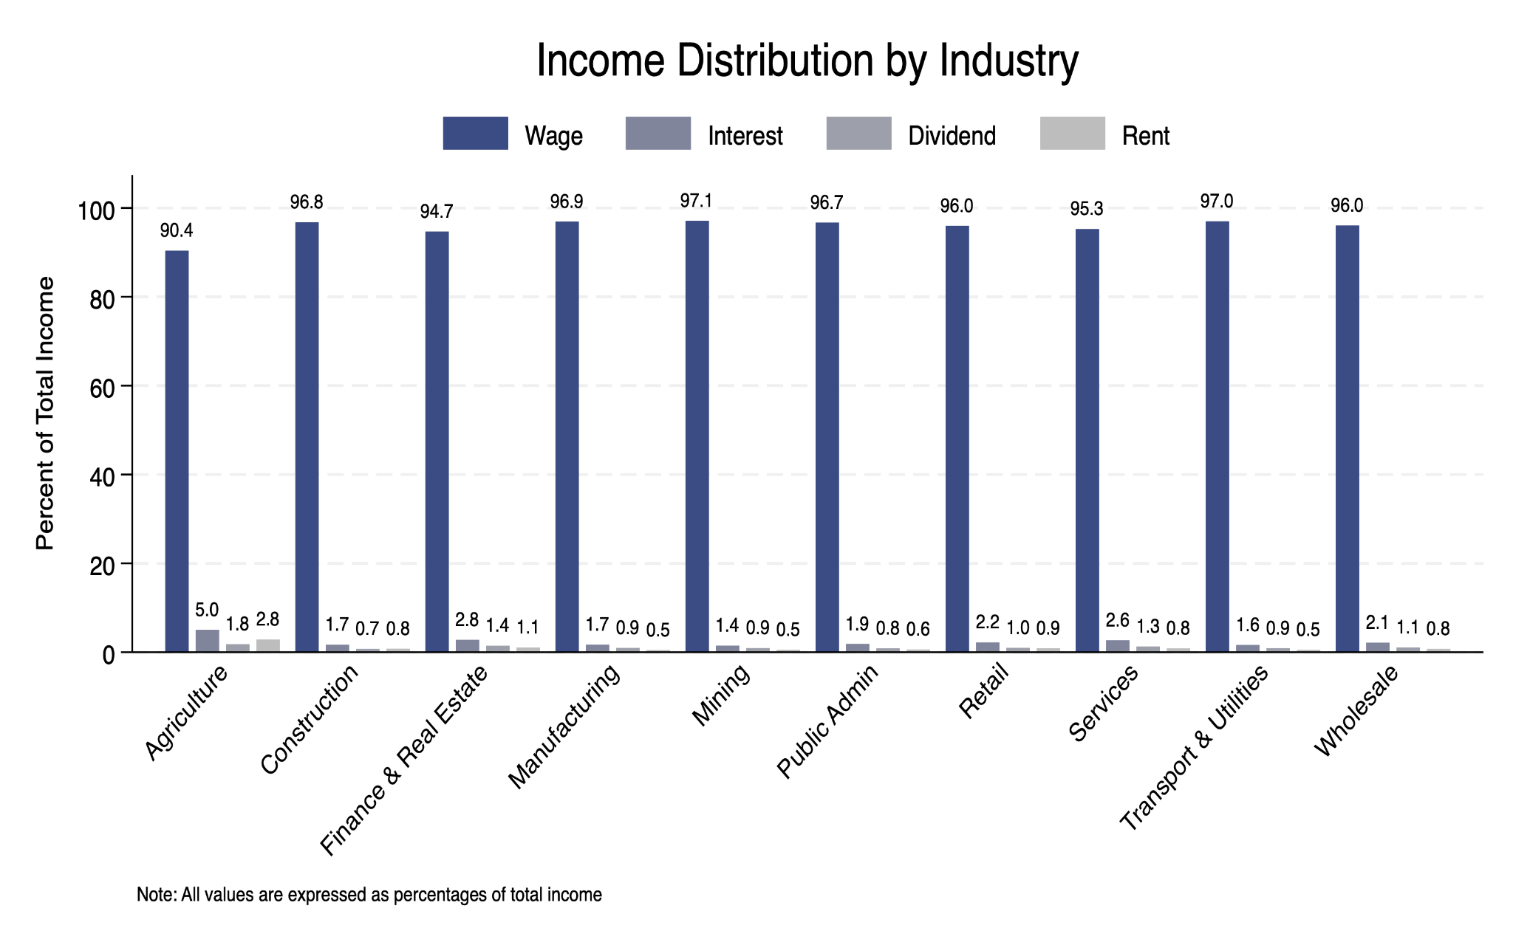

Analysis of the data reveals striking patterns in income composition across industries. Wages consistently dominate income structure across all sectors, accounting for 90-97% of total income, with Mining showing the highest wage share (97.1%) and Agriculture, forestry, and fishing showing the lowest (90.4%). The remaining components—interest, dividends, and rent—collectively constitute a relatively small portion of total income, typically ranging from 3-10% across industries. Among these non-wage components, interest income shows the highest contribution, particularly in Services (2.6%) and Finance, insurance, and real estate (2.8%), suggesting these sectors may offer more opportunities for interest-bearing investments or activities.

A particularly intriguing question emerges from this data: "Why do wage shares remain remarkably high across all industries despite the increasing financialization of the economy?" The data suggests that despite the growing importance of financial markets and investment opportunities, labor income remains the predominant source of earnings across all sectors. This pattern holds true even in sectors traditionally associated with financial activities, such as Finance, insurance, and real estate, where one might expect higher shares of non-wage income. This finding may reflect the continued importance of human capital and labor input in the modern economy, even in sectors that deal primarily with financial assets and transactions. The consistency of high wage shares across industries also suggests that opportunities for generating significant income from interest, dividends, or rent remain limited for most workers, regardless of their industry of employment. This has important implications for understanding income inequality and the relationship between labor and capital income in the contemporary economy.

The cross-industry comparison also reveals subtle but important variations in non-wage income components. Services and Finance sectors show relatively higher proportions of interest and dividend income compared to other industries, suggesting these sectors may offer more opportunities for their workers to participate in financial markets or receive compensation through financial instruments. In contrast, manufacturing and construction show lower shares of non-wage income, reflecting their more traditional employment and compensation structures.

* 1. **Income Levels and Volatility to Interest Rate**

Table 4 presents a comprehensive analysis of income composition and volatility across major industrial sectors in the United States, with monetary values adjusted to 2024 dollars. The table breaks down total income into its constituent components—wages, interest, dividends, and rent—while also providing information about income levels and their variability through the coefficient of variation measure. This analysis offers insights into both the structural differences in income composition and the relative stability of earnings across different industries.

**Table 4.** Industry Income Analysis

| **Industry Name** | **Real Wage Level** | **Real Total Income Level** | **Wage Share (%)** | **Interest Share (%)** | **Dividend Share (%)** | **Rent Share (%)** | **Coefficient of Variation** |
| --- | --- | --- | --- | --- | --- | --- | --- |
| Mining | 80721 | 83029 | 95.97 | 2.52 | 0.83 | 0.68 | 80 |
| Finance, insurance, and real estate | 72143 | 75997 | 100.57 | 15.55 | 1.84 | -17.97 | 126 |
| Public administration | 70753 | 73097 | 96.51 | 2.36 | 0.75 | 0.38 | 72 |
| Wholesale trade | 66119 | 68780 | 93.62 | 4.22 | 1.22 | 0.95 | 108 |
| Manufacturing | 66728 | 68779 | 95.19 | 3.32 | 0.90 | 0.58 | 91 |
| Transportation and public utilities | 64344 | 66379 | 96.11 | 2.69 | 0.75 | 0.45 | 98 |
| Services | 52010 | 54487 | 91.51 | 6.06 | 1.62 | 0.81 | 131 |
| Construction | 48983 | 50551 | 90.76 | 11.59 | 5.89 | -8.24 | 116 |
| Retail trade | 32814 | 34122 | 93.72 | 4.76 | 1.02 | 0.49 | 142 |
| Agriculture, forestry, and fishing | 23559 | 25921 | 72.47 | 20.01 | 3.18 | 4.35 | 169 |

Several notable patterns emerge from the data. First, there is substantial variation in income levels across industries, with mining showing the highest average total income ($83,029) while agriculture, forestry, and fishing report the lowest ($25,921). Wage income consistently represents the dominant share across most industries, typically accounting for 90-97% of total income, with the notable exception of agriculture, forestry, and fishing at 72.47%. Interestingly, the finance, insurance, and real estate sector, along with the construction industry, exhibit negative rent shares (-17.97% and -8.24% respectively), suggesting significant rental expenses or losses in these sectors. The agriculture sector shows the most diverse income composition, with substantial contributions from non-wage sources: 20.01% from interest income, 3.18% from dividends, and 4.35% from rental income.

The coefficient of variation reveals important insights about income stability across industries. Agriculture, forestry, and fishing shows the highest income volatility (169%), followed by retail trade (142%) and services (131%). In contrast, public administration demonstrates the lowest income volatility (72%), followed by mining (80%) and manufacturing (91%). This pattern suggests that industries more closely tied to government operations or essential commodities tend to have more stable income streams, while those more exposed to seasonal fluctuations or consumer discretionary spending experience greater income variability. The relatively high volatility in the finance sector (126%) reflects the inherent variability in financial market-related activities despite its high average income level.

* 1. **Industry-Specific Income Sensitivity to Monetary Policy Changes**

This table presents the estimated relationships between federal funds rates and industry-specific real incomes across ten major sectors in the United States from 1990 to 2008. For each industry, the analysis provides regression coefficients measuring the sensitivity of real income to changes in interest rates, along with corresponding statistical significance measures including standard errors, p-values, and significance levels.

**Table 5:** Industry Income Response to Federal Funds Rate Changes with 1-Month Lead

| **Industry Name** | **Coefficient** | **Standard Error** | **P-value** | **Significance**  **Level** |
| --- | --- | --- | --- | --- |
| Finance, insurance, and real estate | -1.39 | 0.42 | 0.005 | ** |
| Construction | -0.94 | 0.28 | 0.003 | ** |
| Manufacturing | -0.79 | 0.25 | 0.005 | ** |
| Transportation and public utilities | -0.65 | 0.21 | 0.007 | ** |
| Services | -0.59 | 0.23 | 0.021 | * |
| Wholesale trade | -0.49 | 0.19 | 0.019 | * |
| Agriculture, forestry, and fishing | -0.49 | 0.34 | 0.175 |  |
| Retail trade | -0.45 | 0.13 | 0.003 | ** |
| Public administration | -0.32 | 0.21 | 0.142 |  |
| Mining | -0.25 | 0.15 | 0.126 |  |

The results reveal substantial heterogeneity in how different industries' incomes respond to monetary policy changes. The Finance, insurance, and real estate sector demonstrates the strongest negative relationship, with a coefficient of -1.39 (p < 0.01), indicating that a one percentage point increase in the federal funds rate is associated with a $1,390 decrease in average real annual income per worker in this sector. This is followed by Wholesale trade (-0.94, p < 0.01) and Services (-0.79, p < 0.01), both showing significant negative responses. Notably, seven out of ten sectors exhibit statistically significant negative relationships between interest rates and income levels, suggesting widespread sensitivity to monetary policy across the economy. However, Construction, Mining, and Transportation sectors show weaker and statistically insignificant relationships with interest rates, indicating these sectors' incomes may be more influenced by other economic factors.

The substantial negative coefficient in the Finance sector reflects the industry's unique position in the monetary transmission mechanism. The sector's core business activities are directly tied to interest rates, affecting everything from transaction volumes to asset valuations, which in turn influence compensation structures. Financial sector workers typically receive significant portions of their income through performance-based compensation and bonuses, which are closely tied to market conditions and transaction volumes. Moreover, the sector's business model inherently leverages interest rate spreads, making revenue streams particularly sensitive to policy changes. This direct exposure to monetary policy fluctuations creates a natural amplification effect on worker incomes, explaining why financial sector employees experience more pronounced income adjustments compared to workers in other industries where the transmission of monetary policy operates through more indirect channels.

1. **Summary**

This comprehensive analysis of Federal Reserve policy and employment across different sectors of the U.S. economy reveals several significant patterns in the temporal and sectoral dimensions of monetary policy transmission. The relationship between federal funds rates and employment demonstrates its strongest positive correlation (0.411) at a one-month lag, gradually diminishing over time and turning negative after 20 months. This pattern exhibits significant asymmetry, with employment showing markedly different responses to rate hikes versus cuts, suggesting complex underlying transmission mechanisms.

The study uncovers substantial sectoral heterogeneity in employment responses to monetary policy. While Public Administration, Finance & Real Estate, and Services consistently maintain higher and more stable employment rates around 95-98%, sectors such as Construction and Mining exhibit greater volatility and sensitivity to economic cycles. Notably, recent tightening cycles show increasing sectoral convergence in employment rates, with most industries falling within a 92-98% range since 2015, suggesting structural changes in the economy's response to monetary policy.

Income sensitivity analysis reveals varying degrees of responsiveness across sectors, with the Finance sector showing the strongest negative response to rate changes (coefficient of -1.39). Seven out of ten sectors exhibit statistically significant negative relationships between interest rates and income levels, though traditional industries like Manufacturing and Construction display more complex response patterns, characterized by initial positive correlations followed by negative relationships.

These findings have important implications for monetary policy implementation. The substantial variation in policy transmission across economic sectors suggests the need for a more nuanced approach to monetary policy. Recent data indicates increased resilience of many sectors to monetary tightening, potentially providing the Federal Reserve greater flexibility in pursuing anti-inflationary policies without causing severe sector-specific employment dislocations. The post-2020 period has been particularly noteworthy, revealing unprecedented synchronization in sectoral recovery and suggesting diminished traditional sector vulnerabilities. Furthermore, income composition analysis shows the persistent dominance of wage income across all sectors, despite increasing financialization of the economy.

This research contributes significantly to our understanding of monetary policy transmission mechanisms and emphasizes the importance of considering sectoral differences in policy formulation. The findings suggest that effective monetary policy must account for these sectoral variations while recognizing the evolving nature of industry responses to policy changes in the modern economy.

1. **Reference**

Blinder, A. S. (2023). *Landings, soft and hard: The Federal Reserve, 1965–2022*. *Journal of Economic Perspectives*, 37(1), 101–120. https://doi.org/10.1257/jep.37.1.101

Council of Economic Advisers. (2024, January 23). *The labor market recovery has been strong across the country*. The White House.https://www.whitehouse.gov/cea/written-materials/2024/01/23/the-labor-market-recovery-has-been-strong-across-the-country/