install.packages("forecast")
install.packages("ggplot2") # Required for checkresiduals()
library(forecast)
library(tseries)
library(ggplot2)

Dataset <- read.csv("Datasett.csv")
# Convert columns to time series (Monthly Data: frequency = 12)
CPIHome_ts <- ts(Dataset$CPI_Home, frequency=12, start=c(2015,1))
CPIForeign_ts <- ts(Dataset$CPI_Foreign, frequency=12, start=c(2015,1))
RealExchangeRate_ts <- ts(Dataset$Real_Exchange_Rate, frequency=12, start=c(2015,1))
Nominalexchange_ts <- ts(Dataset$Nominal_Exchange_Rate, frequency=12, start=c(2015,1))

# Summarize raw data (before log transformation)
cat("Summary Before Log Transformation:\n")
summary(Dataset[, c("CPI_Home", "CPI_Foreign", "Real_Exchange_Rate", "Nominal_Exchange_Rate")])

# Log transformation
Nominalexchange_logts <- log(Nominalexchange_ts)
CPIForeign_logts <- log(CPIForeign_ts)
RealExchangeRate_logts <- log(RealExchangeRate_ts)
CPIHome_logts <- log(CPIHome_ts)

# Summarize data after log transformation
cat("\nSummary After Log Transformation:\n")
summary(data.frame(CPIHome_logts, CPIForeign_logts, RealExchangeRate_logts, Nominalexchange_logts))

# Plot log-transformed time series before differencing
par(mfrow=c(2,2))
plot.ts(Nominalexchange_logts, main="Log Nominal Exchange Rate (Before Differencing)")
plot.ts(RealExchangeRate_logts, main="Log Real Exchange Rate (Before Differencing)")
plot.ts(CPIHome_logts, main="Log CPI Home (Before Differencing)")
plot.ts(CPIForeign_logts, main="Log CPI Foreign (Before Differencing)")
par(mfrow=c(1,1)) # Reset layout

# ADF test before differencing (for all 4 variables)
cat("\nADF Test Before Differencing:\n")
cat("\nADF Test: Log CPI Home\n")
adf_CPIHome_before <- adf.test(CPIHome_logts)
print(adf_CPIHome_before)
cat("\nADF Test: Log CPI Foreign\n")
adf_CPIForeign_before <- adf.test(CPIForeign_logts)
print(adf_CPIForeign_before)
cat("\nADF Test: Log Real Exchange Rate\n")
adf_RealEXR_before <- adf.test(RealExchangeRate_logts)
print(adf_RealEXR_before)
cat("\nADF Test: Log Nominal Exchange Rate\n")
adf_NominalEXR_before <- adf.test(Nominalexchange_logts)
print(adf_NominalEXR_before)

# First-order differencing (Monthly Data)
CPIHome_d1logts <- diff(CPIHome_logts, differences=1)
CPIForeign_d1logts <- diff(CPIForeign_logts, differences=1)
RealEXR_d1logts <- diff(RealExchangeRate_logts, differences=1)
NominalEXR_d1logts <- diff(Nominalexchange_logts, differences=1)

# Plot differenced series
par(mfrow=c(2,2))
plot.ts(CPIHome_d1logts, main="Log CPI Home after Differencing")
plot.ts(CPIForeign_d1logts, main="Log CPI Foreign after Differencing")
plot.ts(RealEXR_d1logts, main="Log Real Exchange Rate after Differencing")
plot.ts(NominalEXR_d1logts, main="Log Nominal Exchange Rate after Differencing")
par(mfrow=c(1,1)) # Reset layout

# ADF test after differencing (for all 4 variables)
cat("\nADF Test After Differencing:\n")
cat("\nADF Test: Log CPI Home (Differenced)\n")
adf_CPIHome_after <- adf.test(CPIHome_d1logts)
print(adf_CPIHome_after)
cat("\nADF Test: Log CPI Foreign (Differenced)\n")
adf_CPIForeign_after <- adf.test(CPIForeign_d1logts)
print(adf_CPIForeign_after)
cat("\nADF Test: Log Real Exchange Rate (Differenced)\n")
adf_RealEXR_after <- adf.test(RealEXR_d1logts)
print(adf_RealEXR_after)
cat("\nADF Test: Log Nominal Exchange Rate (Differenced)\n")
adf_NominalEXR_after <- adf.test(NominalEXR_d1logts)
print(adf_NominalEXR_after)

# Cointegration Test for Absolute PPP
cat("\nAbsolute PPP: Unit Root Test on Log Real Exchange Rate\n")
# ADF test for log real exchange rate
adf_RealEXR <- adf.test(RealExchangeRate_logts, alternative="stationary")
print(adf_RealEXR)

# Cointegration Test for Relative PPP
cat("\nRelative PPP: Unit Root Test on Log CPI Ratio\n")

# Construct log CPI Ratio (RATIO APPROACH)
CPI_Ratio_logts <- CPIHome_logts - CPIForeign_logts
# ADF test for log CPI ratio
adf_CPI_Ratio <- adf.test(CPI_Ratio_logts, alternative="stationary")
print(adf_CPI_Ratio)

# OLS Regression for Relative PPP
PPP_model <- lm(Nominalexchange_logts ~ CPI_Ratio_logts)
summary(PPP_model)

# Extract residuals
PPP_residuals <- residuals(PPP_model)

# ADF test for residuals
cat("\nADF Test for OLS Residuals \n")
adf_Residuals_1 <- adf.test(PPP_residuals, alternative="stationary")
print(adf_Residuals_1)

# OLS regression (log_s on log_p and log_pstar) INSTEAD OF USING RATIO APPROACH, WE SEPERATE PARAMETER B1,B2
cat("\nOLS Regression Model\n")
ols_model <- lm( Nominalexchange_logts~ CPIForeign_logts + CPIHome_logts)
# Print regression results
cat("\nRegression Results:\n")
# Extract residuals from OLS regression
ols_residuals <- resid(ols_model)
# Print first few residuals to check
cat("\nFirst few residuals:\n")
# ADF Test on Residuals
cat("\nADF Test on Residuals
adf_residuals_2 <- adf.test(ols_residuals)
print(adf_residuals_2)

#PACF AND ACF PLOT

par(mfrow = c(1, 2)) # 1 row, 2 columns
acf(RealEXR_d1logts, lag.max = 20, main = "ACF of RealEXR_d1logts")
pacf(RealEXR_d1logts, lag.max = 20, main = "PACF of RealEXR_d1logts")
par(mfrow = c(1, 1)) # Reset layout

# Fit the six ARIMA models on log-transformed Real Exchange Rate
# Fit the six ARIMA models on log-transformed Real Exchange Rate
fix_1 <- Arima(RealEXR_d1logts, order=c(1,0,0)) # ARIMA(1,1,0)
fix_2 <- Arima(RealEXR_d1logts, order=c(2,0,0)) # ARIMA(2,1,0)
fix_3 <- Arima(RealEXR_d1logts, order=c(0,0,1)) # ARIMA(0,1,1)
fix_4 <- Arima(RealEXR_d1logts, order=c(0,0,2)) # ARIMA(0,1,2)
fix_5 <- Arima(RealEXR_d1logts, order=c(1,0,1)) # ARIMA(1,1,1)
fix_6 <- Arima(RealEXR_d1logts, order=c(2,0,1)) # ARIMA(2,1,1)

fix_1
fix_2
fix_3
fix_4
fix_5
fix_6

tsdiag(fix_1)
tsdiag(fix_2)
tsdiag(fix_3)
tsdiag(fix_4)
tsdiag(fix_5)
tsdiag(fix_6)

# Store all models in a list
models <- list(
`ARIMA(1,0,0)` = fix_1,
`ARIMA(2,0,0)` = fix_2,
`ARIMA(0,0,1)` = fix_3,
`ARIMA(0,0,2)` = fix_4,
`ARIMA(1,0,1)` = fix_5,
`ARIMA(2,0,1)` = fix_6
)

# Function to extract diagnostics from each model
diagnostics <- lapply(models, function(model) {

# Coefficients
coefs <- coef(model)
coefs_se <- sqrt(diag(vcov(model))) # Standard Errors
t_values <- coefs / coefs_se # t-values

# Ljung-Box test for residuals at lags 4, 8, 12
Q4 <- Box.test(residuals(model), lag = 4, type = "Ljung-Box")
Q8 <- Box.test(residuals(model), lag = 8, type = "Ljung-Box")
Q12 <- Box.test(residuals(model), lag = 12, type = "Ljung-Box")

return(list(
coefficients = coefs,
t_values = t_values,
Q4_stat = Q4$statistic, Q4_p_value = Q4$p.value,
Q8_stat = Q8$statistic, Q8_p_value = Q8$p.value,
Q12_stat = Q12$statistic, Q12_p_value = Q12$p.value
))
})

# Print the results
for (i in 1:length(diagnostics)) {
cat("\nModel:", names(diagnostics)[i], "\n")

# Coefficients and t-values
cat("Coefficients:\n")
print(diagnostics[[i]]$coefficients)

cat("t-values:\n")
print(diagnostics[[i]]$t_values)

# Ljung-Box Q-test results at lags 4, 8, and 12
cat("\nLjung-Box Q-test Results:\n")
cat("Lag 4: Q-statistic =", diagnostics[[i]]$Q4_stat, ", p-value =", diagnostics[[i]]$Q4_p_value, "\n")
cat("Lag 8: Q-statistic =", diagnostics[[i]]$Q8_stat, ", p-value =", diagnostics[[i]]$Q8_p_value, "\n")
cat("Lag 12: Q-statistic =", diagnostics[[i]]$Q12_stat, ", p-value =", diagnostics[[i]]$Q12_p_value, "\n")

cat("\n----------------------------\n")
}

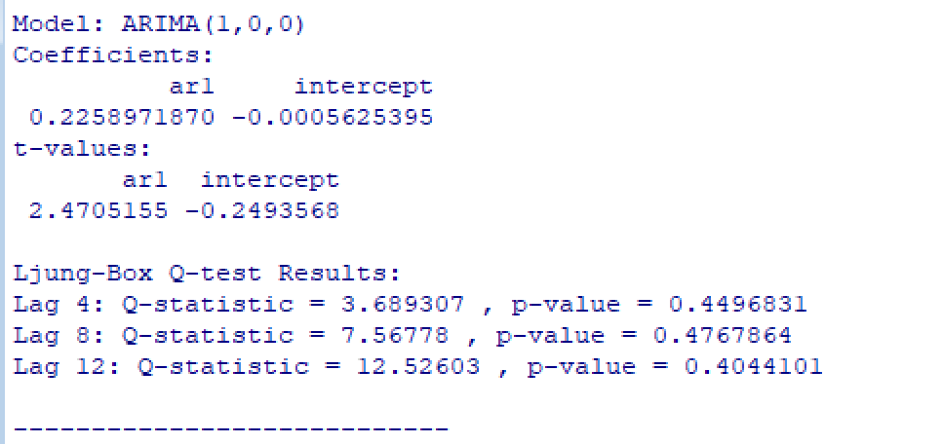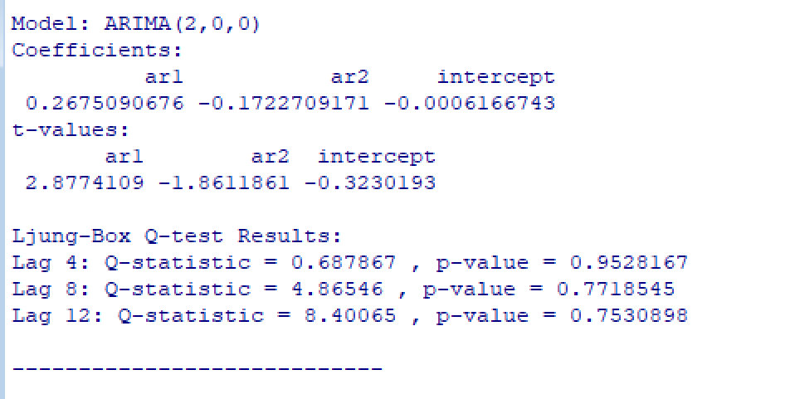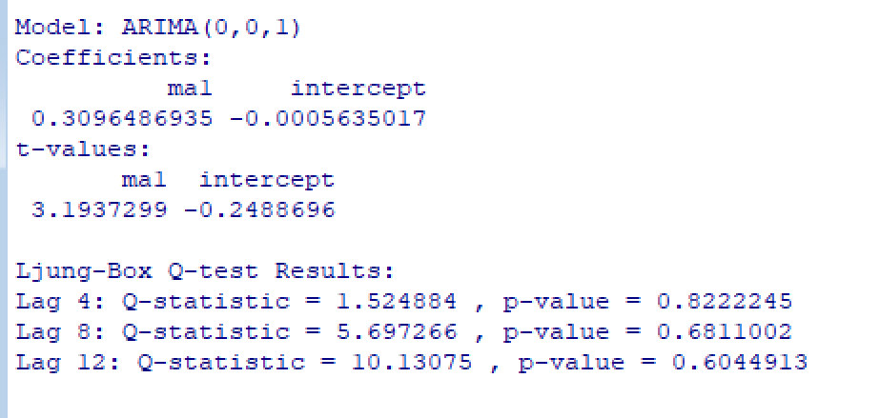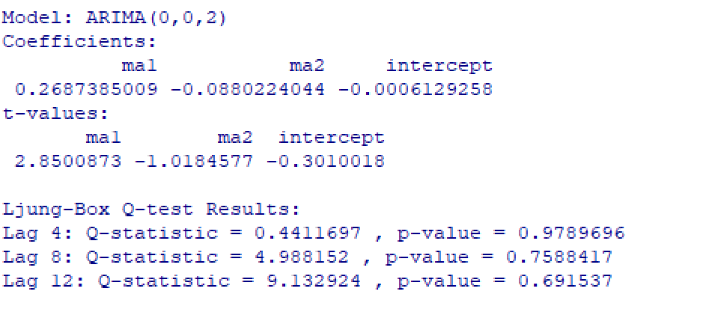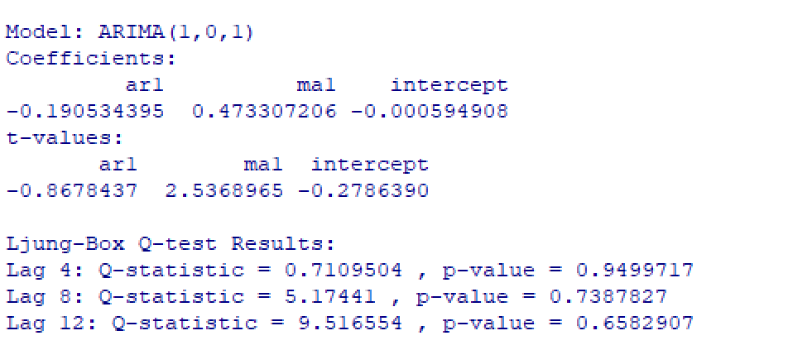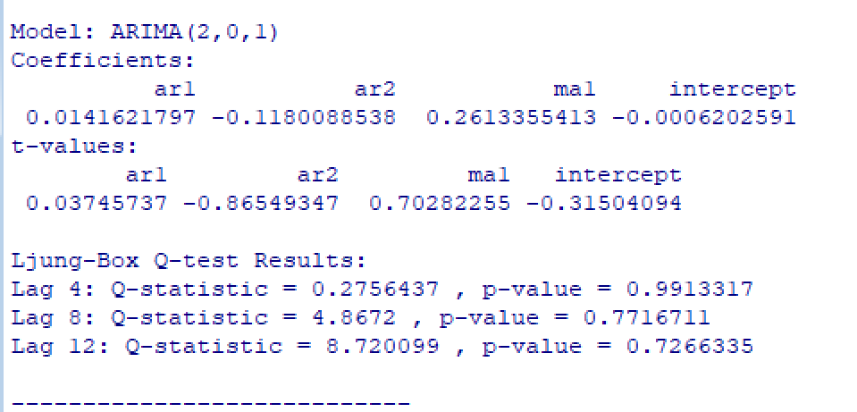

library(forecast)
# Forecast 12 periods ahead (can change to any number)
forecast_horizon <- 12

# Generate forecast
forecast_result <- forecast(model_3, h = forecast_horizon)

# Print forecast values
print(forecast_result)

# Plot the forecast with confidence intervals
plot(forecast_result, main = "Forecast using ARIMA(0,1,1)")

fix_11 <- Arima(RealExchangeRate_logts, order=c(1,1,0)) # ARIMA(1,1,0)
fix_22 <- Arima(RealExchangeRate_logts, order=c(2,1,0)) # ARIMA(2,1,0)
fix_33 <- Arima(RealExchangeRate_logts, order=c(0,1,1)) # ARIMA(0,1,1)
fix_44 <- Arima(RealExchangeRate_logts, order=c(0,1,2)) # ARIMA(0,1,2)
fix_55 <- Arima(RealExchangeRate_logts, order=c(1,1,1)) # ARIMA(1,1,1)
fix_66 <- Arima(RealExchangeRate_logts, order=c(2,1,1)) # ARIMA(2,1,1)

fix_11
fix_22
fix_33
fix_44
fix_55
fix_66

