Free Factory

Documentation

by

Jim Hines and Karl Swisher

Table of Contents
Introduction 4
Setting Up Free Factory 4
Company Name 4
Apple Delay 4
Notify Directories 4
Directory Path 4
Directory Dialog Button 5
User Name 5
New Button 6
Save Button 6
Update Button 6
Delete Button 6
Rewrite Startup 6
Running Processes 6
Setting Up Factories 6
New Button 7
Save Button 7
Delete Button 7
Exit Button 7
Edit Settings Button 7
Save Settings Button 7
Help Button 8
About Button 8
License Button 8
Read Only Button 8
Factory List Box 8
Factory File Name 8
Factory Description 8
Notify Directory 8
Output Directory 8
Output File Suffix 8
FTP Options 8
URL 8
User Name 8
Password 8
FTP Program 8
Transfer Type 8
Delete After 8
Video and Audio Options 9
Other Free Factory Options 9
Enable Factory 9
Delete Source 9
Delete Logs 9
Settings 9
Display 9
Date/Time 9
Misc 11
PDF Reader Path 11
Select All Text 11
Confirm File Saves 11
Confirm File Deletions 11
Show Tool Tips 11
Bottom Buttons 11

Introduction

Free Factory is a group of TCL and BASH scripts to perform on a professional broadcast level to convert video files. The goal of this project is to make a contribution toward being able to run a TV station with open source software under Linux. This is not a GUI front end to manually convert video files. There are much better programs out there to do this. The GUI provided is for administering Free Factory. What Free Factory does is to allow multiple users on different computers to copy video files to a shared networked directory or directories monitored by Free Factory. Free Factory then calls ffmpeg or ffmbc to convert the video file according to the options you give it through the preset factories to the output directory specified in the factory. After a successful conversion the source file can be set to be automatically deleted so your notify directories will not fill up your storage media Free Factory uses the command inotifywait in the recursive mode to monitor directories you select.

The Free Factory run time can be run two different ways. One is by root calling another user the the other is by running under a user. There are two different start up scripts one to be run by root and the other by any user. They are InotifyStartupRoot.sh and InotifyStartupUser.sh. InotifyStartupRoot.sh can be run by root either from a shell or included in rc.local to automatically start on boot. The command path is /opt/FreeFactory/bin/InotifyStartupRoot.sh. Starting Free Factory run time by any user is done by typing in /opt/FreeFactory/bin/InotifyStartupUser.sh or by starting from the administration GUI. The administration GUI can be accessed either by typing in /opt/FreeFactory/bin/FreeFactory.tcl from a shell or clicking on the desktop icon provided.

Setting Up Free Factory
Here is the quickest way to be up and running in Free Factory. The Free Factory settings tab is what needs set first. The other tabs are defaulted to what will work and can be modified later if you wish. Click on the edit settings icon located on the main Free Factory window. This is what you will see after clicking on the Free Factory tab of the edit settings window. The following will take you through this process.

Company Name
First type replace “Company Name” with your company name.

Apple Delay
Then decide the Apple delay if you have Apple computers copying video to your notified directories. Apple continuously opens and closes the file it writes to multiple times during the copy. This causes false positives triggered by inotifywait. The delay is there to delay the conversion script from starting before the Apple machine has finished copying the file. The copy must be finished before a successful conversion can take place.

Notify Directories
The two shown here are the default. You can use these, edit them, add new ones and delete these. These are the directories a inotifywait monitors and a factory uses to do the conversions.

Directory Path
This entry widget allows you to type and and edit a directory path. It also receive the selected output from the directory dialog window produced from the open button next to this widget

Directory Dialog Button
This button opens up a directory dialog window that allows you to browse for a directory.

User Name
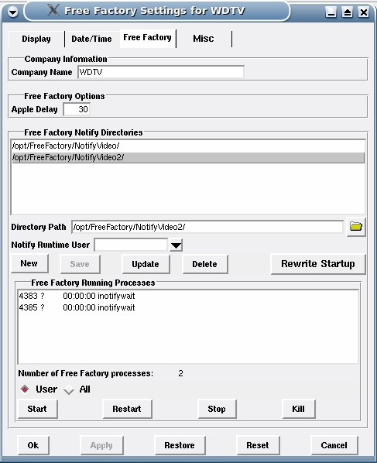
Next is the user name. Each notify directory can has a user name associated with it. The ones that do will be placed in the InotifyStartupRoot.sh file when the Rewrite Startup button is pressed. You only put a user name in here is when you want to start Free Factory run time by root in rc.local or from a shell. The called program inotifywait will run under the user name in the script and not root.

New Button
Erases the contents on the Directory Path entry widget and places the cursor inside this widget. Also activates the Save button and deactivates the Update button.

Save Button
Saves a new path in Directory Path to the FreeFactoryNotifyDirectoryList file. This only saves the notify directory paths and a user if selected. This DOES NOT save any of the other settings. All other settings must be saved using the Save Settings button on the main GUI window.

Update Button
Updates an existing Directory Path to the FreeFactoryNotifyDirectoryList file.

Delete Button
Deletes the path in Directory Path from the FreeFactoryNotifyDirectoryList file.

Rewrite Startup
This buton rewrites the start up files of InotifyStartupRoot.sh and InotifyStartupUser.sh. After this the run time processes can be started or restarted to reflect the changes made to the notify directories.

Running Processes
This section lets you monitor Free Factory run time processes. Processes can be viewed by either the user under which the GUI is running or all users plus gives you a total of processes running. You can also start, restart, stop all and kill a selected process.

Setting Up Factories
Setting up a factory is the next step in getting Free Factory up and running. Factories are what match the notify directories with the desired A/V options in the conversion program along with the output directory. Since inotifywait is run recursively. Any directories created within the path chain will trigger a response to convert. As an example you can can have /video/dropbox as your notification directory in startup. Addition directories can be created within /video/dropbox for different conversion needs. Directory paths in the factories can be like /video/dropbox/AVI, /video/dropbox/MPG or /video/dropbox/MP4 or what ever naming convention you want to use. Each factory will have a unique notify directory that is one of the notify master directories or a sub directory of them. Depending on what notify directory it is, certain conversion options will be applied to the output file.

Below describes the function of the main Free Factory administration window. This is where factories are built. The conversion programs ffmpeg and ffmbc provide many more audio and video options than are currently supported here. More will be added in the future.
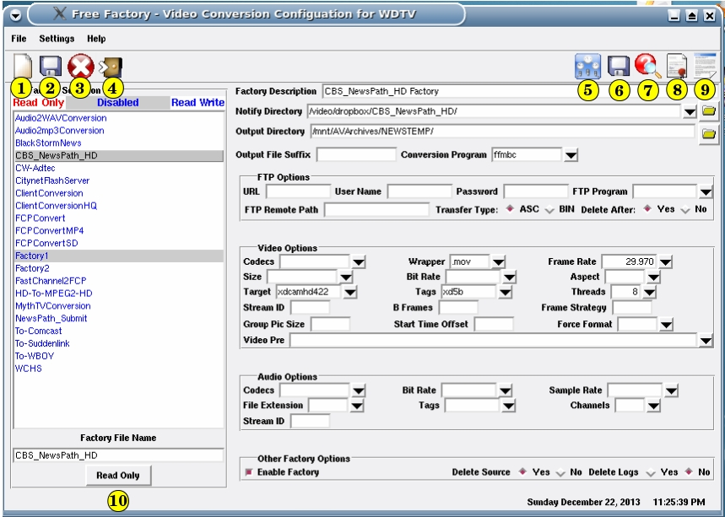
1. New Button. - Clears the GUI fields and makes ready for a new factory.

2. Save Button – Saves a new or edited factory.

3. Delete Button – Deletes a factory.

4. Exit Button – Closes and exits the Free Factory GUI.

5. Edit Settings Button – Allows you to edit settings. Change fonts, colors and the feel of how the GUI operates. Most importantly this is where you initially set up the notify directories for Free Factory.

6. Save Settings Button – This saves the settings. Edited settings are not automatically saved. You must do this. It is an extra safe guard against you screwing the GUI up. You can change the fonts and colors in such a manner that you are unable to navigate the GUI. If this happens and you are unable to click on the Restore or Reset buttons you can exit the program and start over.

7. Help Button – Displays this very document you are reading.

8. About Button – Displays the about window.

9. License Button – Displays the license.

10. Read Only Button – This will make the selected factory file a read only file. After a file is made read only it can no longer be saved to. This prevents accidental rewriting of a factory. The a read only factory can be saved with a different file name. You still can delete a read only factory.

Factory List Box - Displays all the factory files that can be edited or deleted. Any file item with a gray background is disabled. If file name is in red it means the file is read only. If the file name is in blue it is read writable. Read only files cannot be save over but they can be deleted.

Factory File Name - Either displays the factory file name you clicked on in the list box or when you type in the name of a new factory to add. You can take existing factories and rename the file name to a different one and save as a new one.

Factory Description - You can add a description of what the factory does.

Notify Directory - This field contains the directory path the conversion script compares to the directory path sent by inotifywait. If they match the FFMx (ffmpeg or ffmbc) program is called to convert the file based on the A/V options to the output directory. This is a combo box pre-filled with the directory paths set up in the Free Factory settings window. Form there you can us the directory dialog button to the right to browse for sub-directories if needed.

Output Directory - This is the directory path where the converted output file will be converted to.

Output File Suffix - Allows you to append what text is entered here to the output file name before the extension is added.

FTP Options - If there is something in the URL field and something in the FTP Program field then after the file is converted it can be sent automatically by ftp.

URL – The IP address you want to FTP to.

User Name – User name if needed.

Password - Password if needed.

FTP Program – The ftp program used.

Transfer Type - Sets the transfer type to ASCII or Binary.

Delete After - If set to Yes will also delete the output destination file after FTP is completed. Is ignored if no FTP is set to be attempted.

Video and Audio Options
This should be straight forward. Set the options you want the output file converted to in the factory. This documentation does not attempt to address video and audio knowledge. It is up to the user to know how to apply the options.

Other Free Factory Options

Enable Factory - When checked enables the factory to be included in the conversion selection process. If unchecked the factory will be excluded from the conversion selection process.

Delete Source – If Yes is selected then the source file after

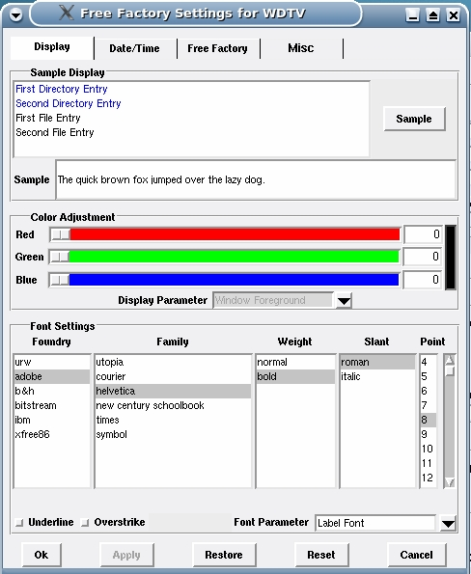
Delete Logs – Logs are stored in the /var/log/FreeFactory/ directory. There up to three logs generated by the scripts on each file converted. This will accumulate many log files and take up disk space. This is a determination made for each factory. If everything is working properly then you don't want to spend time looking at what is working. You want to know what does not work. There is one log generated from the FreeFactoryNotify.sh script. It should have very little to zero ever written to it. The other three logs are generated by FreeFactoryConversion.tcl script and the FFMx program. Here is the format for the log file names.

FreeFactoryFFMxLog-FILENAME.log - Generated by FFMx
FreeFactoryConversion-FILENAME.log – Generated by FreeFactoryConversion.tcl
FreeFactoryFTP-FILENAME .log – Generated by FreeFactoryConversion.tcl

Where FILENAME is the name of the output file.

By default the Delete Logs is set to “No” to keep the logs. After you look at a few and everything works you can change this to “Yes” on each factory. If the factory does not FTP then there will not be a FTP log file created.

Settings

Display – The top part is a sample of the result when changing colors. You first pick the parameter you want to change from the Display Parameter combo box. The fonts also update the samples.
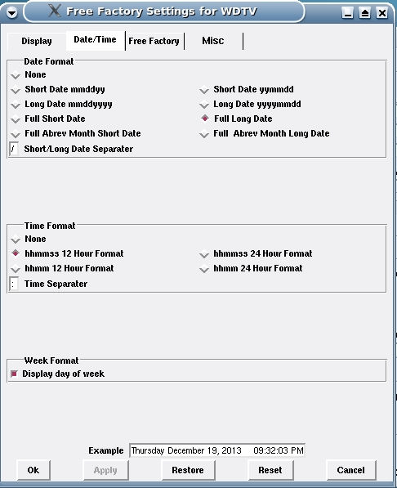

Date/Time - This allows you to pick the date and time format displayed at the bottom right of the main Free Factory window. The example at the bottom will show your changes before they are applied.

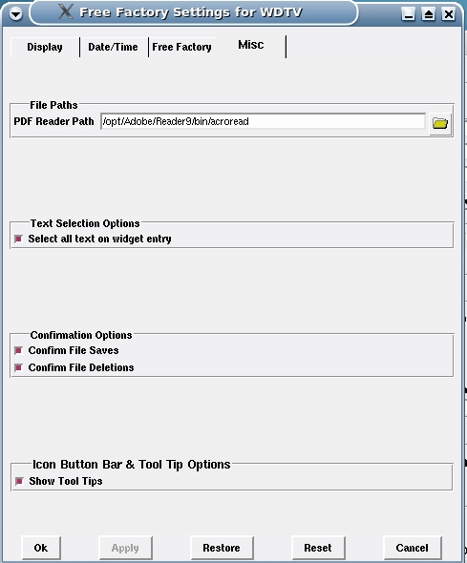
Misc

PDF Reader Path – The path to your PDF reader. Acrobat is shown here but it can be any PDF reader.

Select All Text - When you enter a text widget this gives you the option of having all the text selected or not.

Confirm File Saves - If checked will bring up an additional confirmations dialog requiring manual confirmation before a save of a file takes place.

Confirm File Deletions - If checked will bring up an additional confirmations dialog requiring manual confirmation before the deletion of a file takes place.

Show Tool Tips - This turns on and off the display of tool tips over the buttons.
Bottom Buttons

The bottom buttons function as labeled. The Ok and Cancel buttons function the same if nothing is changed. They exit the Settings window. If changes have been make Ok copies the changes to the system preferences. Cancel exits the Settings window without copying those changes.. The Apply button copies the changes to the system preferences but does not exit the Settings window. The Restore button restores any changes you make to the preferences back to the way they were before you made the changes. The Reset button sets the preferences to the programmers preferences when the program was first installed.

Hot Key Shortcuts

On the main factory GUI there are certain key strokes that will initiate a button press. The are:

Ctr-n or Ctrl-N = New Factory
Ctrl-s or Ctrl-S = Save Factory
Ctrl-d or Ctrl-D = Delete Factory
Ctrl-h or Ctrl-H = Help
Escape = Exit

Users & Permissions

Free Factory is a very flexible program. The simplest use of it is under a single user. You can have the notification of different directories run by different users. Care must be take with permissions so that everyone that is suppose to have write access does to a given directory and those that are not suppose to don't. One solution might be through group membership. Create a group and assign everyone to that group that needs to write to the notify directories. All users running Free Factory in run time would need to belong to the same group. As well as have write permission on the output directories. In addition write permissions are needed to the /var/log/FreeFactory log directory.

