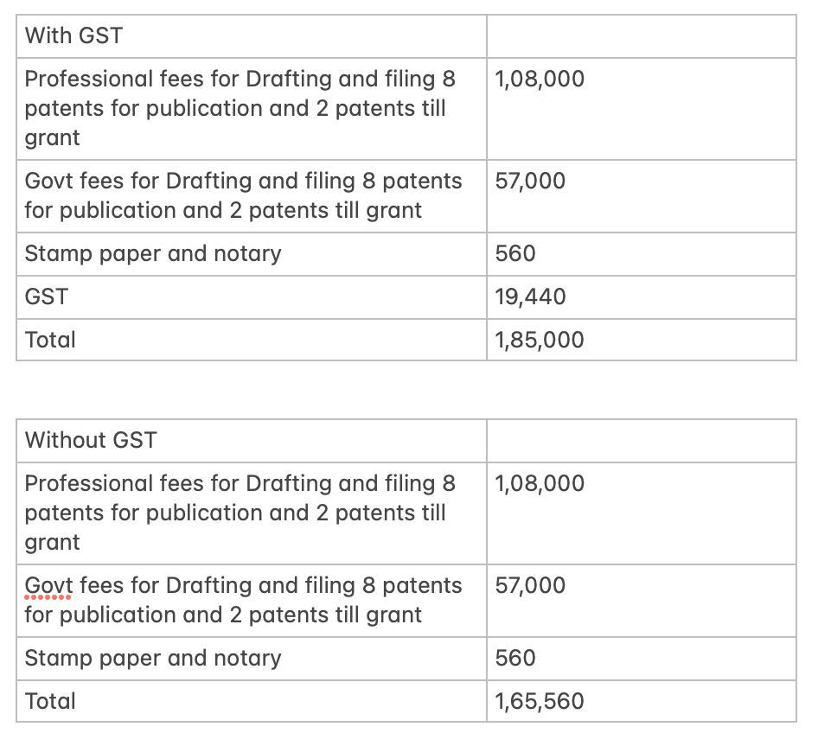

Yours sincerely,

Adv. Pranav Bhat
Lextria Research

