Arduino Nano-Based GPS Tracker

A Capstone Project Presented
To Mr. James Enopia In Partial Fulfillment of the Requirements for
B.S Computer Engineering course

By

Belisario, Lexus
Batang, Ernesto
Cabab, Dave
Durana, Jeric
Andres, Cris John

December 2022
Mr. James Enopia

Certificate of Originality
This is to certify, that the study entitled “Arduino Nano Based GPS Tracker ” which is submitted by the researchers is an outcome of their original work. This is to also certify that the researchers have duly acknowledged all the sources from which the ideas and extracts have been taken.

Lexus Belisario
Researcher

Dave Cabab
Researcher

Ernesto Batang
Researcher

Jeric Durana
Researcher

Cris John Andres
Researcher

Attested by:
Mr. James Enopia
Research Adviser
December 15, 2022

Acknowledgments

Preparing a research paper on any sector or subject is challenging work for anyone. The researchers accept it as a challenge, and opportunity and also became successful to present this research paper with our full endeavor. This capstone project has been duly prepared and submitted to meet the partial fulfillment of the Inquiries, Investigations & Immersion subjects. The researchers are so pleased and proud for being integral to this project.
The researchers would like to thank Mr. James Enopia, the instructor of Cognate/Elective Course 1 subject for his constant encouragement, patient guidance, and valuable supervision at every stage of our work. This research project would not have materialized in the present form without her incisive observation and intellectual direction in the course of completion.
The researchers extend their sincere thanks to the respondents who participated in the said survey and those who gave us some suggestions regarding our research paper.

Abstract

The Arduino Nano-Based GPS Tracker was proposed to provide real-time location tracking of an individual and objects, improve security and ease the mind of the parties involved. This Study is concerned with the ongoing issue of kidnapping and missing individual cases, The researchers are eager to lessen the said cases and help our community to become safer for everyone. The device has different features that can be used to track down both humans and objects which would be helpful to prevent these said incidents.

Table Of Contents

PRELIMINARIES………………………………………………………………………i
Title Page………………………………………………………………………………i
Certificate of Originality……………………………………………………………….ii

Acknowledgements…………………………………………………………………….iii
Abstract………………………………………………………………………………...iv

CHAPTER I……………………………………………………………………………….I
The Problem and Its Background……………………………………………………..I
Introduction……………………………………………………………………………...1
Background of the Study………………………………………………………………...1
Statement of the Problem………………………………………………………………..3
The objective of the Study………………………………………………………………5
System Design Paradigm………………………………………………………………...6
Scope and Delimitation………………………………………………………………….6
The Significance of the Study……………………………………………………………7
Definition of Terms…………………………………………………………………….... 8

CHAPTER II 9
Review of Related Literature and Studies 9
Related Literature 9
CHAPTER III 13
Project Methodology 13
Agile SDLC Model 13
IPO Model 14
Context Diagram 15
System Flowchart 16
Project Locale 17
Project Participants 17
Project Instruments 17

CHAPTER I

The Problem and Its Background
Introduction
One of the most concerning issues nowadays here in our country is “Security’, lately, there are concerning numbers of missing individuals that reach the headlines of the newspapers and media, according to Statista, there are 27 cases of kidnapping cases this year, compared to 38 of 2021, 33 for 2020 and 85 in 2019. The PNP also quoted “There are 27 kidnapping cases this year versus the 38 incidents we recorded in 2021. Eleven of those have been solved. Four have been cleared, which means we filed cases but have yet to catch the suspect. And the remaining 12 remain under investigation”. These numbers are still alarming since the face-to-face classes in different schools are back, “Recent disturbing events create a state of fear and uneasiness among the Filipino-Chinese community. This is because of the recent rampant kidnapping cases both in Metro Manila and some parts of Luzon,” said the statement read by PCCCII secretary general Bengsum Ko during a press conference with House Minority Leader Marcelino Libanan and PNP officer in charge and deputy chief for administration Lt. Gen. Jose Chiquito Malayo.

Missing persons are therefore a major concern, not only for the police but for society in general. It is scarcely surprising, therefore, that more and more citizen initiatives are emerging to help find missing people. “In Sweden, for example, Missing People in Sweden was set up in response to a case in 2010” (Uhnoo & Hansen Löfstrand, 2018. Even though we want to keep a close eye on our children and never let a moment pass without watching them, parenting is a demanding stage of life, and there are many other things we need to take care of. Nowadays, citizen initiatives are typically facilitated and supported by a technological component. There will always be a point when we must turn our attention away from them to complete a task or leave for work. Numerous things could occur in these minutes. Children walk off when they are young and are unaware of the dangers that await them outside. Many individuals are evil enough to exploit others' naivety. ). “Parenthood comes with greater responsibilities than we can only handle, so it is only to be expected that every day, we wake up to a different set of things to worry about. This somehow always leaves us preoccupied. Having a GPS tracker and having access to your kid’s real-time location gives you peace of mind. The fact that a device is giving you a way to know your kid’s whereabouts even when you’re not physically with them is a breath of fresh air at times when the demands of parenthood become too much”. (James Harold, 2018).

In the world today, a technical component typically supports and facilitates citizen activities such as locating a missing or lost person, so using a GPS tracker might help reduce these cases.

Background of the Study
A GPS Tracker is the surveillance of location through a Global positioning system (also known as GPS) to track the location of the specific person you want to track. As our goals for this program suggest, the GPS tracker can be used to track down people for their safety. Here in the Philippines, many cases of missing people are reported almost every night every month. It is estimated that 35,000 people are reported as missing every year in the Philippines. This equates to one person disappearing every 15 minutes or a rate of 1.7 people per 1,000 Filipinos.

Statement of the Problem

General problem
In our country, Kidnapping has a harsher reality than we all realize. There is much more to the problem than what we are just taught to understand. The researchers are aiming to reduce and if possible, avoid these kinds of cases, especially among young people.

Specific problem
- The Philippines is lacking security devices and monitoring such as CCTV Cameras.
- Philippines is one of the most corrupt countries and the investigation and judicial process are slow.
- Philippines has a high crime rate.

The objective of the Study
The research aims to create and develop Arduino Nano-Based GPS Tracker with Mobile Application for all people, especially younger ones. The proposed system will track the progress of a project or specific individual. More effectively, it provides real-time location information for a person or target object. An old problem that can be solved by modern solutions.

Specific Objectives:
The specific objectives of the proponents are the following:
- To develop a system that will enable parents/guardians to monitor the current status of the targets.
- Secure the target’s whereabouts and confidential information related to it.
- Develop a simple user-friendly application system.
- Give access to make calls to the nearest emergency hotlines near the targets.

Scope and Delimitation
The research Arduino Nano-Based GPS Tracker focused on widespread utilization and cost-effective method to provide comfortable and worry-free conditions tracking their targets’ whereabouts. Arduino Nano-Based GPS Tracker with Mobile Application prioritizes a user’s security. This GPS can detect a person's location within the NCR area and automatically send a mobile text to the nearby Police station if the user became inactive over a long period. It needs cellular data or a Wi-Fi connection to operate. If a user is beyond the NCR area, the GPS will be out of coverage.

Significance of the Study

This study is conducted to benefit of the following:

Students. This study may serve as a guide or reference for students undertaking similar studies.

Parents/Guardians. This study will help them to monitor their children’s whereabouts and eliminates the condition of worriedness.

Targets. This study will help them feel safe as their parents/guardians know where they are at every moment.

To Future Researchers. The concepts offered could be consulted when doing new research. Additionally, future developers can keep developing the system to include new features and make it more accurate and effective.

Definition of Terms
For clarification, important terms used in this study have been defined:
Arduino - Arduino is an open-source hardware and software company, project, and user community that designs and manufactures single-board microcontrollers and microcontroller kits for building digital devices.
Arduino Nano - a small, complete, and breadboard-friendly board based on the ATmega328P released in 2008. It offers the same connectivity and specs as the Arduino Uno board in a smaller form factor.
GPS - a navigational system using satellite signals to fix the location of a radio receiver on or above the earth's surface.
Widespread utilization – widespread usage of something useful especially to make profitable or effective use of.
Delimitation - the action of fixing the boundary or limits of something.
Significance - the quality of being worthy of attention/ importance.
Mobile Application - most commonly referred to as an app, is a type of application software designed to run on a mobile device, such as a smartphone or tablet computer.

CHAPTER II
Review of Related Literature and Studies
Foreign Literature

Paper 1
Tracking System using GPS and GSM: Practical Approach
According to S. Darekar (2012). GPS tracking systems are now used to track anyone and everything. In the past, technology has advanced at a rapid pace. It has become very simple for the average person in the last few years. To employ a tracking system If you own a car, you could want to install a GPS tracking system under your dash or in your vehicle the glove compartment If your car is ever stolen, you will be able to locate it in seconds and recover it, catching the culprit.

Paper 2
GPS tracking technology for people with dementia

According to J. Wharton (2022) Issues of ‘wandering’ or becoming lost outside are among the most frequent problems faced by people living with dementia. Technologies based on Global Positioning Systems (GPS) can constantly give a person’s position online, thus enabling carers to track and locate the person with dementia outside their home. These technologies can be configured to raise alerts if the wearer exits a predefined ‘safe zone’ or leaves the home at certain times. To deliver and support practical GPS solutions through co-production, the care provider must first grasp the difficulties associated with employing GPS tracking systems. Co-production is a participatory design method that emphasizes user-centered "design-in-use" of both the technology and ways of using it. It does this by continuously incorporating user feedback and practices into the design and development process.

Local
Paper 1
Crime tracking Devices using GPS and SMS Technologies.
According to C. Almario., J. Beltran., N. Besin., A. Mancilla (2015). Our country has a high crime rate that causes injuries and fatalities, by developing a tracking device that could help anyone in danger must be made. Using different technologies, the researchers developed a device that could locate a person in danger by just pressing the SOS button to send his/her location to the necessary receiver/s.

Paper 2
Distress Signal Tracker Using GPS and SMS Technology.
According to R. Balinghasa (2015). The emergence of the Global Positioning System (GPS) gives tracking units a sense of power and modification which helps one to identify the exact location, time, and speed of a person, vehicle, pet, and other things including one's assets to which the unit is attached. Moreover, the development of a compact, portable and economical GPS device or receiver has made a lot of difference in today's living; aside from GPS devices, GPS can also be implemented in mobile phones and computers with the Internet [1]. When it comes to its value, GPS is a benefit to almost all areas -- agriculture, military, maritime, automotive, surveying, aviation and forestry, environmental, and public safety.

Chapter III
Methodology

The systems development life cycle (SDLC) is a conceptual model used in project management that describes the stages involved in an information system development project, from an initial feasibility study through maintenance of the completed application.

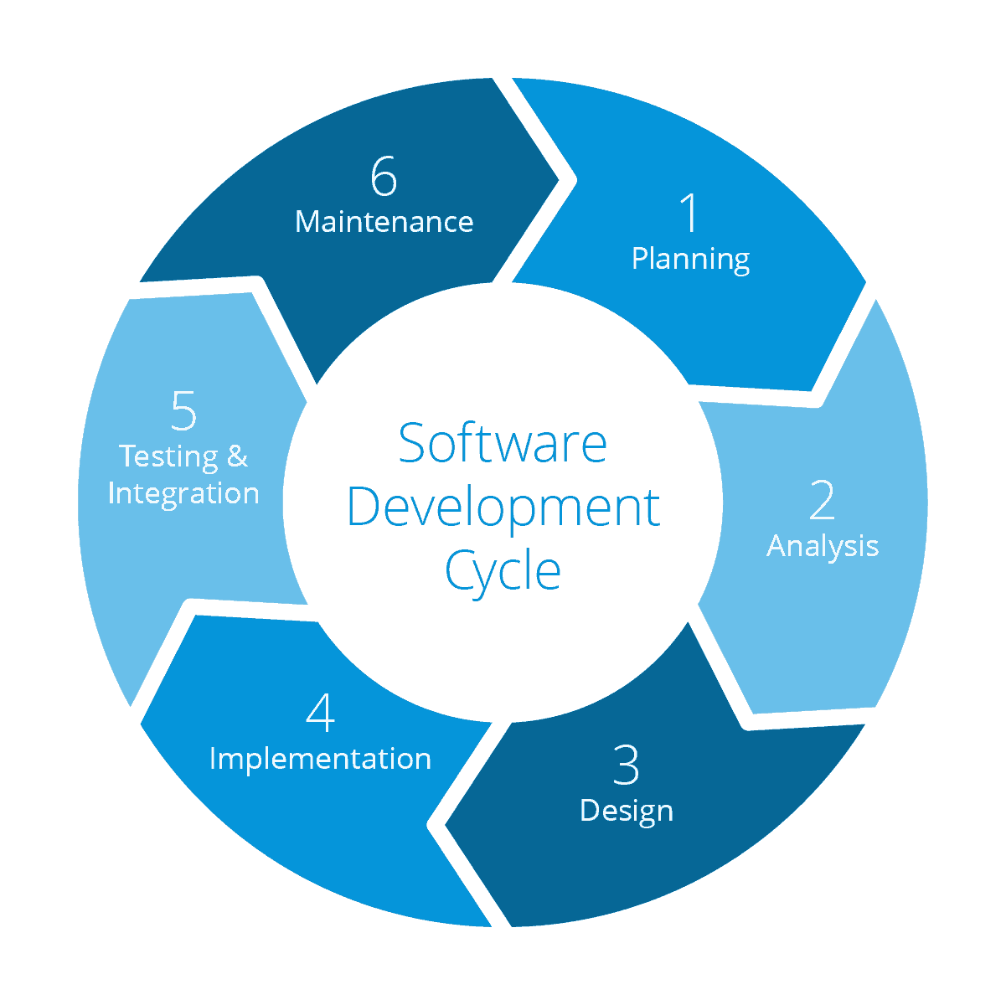

Figure 1: Agile software development life cycle model
This model is known as the Agile SDLC model. It combines iterative and incremental process models with a focus on process adaptability and customer satisfaction by rapidly delivering working software products.

IPO Model
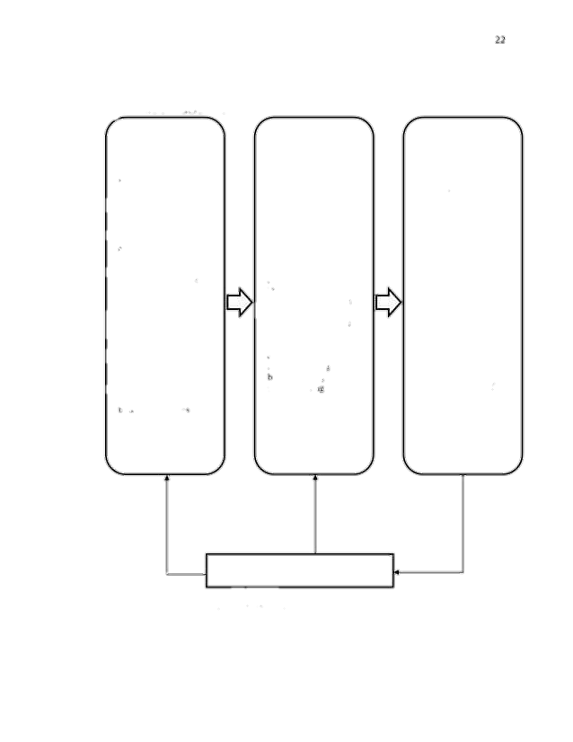
The input-process-output (IPO) model, or input-process-output pattern, is a widely used approach in systems analysis and software engineering for describing the structure of an information processing program or another process
Knowledge Requirements
a. Basic Troubleshooting
b. Database System
Software Requirements
a. Java System
b. JDK 17
c. Apache Netbeans
Hardware Requirements
a. Computer
b. Minimum Specs
System Requirements
a. Requirements Analysis
b. Requirements Description
System Design
a. Context Diagram
System Development
a. Agile Model
System Testing
a. Alpha Test
b. Beta Test
c. Pilot Test

EVALUATION
Arduino Nano-Based GPS Tracker

System Flowchart
A system flowchart is a graphical representation of the flow of data in the system and represents the work process of the system.

Context Diagram
A context diagram is a figure that defines the boundary between the structure, surrounded by those elements in the environment in which it is.

Project Locale
The study is conducted around the provinces of Rizal.
Project Participants
The researchers will be choosing one member to test the
Project Instruments
The primary instrument for this study is the proponents themselves. Other instruments are gadgets such as computers and laptops, to create the paper and the system that will be used by the beneficiaries.
Data Collection Process
To ensure that the data gathered are valid and accurate, the researcher used the data gathering tools listed below:
- Observation.
Observation is the collection of Primary Data through observing people.

CHAPTER IV
Project Design & Result Discussion
Project Design
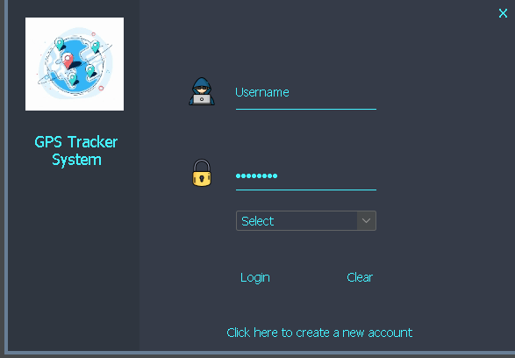

Figure 6: Main menu - this will show all the features and information needed in accessing
the system.



Figure 7: Register Form- where the administrator/user input the necessary data to register.

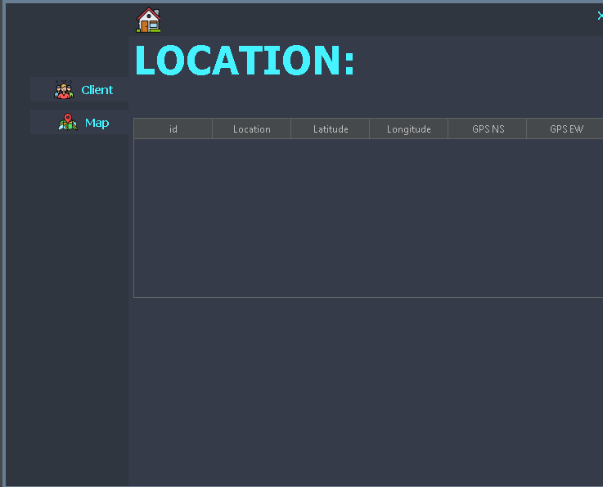

Figure 8: Main Menu - this is where the user can choose and navigate to his/her desired option.

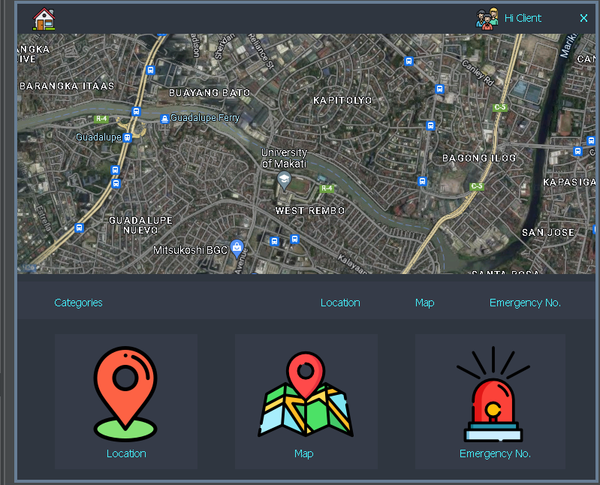

Figure 9: Tracking Form- this is where the user can locate and track down the GPS

CHAPTER V
Conclusion & Recommendation
Conclusion
The proponents have only a single goal, which is to develop a GPS tracker that eases the mind of the users in certain situations. To fulfill the proponents’ research project, they have developed a tracking system that provides an easy and helpful use to fulfill the needs of the institution.

To conclude, the overview for this capstone project named “Arduino Nano Based GPS Tracker” is that, the system developed is efficiently, and consistently running, however, it needs some tweaks and updates to function as needed for the institution that which the proponents chose to benefit. The proponents gave a solution to the lack of security and achieved the goals of the study.

Recommendation
Based on the conclusion above, the proponents recommend that this capstone project can be used by future researchers as their reference for their future project which is in track for this course.
The proponents also suggest that, since we are in the 21st century and technologies can be widely used in security and other institutions would consider funding and utilizing the use of GPS Tracking devices to avoid or lessen the crimes in our country creating safe spaces for our children and loved ones.

APPENDICES

Expenses | Cost | Units | Total
Arduino Nano | ₱350 | 1x | ₱350.00
GSM Module | ₱800 | 1x | ₱800.00
GPS Module | ₱400.00 | 2x | ₱800.00
Breadboard | ₱90.00 | 1x | ₱90.00
Jumper Wires ₱10 pesos each 10x |  |  | ₱100.00
Total Expenses |  |  | ₱2140.00
APPENDIX E
Research Budget


CURRICULUM VITAE
NAME: Durana, Jeric Labido
Address: #0455 Brgy. Sta Cruz Lower Sto. Nino Street
Antipolo City
Email: Jericdurana21@gmail.com

EDUCATIONAL BACKGROUND:

TERTIARY: Rizal Technological University 2020 – Present
Eusebio, Pasig, Metro Manila

SECONDARY (SHS): Our Lady of Fatima University — Antipolo 2018 – 2020
Km. 23, Sumulong Hi-way, Sta. Cruz, Antipolo City

SECONDARY (JHS): Antipolo National High School 2014 – 2018
Olalia Rd., Sta. Cruz, Antipolo City

ELEMENTARY: Sta. Cruz Elementary School 2008 – 2014
Olalia Rd., Sta. Cruz, Antipolo City


CURRICULUM VITAE
NAME: Batang, Ernesto
Address: 1644 Ampalaya St. Napico Manggahan Pasig City
Email: kemobatang24@gmail.com

EDUCATIONAL BACKGROUND:

TERTIARY: Rizal Technological University
2020 – Present
Eusebio, Pasig, Metro Manila

SECONDARY (SHS): Manggahan Highschool
2018 – 2020
44 Street, Karangalan Village, 1611,, Kaginhawaan, Pasig, Metro Manila

SECONDARY (JHS): Manggahan Highschool 2014 – 2018
44 Street, Karangalan Village, 1611,, Kaginhawaan, Pasig, Metro Manila

ELEMENTARY: Manggahan Elementary School 2008 – 2014
General Capinpin, Pasig, Metro Manila


CURRICULUM VITAE
NAME: Dave C. Cabab
Address: Bldg 7 Unit 110 LRB Manggahan Residence
East Bank Rd. Sta. Lucia Pasig City
Email: davecabab0619@gmail.com

EDUCATIONAL BACKGROUND:

TERTIARY: Rizal Technological University 2020 – Present
Eusebio, Pasig, Metro Manila

SECONDARY (SHS): Eusebio Highschool (EHS)
2018 – 2020
H3QQ+G9M, C. Raymundo Ave, Pasig, 1609 Metro Manila

SECONDARY (JHS): Eusebio Highschool (EHS) 2014 – 2018
H3QQ+G9M, C. Raymundo Ave, Pasig, 1609 Metro Manila

ELEMENTARY: Rosario Elementary School (RES) 2008 – 2014
4 Pearl St, Pasig, 1609 Metro Manila


CURRICULUM VITAE
NAME: Andres, Cris John V.
Address: 51/a DMC st. Brgy. Sta Ana Taguig City
Email: crisjohnandres@gmail.com

EDUCATIONAL BACKGROUND:

TERTIARY: Rizal Technological University
2020 – Present
Eusebio, Pasig, Metro Manila

SECONDARY (SHS): Arellano University-Pasig
2018 – 2020
Teodora Alonzo, Santa Cruz, Manila, 1008 Metro Manila

SECONDARY (JHS): Gen.Ricardo G. Papa Memorial High School 2014 – 2018
Col P Cruz, Taguig, Metro Manila

ELEMENTARY: Plainview Elementary School 2008 – 2014
San Ignacio, Corner San Joaquin, Mandaluyong, 1550 Metro Manila

CURRICULUM VITAE
NAME: Lexus John H. Belisario
Address: Lot 6 Blk 20 Ashburton Street, Greenridge,
Brgy. Tagpos Binangonan Rizal
Email: lexusbelisario@gmail.com

EDUCATIONAL BACKGROUND:

TERTIARY: Rizal Technological University
2020 – Present
Eusebio, Pasig, Metro Manila

SECONDARY (SHS): AMA Computer Learning Center
2018 – 2020
419 D & I Bldg, Epifanio de los Santos Ave, East Grace Park, Caloocan, 1400 Metro Manila

SECONDARY (JHS): Arellano University Malabon Campus 2014 – 2018
Manila 2600 Legarda St. Sampaloc Manila

ELEMENTARY: Arellano University Malabon Campus 2007 – 2013
Manila 2600 Legarda St. Sampaloc Manila

References and Links:

https://newsinfo.inquirer.net/1660078/to-set-record-straight-pnp-says-only-27-kidnapping-cases-so-far-in-2022#ixzz7hhV06rmF
Advantage of Using GPS Trackers as Anti-Kidnapping Devices – Trackimo

1.-DISTRESS-SIGNAL-TRACKER-USING-GPS-AND-SMS-TECHNOLOGY.pdf (lpulaguna.edu.ph)

Philippine EJournals| CRIME TRACKING DEVICE USING GPS AND SMS TECHNOLOGIES

https://www.phc.ox.ac.uk/research/interdisciplinary-research-in-health-sciences/scals/case-studies/gps-tracking

