Jason Rutledge

Comp 232

Lab 8 - Databases

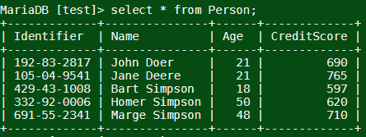

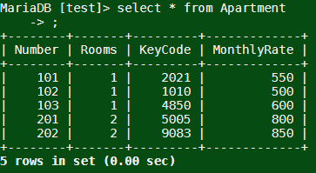

1.

Find the all persons with an age that is equal or greater than 40. List all the

attributes in the result set.

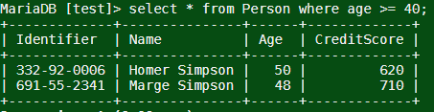

2.

Create a list of names and their credit scores where the credit score is less than 650

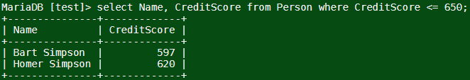

3.

Find all persons whose name mentions ‘D’, followed by any one character, followed

by ‘e’.

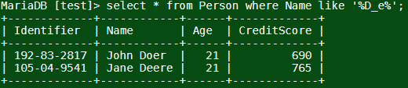

4.

Find all persons whose credit score is greater than 600 and their age is less than 50.

Order the list by descending values of Age and Name. The results set should only

contain the Name, Age, and Credit Score of the person.

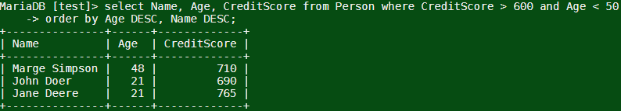

5.

Find the monthly rates for apartments where tenants have credit score greater than

700. Note, this requires a JOIN operation. The result set should only contain the

apartment number and the associated monthly rate.

//This one didn’t make sense to me, so this is my best guess as to what is requested

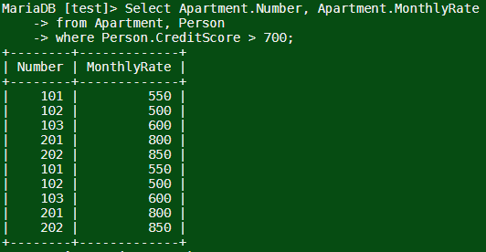

1.

Add another person with the following attributes to the

Person

table using the insert

command:

A.

401-29-4422, Peter Griffin, 45, 651

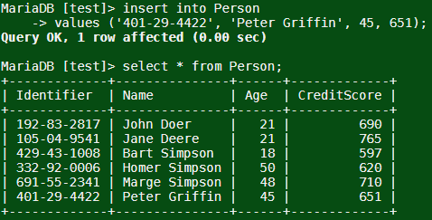

1.

Delete the entry for room number 202 from the Apartment table

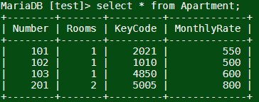

2.

Delete both tables from the database

