**Microprocessor Lab**

Laboratory Activity No. 3

**8-bit Binary Representation (0-255) using 8 LEDs**

|  |
| --- |
|  |

Score

*Submitted by:*

**Cometa, Leyan Kristoffer P. (Leader)**

**Marquez, Kert Justine D.**

**Mui, Marc Jefferson T.**

**Salazar, Harold**

**Quintano, Jeremiah**

**4PM – 7PM / CPE0412-2**

*Date Submitted*

**10-14-2023**

*Submitted to:*

**Engr. Maria Rizette H. Sayo**

I. Objectives

- To create Arduino circuit of Binary representation (decimal 0-255 using 8 LEDs) and have an actual implementation using hardware.

II. Methodology

* Design and construct a functional Arduino circuit capable of visually representing decimal numbers from 0 to 255 (8-bit binary) using a set of 8 LEDs.

- Ensure that each LED corresponds to one bit in the binary representation

- Ensure that visual representation in binary and decimal value in serial monitor are

the same.

* Implement it in hardware after making it in TinkerCAD

Figure 1. TinkerCAD Implementation of 8 Bit Binary Representation (0-255) using 8 LEDs

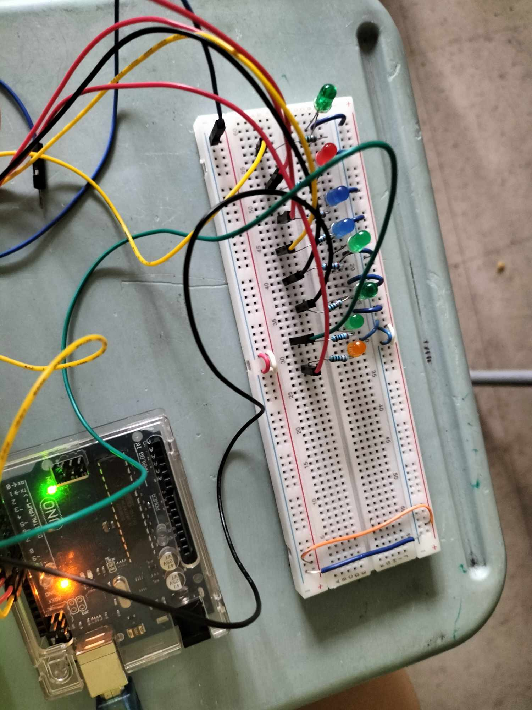

Figure 2. Hardware Implementation of 8 Bit Binary Representation (0-255) using 8 LEDs

**Components Used**

1. 8 LEDs
2. 8 pcs. of 220 Ω resistor
3. Breadboard
4. Jumper wires

III. Results

**TinkerCad**

<https://www.tinkercad.com/things/bHeyxHnIJr6-8-bits-binary-counter/editel?sharecode=TuMDjZm3w0ZOMSxF11_TnNA1_lj7n21LIJE6XgRBFCQ>

-This link is directed to the TinkerCAD implementation of 8 Bit Binary Representation (0-255) using 8 LEDs.

<https://drive.google.com/file/d/15kRsSfhVRfoMu_G4zr-5Ksr12jF5QZ_8/view?usp=drivesdk>

-This link is directed to the video output of hardware implementation of 8 Bit Binary Representation (0-255 using 8 LEDs.

In the lab activity, the group have found out that the lighting up of the LED depends on the current decimal value that is being presented. It will traverse starting from 0 until 255. Upon reaching 255, it will start again from 0 up to 255, repeating the same process. The program that was made effectively cycles through all possible binary patterns for the 8 LEDs connected to pins 2 to 9, with a half-second delay between each pattern change.

Figure No.3 8 Bit Binary Representation (0-255) using 8 LEDs

**CODE:**

IV. Conclusion

For this experiment, the group designed a setup in the laboratory where we’ve established a connection between eight LEDs and specific digital pins on the Arduino. By leveraging binary encoding, the setup allowed us to visually exhibit decimal numbers within the range of 0 to 255. The central program loop was responsible for incessantly increasing a variable called 'count' while also keeping the LEDs updated to depict its binary format. Concurrently, we printed the decimal value of 'count' on the serial monitor to ensure accuracy. This exercise effectively demonstrated my expertise in Arduino programming and the adept application of bitwise operations. It showcased the construction of an 8-bit binary counter, which was vividly represented through the illumination of LEDs within the TinkerCad simulation.

**References**

[1] D.J.D. Sayo. “University of the City of Manila Computer Engineering Department Honor Code,” PLM-CpE Departmental Policies, 2020.

[2]P. Marian, “Arduino 8 bit binary led counter,” ElectroSchematics.com, https://www.electroschematics.com/arduino-8-bit-binary-led/ (accessed Oct. 13, 2023).

[3]“CCENT/CCNA ICND1 640-822 official CERT Guide,” O’Reilly Online Learning, https://www.oreilly.com/library/view/ccentccna-icnd1-640-822/9780132660181/app02.html (accessed Oct. 13, 2023).

[4]N. Guluzade, “Arduino binary (8 bit) led’s counter.,” YouTube, https://www.youtube.com/watch?v=HYOsJhSR9S8&ab_channel=NurlanGuluzade (accessed Oct. 13, 2023).