**Sales Forecasting Project**

**Overview**

**Sales Forecasting Project Overview**

This sales forecasting project aims to address key objectives for optimizing department-wide sales at various stores, with a focus on enhancing predictive accuracy, modelling the impact of markdowns during holiday weeks, and providing actionable insights.

**Objectives:**

**Predict Department-wide Sales:**

The primary objective of this project is to develop a predictive model that accurately forecasts the department-wide sales for each store for the upcoming year. By leveraging historical sales data and various features such as temperature, fuel price, markdowns, and holiday indicators, the model aims to provide insights into future sales trends.

**Model Impact of Markdowns on Holiday Weeks:**

Investigate and model the specific effects of markdowns during holiday weeks on sales.

Identify patterns, correlations, and causal relationships to refine the forecasting models during holiday periods.

**Provide Actionable Insights:**

Derive meaningful insights from the forecasting models and markdown analysis.

Prioritize recommendations based on the potential business impact.

Offer clear, actionable steps for improving sales performance, with a focus on maximizing return on investment.

**Visualizations:**

Visualizations for this project have been created using both Power BI and Tableau. Here are links to the interactive dashboards.

[Sales Forcasting Dashboard - Power BI](https://app.powerbi.com/groups/me/reports/e47b8bc0-d98e-4ac1-a1da-9b0a46501293/ReportSectiondf4e43142765aec129e7?experience=power-bi)

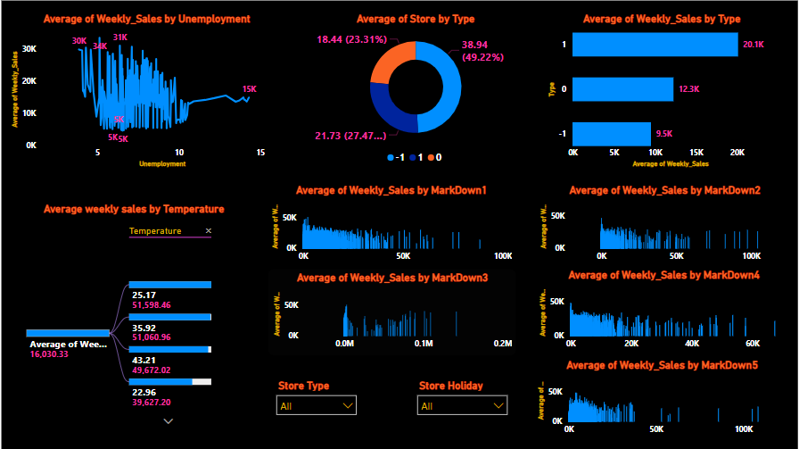

**Sales Prediction:**

The sales prediction module utilizes [mention the models or algorithms used] to forecast store sales. [Discuss any notable results or challenges encountered during the prediction process.]