Background:
This study is coming from the “A longitudinal study of angiogenic (placental growth factor) and anti-angiogenic (soluble endoglin and soluble vascular endothelial growth factor receptor-1) factors in normal pregnancy and patients destined to develop preeclampsia and deliver a small for gestational age neonate”. In this paper, it mostly focus on building the mixed model and see the relation with three groups with time effect. First of all, we consider all the model with time effect which up to 5 times to performance in the data. After that we need to check its significance of those parameters and decide to keep the max times effect. Then we have find some relationship between those three groups. They looks like separate at 22-27 weeks when we consider the different index. For this report, we consider the SVE as our response variable and the bmi and time as our covariance. Growth curve models were fitted to the transformed plasma concentration (log (1þ concentration)) of each analyte adjusting for baseline and clinical risk factors. This log transformation also has a variance stabilization property.
During the paper, it just give the time point which those group are different. However, we are more interested in the time interval. If we can get the interval of those patient and healthy pregnant women, we could give them more suitable advice to ensure them and their baby’s health. So in this report, we not only build the mixed model in the paper, we also use the bootstrap method to get the time 95% confidence interval.

Explore for the data and model:
Before we start the model build, we look at our data. In the data and study design, this longitudinal nested case–control study comprised 144 patients with singleton pregnancies with the following diagnoses: (1) those with uncomplicated pregnancies who delivered appropriate for gestational age (AGA) neonates, (2) patients who delivered an SGA neonate, and (3) patients who developed PE. They are our 3 groups data and in the 144 patient, each patient we have record their information 6 times from 8 weeks to 42 weeks. In those patient, we also find that some patients are not fit for our study design, so we remove those patients. Now we could just have 137 patients in the data analysis and each patient with 6 records in the different time for us to see the time effect.
When we build the model, we draw the plot of the average mean profile of three groups in the figure1.
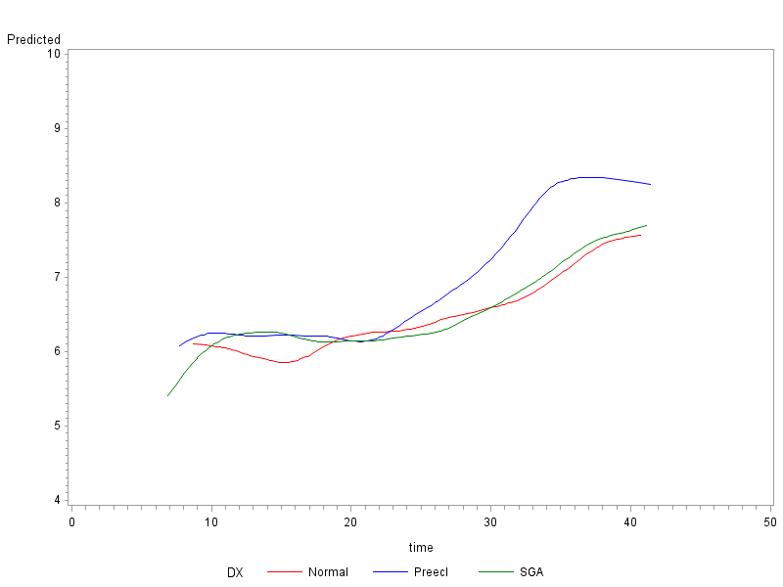
Figure1, Forward analysis of the maternal plasma concentration of soluble vascular endothelial growth factor receptor-1 (sVEGFR-1) in patients with normal pregnancies and those with pregnancy complications. Patients destined to develop preterm had a significantly higher plasma concentration of sVEGFR-1 at 26 and 29 weeks of gestation, respectively, than normal and SGA. However, there was no difference in the increment of sVEGFR-1 between normal patients and those who delivered an SGA neonate.

According to the figure1, we have get idea for our continue working. We could assume that the group1 (normal) and group 3(SGA) are similar. If we can prove that we only need to compare two group and just to find one time point instead of compare three groups which can highly reduce our working. So the next step, we need to check those two group, to see whether they are the same. In order to test the two group is the same, we try to use those group1 and group3 data set to combine as one data set. And in the model, we consider the group effect at first, to see the group effect is significant or not. When we try to use the F test, the result shows that:

Table1 F test for the group effect
Effect | Num DF | Den DF | F Value | Pr > F
DX | 2 | 222 | 1.73 | 0.1805
In the result, the p value>0.05, so we should reject the null hypothesis that the group effect is not equal to zero. Which shows us, if we treat them as two groups the model tell us the group effect is not significant for them. So this means we should treat them as just one group and compare the whole group with group2.
Then we renew our model and just have two groups to do the analysis. When we check the significant of the parameters, we found that in the table1, if we keep the time^5 effect for the model, the whole parameter would be not significant. In the table2, we could see that if we remove the time^5 effect for the model the mostly all the parameters are significant in the model. So we decided to choose the model 2 as our best model to describe the data set feature.

Table2
Solution for Fixed Effects
Effect | PE_DX | Estimate | Standard  Error | DF | t Value | Pr > |t|
PE_DX | 0 | 0.4426 | 2.0373 | 281 | 0.22 | 0.8282
PE_DX | 1 | 1.1239 | 3.5598 | 281 | 0.32 | 0.7525
time*PE_DX | 0 | 1.2941 | 0.5229 | 281 | 2.47 | 0.0139
time*PE_DX | 1 | 1.2217 | 0.9121 | 281 | 1.34 | 0.1815
time2*PE_DX | 0 | -0.1088 | 0.05006 | 281 | -2.17 | 0.0306
time2*PE_DX | 1 | -0.1039 | 0.08701 | 281 | -1.19 | 0.2335
time3*PE_DX | 0 | 0.004219 | 0.002256 | 281 | 1.87 | 0.0625
time3*PE_DX | 1 | 0.003803 | 0.003905 | 281 | 0.97 | 0.3310
time4*PE_DX | 0 | -0.00008 | 0.000048 | 281 | -1.57 | 0.1183
time4*PE_DX | 1 | -0.00006 | 0.000083 | 281 | -0.69 | 0.4927
time5*PE_DX | 0 | 5.173E-7 | 0 | 281 | Infty | <.0001
time5*PE_DX | 1 | 2.729E-7 | 0 | 281 | Infty | <.0001

Table3
Solution for Fixed Effects
Effect | PE_DX | Estimate | Standard  Error | DF | t Value | Pr > |t|
PE_DX | 0 | 2.8660 | 0.8636 | 283 | 3.32 | 0.0010
PE_DX | 1 | 2.4246 | 1.4858 | 283 | 1.63 | 0.1038
time*PE_DX | 0 | 0.6458 | 0.1721 | 283 | 3.75 | 0.0002
time*PE_DX | 1 | 0.8751 | 0.2990 | 283 | 2.93 | 0.0037
time2*PE_DX | 0 | -0.04496 | 0.01189 | 283 | -3.78 | 0.0002
time2*PE_DX | 1 | -0.06988 | 0.02071 | 283 | -3.37 | 0.0008
time3*PE_DX | 0 | 0.001292 | 0.000341 | 283 | 3.79 | 0.0002
time3*PE_DX | 1 | 0.002251 | 0.000596 | 283 | 3.78 | 0.0002
time4*PE_DX | 0 | -0.00001 | 3.455E-6 | 283 | -3.60 | 0.0004
time4*PE_DX | 1 | -0.00002 | 6.077E-6 | 283 | -3.92 | 0.0001

When we combine the group1 and group3, the result is much similar as we see previously. They are different at time around 23 weeks.
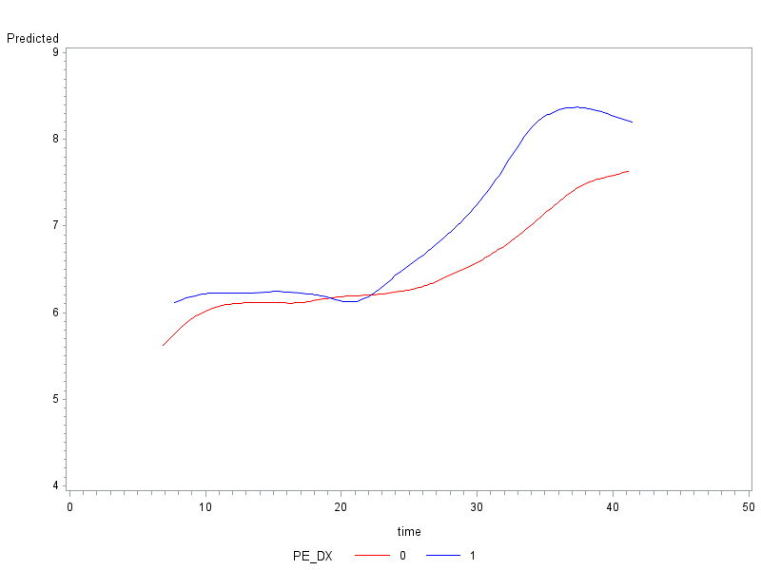

Figure2

Method to get the confidence interval:

And the confidence interval for would be expressed by this:
,
Where the =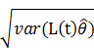 and the =
And the Variance of the comes from the mixed model, we draw the hessian matrix and put the whole hessian matrix into the equation to get the .
So we can use this method to get the lower bound of the time point which time group whole is not equal to group2.Then we can use the bootstrap method. In this method, we need to resample data set thousand time and to the mixed model regression and also compute the lower bound t. After thousands result, we can plot the distribution of the lower bound of t, if it is similar to the normal distribution, we can use the quantile of the thousands result as the lower bound 95% confidence interval.

Before we start the bootstrap method, we could do the
We compare the group and group2 and get a very nice plot which shows that they do have some points to be significant different.
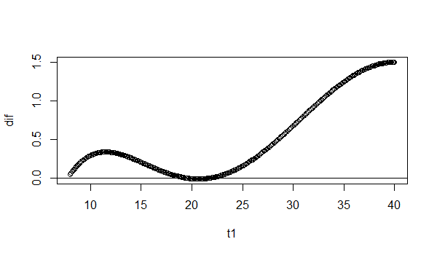
We compare the group1 and group3 and get a very bad plot which shows that they do not have a clear point to be significant different.
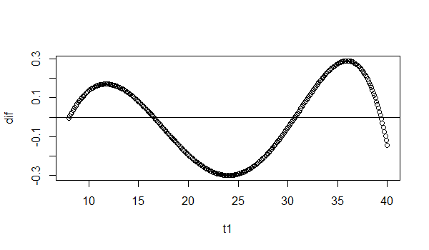

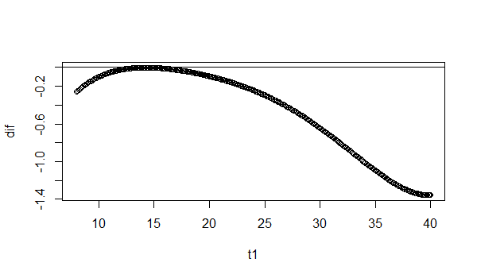
So consider the fiture1, we need to compare the group1 and group3 whether they exist a significant between two groups. We try to use the F test for the two model, and the result shows that we should treat them as just one group. Now we just need to check the new big group and group2’s difference is significant at some time.

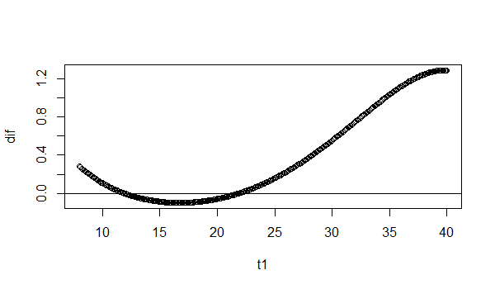
This figure come from the group and group2, shows that the difference point looks like at 20 to 25 weeks for those women. And if we can find the confidence interval for this point, we could give them better advices. They can go to hospital at the best time to ensure their children’s status. In order to solve this question, we come up with idea that :
We decide to choose the point t and through the estimate variance to get its confidence interval. And we want to find the lower bound one which equal to zero. Then we resample the whole data set try to use the bootstrap method to get the distribution of the lower bound time t1.Then we take the 95% quantile of those time to get the time confidence interval.
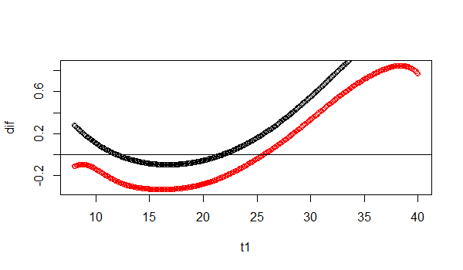
In this figure, the black lines represent the true time value and the red one represent the lower bound time value. This result give us the confident to let us continue our work.

After the 5000 times repeat the bootstrap, we get the final result:

The lower bound 95% CI= [20.7 ,27.4], which is much close to what we see in the previous plot.

