The confidence interval of lower bound time value for the pregnant women
Leyi Li

Abstract：
Introduce: For the previous study, we have already study the relationship between the normal, PE and SGA group of the different response variable. And in the figure and some statistics analysis, we noticed that the group difference would be significant from zero. But the previous study doesn’t show the time confidence interval. In this report, we would focus on finding the lower bound time value confidence interval as our final result. Then we could give those pregnant women better time advice to check their baby health.
Result: （1）the t-value would follow a normal distribution showing in the plot (2) the confidence interval would be 95% CI [21.4,27.9], which is close to what we see in the previous mixed model of the mean profile.

Background:
This study is coming from the “A longitudinal study of angiogenic (placental growth factor) and anti-angiogenic (soluble endoglin and soluble vascular endothelial growth factor receptor-1) factors in normal pregnancy and patients destined to develop preeclampsia and deliver a small for gestational age neonate”. In this paper, it mostly focuses on building the mixed model and find the relationship between three groups with time effect. First of all, the paper considers all the model with time effect which up to 5 times to performance better in the data. After that we need to check its significance of those parameters and decide to keep the max time effect. Then we draw the relationship figure and see some relationship between those three groups. They look like separate at 22-27 weeks when we use the SVE as our response variable in the model. For this report, we consider the SVE as response variable and the bmi and time as our covariance. Growth curve models were fitted to the transformed plasma concentration (log (1þ concentration)) of each analyte adjusting for baseline and clinical risk factors. This log transformation also has a variance stabilization property. And the paper takes them to build the model.
During the paper, it just gives the time point which those group are different. However, we are more interested in the time interval. If we can get the interval of those patient and healthy pregnant women, we could give them more suitable advice to ensure them and their baby’s health. So in this report, we not only build the mixed model in the paper, we also use the bootstrap method to get the time 95% confidence interval.

Explore for the data and model:
Before we start the model build, we look at the data. In the data and study design, this longitudinal nested case–control study comprised 144 patients with singleton pregnancies with the following diagnoses: (1) those with uncomplicated pregnancies who delivered appropriate for gestational age (AGA) neonates, (2) patients who delivered an SGA neonate, and (3) patients who developed PE. They are our 3 groups data and in the 144 patient, each patient we have record their information 6 times from 8 weeks to 42 weeks. In those patient, we also find that some patients are not fit for our study design, so we remove those patients. Now we could just have 137 patients in the data analysis and each patient with 6 records in the different time for us to see the time effect.
When we build the model with time effect up to 5 times and with three groups, we draw the plot of the average mean profile of three groups in the figure1.
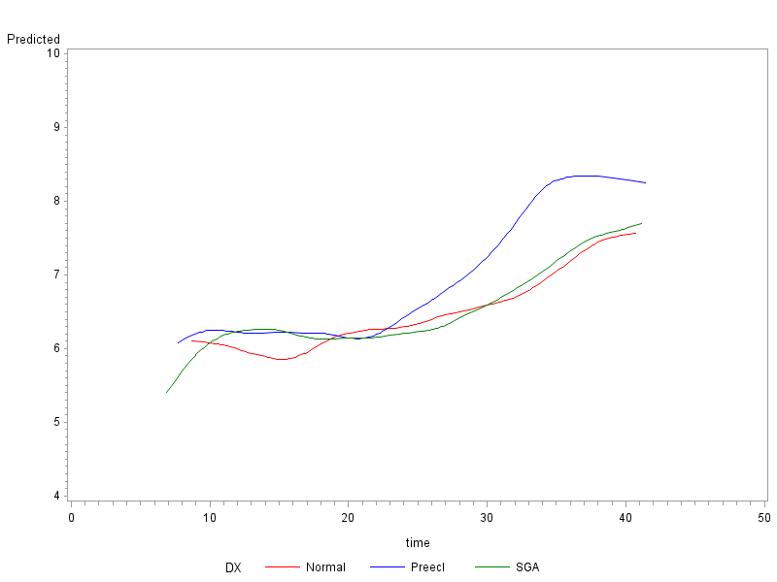
Figure1, Forward analysis of the maternal plasma concentration of soluble vascular endothelial growth factor receptor-1 (sVEGFR-1) in patients with normal pregnancies and those with pregnancy complications. Patients destined to develop preterm had a significantly higher plasma concentration of sVEGFR-1 at 26 and 29 weeks of gestation, respectively, than normal and SGA. However, there was no difference in the increment of sVEGFR-1 between normal patients and those who delivered an SGA neonate.

According to the figure1, we have get idea for continuing work. We could assume that the group1 (normal) and group 3(SGA) are similar and test this assumption. If we can prove that we only need to compare two groups and just to find one time point instead of compare three groups which can highly reduce our working. So the next step, we need to check those two groups (normal and SGA group), to see whether they are the same. In order to test the two groups is the same, we try to use those group1 and group3 data set to combine as one data set. And in the model, we consider the group effect at first, to see the group effect is significant or not. When we try to use the F test, the result shows that:

Table1 F test for the group effect
Effect | Num DF | Den DF | F Value | Pr > F
DX | 2 | 222 | 1.73 | 0.1805
In the table1, the p value>0.05, so we should reject the null hypothesis that the group effect is not equal to zero. Which shows us, if we treat them as two groups the model tells us the group effect is not significant for them. So this means we should treat them as just one group and compare the whole group with group2 (PE group).
Then we renew our model and just have two groups to do the analysis. When we go back to check the significant of the parameters, we found that in the table2, if we keep the time^5 effect for the model, the whole parameter would be not significant. In the table3, we could see that if we remove the time^5 effect for the model the mostly all the parameters are significant in the model. So we decided to choose the model 2 as our best model to describe the data set feature.

Table2
Solution for Fixed Effects
Effect | PE_DX | Estimate | Standard  Error | DF | t Value | Pr > |t|
PE_DX | 0 | 0.4426 | 2.0373 | 281 | 0.22 | 0.8282
PE_DX | 1 | 1.1239 | 3.5598 | 281 | 0.32 | 0.7525
time*PE_DX | 0 | 1.2941 | 0.5229 | 281 | 2.47 | 0.0139
time*PE_DX | 1 | 1.2217 | 0.9121 | 281 | 1.34 | 0.1815
time2*PE_DX | 0 | -0.1088 | 0.05006 | 281 | -2.17 | 0.0306
time2*PE_DX | 1 | -0.1039 | 0.08701 | 281 | -1.19 | 0.2335
time3*PE_DX | 0 | 0.004219 | 0.002256 | 281 | 1.87 | 0.0625
time3*PE_DX | 1 | 0.003803 | 0.003905 | 281 | 0.97 | 0.3310
time4*PE_DX | 0 | -0.00008 | 0.000048 | 281 | -1.57 | 0.1183
time4*PE_DX | 1 | -0.00006 | 0.000083 | 281 | -0.69 | 0.4927
time5*PE_DX | 0 | 5.173E-7 | 0 | 281 | Infty | <.0001
time5*PE_DX | 1 | 2.729E-7 | 0 | 281 | Infty | <.0001

Table3
Solution for Fixed Effects
Effect | PE_DX | Estimate | Standard  Error | DF | t Value | Pr > |t|
PE_DX | 0 | 2.8660 | 0.8636 | 283 | 3.32 | 0.0010
PE_DX | 1 | 2.4246 | 1.4858 | 283 | 1.63 | 0.1038
time*PE_DX | 0 | 0.6458 | 0.1721 | 283 | 3.75 | 0.0002
time*PE_DX | 1 | 0.8751 | 0.2990 | 283 | 2.93 | 0.0037
time2*PE_DX | 0 | -0.04496 | 0.01189 | 283 | -3.78 | 0.0002
time2*PE_DX | 1 | -0.06988 | 0.02071 | 283 | -3.37 | 0.0008
time3*PE_DX | 0 | 0.001292 | 0.000341 | 283 | 3.79 | 0.0002
time3*PE_DX | 1 | 0.002251 | 0.000596 | 283 | 3.78 | 0.0002
time4*PE_DX | 0 | -0.00001 | 3.455E-6 | 283 | -3.60 | 0.0004
time4*PE_DX | 1 | -0.00002 | 6.077E-6 | 283 | -3.92 | 0.0001

After we build the model with the group and group2, we also draw the mean profile figure to see the trend of the data. The result is much similar as we see previously. And this also means our method to combine the group1 and group3 should be right.
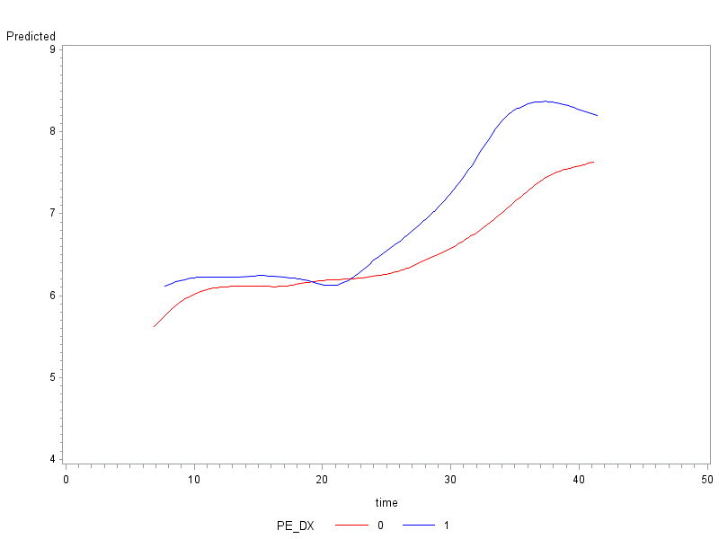
Figure2 PE_DX(0) would be the normal and SGA group, PE_dx(1) would be the PE group. During the figure, we could see the obvious different time point should be 23 weeks around.

Method to get the confidence interval:
After build the model, we can get enough information about the model, and we could draw the estimate parameter and the Hessian matrix to realize our goal.
The mathematic equation:
And the confidence interval for would be expressed by this:
,
Where the =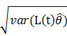 and the =
And the Variance of the comes from the mixed model, we draw the hessian matrix and put the whole hessian matrix into the equation to get the .
So we can use this method to get the lower bound of the time point which time group whole is not equal to group2. Then we can use the bootstrap method. In this method, we need to resample data set thousand times and do the mixed model regression and also compute the lower bound t. After thousands result, we can plot the distribution of the lower bound of t, if it is similar to the normal distribution, we can use the quantile of the thousands result as the lower bound 95% confidence interval.

Before we start the bootstrap method, we could do the difference between the two groups.
We compare the group and group2 and get a very nice plot which shows that they do have some points to be significant different.
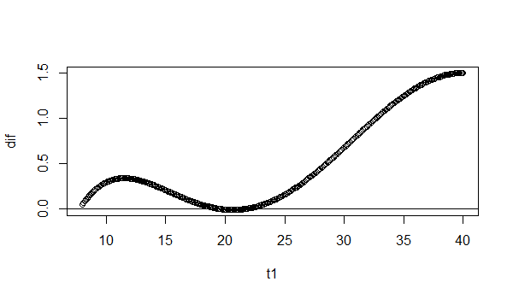
Figure3,in this plot, we could see the difference between group and group2 which equal to zero would be around 8 and around 23 weeks.This means the result is much smilar to the figure 2. Those two groups would separate at time 23 weeks.
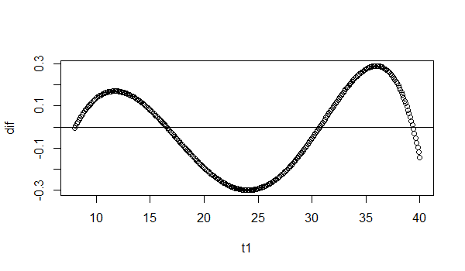
Figure4 ,in this plot the difference is between group1 and group3 which give us the same result,during those times the difference is always around the zero, and looks like converge to zero.So we turely should regared them as just one group.

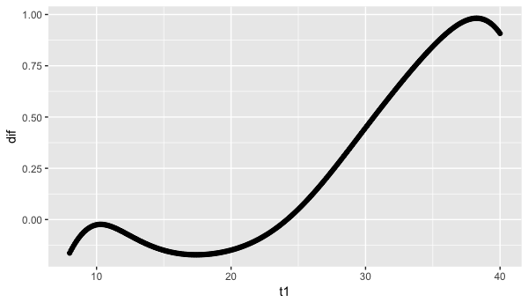
Figure5,the difference between the group and group2 when we consider the effect for the lower bound into the model. And the time point is also around 23 weeks.

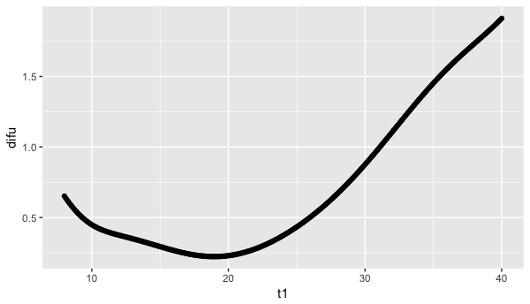
Figure6 the difference between the group and group2 when we consider the effect for the upper bound into the model. And the time point is around 20 weeks.

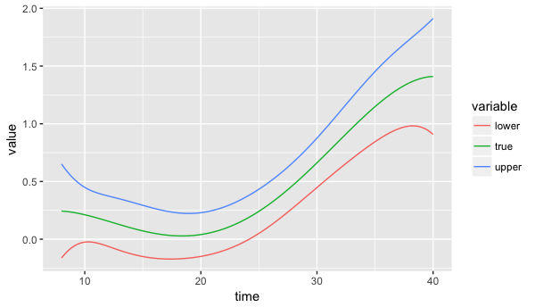
Figure7, the whole data come from the original data set, lower bound would reduce the 1.96* and the upper bound would plus 1.96 * in to the t point. When we combine those three lines into one plot we could find the lower bound would give us later time to be the significant difference point. So we believe that we choose the lower bound confidence interval could get a better result.

The bootstrap method:
After the analysis the whole model and confidence interval, we need to do the resample part of the whole data set. In order to keep the data set information, each time we choose 137 patients with replacement in the original data. More importantly, we need to keep some structure of the whole data, which means the resample data should contain not only some sample from group but also from group2. The simple resample may choose too many sample from just one group and lead to the wrong result. For this question, we decide two ways to solve this. First of all, we could increase the number of our bootstrap, from 1000 times to 5000 times to see the difference of the two result.

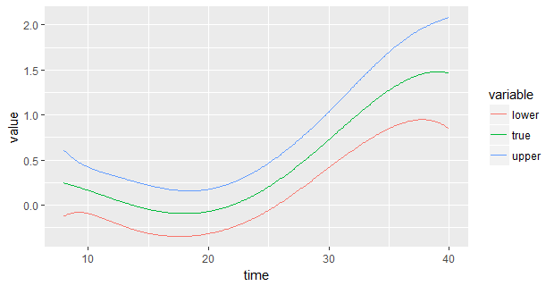
Figure 8, we use the resample method to do it again and the whole plot would be very similar to the Figure7,and the zero point of lower bound have also change a little bit.

Here we draw the density distribution plot of the 1000 and 5000 times to see the difference.
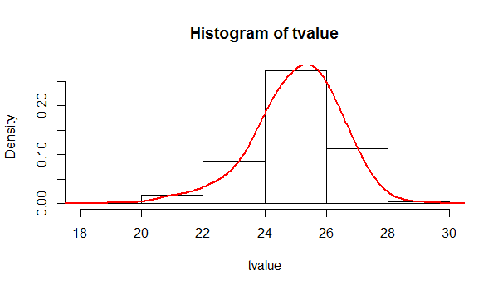
Figure9, the density of the tvalue in 1000 bootstrap and most value are between 24 to 26 weeks, much similar with the previous figure.

When we take the quantile of the bootstrap result, it gives us the 95% CI [20.3,27.4].
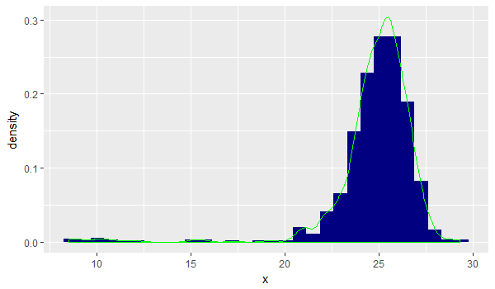
Figure10 the density of t-value in 5000 bootstrap and most value are between 24 to 26 weeks, much similar with the previous figure. Comparing with figure8 they are similar. So it tells us the resample times is enough for this t-value.
When we take the quantile of the bootstrap result, it gives us the 95% CI [21.4,27.9]. It is close to the 1000 bootstrap method.
And the second way to reduce the resample bias which choose too many sample from just one group, we could set a percent of the group, when the resample data take less than 15% of group2 or more than 45%, we reject the resample data to keep its structure of the whole data. And also do 1000 bootstrap to see the final result.
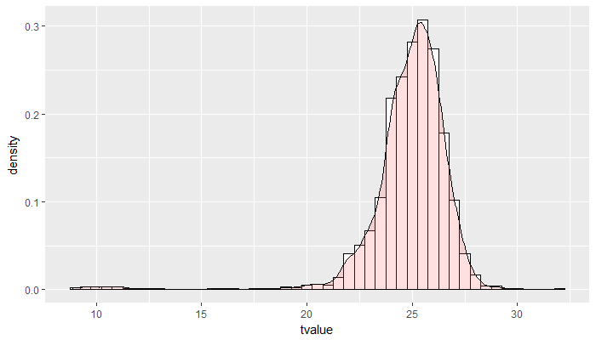
Figure11 the result comes from the structure resample method. This plot also like the normal distribution with the mean of 25 weeks. And according to this, we could draw the 95% confidence interval of the t-value as our final result.
And the 95% confidence interval CI= [21.145,27.4], when we take 1000 times bootstrap for the structure resample method.

Conclusions
Collectively, our results indicate that the normal women and patients destined to deliver an SGA neonate show them are the same group in the growth factor (sVEGFR-1), and these changes differ from those in patients destined to develop preterm or term PE during time at when we resample 1000 times CI=[20.3,27.4] , CI= [21.4,27.9] for 5000 times and CI=[21.145,27.4] for structure resample for those two groups women. If we can classify those women, and the doctor may should take care of the time during 20-28 weeks to see whether they are safe or not.

Acknowledgement:
This research was consider the point wise method. The confidence interval would dependent on the time value. The more advanced method should use the s-spline method instead of the bootstrap method, to get the confidence interval. And this one would be more reliable than the bootstrap way. However, due to the limited time, we could not talk about this method in the report.

